|  |  |
| --- | --- |
| **Topic** | ORACLE Analytic SQL |
| **Document Name** | AnalyticSQL01-EX-01-05 |
|  |  |

## Exercise EX -01:

**Definiton :** 1-List employees’ first name and last name in same department in one row.  
 Firstname Lastname; Firstname Lastname ;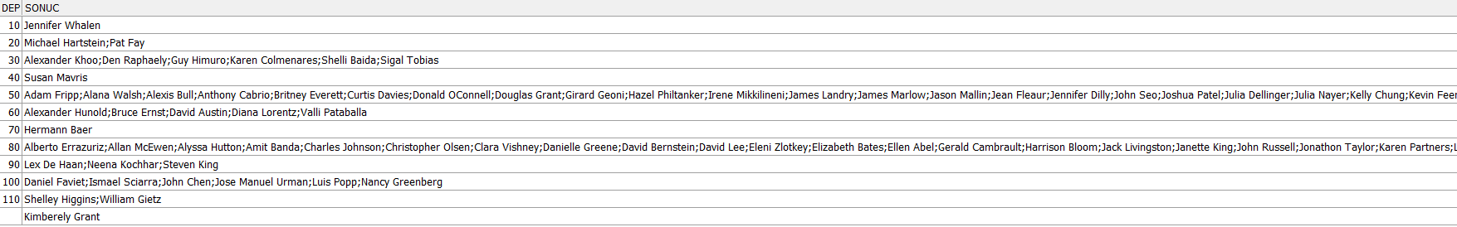

**SQL:**

SELECT department_id,

LISTAGG(first_name || ' ' || last_name, ' ; ') WITHIN GROUP (ORDER BY first_name) AS employees

FROM hr.employees

GROUP BY department_id;

**Screenshot:**

metin, makbuz, ekran görüntüsü, yazı tipi içeren bir resim

Açıklama otomatik olarak oluşturuldu

## Exercise EX -02:

**Definiton :** Write a SQL statement that shows employees’ preceeding 1 and following 1 salary totals in same job_id and ordered by hiredate.

**SQL:**

SELECT employee_id, job_id, hire_date, salary,

SUM(salary) OVER (PARTITION BY job_id ORDER BY hire_date ROWS BETWEEN 1 PRECEDING AND 1 FOLLOWING) AS salary_total

FROM hr.employees

ORDER BY job_id, hire_date;

**Screenshot:**

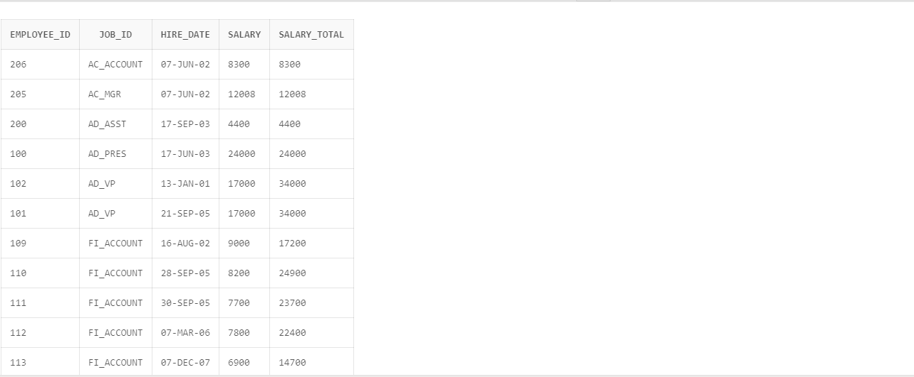

## Exercise EX -03:

**Definiton :** List employees’ salary orders in their department and exclude higest salaried employee.

(Hint: ROW_NUMBER)

**SQL:**

WITH RankedSalaries AS (

SELECT

employee_id,

first_name,

last_name,

department_id,

salary,

ROW_NUMBER() OVER (PARTITION BY department_id ORDER BY salary DESC) AS salary_rank

FROM

hr.employees )

SELECT

employee_id,

first_name,

last_name,

department_id,

salary,

salary_rank

FROM

RankedSalaries

WHERE

salary_rank > 1

ORDER BY

department_id, salary_rank;

**Screenshot:**

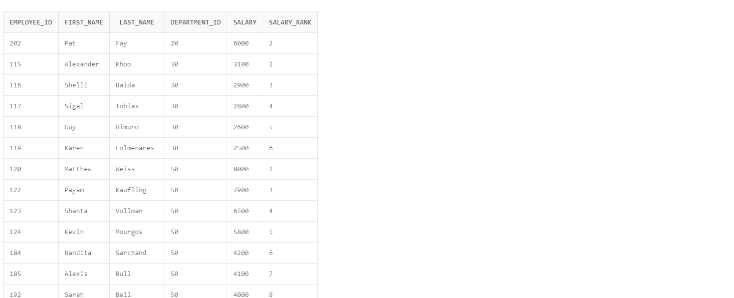

## Exercise EX -04:

**Definiton :** Listemployees’ hire order according to hiredate year value.

**SQL:**

WITH HireOrder AS (

SELECT

employee_id,

first_name,

last_name,

hire_date,

EXTRACT(YEAR FROM hire_date) AS hire_year,

ROW_NUMBER() OVER (PARTITION BY EXTRACT(YEAR FROM hire_date) ORDER BY hire_date) AS hire_order

FROM hr.employees

)

SELECT

employee_id, first_name, last_name, hire_date, hire_year, hire_order

FROM

HireOrder

ORDER BY

hire_year, hire_order;

**Screenshot:**

**metin, ekran görüntüsü, sayı, numara, yazı tipi içeren bir resim

Açıklama otomatik olarak oluşturuldu**

## Exercise EX -05:

**Definiton :** List employees’ firstname, lastname, salary and salaries of employees’ hired before and after this employee according to hirededate.

**SQL:**

SELECT

employee_id,

first_name,

last_name,

hire_date,

salary,

LAG(salary, 1) OVER (ORDER BY hire_date) AS previous_salary,

LEAD(salary, 1) OVER (ORDER BY hire_date) AS next_salary

FROM

hr.employees

ORDER BY

hire_date;

**Screenshot:**

ekran görüntüsü, metin, tasarım içeren bir resim

Açıklama otomatik olarak oluşturuldu