  
  
  
  
CS 319 - Object-Oriented Software Engineering  
Analysis Report  
  
  
Where is My Ring  
Group 1-C  
Hamza Akbar

Emre Dikeneli  
Bahadır Durmaz  
Ali Soyaslan

1. **Introduction**

“Where’s My Ring” is an Android application we are designing for Bilkent University students. Its primary purpose is to tell students in real-time where each Bilkent University’s bus is at the time. This information given to the student using the app will be in the form of a map that will show the location of each bus, and the time it will take a particular bus to reach the student’s location. We chose this app because of late in Bilkent University there have been discrepancies in the buses’ stated arrival times and their actual arrival times due to several factors. By making this app, we hope to alleviate the problem, if not completely eradicate.

1. **Overview**

The app “Where’s My Ring” will make use of three technologies: one, Android library on Android Studio IDE; two, PHP for server-side scripting on CLOUD9 IDE; three, MySQL for database management. We plan to use a remote server, but if that’s not possible, we will establish the server on our own computer, which will serve as both the server and the client.

“Where’s My Ring” will be a simple app; it will show the location of all Bilkent University’s buses on a map, and if a student wants to know the arrival time of a bus, then the app will ask the student’s current location and where the student wants to go in the form of 5 options: “Nizamiye”; “Tunus”; “Sihiyye”; “East Campus”; “Main Campus.” After choosing one of the 5 options, the app will tell how much time it will take until the bus to come to the student’s location.

For tracking Bilkent University’s buses, we need real-time GPS data of the buses. Towards this end, we spoke with Bilkent University Transportation Department and they agreed to provide us with the data; however, later they told us that they do not have the data because the bus drivers don’t turn their GPS devices on, and so due to this problem, we will simulate the data on our own so that simulated data can be fed into our app. Furthermore, we will map the simulated data onto a map through Android’s GPS API. The app will only be available to Bilkent University students for using, as the app will only accept Bilkent University’s webmail addresses during signup; any other email addresses will be rejected.

* 1. **Authentication (not sure)**

Authentication for this app should be precise and private because Bilkent University does not permit people other than its own students and staff to use the services. This process will involve entry of the student number and some other personal data that also we can reach but also enough to prove that the applicant is a student in Bilkent University. After the authentication, the user can access any data our application offers.

* 1. **General Map Display**

This function will display city map with colored pins, which represent buses, showing the real-time locations of the buses. Users, whose time schedule is flexible, can use this option to schedule their travels (i.e. to city, to A.Ş.T.İ). If the user touches on any of the colored pins on the map, a dialog box or sliding panel will appear and show the specifications of the bus, driver and remaining time to next stop and final destination.

* 1. **Select Bus**

This function is for students with tight schedules, and particularly for exchange students who can’t navigate the city. On the main page of this function, there will be a few fields to fill, such as, “From where, to where.” Then the application will choose the best bus for your trip and show the alternatives for the trip.

* 1. **Bus Types**

There are 2 types of Bilkent university buses available for transportation. On-campus (ring) buses are buses that only operate within the campus, usually commuting students between Main Campus and East Campus. Off-campus buses, called SMD and TMD, commute students between different locations in the city and Bilkent University campus.

* + 1. **On Campus**

On-campus buses will probably have a lower usage than off campus ones. This is so because the maximum waiting time for these buses is usually 4-6 minutes. This function is good for catching classes in breaks. This function could also be used as an alert mechanism for the rings in the feature.

* + 1. **Off Campus**

Off-campus buses are most often used by students for commuting between the city downtown and Bilkent University. These buses are of two types: SMD and TMD. SMD buses travel to and from Sihiye Merkez and TMD buses travel to and from Tunus. Most of the interaction made by students in our application will be with these buses’ representation on the map.

1. **Requirement Specifications**
   1. **Functional Requirements**
      1. **Login**

The login information is gathered from a database that we are going to build with MySQL. Before the login phase, there should be a signup phase for the new users. The access to our database is protected by standard HTTP and the tools we will use will give us additional functions for data protection. So, our database will be secure enough against penetration or injections.

* + 1. **Signup**

During signup, users will be authenticated, and this will allow only Bilkent University students to use our app. The authentication will be done automatically by our app as only Bilkent University webmail id’s will be accepted during signup, and since only registered students of Bilkent University get a webmail id, only students will be able to signup.

* + 1. **Map Activity**

This activity (means page in Android platform) will show the user the map, and buses on it which are represented by colored pins. The map will be the system map of Google Maps and the pins on it are supported by the system map itself. The bus data will be simulated by us and put on the map with a locate function. Users will be able to see all the buses on this activity and plan their trips. The update speed of GPS data changes in time so the application will send a ping over a fixed period of time, check the changes in data and then update the map accordingly.

* + 1. **Selection Bus Activity**

The selection of buses is easy enough for everyone to use. Users only have to select “from” and “to” of the bus specifications. The application will show the user the bus best suitable for the journey and display the alternatives. User’s selection will filter the buses on the map and then check the GPS data for time issues.

* 1. **Non-functional Requirements**
     1. **Application Performance**

These days mobile application performance has the highest priority, and so we will implement our application as optimized as we can. We are going to use different tools and packages that free the memory off some unnecessary data. We will avoid instant generation of data and store them in a temporary cache so that our application does not affect the refreshment and usage of other background applications.

* + 1. **User Friendly Interface**

We want make our application’s user interface simple enough so that it is easily navigable by all users. For this we will position all graphical icons appropriately on the map, make all graphical icons large enough to be interacted with by a finger bud, and we will use scroll pages at a minimum.

* + 1. **Modifiability**

As new versions of Android are frequently released with new features, our application will be modifiable and patchable in order to accommodate new functionality.

**3.2.4 Extensibility**

Our application will be extensible so that extra application features can be added to match changing user needs.

1. **System Model**
   1. **Use Case Diagram**

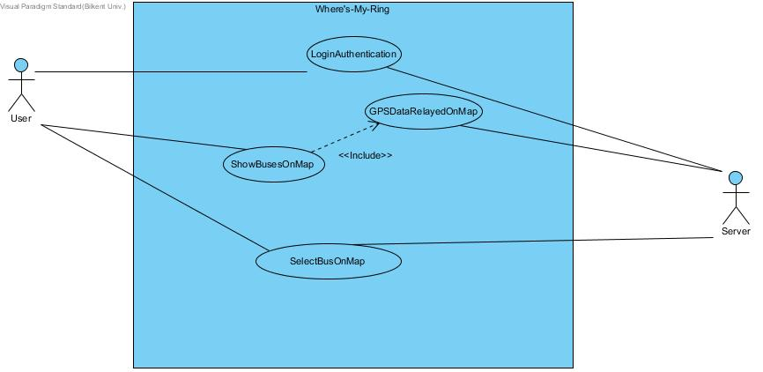

Use Case Model of Where’s My Ring

**4.2. Textual Description of Use Cases**

**4.2.1. Login Authentication**

Use Case Name: Login Authentication

Participating Actors: User, Server

Flow of Events:

1. The User inputs his Bilkent University webmail ID and password.

2. The Server checks whether the login information is correct.

3. The User successfully logs in on “Where’s My Ring” if the information is correct. If the information is wrong, the User is denied access.

4. On a successful login, the User is taken to the main screen of the app.

Entry Condition: The User has opened the app on his Android device.

Exit Condition: The User has successfully logged in.

**4.2.2. Show Buses On Map**

Use case name: Show Buses On Map

Participating Actors: User, Server

Flow of Events:

1. The User chooses the “Show Rings on Map” option from the app’s main screen.

2. The Server retrieves the GPS data and relays it onto the map.

3. The app displays all the buses on the map at the time.

4. The User views the interactive map with buses displayed.

Entry condition: The user has reached the main screen of the app and chosen the “Show Rings On Map” option.

Exit Condition: All buses operating at that time have appeared on the map.

Quality Requirements: The use case “ShowBusesOnMap” **includes** the use case “GPSDataRelayedOnMap” at all times, as the GPS data allows the representation of buses in real time.

**4.2.3. Select Bus On Map**

Use case name: SelectBusOnMap

Participating Actors: User, Server

Flow of Events:

1. The User chooses the “Where’s My Ring” option from the app’s main screen.

2. The app asks the User his current location by presenting on a new screen 5 options: Nizamiye, Sihiye, Tunus, Main Campus, and East Campus.

3. The User chooses one of the 5 options.

4. The app asks the User where he wants to go by presenting on a new screen 5 options: Nizamiye, Sihiye, Tunus, Main Campus, and East Campus.

5. The Server retrieves the corresponding GPS data.

6. The app tells how much time until a bus will reach the User’s location.

Entry Condition: The User has reached the main screen of the app and chosen the “Where’s My Ring” option.

Exit Condition: The application has successfully displayed the time of the bus according to User’s inputs.