
CS 319 - Object-Oriented Software Engineering
2nd Iteration Design Report
“Where’s My Ring”
Group 1-C
Hamza Akhbar
Emre Dikeneli
Bahadır Durmaz
Ali Soyaslan

- Introduction

  - Purpose of the System

“Where’s My Ring” is an Android application whose primary purpose is to ease travelling for Bilkent University students who use Bilkent buses to commute to and from the university. It allows Bilkent University students to track Bilkent buses within the campus and the city in real time on an interactive map in order to locate where the buses are, how long before a particular bus will come to the bus-stop nearest to a specific student’s current location and where that student chooses to go from among options that will correlate with the locations in the city of Ankara that Bilkent buses go to which are Sihhiye, Tunus, Bilkent University Main Campus, Bilkent University East Campus, and Nizamiye.

  - Design Goals

In order to ensure that our software system wholly qualifies in fulfilling user needs, we have decided on criteria that we plan for our application to meet. The criteria are given below:

- Criterion 1: Usability

Usability is one of our primary criterions so that users are able to easily use the application without encountering any needless difficulties. Since the application will be used by students with differing ease of using cell phone applications, we have designed a quite an easy-to-navigate User Interface with just 3 screens, or Activities in Android Lingo, so that users don’t spend more time than necessary in understanding the application. Moreover, the application will have a sideways sliding panel that will allow users to navigate to other screens of the application. The 3 screens (activities) will be the following:
1) Signup Screen
2) Login Screen
3) Interactive Map Screen (The sliding panel will be on this screen)

- Criterion 2: Extensibility

The Android Operating System has many different versions deployed to many different Android cell phone devices, and so our app will be supported on Android Jelly Bean 4.1 to Android Oreo 8.0; this covers 93% of the Android devices making our app highly platform extensible.

- Criterion 3: Modifiability

In order for our app to be modifiable by us or someone else in the future to add more functionality to the app, we will minimize the dependency of each software component on other software components so that changes made in one component do not deeply affect other components.

- Criterion 4: Reliability

Since our app will contain intricate functionality and linkage of user signup, authentication, map interactivity, and GPS data, we need a robust system that easily shoulders the app’s functionality, and towards that end we have chosen the latest Android version, 8.0 Oreo. This design decision will make our app reliable and less prone to errors and breakdowns.

- Criterion 5: Efficiency

The app will be highly efficient because it will be made on Android Studio, the standard IDE for making Android apps; it will be supported on the latest version of Android that will allow our app to be robust and to contain strong functionality, and this will also allow our app to operate bug-free on versions of Android older than 8.0 Oreo, which is the latest one.

  - Tradeoffs

- Android - Apple’s iOS: We chose Android because the process of developing Android apps is more streamlined. Furthermore, to develop iOS apps every developer needs an Apple Macbook and a subscription on Apple’s developer’s system, and not all of our group members have an Apple computer.

- Functionality - Usability: We chose usability over functionality as a criterion because we want our app to be easy-to-use and yet be able to perform its core function properly which is facilitating students in their commute.

- Android 4.1 Jelly Bean to Android 8.0 Oreo - Android versions older than 4.1: If we had chosen Android versions older than Android 4.1 , then we would have had to compromise on the robustness of our app as the functionality we want our app to have is not supported by older versions of Android. This design decision will allow our app to be highly efficient, reliable, and extensible.

  - Definitions

Android [1]: Android is the operating system developed by google. It is primarily used for cell phones and tablets.

Activity [2]: An activity is a primary building app of Android apps. It is an entrypoint for how users interact with and navigate the app.

iOS [3]: iOS is a mobile operating system developed by Apple Inc for its devices.

Android 4.1 Jelly Bean [4]: Android 4.1 Jelly Bean is a name given to a version of Android operating system.

Android 8.0 Oreo [5]: Android 8.0 Oreo is a name given to the most recently released version of Android operating system.

  - References
[1] https://en.wikipedia.org/wiki/Android_(operating_system)

[2] https://developer.Android.com/guide/components/activities/index.html

[3] https://en.wikipedia.org/wiki/IOS

[4] https://en.wikipedia.org/wiki/Android_Jelly_Bean

[5] https://www.Android.com/versions/oreo-8-0/

- Software Architecture

  - Overview

In this section, we will clarify what exact software and hardware systems our application will be using and how we plan to connect them. We will also explain how we manage and access data while providing a secure framework for the application.

  - Hardware / Software Mapping

“Wheres My Ring” will be implemented mostly in Java using Android Studio. Our minimum SDK (Software Development Kit) Version will be API 23 meaning that the app will work on Android devices with Version 6 (Marshmallow) or later, covering about 93% of all Android devices.
Though the offline components can be implemented using Android Studio, database and server clients have to be implemented outside Android Studio since they are not supported.
For storing current locations of buses in our database we will utilize MySQL and will rent a server.
Our main program written in Android Studio will access the database using a PHP based server client which will be written in Cloud 9 online IDE.

  - Persistent Data Management

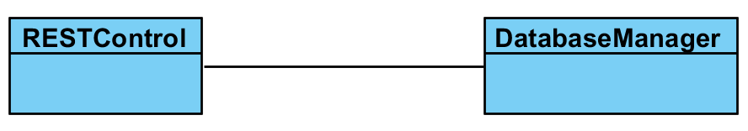
We decided to use PHP to connect to database instead of directly connecting from Android. Although this seems like an extra layer, we think that this decision is going to be helpful in programming and debugging phase. Using PHP will make things easier for us. In the case of reaching database Android studio will first connect to Cloud9 which is an online PHP IDE, and afterwards cloud nine will interact with our database that contains GPS and user data. We decided to write our database with MySQL. The reason we chose MySQL is that all of our group members are familiar with it.

  - Access Control and Security
“Where’s My Ring” is an app that displays where Bilkent Busses are and their approximate distances from Bilkent’s designated bus stops. Thus it is only intended to be used by Bilkent University’s students/personnel and not by people not affiliated with Bilkent University in any way.
To verify each user, we will have a login page on which each user can login with his personal information that can be obtained by signing up with a bilkent email (an email that has @bilkent.edu.tr in it).
Since Bilkent University’s Transportation Department does not keep its buses’ GPS data like it had told us before, we will simulate the buses’ GPS data ourselves.

- Subsystem Services
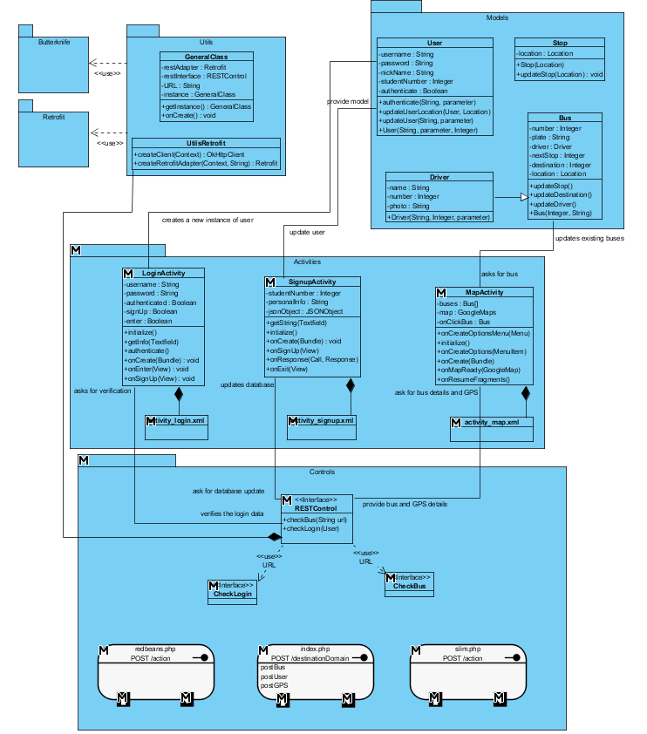
In this part of the report, we will explain the classes of our project in detail.

  - Architectural Style / Design Patterns

- Architectural Style - MVC
MVC architectural style is an architecture that separates main concerns of the application. There are three parts. First of them is Model. Model holds the objects and the data of these objects. It also has the methods to update and delete the data. Second part is View. This part is where all the user interfaces are drawn. Data in this part is mainly on the components of user interface. Third part is the controller part. This part holds all the methods and attributes that operates on both Model and View. The main mission of this part is to manipulate both parts and create a dataflow between them.
For our case, we hold all the objects in Model part, bus, user, stop, location and driver. These objects are 5 main objects to be used in this application. In view part, we will implement the xml files that contain buttons, textfields, drawable menus, etc. The final part, Controller holds our utility classes and objects, such as, PHP control, REST control, CallBack adapters, general utilities (keyboard, click listeners) and NetworkInterceptor.

- Facade Design Pattern:

Facade design pattern’s purpose is to hide the complexity of the system and provide a usable and simple interface. Since we are writing our system on an Android platform, the Façade Design Pattern fits our application’s activity classes. We have three facade classes which are SignupActivity, LoginActivity and MapActivity. The SignupActivity facade class represents the login page where users type their username and password for creating an account. It contains methods like getString() and initilize(). The LoginActivity façade class represents the login page which users use for logging in by entering their username and password; it containts methods such as getInfo() and authenticate(). The last façade class, the MapActivity class, represents the screen where users see the buses and their relevant information. This class contains methods like showBusInfo().

- Singleton Design Pattern:

Singleton design pattern is the pattern where only one instance of a class is created. Although our activity classes were suitable for this design pattern, we realized that representing our classes’ instances as singleton objects would make the coding phase harder for us. But we needed a singleton object no matter what. So we decided to make our GeneralClass class with singleton design pattern. GeneralClass is where we reach subsystem control. With this design pattern we make sure that for each user only one GeneralClass is created, and since GeneralClass is connected with control class it is above in subsystem hierarchy which in turn justifies our decision of using Singleton design pattern.

  - Object Models
These are the main models of our project, which will create the main object. The two main objects in this application are User and Bus.
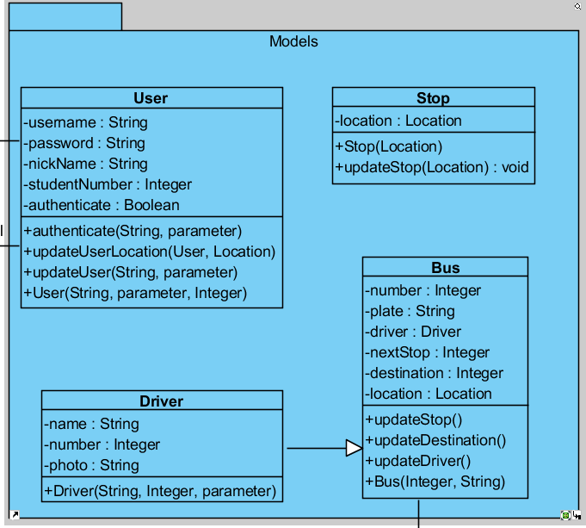

    - Bus Class
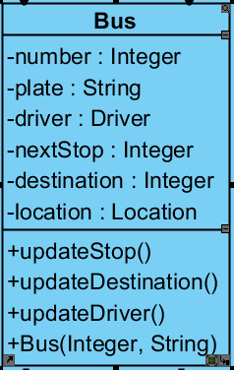

Attributes:
- int number: This is a unique number assigned to each bus for easy connection with the database.
- String plate: This is the plate number of the bus for recognizing it from the security records of school
- Driver driver: This is the driver that takes over the bus for the trip. We gather this data for security issues.
- Stop nextStop: This attribute is to show the next stop of the bus. If the bus changes direction for some reason. We will be able to tell that there is a problem.
- Stop destination: This is to show where the bus is heading and this will be useful in SelectBus activity.
- Location location: This is to track the location of the bus on GPS update.
Constructors:
Bus (int, String): This is the bus object that will be shown on the map as colored pin. It should have a database identifier number and a plate.
Methods:
void updateStop: After each stop, this method will be called and update the next stop.
    - Stop Class

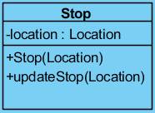

Attributes:

Location location: This attribute holds the GPS data of the Stop, as a Location object.

Constructors:

Stop(Location): The Stop is created with the Location. If a stop is added to the pathway, this method will kick-in.

Methods:

updateStop(Location): If the number of stops are still same but there are changes in the locations of stops, this method will be used automatically.

    - Driver Class

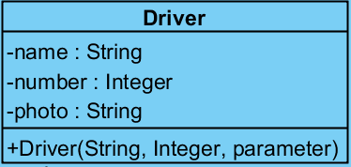

Attributes:

String name: Name of the driver for security issues.

int number: Every driver has a unique number for easy access to the database.

String photo: This attribute is also for safety issues. The string will be used as a url in the driver database.

Constructors:

Driver (String, Integer, String): Even the drivers does not have much to contribute to the application, the safety issues will require this data to be shown on the screen for users information. (Like UBER)

  - View
This part in Android applications is a little different than normal Java applications. The pages are called Activities and there 2 different versions of each activity. An XML class and a semi-controller class for connecting to these XMLs.
These are created together but do not share the same attributes. XML files are made up of fields, buttons, selectors on a layout, but java files are formed up of methods in connection with those GUI units. XML files are where we will communicate with the user.
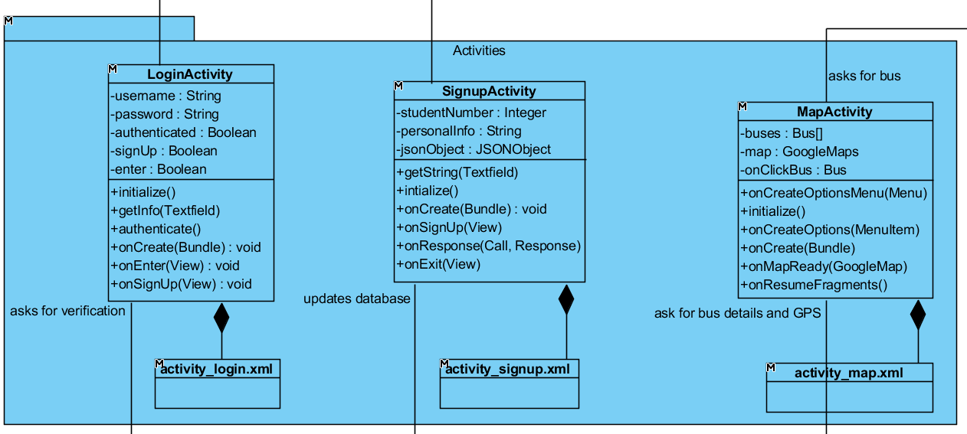

    - LoginActivity Class

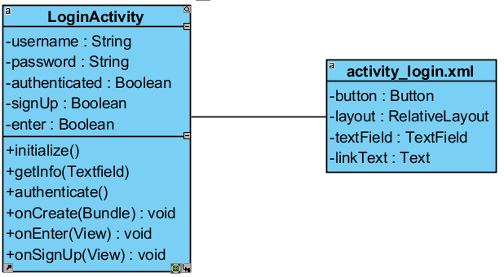
Attributes:

String username: User enters the username to this variable to send it to database.

String password: User enters the username to this variable to send it to database.

Boolean authenticated: User’s authentication variable. User can use the app if this is true.

Boolean signUp: Difference between admins and users.

Constructors:

void onCreate(Bundle): This method is called whenever this page is called. It asks Android Manifest for the initialization of this activity.

void initialize(): This methods loads the XML part of the project. It is called automatically when onCreate method is finished.

Methods:

void getInfo(TextField): Gets any kind of info from text fields to use in operations.

void Authenticate(): This method turns the Boolean variable authenticated on manually. Admins will deal with this future for now.

void onEnter(View): This method is a bridge method that on click of enter button, if the information is correct, it will open a new activity (MapActivity in this case).

void onSignUp(View): This method is a bridge method that on click of signUp text, it will directly open a new activity. (SignUpActivity in this case)

    - SignupActivity Class

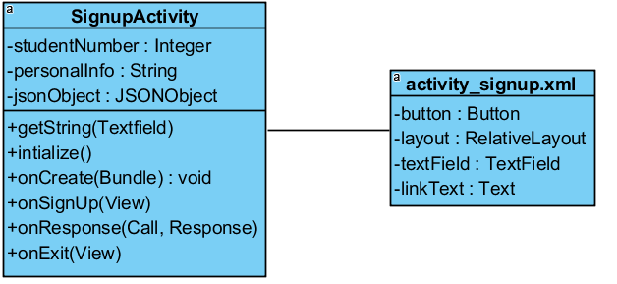

Attributes:

Integer studentNumber: User’s official student number given from school.

String personalInfo: We need a personal info to authenticate the user but we did not decided which info we can use yet.

JSONObject jsonObject: This object is to create a JSON message and send it to PHP in correct format.

Constructors:

void onCreate(Bundle): This method is called whenever this page is called. It asks Android Manifest for the initialization of this activity.

void initialize(): This methods loads the XML part of the project. It is called automatically when onCreate method is finished.

Methods:

void getString(TextField): This methods gets username and password from the user in the activity.

void onSignUp(View): This method will kick-in and open a new window if the information is proper. (password requirements)
void onResponse(Call <T>, Response): This is the most important method of all. This methods sends a Call to PHP file which will later send a REST call to the database. The return of this call will be a response that is specifically designed for this method in index.php file.

void onExit(View): This method is connected to the Exit button and on click of the Exit button, this methods finishes the activity and goes back to previous one. (LoginActivity in our case)

    - MapActivity Class
SupportMapFragment: Utility class for the Map in which map is expressed as a Fragment in the xml file with access code to Google's Maps API.
Methods:
onBackPressed(): If navigation window is opened closes it else exits the activity
onNavigationItemSelected(MenuItem item): Calls the appropriate class or action according to the xml view clicked.
onMapReady(GoogleMap map): Calls enableMyLocation() and sets location and adds the stops to the initial map view while simulating a zooming animation towards the user's locatiom.
enableMyLocation(): After Android 5 any important permission such as location and contacts also need to be asked in runtime rather than the manifesto file. This function prompts the user to enable location, if they deny it states that the app would not be able to work.
onRequestPermissionResult(int requestCode, @NonNull String[] permissions,@NonNull int[] grantResults): Overrideble method for organizing runtime permissions.
onResumeFragments(): Let's map fragment continue to work correctly if location is enabled but shows an error message if denied.

  - Controller

In Android Applications a General utilities class is usually created and after categorizing everything, the extra methods are added to that class. What we have in this section are PHP connection classes and GSON/JSON objects.

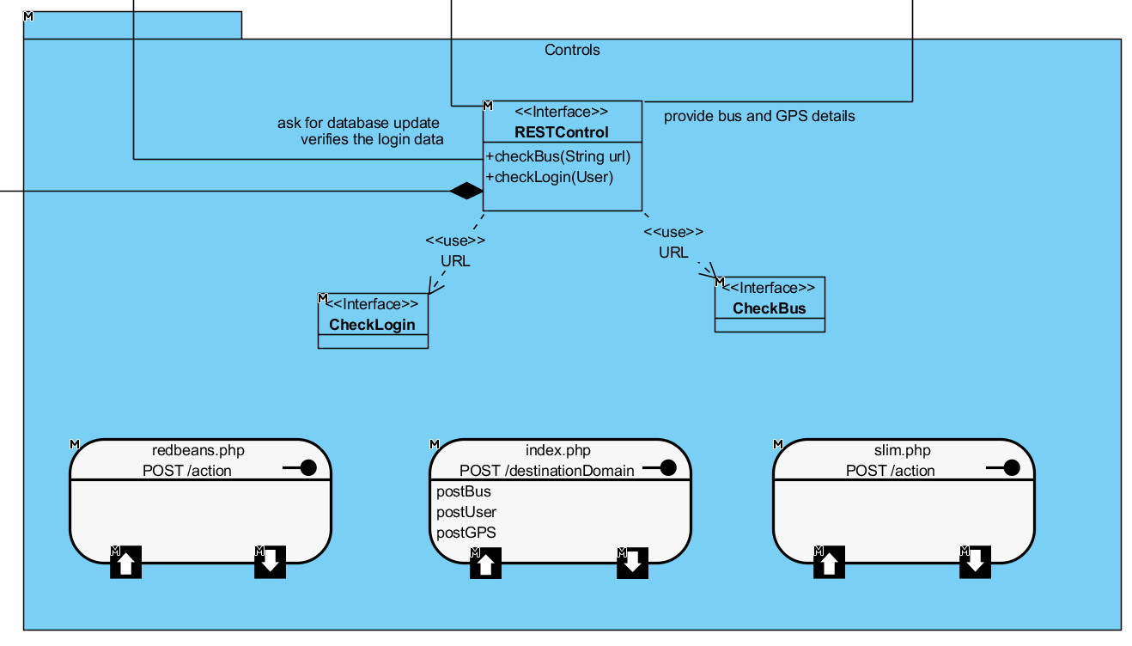

    - RESTControl Class

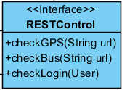

The main concern of this interface is to hold the URLs of the GET/POST calls. This Interface creates a connection between PHP file and Android Studio.

Methods:

void checkBus(String): This one is for gathering the bus data after the checkGPS function ends.

void checkLogin(User): This is for gathering the user’s data from our database.

    - Index.php File

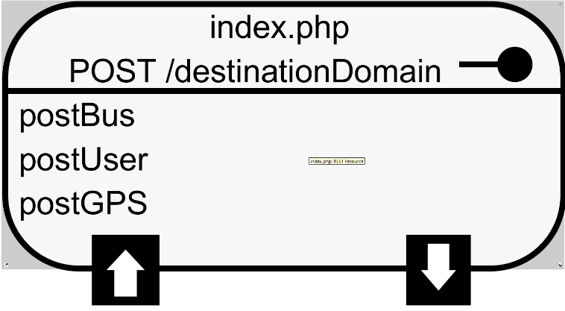
This file will be online in the Cloud9 online PHP IDE. This file will contain 3 (for now) POST methods that will take in the data from Android Studio and send the request to the database. This file will have 2 packages installed on it.

- Slim.php
Slim Framework is similar to .NET NuGet packages and supports REST actions for Cloud9 IDE. The GET and POST calls from this framework is both fast and secure. Slim has its own protocols and optional hash functions for detailed security concerns. This connects PHP with Android Studio.
- RedbeanPHP
Redbeans is a package for connecting MySQL databases from Cloud9 IDE. This package have 2 objects, one of them serves as connection object, and the other is converter object. Converter object gets the data from PHP in JSON form and converts it to a language that database understands and then passes it to connector object. Connector object sends the request and retrieves the data, then passes it to converter object again to convert it back to JSON object form.

  - General Utility Classes

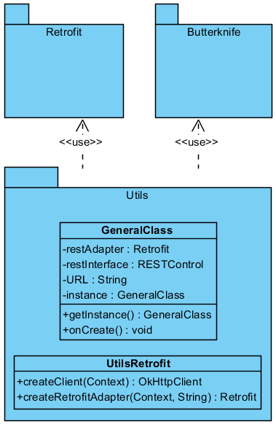
    - GeneralClass Class

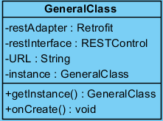

Attributes:
Retrofit restAdapter: This adapter allows Retrofit to operate on data in the program.
RESTControl restInterface: This object will help REST calls to make them easier to call. This object also embeds the RESTControl into the View part.
String URL: The main URL we have to connect to activate the RESTControl methods.
GeneralClass instance: This instance is essential to existence of this class. This class exists by calling itself in the application start.

Constructors:
void onCreate(Bundle): This method is called whenever this page is called. It asks Android Manifest for the initialization of this activity.

Methods:
GeneralClass getInstance(): This method is the initiator of the application after the onCreate method for this class is called. By calling itself, this creates an instance of its own and activates other classes.

    - UtilsRetrofit Class

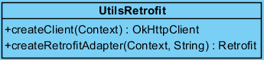

Methods:
OkHttpClient createClient(Context): This returns a OkHttpClient object that makes connection to the URL. There is also some message that is to be send inside it.
Retrofit createRetforitAdapter(Context, String): This method creates a Retrofit object with a message and a URL in it. Mainly, this Retrofit object is used for sending data in to web but occasionally, according to message attributes and URL destination attributes, OkHttpClient can be used.

4. Improvement Summary

- In the second iteration we have removed the SignUpActivity screen and added the functionality of the screen to a sliding menu in the MapActivity class.

- Since Bilkent University’s Transportation Department does not keep GPS data of the buses, we have removed the checkGPS() method from the PHP part of the project. We no longer take the location from GPS database, we generate (simulate) it ourselves and then send it to the Map.

- We have removed the Location Class from the model and have instead created a new location based structure inside GoogleMaps Library.

- We have changed the MapActivity class; it now has the GoogleMaps object in it with a new marker location design and trace mechanism.

- Lastly, the permissions for the new Android Application design are added to Android Manifest.

