
CS 319 - Object-Oriented Software Engineering
Analysis Report
Where is My Ring
Group 1-C
Hamza Akhbar
Emre Dikeneli
Bahadır Durmaz
Ali Soyaslan

- Introduction

  - Purpose of the System
“Where’s My Ring” is an Android application whose primary purpose is to ease travelling for Bilkent University students who use Bilkent buses to commute to and from the university. It allows Bilkent University students to track Bilkent buses within the campus and the city in real time on an interactive map in order to locate where the buses are, how long before a particular bus will come to the bus-stop nearest to a specific student’s current location and where that student chooses to go from among options that will correlate with the locations in the city of Ankara that Bilkent buses go to which are Sihhiye, Tunus, Bilkent University Main Campus, Bilkent University East Campus, and Nizamiye.

  - Design Goals
In order to ensure that our software system wholly qualifies in fulfilling user needs, we have decided on a criteria that we plan our application to meet. The criteria is given below:

- Criterion 1: Usability
Usability is one of our primary criterion so that users are able to easily use the application without encountering any needless difficulties. Since the application will be used by students with differing ease of using cell phone applications, we have designed a quite an easy-to-navigate User Interface with just 4 screens, or Activities in Android Lingo, so that users don’t spend more time than necessary in understanding the application. Moreover, the application will have a drawable sliding panel that will allow users to navigate to other screens of the application. The 4 screens will be the following:
1) Signup Screen
2) Login Screen
3) Interactive Map Screen
4) Where to Go Screen

- Criterion 2: Extensibility
The Android Operating System has many different versions deployed to many different Android cell phone devices, and so our app will be supported on Android Jelly Bean 4.1 to Android Oreo 8.0; this covers 93% of the Android devices making our app highly platform extensible.

- Criterion 3: Modifiability
In order for our app to be modifiable by us or someone else in the future to add more functionality to the app, we will minimize the dependency of each software component on other software components so that changes made in one component do not deeply affect other components.
- Criterion 4: Reliability
Since our app will contain intricate functionality and linkage of user signup, authentication, map interactivity, and GPS data, we need a robust system that easily shoulders the app’s functionality, and towards that end we have chosen the latest Android version, 8.0 Oreo. This design decision will make our app reliable and less prone to errors and breakdowns.

- Criterion 5: Efficiency

The app will be highly efficient because it will be made on Android Studio, the standard IDE for making Android apps; it will be supported on the latest version of Android that will allow our app to be robust and contain strong functionality, and this will also allow our app to operate bug-free on versions of Android older than 8.0 Oreo, which is the latest one.

  - Tradeoffs
- Android - Apple’s iOS: We chose Android because the process of developing Android apps is more streamlined. Furthermore, to develop iOS apps every developer needs an Apple Macbook and a subscription on Apple’s developer’s system, and not all of our group members have an Apple computer.

- Functionality - Usability: We chose usability over functionality as a criterion because we want our app to be easy-to-use and yet be able to perform its core function properly which is facilitating students in their commute.

- Android 4.1 Jelly Bean to Android 8.0 Oreo - Android versions older than 4.1: If we had chosen Android versions older than Android 4.1 , then we would have had to compromise on the robustness of our app as the functionality we want our app to have is not supported by older versions of Android. This design decision will allow our app to be highly efficient, reliable, and extensible.

  - Definitions
Android [1]: Android is the operating system developed by google. It is primarily used for cell phones and tablets.

Activity [2]: An activity is a primary building app of Android apps. It is an entrypoint for how users interact with and navigate the app.

iOS [3]: iOS is a mobile operating system developed by Apple Inc for its devices.

Android 4.1 Jelly Bean [4]: Android 4.1 Jelly Bean is a name given to a version of Android operating system.
Android 8.0 Oreo [5]: Android 8.0 Oreo is a name given to the most recently released version of Android operating system.

  - References
[1] https://en.wikipedia.org/wiki/Android_(operating_system)

[2] https://developer.Android.com/guide/components/activities/index.html

[3] https://en.wikipedia.org/wiki/IOS

[4] https://en.wikipedia.org/wiki/Android_Jelly_Bean

[5] https://www.Android.com/versions/oreo-8-0/

- Software Architecture

  - Overview
In this section, we will clarify what exact software and hardware systems our application will be using and how we plan to connect them.
We will also be explaining how we manage and access data while providing a secure framework for the application.

  - Hardware / Software Mapping
Wheres My Ring will be implemented mostly in Java using Android Studio. Our minimum SDK (Software Development Kit) Version will be API 23 meaning that the app will work on Android devices with Version 6 (Marshmallow) or later, covering about 93% of all Android devices.
Though the offline components can be implemented using Android Studio, database and server clients have to be implemented outside Android Studio since they are not supported.
For storing current locations of busses in our database we will utilize MySQL and will rent a server.
Our main program written in Android Studio will access the database using a PHP based server client which will be written in Cloud 9 online IDE.

  - Persistent Data Management
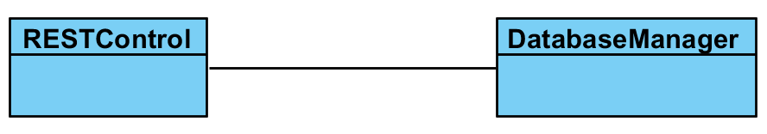
We decided to use PHP to connect to database instead of directly connecting from Android. Although this seems like an extra layer, we think that this decision is going to be helpful in programming and debugging phase. Using PHP will make things easier for us. In the case of reaching database Android studio will first connect to Cloud9 which is an online PHP IDE. And afterwards cloud nine will interfere with our database that contains GPS and user data. We decided to write our database with MySQL. Reason why we chose MySQL was more group members were familiar with it.

  - Access Control and Security
Wheres My Ring is an app to display where Bilkent Busses are and their distances to Ring Stops. Thus it is only intended to be used by Bilkent students/personnel and not by non-Bilkenters.
To verify each user, we will have a login page in which each user can login with their personal credentials that can be obtained by signing up with a bilkent email (an email that has @bilkent.edu.tr in it).
We will get where each bus is from a third party service which the Transportation Unit will give the credentials for.

- Subsystem Services
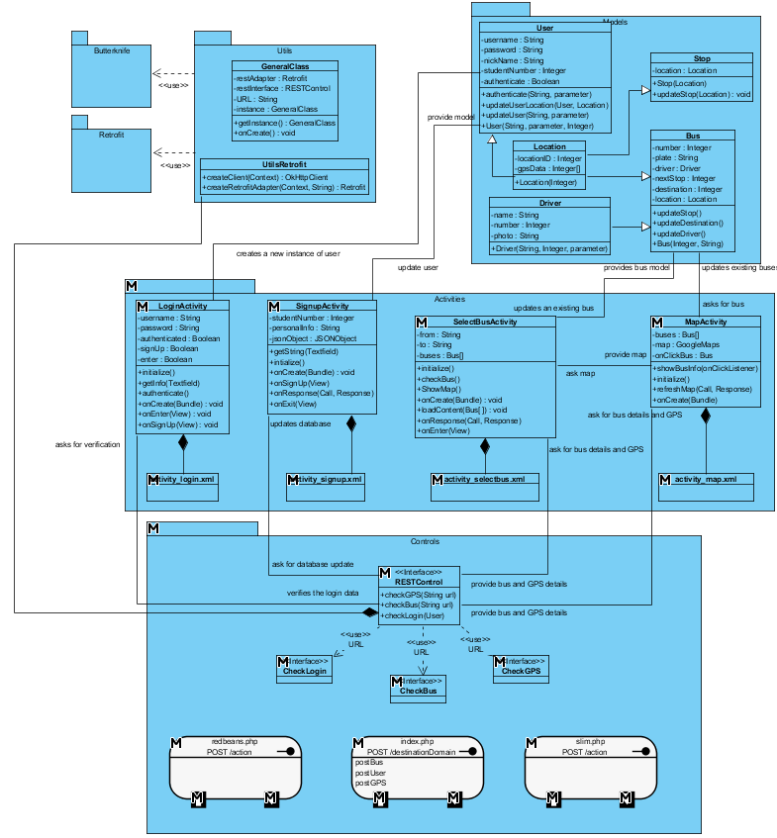
In this part of the report, we will explain the classes of our project in detail.

  - Design Pattern
- MVC Design Pattern
MVC design pattern is a design that separates main concerns of the application. There are three parts in this pattern. First of them is Model. Model holds the objects and the data of these objects. It also has the methods to update and delete the data. Second part is View. This part is where all the user interfaces are drawn. Data in this part is mainly on the components of user interface. Third part is the controller part. This part holds all the methods and attributes that operates on both Model and View. The main mission of this part is to manipulate both parts and create a dataflow between them.
For our case, we hold all the objects in Model part, bus, user, stop, location and driver. These objects are 5 main objects to be used in this application. In view part, we will implement the xml files that contain buttons, textfields, drawable menus, etc. The final part, Controller holds our utility classes and objects, such as, PHP control, REST control, CallBack adapters, general utilities (keyboard, click listeners) and NetworkInterceptor.

  - Object Models
These are the main models of our project, which will create the main object. The two main objects in this application are User and Bus.
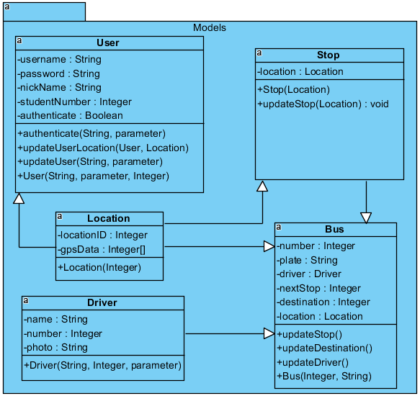

    - Bus Class
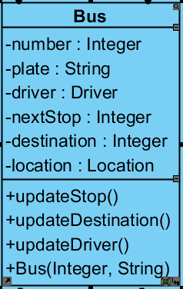

Attributes:
- int number: This is a unique number assigned to each bus for easy connection with the database.
- String plate: This is the plate number of the bus for recognizing it from the security records of school
- Driver driver: This is the driver that takes over the bus for the trip. We gather this data for security issues.
- Stop nextStop: This attribute is to show the next stop of the bus. If the bus changes direction for some reason. We will be able to tell that there is a problem.
- Stop destination: This is to show where the bus is heading and this will be useful in SelectBus activity.
- Location location: This is to track the location of the bus on GPS update.
Constructors:
Bus (int, String): This is the bus object that will be shown on the map as colored pin. It should have a database identifier number and a plate.

Methods:
void updateStop: After each stop, this method will be called and update the next stop.

    - Stop Class

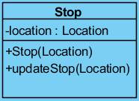

Attributes:

Location location: This attribute holds the GPS data of the Stop, as a Location object.

Constructors:

Stop(Location): The Stop is created with the Location. If a stop is added to the pathway, this method will kick-in.

Methods:

updateStop(Location): If the number of stops are still same but there are changes in the locations of stops, this method will be used automatically.

    - Location Class

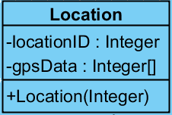

Attributes:

int locationID: Every location has a unique id. This attribute is for easy communication with the database.

int[ ] gpsData: These series of integer are the real time gps data that is hold in the schools own database in the transportation unit.

Constructors:

Location (gpsData): This is main object that is going to be used in nearly every other model and operation.

    - Driver Class

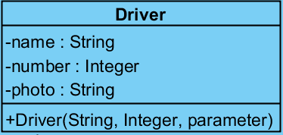

Attributes:

String name: Name of the driver for security issues.

int number: Every driver has a unique number for easy access to the database.

String photo: This attribute is also for safety issues. The string will be used as a url in the driver database.

Constructors:

Driver (String, Integer, String): Even the drivers does not have much to contribute to the application, the safety issues will require this data to be shown on the screen for users information. (Like UBER)

  - View
This part in Android applications is a little different than normal Java applications. The pages are called Activities and there 2 different versions of each activity. An XML class and a semi-controller class for connecting to these XMLs.
These couples are created together but does not share the same attributes. XML files are formed up of fields, buttons, selectors on a layout, but java files are formed up of methods in connection with those GUI units. XML files are where we will communicate with the user.

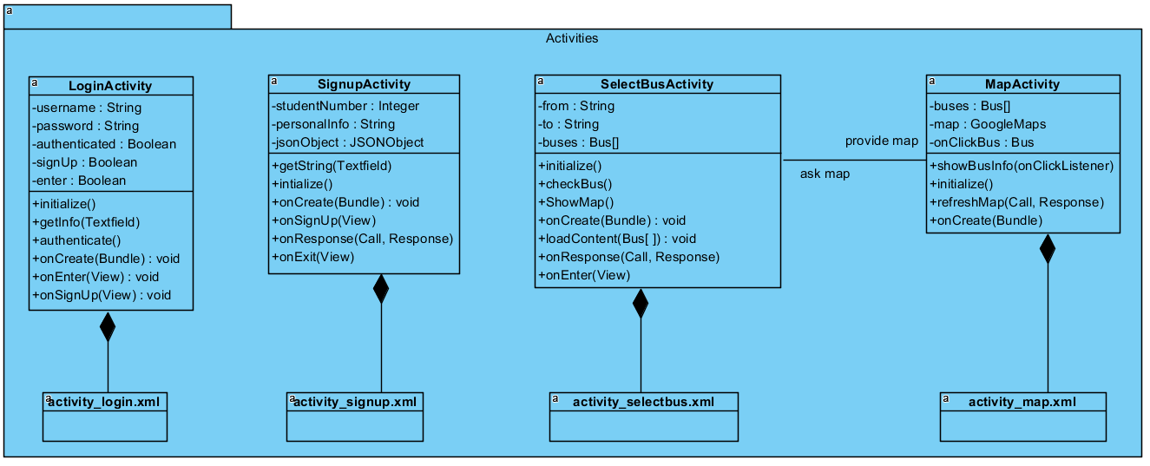

    - LoginActivity Class
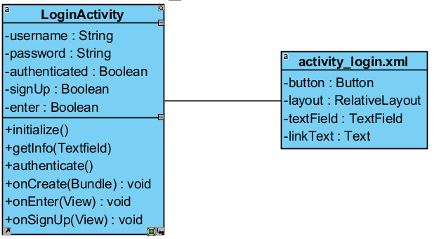
Attributes:

String username: User enters the username to this variable to send it to database.

String password: User enters the username to this variable to send it to database.

Boolean authenticated: User’s authentication variable. User can use the app if this is true.

Boolean signUp: Difference between admins and users.

Constructors:

void onCreate(Bundle): This method is called whenever this page is called. It asks Android Manifest for the initialization of this activity.

void initialize(): This methods loads the XML part of the project. It is called automatically when onCreate method is finished.

Methods:

void getInfo(TextField): Gets any kind of info from text fields to use in operations.

void Authenticate(): This method turns the Boolean variable authenticated on manually. Admins will deal with this future for now.

void onEnter(View): This method is a bridge method that on click of enter button, if the information is correct, it will open a new activity (MapActivity in this case).

void onSignUp(View): This method is a bridge method that on click of signUp text, it will directly open a new activity. (SignUpActivity in this case)

    - SignupActivity Class

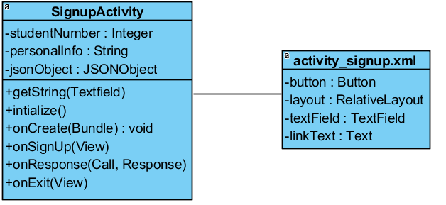

Attributes:

Integer studentNumber: User’s official student number given from school.

String personalInfo: We need a personal info to authenticate the user but we did not decided which info we can use yet.

JSONObject jsonObject: This object is to create a JSON message and send it to PHP in correct format.

Constructors:

void onCreate(Bundle): This method is called whenever this page is called. It asks Android Manifest for the initialization of this activity.

void initialize(): This methods loads the XML part of the project. It is called automatically when onCreate method is finished.

Methods:

void getString(TextField): This methods gets username and password from the user in the activity.

void onSignUp(View): This method will kick-in and open a new window if the information is proper. (password requirements)
void onResponse(Call <T>, Response): This is the most important method of all. This methods sends a Call to PHP file which will later send a REST call to the database. The return of this call will be a response that is specifically designed for this method in index.php file.

void onExit(View): This method is connected to the Exit button and on click of the Exit button, this methods finishes the activity and goes back to previous one. (LoginActivity in our case)

    - SelectBusActivity Class
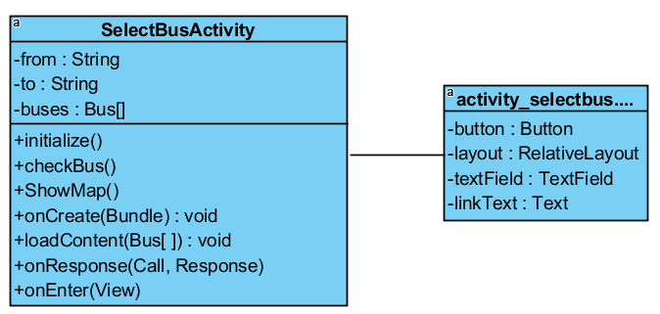

Attributes:

String from: This is for indicating where user will get on the bus from.

String to: This is for indicating where the user goes.

Bus[ ] buses: This array contains all the buses that are found in user’s path and these buses will be send to MapActivity to be shown on the map.

Constructors:

void onCreate(Bundle): This method is called whenever this page is called. It asks Android Manifest for the initialization of this activity.

void initialize(): This methods loads the XML part of the project. It is called automatically when onCreate method is finished.

Methods:

void checkBus(): This method checks the buses on the user’s path from database (according to GPS data) and then returns them 1 by one to the array of buses.

void showMap(View): This method takes the user directly to map page without any entries.

void loadContent(Bus[ ]): This method sorts the buses according to the selected sort type. (time, distance) and then puts it back to buses attribute.

void onResponse(Call <T>, Response): This is the most important method of all. This methods sends a Call to PHP file which will later send a REST call to the database. The return of this call will be a response that is specifically designed for this method in index.php file.

void onEnter(View): This method kicks-in on the click action of Enter button. Takes the user to map page and shows the selected buses on the map with pins.

    - MapActivity Class
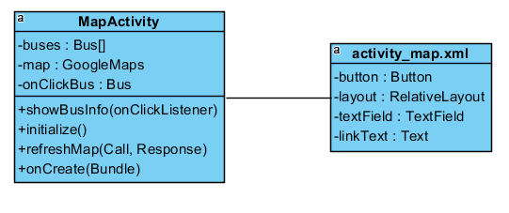
Attributes:

Bus[ ] buses: This attribute is sent from the SelectBusActivity. If the array is empty, it means there in no selected path. Then, the map shows every bus out in the city.

GoogleMaps map: This feature is already on Android Studio. This is Google’s own map system that we use navigation application on Android phones. We can create instances on it (Buses in our case) and give them colors and shapes and so on. This will cover the whole screen and the coordinates will be available on it.

Bus onClickBus: On click of the bus, this method will kick-in and show the details of the selected bus.

Constructors:

void onCreate(Bundle): This method is called whenever this page is called. It asks Android Manifest for the initialization of this activity.

void initialize(): This methods loads the XML part of the project. It is called automatically when onCreate method is finished.

Methods:

void refreshMap(Call <T>, Response): This method is called whenever the school’s databse is refreshed. Each time, this method reads the GPS data of the buses and writes them to the Bus array, in each of the buses available. By this way, we can cross check our bus data with school’s to see if there are any missing buses in our list and to show the real time locations of the buses.

void showBusInfo(OnClickListener): This method is called whenever user wants any extra information on a bus shown on the map. If user touches a pin (a bus) on the map, this method brings a drawable screen down and shows the attributes of the bus. (next stop, destination, plate, driver, etc.)

  - Controller
In this part of the design we still have not much yet. In Android Applications, people usually create a General utilities class and after categorizing everything, they put the extra methods to there. Basically what we have in this section is PHP connection classes and GSON/JSON objects.
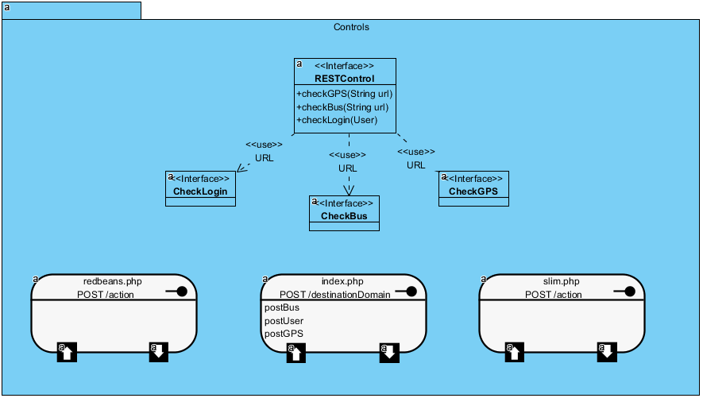

    - RESTControl Class

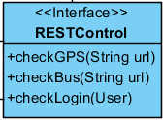

The main concern of this interface is to hold the URLs of the GET/POST calls. This Interface creates a connection between PHP file and Android Studio.

Methods:

void checkGPS(String): This methods holds the URL for GPS data. It tells the PHP file the location of these data.

void checkBus(String): This one is for gathering the bus data after the checkGPS function ends.

void checkLogin(User): This is for gathering the user’s data from our database.

    - Index.php File

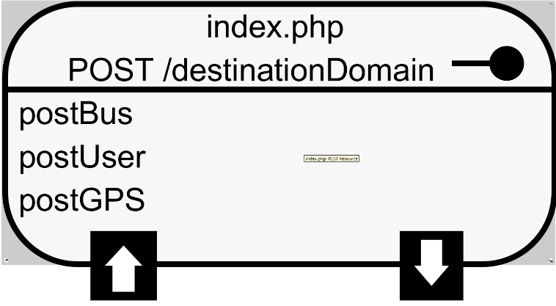
This file will be online in the Cloud9 online PHP IDE. This file will contain 3 (for now) POST methods that will take in the data from Android Studio and send the request to the database. This file will have 2 packages installed on it.

- Slim.php
Slim Framework is similar to .NET NuGet packages and supports REST actions for Cloud9 IDE. The GET and POST calls from this framework is both fast and secure. Slim has its own protocols and optional hash functions for detailed security concerns. This connects PHP with Android Studio.
- RedbeanPHP
Redbeans is a package for connecting MySQL databases from Cloud9 IDE. This package have 2 objects, one of them serves as connection object, and the other is converter object. Converter object gets the data from PHP in JSON form and converts it to a language that database understands and then passes it to connector object. Connector object sends the request and retrieves the data, then passes it to converter object again to convert it back to JSON object form.

  - General Utility Classes

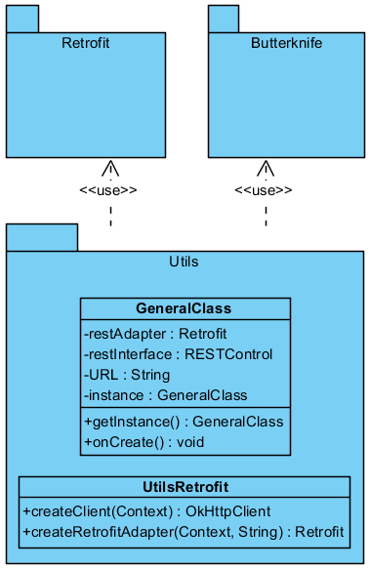

    - GeneralClass Class

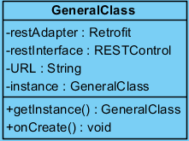

Attributes:
Retrofit restAdapter: This adapter allows Retrofit to operate on data in the program.
RESTControl restInterface: This object will help REST calls to make them easier to call. This object also embeds the RESTControl into the View part.
String URL: The main URL we have to connect to activate the RESTControl methods.
GeneralClass instance: This instance is essential to existence of this class. This class exists by calling itself in the application start.

Constructors:
void onCreate(Bundle): This method is called whenever this page is called. It asks Android Manifest for the initialization of this activity.

Methods:
GeneralClass getInstance(): This method is the initiator of the application after the onCreate method for this class is called. By calling itself, this creates an instance of its own and activates other classes.

    - UtilsRetrofit Class

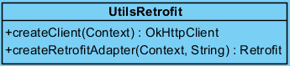

Methods:
OkHttpClient createClient(Context): This returns a OkHttpClient object that makes connection to the URL. There is also some message that is to be send inside it.
Retrofit createRetforitAdapter(Context, String): This method creates a Retrofit object with a message and a URL in it. Mainly, this Retrofit object is used for sending data in to web but occasionally, according to message attributes and URL destination attributes, OkHttpClient can be used.

