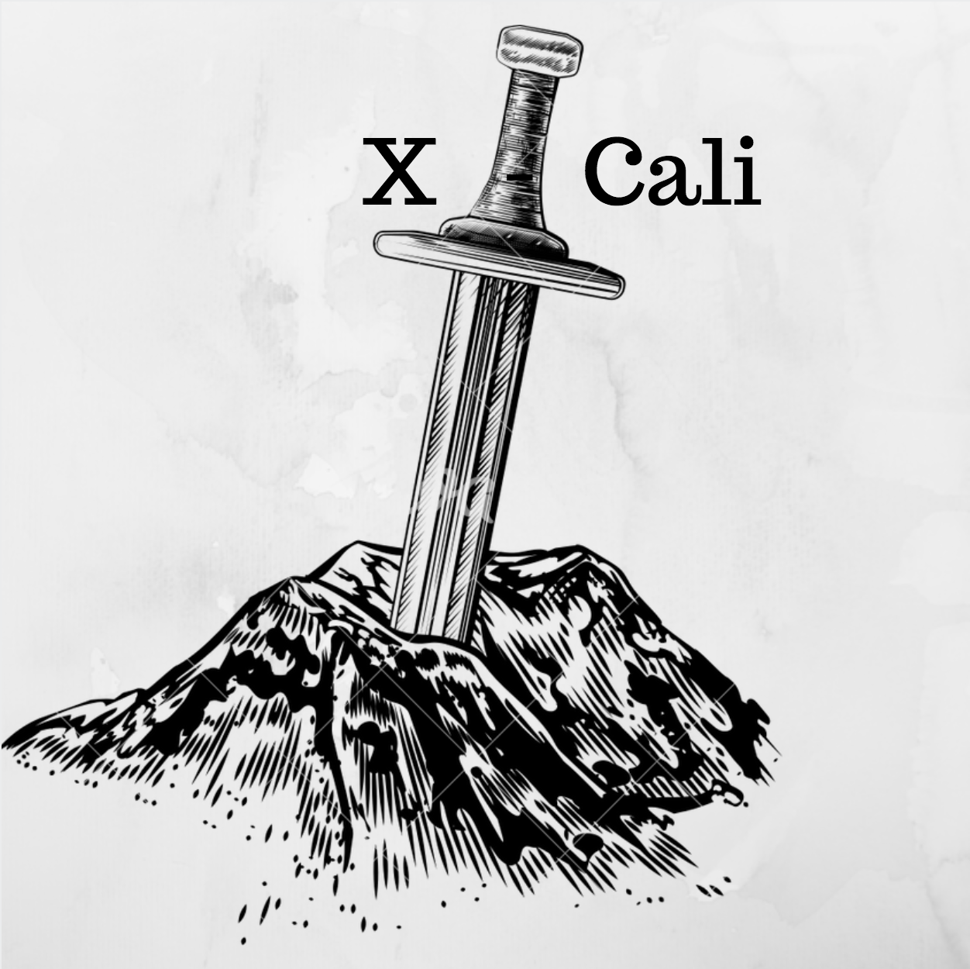

**X-CALI**

Conceptual Design Report

*Designing robots collaboratively carrying a long object through an open-top maze*

Submitted to: Ali Özgür Yılmaz

Date of Submission: 29/12/2017

**Company Owners**

* Oytun Akpulat 2093201 [oytun.akpulat@metu.edu.tr](mailto:oytun.akpulat@metu.edu.tr)
* Göksenin Hande Bayazıt 2093441 [hande.bayazit@metu.edu.tr](mailto:hande.bayazit@metu.edu.tr)
* Emre Doğan 2093656 [dogan.emre@metu.edu.tr](mailto:dogan.emre@metu.edu.tr)
* Taha Doğan 2093672 [taha.dogan@metu.edu.tr](mailto:taha.dogan@metu.edu.tr)
* Burak Sezgin 2094456 [burak.sezgin@metu.edu.tr](mailto:burak.sezgin@metu.edu.tr)

# Executive Summary

|  |
| --- |
| ***The executive summary is professional and creates curiosity in the reader to go further in the report.*** |

This conceptual design report is prepared and presented by X-CALI to explain the whole design process of the project “Designing robots collaboratively carrying a long object through an open-top maze” in detail.

X-CALI Inc. is a company founded in 2017 by five visionary and innovative electronics engineer. The mission of the company is to create simple and innovative solutions to the daily-life problems. Although the employees are working on different areas, they all have the skill of interdisciplinary team work.

Table of Contents

Executive Summary 2

Introduction 4

Problem Statement 4

Solution 4

Overall System 4

Sub-system 4

Test Results 5

Plans 5

Management 5

Engineering 5

Conclusion 5

References 5

Appendices 5

# Introduction

|  |
| --- |
| ***The introduction contains complete background information about the project, the current situation about the work on the project, the scope of the report, organization of the report.*** |

# Problem Statement

|  |
| --- |
| ***The problem is clearly stated. The design requirements, functional specifications and measurable objectives are clearly identified. Technical details are provided and measurable performance criteria are defined.*** |

# Solution

## Overall System

***Overall description of the system with a block diagram and system operation with a functional flow diagram are clearly indicated.***

***The diagrams include sub-system interaction and interfaces.***

***An extensive feasibility analysis is incorporated both for main solution concept as well as for its alternatives.***

***Expected weight, dimensions, and total power consumption of the robot are clearly provided.***

## Sub-system

***Individual sub-systems are clearly described. Solution for each sub-system and relevant algorithms are clearly provided. Plan B for critical sub-systems are clearly indicated.***

## Test Results

***Test plans and test results for subsystems (evaluated to date) are clearly presented. Compliance of the test results with the design requirements is discussed in details.***

# Plans

## Management

***Detailed breakdown of planned work and other responsibilities among the team members is clearly presented.***

***The time schedule is given professionally as a Gantt chart supported by justification of sequential and parallel tasks. Team member allocation is shown. Steps from concept to completion have been scheduled efficiently and in details including possible vacation days.***

***Foreseeable difficulties (risks) are clearly discussed and contingency plans for handling these difficulties are clearly indicated.***

***A detailed cost analysis is provided to indicate the estimated cost of the project.***

***Deliverables are completely listed.***

## Engineering

***Test plans and measure of success for sub-systems (yet to be built) are clearly explained.***

***Integration plans, test procedures, and measure of success for the complete system are clearly described.***

# Conclusion

|  |
| --- |
| ***A conclusion based on the analysis of the main solution and its alternatives is included. It also includes concluding remarks about the content presented in the report.*** |

# References

***A proper list of references is present with correct citations in the text and figures.***

# Appendices

***All required sections of the report exist and supporting details are included as appendices as necessary.***