Emre Doğan tarafından düzenlendi.

# Plans

## Management

***Responsibilities Among the Group Members***

As X-Cali, we are a group of electronics engineers working in different areas. Each group member is specialized in different topics and we distributed the technical workload with regard to this fact. The distribution of technical work is as given in Table XX.

|  |  |
| --- | --- |
| The Subject | Member(s) in charge |
| Microprocessor Programming | * Burak Sezgin * Taha Doğan |
| Algorithm Design | * Taha Doğan * Emre Doğan |
| Sensors & Communication | * Emre Doğan * Burak Sezgin |
| Control System Design | * Hande Bayazıt * Oytun Akpulat |
| Mechanical System Design | * Hande Bayazıt |

Table XX. Distribution of the technical workload in X-Cali.

Although we separated the technical workload for different group members, we mostly work together in all tasks. This situation is quite important for us as we have a chance to gain the habit of interdisciplinary team work.

Beyond the technical issues, there are some other important management subjects to handle. Our financial control specialist is Taha Doğan. He is in charge of the all financial issues due to the project.

***Detailed Version of Gantt Chart***

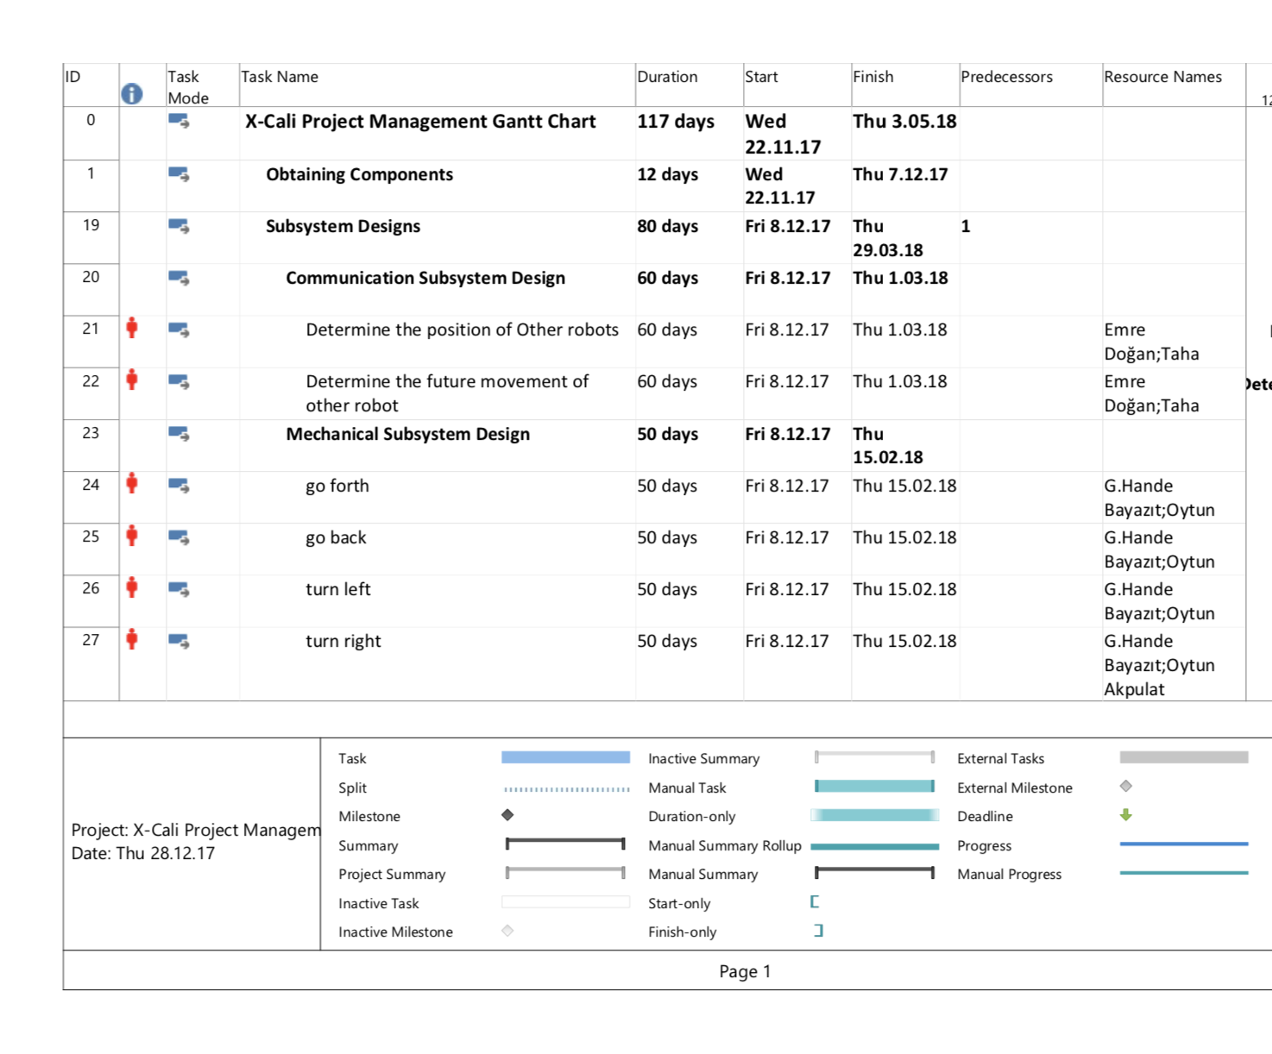

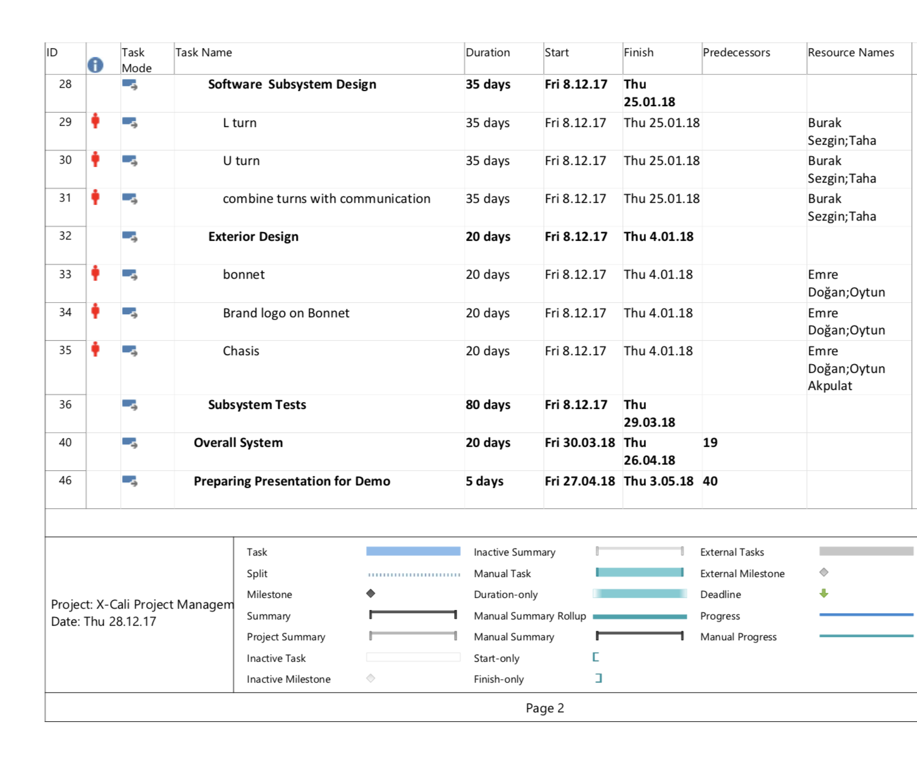

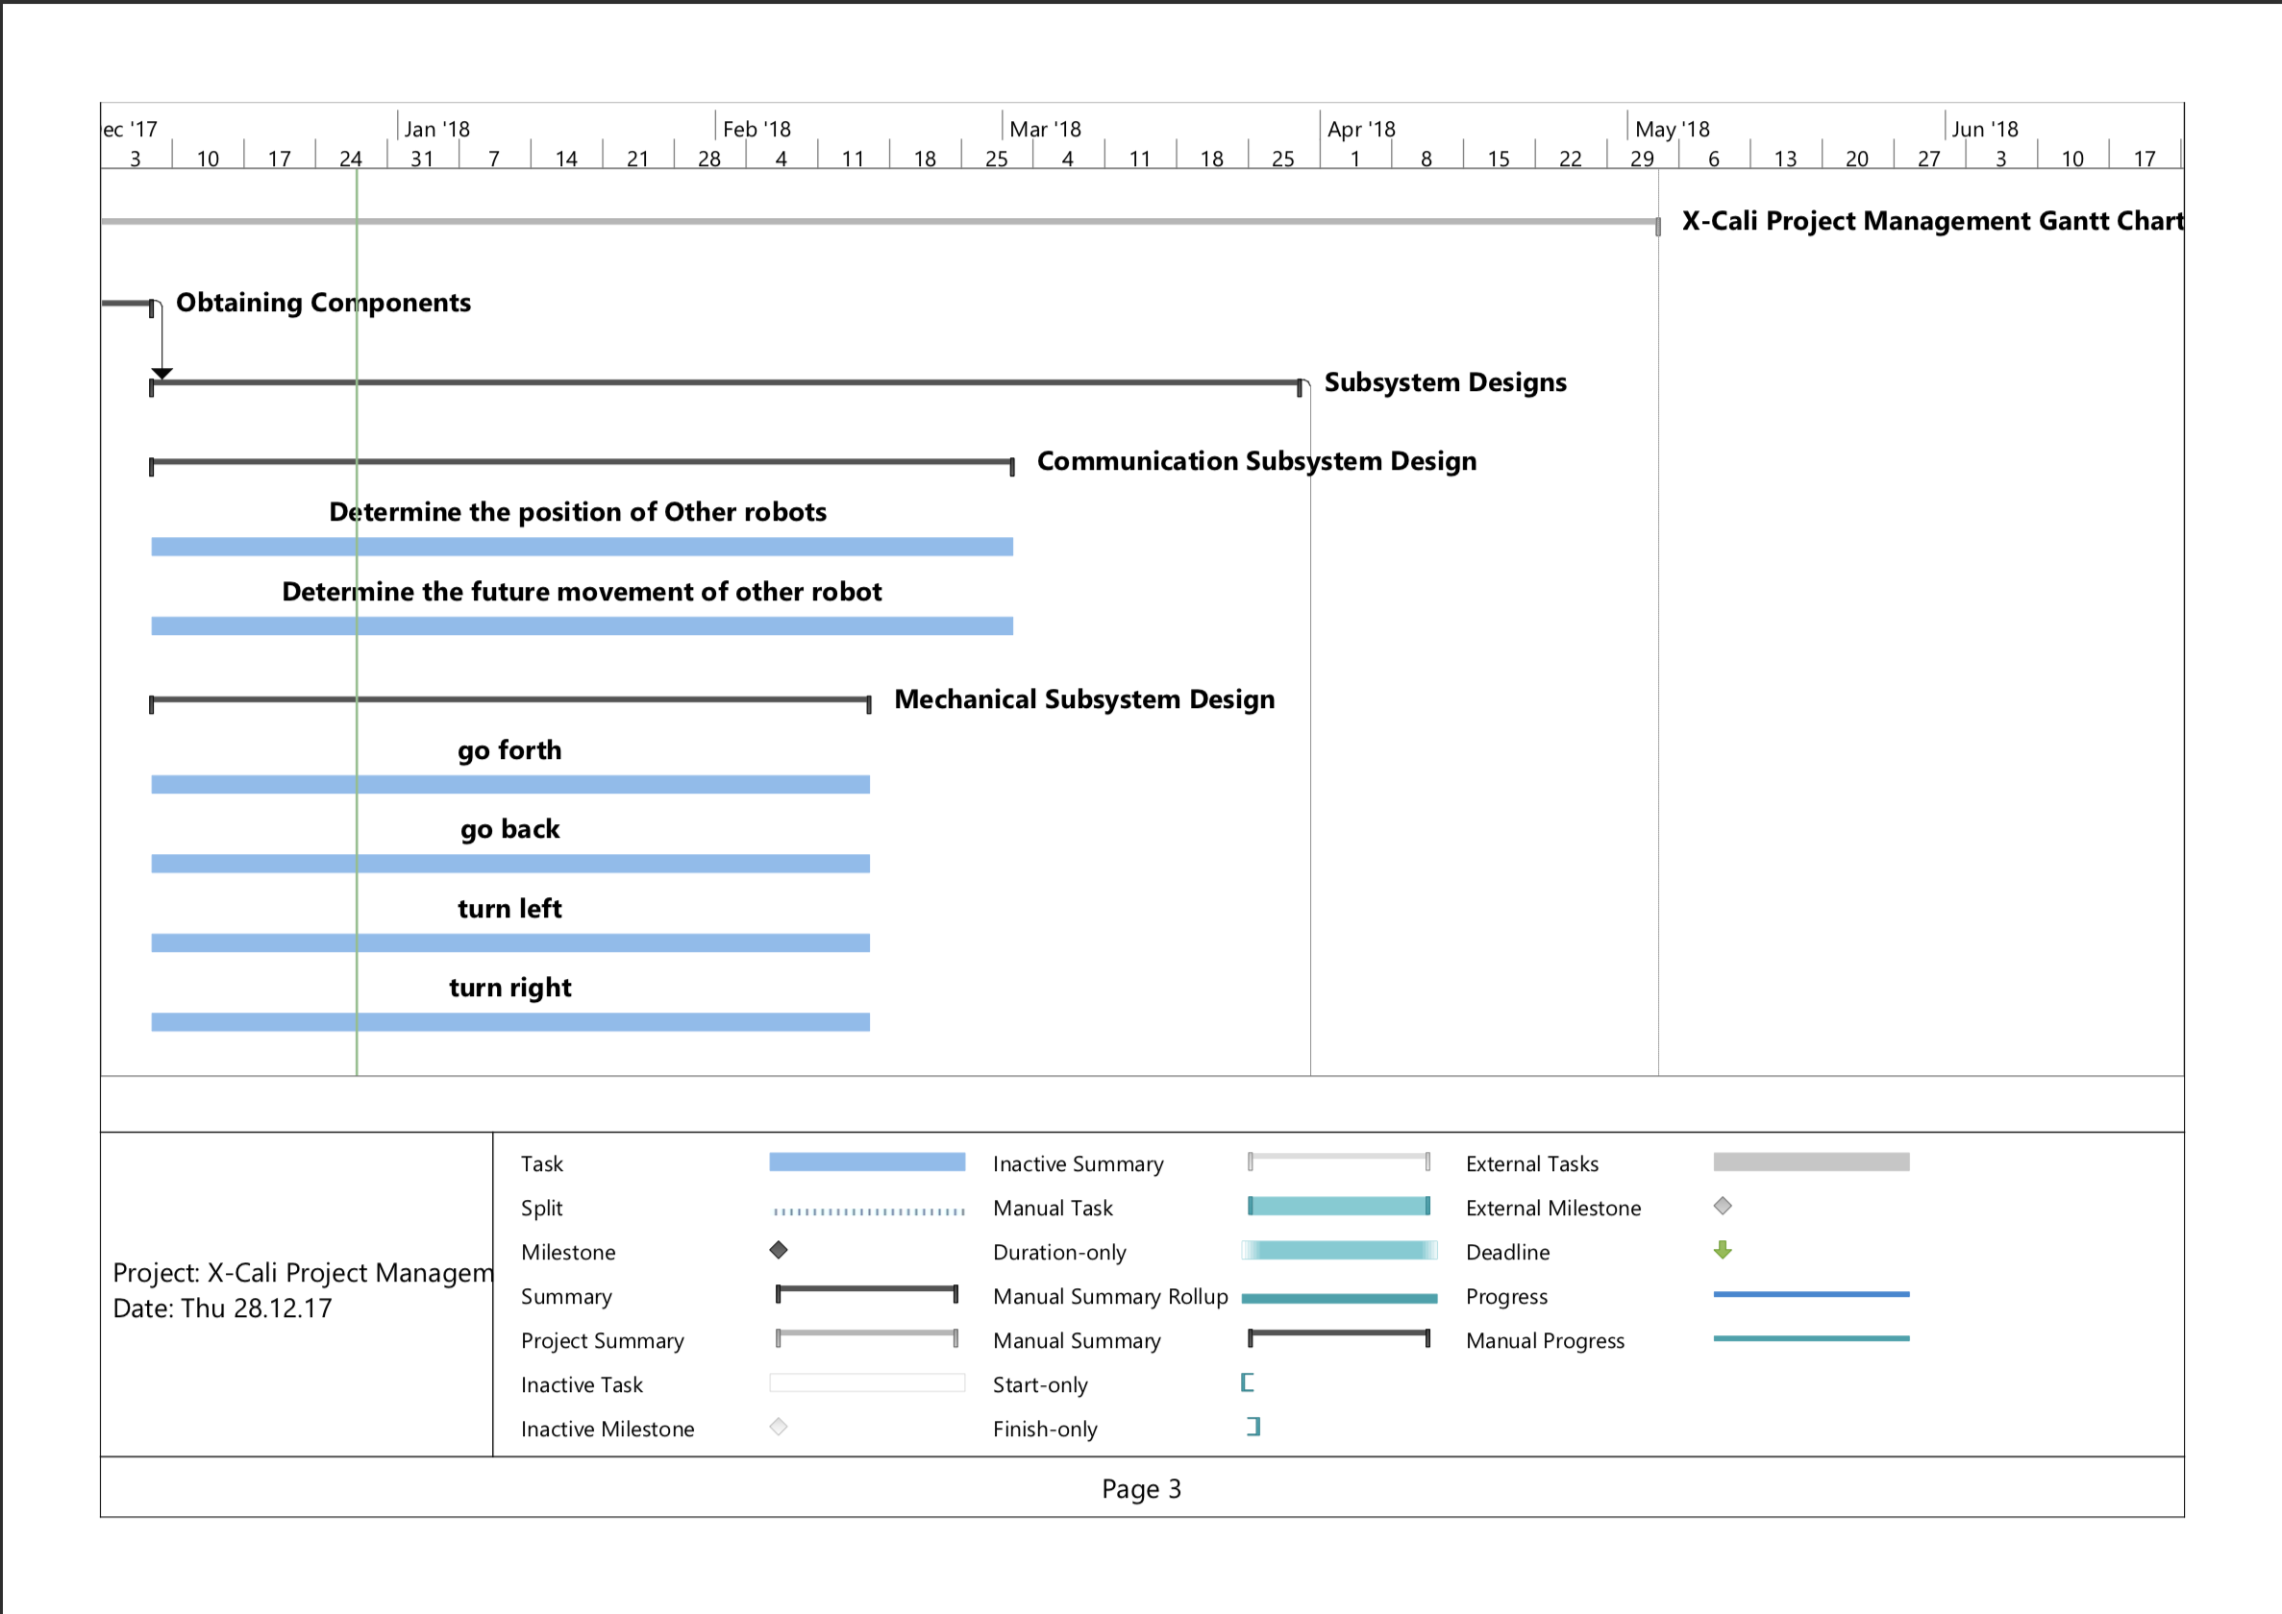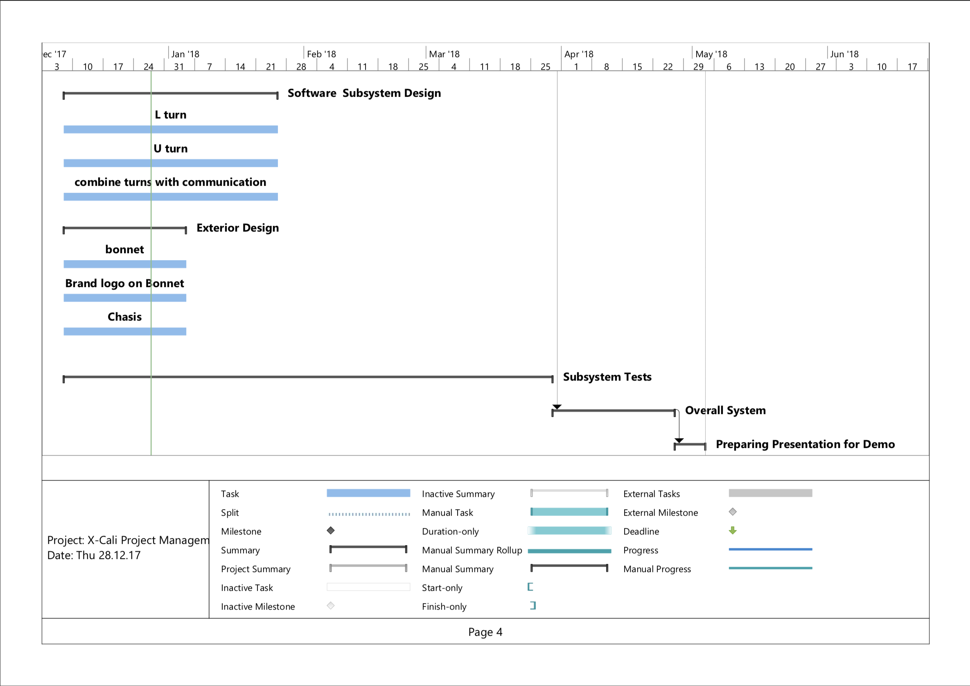

**Cost Analysis**

After a detailed research process, we checked the market to be able figure how to solve the problem with the minimized cost. By making a comparison list, we found our optimal component set and purchased them. This component list can be observed below in Table XX.

|  |  |  |  |
| --- | --- | --- | --- |
| Product Name | Price Per Product | Quantity | Total Price |
| Raspberry Pi 3 | 181.65 ₺ | 1 | 181.65₺ |
| HC-SR04 Arduino Ultrasonic Distance Sensor | 5.50₺ | 4 | 22.00₺ |
| E18 D80NK Infrared Sensor | 22.75₺ | 4 | 91.00₺ |
| Logitech C270 Webcam | 115.75₺ | 1 | 115.75₺ |
| L298N Motor Driver | 12.00₺ | 1 | 12.00₺ |
| Ball transfer unit | 4.20₺ | 1 | 4.20₺ |
| Robot Chassis & Wheels | 50.00₺ | 1 | 50.00₺ |
| Jumper Cables | 10.00₺/set | 1 | 10.00₺ |
| 11.1V 1300mA LIPO Battery | 69.50₺ | 1 | 69.50₺ |
| LIPO Battery Charger | 45.00₺ | 1 | 45.00₺ |
| 24V-5V 3A DC to DC USB Power Module | 6.65₺ | 1 | 6.65₺ |
|  |  | **TOTAL PRICE** | 607.75₺ |

Table XX. Cost Analysis of the Project.

It does not seem like that we will need other components. But if we need to add some new parts to our robot, we still have almost 40% of our project budget.

**Deliverables**

The expected deliverables of the work packages of our project process can be observed in the Table XX.

|  |  |  |
| --- | --- | --- |
| The Work Package | Corresponding Deliverable | STATUS |
| Research | Tentative Report | Completed. |
| Component Tests | Results and analysis of the component tests | Completed for the ultrasonic sensors and RP3.  Test plan is achieved. |
| Communications Subsystem Design | Results of the procedure of receiving& processing data | Not completed. |
| Mechanical Subsystem Design | Driving tests and analysis of the robot | Completed.  Test plan is achieved. |
| Software Subsystem Design | Documentation of the algorithms and debugging results | Started but not completed. |
| Overall System Implementation& Tests | A robot completing the labyrinth by itself | Not completed yet. |
| Demonstration | A robot completing the labyrinth collaboratively with the other groups.  The product within its package. | Not completed. |

Table XX. Expected deliverables of the work packages.

Beyond the deliverables of the R&D process, the package of our product will include the main body of robot, a plank, user manual, 2 spare tires, a back-up battery and a remote controller deciding the robot to become master or slave.

The size of the robot is not strictly unalterable as the company will not have a stockpiling policy. After your order, your product will be prepared with respect to your requests and sent you in 10 weekdays.

Our product will have a low-power consumption so that charging will not be an issue for users. Rechargeable batteries with higher charging cycles will be preferred in the design process. But still, for the degeneration problems due to battery, we are sending a back-up battery within the package.

In the user manual, customers will be able to find all necessary information about the setup of the robot, methods of changing the tires and battery and switching the robot’s duty (master or slave). All this information and some extra contents will be available on our company website <http://www.xcali.ml/> . You can easily leave a message from the contact tab to ask anything about our company and products.

Our company cares about customer satisfaction. For this reason, we are offering a 2-year warranty for all products except the batteries. After 2 years, you can extend your existing warranty with a small amount of money. Our maintenance and repair service will be in Ankara. But you can send your broken product with our negotiated logistic partner, a well-known shipping company from all around the world.

***Foreseeable difficulties (risks) are clearly discussed and contingency plans for handling these difficulties are clearly indicated.***

## 

## Engineering

Test Plans

As we completed two subsystems, Proximity Sensor Sensing and DC Motor Driving, we have three test plans, including these subsystems and integrated version of them, prepared up to now. These plans are given in the following order,

1st Test Plan: Proximity Sensor Measurements

HC-SR04 model of ultrasonic proximity sensor is used to sense the maze walls. Before the integration of proximity sensors, they are tested. The test specifications are provided below.

|  |  |
| --- | --- |
| ***Environment*** | : Living Room, silent |
| ***Driver*** | : Raspberry Pi 3 |
| ***Obstacle Object*** | : a thick book |
| ***Temperature***  ***Measurement Tool*** | : 24℃  : Tape measure  N |

***Measurement Method***

First, the distance between the proximity sensor and the obstacle is set to specific values such as 5cm, 10cm… up to 75cm with a tape measure. Then the distance is measured with the proximity sensor and the values are saved. Five samples are collected at each distance value.

Measurement is done with RaspberryPi3 and the results are observed on the monitor, on the RP3 GUI.

The measurement results is given in Table XX.

|  |  |  |  |  |  |
| --- | --- | --- | --- | --- | --- |
|  | Measurement #1 | Measurement #2 | Measurement #3 | Measurement #4 | Measurement #5 |
| Real Distance | Measured Distance | Measured Distance | Measured Distance | Measured Distance | Measured Distance |
| 5 | 5.9 | 5.4 | 5 | 5.2 | 5.2 |
| 10 | 9.7 | 9.67 | 9.74 | 9.74 | 9.71 |
| 15 | 15.2 | 15.16 | 15.16 | 15.5 | 15.18 |
| 20 | 19.62 | 19.58 | 19.62 | 19.58 | 19.6 |
| 25 | 24.56 | 24.56 | 24.64 | 24.59 | 24.61 |
| 30 | 29.15 | 29.7 | 29.15 | 29.57 | 29.14 |
| 35 | 34.12 | 34.21 | 34.16 | 34.12 | 34.12 |
| 40 | 39.41 | 39.44 | 39.32 | 39.42 | 39.39 |
| 45 | 43.92 | 43.88 | 43.88 | 43.93 | 43.9 |
| 50 | 49.7 | 48.82 | 48.88 | 48.15 | 48.22 |
| 55 | 53.71 | 53.68 | 53.64 | 53.68 | 53.59 |
| 60 | 58.92 | 58.93 | 59.36 | 59.77 | 58.92 |
| 65 | 63.18 | 63.6 | 63.5 | 63.56 | 63.43 |
| 70 | 68.53 | 68.1 | 68.18 | 68.48 | 68.12 |
| 75 | 73.74 | 74.19 | 74.6 | 73.76 | 73.28 |

Table XX: Measurement results of HC-SR04 model prox. sensor with given measurement specifications.

HC-SR04 has 4 pins

* VCC
* TRIG
* ECHO
* GND

TRIG and ECHO pins are connected to the RP3 pins 23 and 24 respectively. The code, sense.py, for measurement is provided in our project’s GitHub Repository.

The following graphs are obtained using MATLAB.

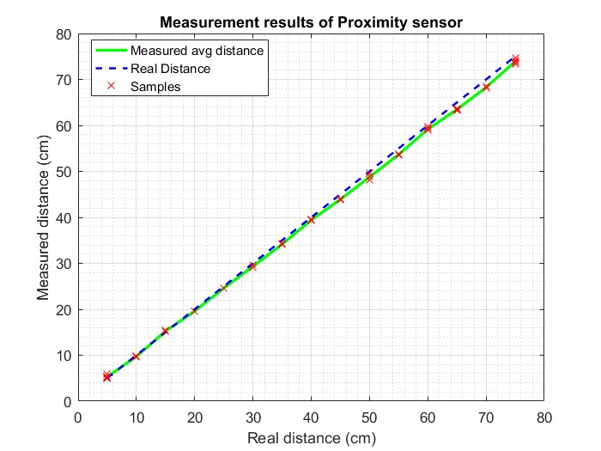

Figure XX: Measurement Results of HC-SR04 proximity sensor

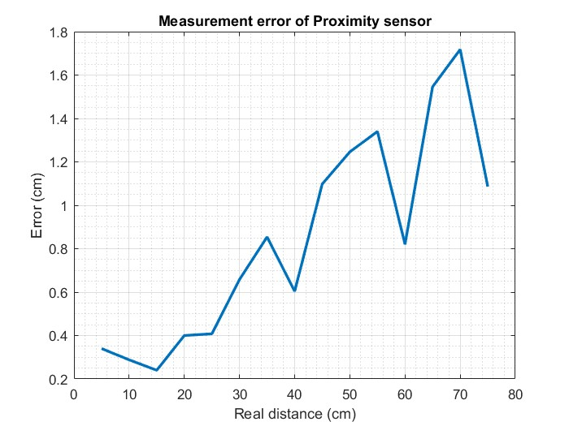

Figure XX: Measurement error of HC-SR04

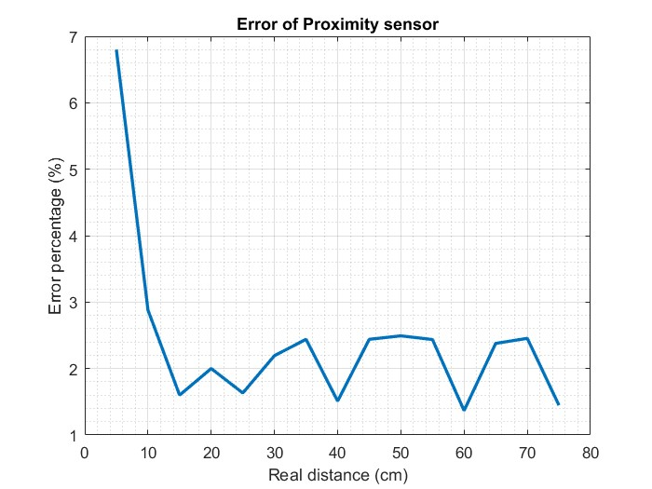

Figure XX: Error Percentage of HC-SR04

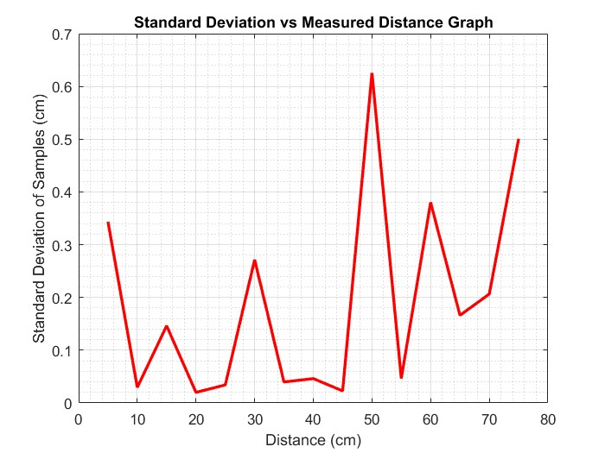

Figure XX: Standard Deviation of HC-SR04

***Result***

When the error percentages of the component at different distances are monitored, it is seen that up to 400 millimeters, there is not a significant error. But after this amount, the amount of error is more than 10 millimeters. With all these data, we decided that our robot will stop when the distance to the wall is 150 millimeters and make a decision at this point. So, this component is suitable for our system.

2nd Test: DC Motor Starting Current Test

**Test Conditions**

***Location*** : Design Studio

**Date**  : Dec. 17, 2017

***Temperature*** : Room temperature (appx. 23-25◦ C)

***Environment***  : Loud, luminous

**Test Procedure**

The aim of this test is to measure the zero-speed current (maximum current) of the DC motor. To achieve this, we used the DC Power Supply’s Current Limiter property. We directly connected the power supply to the motor. And by fixing the voltage level, we changed the current limit value step by step. The corresponding current values can be seen in the following table.

|  |  |  |  |
| --- | --- | --- | --- |
| Trial Number | Voltage Level | Current Level | Is the limit exceeded? |
| #1 | 7.8 V | 3.00 A | NO |
| #2 | 7.8 V | 2.74 A | NO |
| #3 | 7.8 V | 2.30 A | YES |
| #4 | 7.8 V | 2.60 A | NO |
| #5 | 7.8 V | 2.40 A | YES |
| #6 | 7.8 V | 2.50 A | NO |
| #7 | 7.8 V | 2.49 A | YES |

Table XX. Current values corresponding to the different trials.

The DC power supply makes a clique sound and turns the CC (Control and Current) LED on when the current limit is exceeded. By this method, we found the maximum current level under the voltage level 7.8 Volts which is about 2.49 Amperes. Below this value, all current levels will exceed the limit during the zero- speed tests.

A similar test is applied while the robot is moving. Two motors took 0.92 Amperes in this test.

**Conclusion**

These tests are performed in order to observe and measure the current rating of the motors at worst case (i.e. at start and at zero-speed issues). Comparing the test results, it can be concluded that the amount current drawn by motors is far from being harmful for the battery, the motor drive and the rest of the system.

3rd Test:  Response Time and Turning Angle Test

-Integration of Motors and Proximity Sensor-

**Test Conditions**

***Location*** : Design Studio

**Date**  : Dec. 17, 2017

***Temperature*** : Room temperature (appx. 23-25◦ C)

***Environment***  : Loud, luminous

***Measure*** : Turning time and turning angle

***Measurement Tools***: Protractor, ruler, pencil

**Test Procedure**

This test aims to observe the behavior of integration of two subsystems, which are motors and proximity sensor.

In the previous tests, we have observed successive results. In this test, the turn angle corresponding to different run times of the code that performs turning to right. Two subsystems integrated on Raspberry Pi 3. The scenario is that the robot continues on its route until it encounters an obstacle, in fact in our case a wall, and turns right first due to Standard Committee Regulations.

The test is performed as follows: The run time of the code is set to different values in order to observe corresponding turning angles of the tyres. Starting point of the vehicle, the point that the vehicle senses the obstacle and stops, the point after the vehicle turns right and stops and the final point that the vehicle stops are marked. These four points form two approximately perpendicular lines and the angle between them is measured with a protractor. This setup is shown in Figure 1, below.

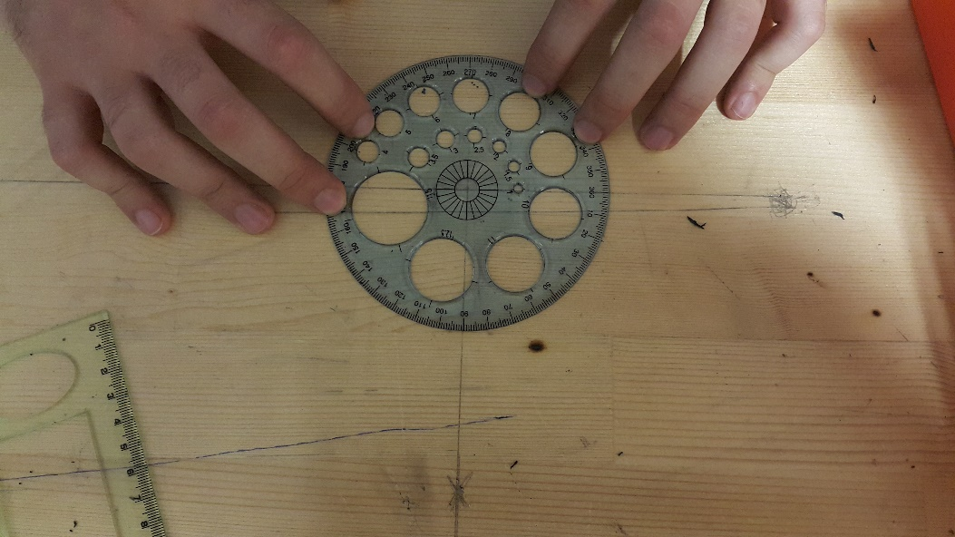

Figure 1: Experimental Setup

**Test Results**

Specifications

*Power Supply to motors, constant:* 8 Volts

*Controller:* RP3

*Motor drive:* L298P Shield

Test results are provided on Table 1, below.

|  |  |  |  |
| --- | --- | --- | --- |
| **Run Time** | 0.5 sec | 0.4 sec | 0.45 sec |
| **Trial 1** | 104 o | 85o | 88o |
| **Trial 2** | 93 o | 86 o | 83 o |
| **Trial 3** | 103 o | 80 o | 90 o |

Table 1: Turn Angles Corresponding to Different Right-Turn Run Times

**Conclusion**

These tests are performed in order to observe integrated system response. As can be seen above, proximity sensor reacts very quickly. The time required to turn robot approximately 90⁰ takes around 0.45 sec. However, please note that there is not neither gearbox in motor setup nor speed control software. Thus, motors are run at top speed at given voltage.

***Test plans and measure of success for sub-systems (yet to be built) are clearly explained.***

***Integration plans, test procedures, and measure of success for the complete system are clearly described.***