Proximity Sensor Measurements – Mini Report

Measurement: Burak SEZGİN, Data extraction: Taha DOĞAN

(BURAYA MODEL GİRİLECEK) model of proximity sensor is used to sense the maze walls. Before the integration of proximity sensors, they are tested. The test specifications are provided below.

Environment : Living Room, silent

Driver : RaspberryPi3

Obstacle Object : a thick book

Temperature : 24℃

(BURAYA BAŞKA TEST ORTAMIYLA AKLINA GELEN VARSA YAZAR MISIN?)

(Buraya Table Eklenecek)

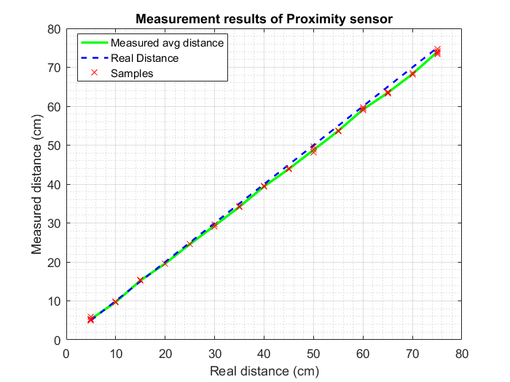

Figure 1: Measurement Results of (MODELLLL) proximity sensor

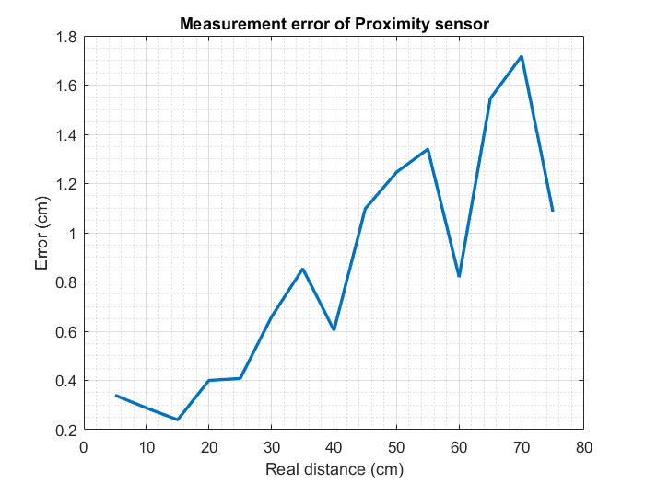

Figure 2: Measurement error of (MODELLLL)

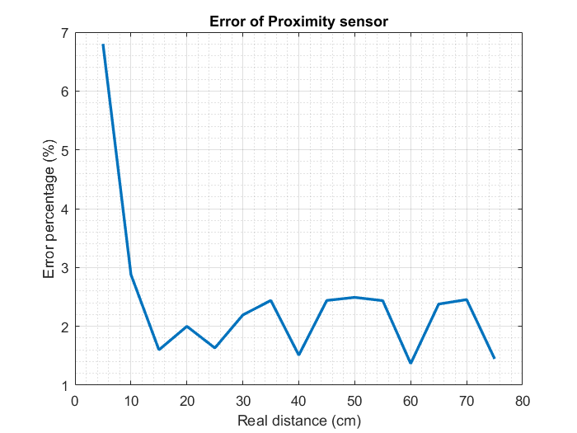

Figure 3: Error Percentage of (MODELLLLL)

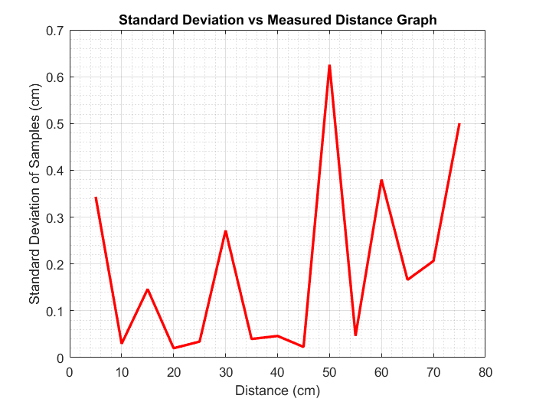

Figure 4: Standard Deviation of (MODELL)