Proximity Sensor Measurements – Short Report X-Cali

Measurement: Burak SEZGİN, Data extraction: Taha DOĞAN

HC-SR04 model of ultrasonic proximity sensor is used to sense the maze walls. Before the integration of proximity sensors, they are tested. The test specifications are provided below.

|  |  |
| --- | --- |
| Environment | : Living Room, silent |
| Driver | : RaspberryPi3 |
| Obstacle Object | : a thick book |
| Temperature | : 24℃  N |

Measurement Tool: Tape measure

Measurement Method :

First, the distance between the proximity sensor and the obstacle is set to specific values such as 5cm, 10cm… up to 75cm with a tape measure. Then the distance is measured with the proximity sensor and the values are saved. Five samples are collected at each distance value.

Measurement is done with RaspberryPi3 and the results are observed on the monitor, on the RP3 GUI.

HC-SR04 has 4 pins

* VCC
* TRIG
* ECHO
* GND

TRIG and ECHO pins are connected to the RP3 pins 23 and 24 respectively. The code, sense.py, for measurement is provided in the GitHub page.

The following graphs are obtained using MATLAB.

|  |  |  |  |  |  |
| --- | --- | --- | --- | --- | --- |
|  | Measurement #1 | Measurement #2 | Measurement #3 | Measurement #4 | Measurement #5 |
| Real Distance | Measured Distance | Measured Distance | Measured Distance | Measured Distance | Measured Distance |
| 5 | 5.9 | 5.4 | 5 | 5.2 | 5.2 |
| 10 | 9.7 | 9.67 | 9.74 | 9.74 | 9.71 |
| 15 | 15.2 | 15.16 | 15.16 | 15.5 | 15.18 |
| 20 | 19.62 | 19.58 | 19.62 | 19.58 | 19.6 |
| 25 | 24.56 | 24.56 | 24.64 | 24.59 | 24.61 |
| 30 | 29.15 | 29.7 | 29.15 | 29.57 | 29.14 |
| 35 | 34.12 | 34.21 | 34.16 | 34.12 | 34.12 |
| 40 | 39.41 | 39.44 | 39.32 | 39.42 | 39.39 |
| 45 | 43.92 | 43.88 | 43.88 | 43.93 | 43.9 |
| 50 | 49.7 | 48.82 | 48.88 | 48.15 | 48.22 |
| 55 | 53.71 | 53.68 | 53.64 | 53.68 | 53.59 |
| 60 | 58.92 | 58.93 | 59.36 | 59.77 | 58.92 |
| 65 | 63.18 | 63.6 | 63.5 | 63.56 | 63.43 |
| 70 | 68.53 | 68.1 | 68.18 | 68.48 | 68.12 |
| 75 | 73.74 | 74.19 | 74.6 | 73.76 | 73.28 |

Table 1: Measurement results of HC-SR04 model prox. sensor with given measurement specifications

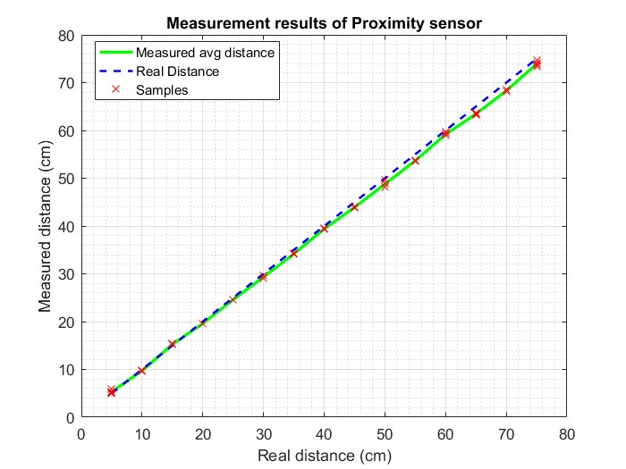

Figure 1: Measurement Results of HC-SR04 proximity sensor

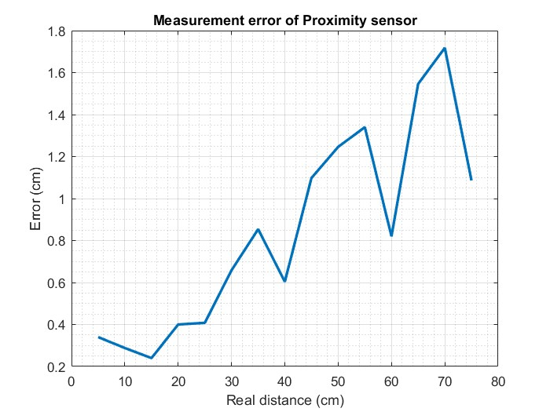

Figure 2: Measurement error of HC-SR04

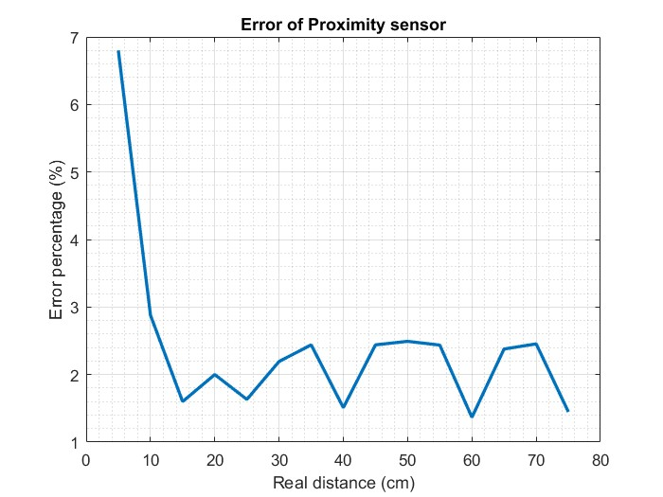

Figure 3: Error Percentage of HC-SR04

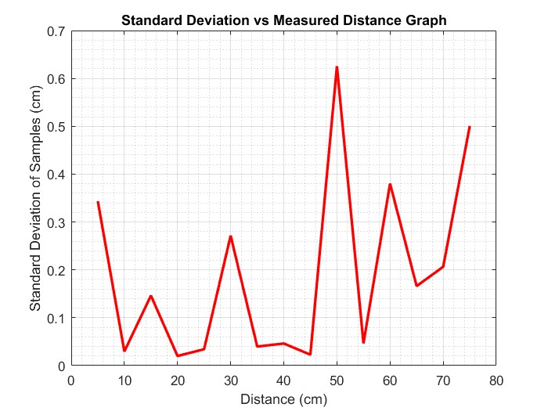

Figure 4: Standard Deviation of HC-SR04