

**EE-493 Engineering Design Project**

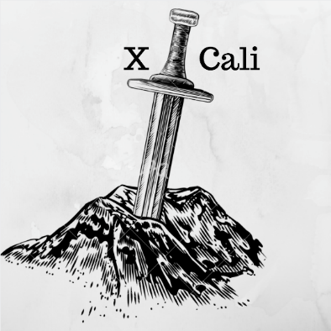

**Company: X-Cali**

**Proposal Report**

Design Studio Instructor: Prof. Dr. Ali Özgür YILMAZ

|  |  |  |
| --- | --- | --- |
| **Project Start Date:** | October 10th, 2015 |  |
| **Project End Date:** | June 4th, 2015 |  |
| **Project Duration:** | 8 Months |  |
|  | ***Company Partners:*** |  |
| **Göksenin Hande BAYAZIT** | 2093441 | hande.bayazit@metu.edu.tr |
| **Emre DOĞAN** | 2093656 | dogan.emre@metu.edu.tr |
| **Taha DOĞAN** | 2093672 | e209367@metu.edu.tr |
| **Burak SEZGİN**  **Oytun AKPULAT** | 2094456  2093201 | [burak.sezgin@metu.edu.tr](mailto:zekier@gmail.com)  oytun.akpulat@metu.edu.tr |

Table of Contents

1 Executive Summary 3

2 Introduction 3

3 Project Goals and Objectives 4

3.1 Requirements 4

3.2 Objectives 4

3.2.1 Company Objectives 4

3.2.2 Project Objectives 4

4 Outline of Standards 4

5 Team Organization 5

6 Solution Procedure 6

6.1 Mechanical Design and Maneuverability 6

6.2 Communication / Sensing 7

6.3 Power and Electronic Systems 8

7 Expected Deliverables 8

8 Conclusion 9

9 Appendices 10

9.1 Appendix A-Criteria Weighted Voting 10

9.2 Appendix B-Gantt Chart 10

9.3 Appendix C-Cost Analysis Table 10

# Executive Summary

X-Cali was founded to manufacture top quality robots with the best technology by five electrical and electronics engineering understudies. Due to our individual specializations, we are very keen robots of different types.

In today’s growing world, importing and exporting goods increase day by day. This cause and increase in need of transportation. However, every good may not be appropriate for simple carrying, like carrying with forklifts and so on. For this purpose, use of robots increase as technology allows us.

In our very first project, the focus is on how to carry a long object through edges and corners, that is normally the object does not fit for turning the corners. For this purpose, a maze environment is used. This project aims to write an algorithm for carrying a long object with two robots, which are they are not allowed to direct-communication.

Of course, there are tremendous amount of approach available to resolve that problem. Nevertheless, we need to find the one which is most suitable for our team members and the constraints. For example, we may not pick the best solution for our project since there is a budget limit as $200 to produce the robot. And also, our solution has to be innovative in order to be at the top among the similar products in this area. We will approach the project systematically in order to realize our goals. To simply put, we will proceed step by step while paying attention to every detail in this project. Major tasks to be considered in this project are movements of the robots in the maze, identifying the turns (such as U-turns and L-turns), subsequent move decision analysis, somehow indirect communication logic between robots. After designing and integration of these subsystem, sanguinely our maze robot fulfills all the necessary tasks, and get out of the maze with its partner.

# Introduction

As X-Cali, we have picked EE493 Engineering Design course as our very first project. We, first, voted several projects to pick suitable one for us. For that purpose, we used a “Criteria Weighted Voting” system. And “[Robots collaboratively carrying a long object through an open-top maze](http://users.metu.edu.tr/capstone/Projects17/#p4)” project was the winner by landslide. In this project, it is required to design and construct an autonomous robot, which can find the exit from the maze while carrying a long object with another robot.

If we divide the project into parts, the first part would be collaboration with other robot. The robots cannot communicate with each other. Sensors and algorithm can be utilized, for that aim, to understand when and which robot must take control. Maze solving algorithm is next part for such a robot project. To get out of the maze, a maze solving algorithm is an essential. This algorithm can be found and implemented with some modifications or a new algorithm can be written for our robot.

In the accompanying parts of the report, point by point clarification of the project is given. Firstly, the objectives and goals of the project are listed. At that point, standards of the project are clarified. Next, the team organizational structure is appeared and brief data about the individuals is given. Besides, a point by point solution procedure and our approach towards to project will be given with a prerequisite analysis. Finally, expected deliverables of our product are given.

# Project Goals and Objectives

## Requirements

* Solving the maze with the other robot
* No direct communication

## Objectives

* Entering and exiting the maze successfully
* Taking the master / slave roles
* Making U-Turns, L-Turns, Double U-Turns, Double L-Turns
* Maintaining the robot at a constant speed

### Company Objectives

* Producing the maze solver robot under 200$
* Providing maintenance service for 2 years

### Project Objectives

* Completing the maze under a specific time limit

# Outline of Standards

Within the scope of “maze-solving robot” project, the design specifications and implementation of the project are standardized with several limitations and conditions. As the project requires strong collaborative work, the standards are especially focused on the plank that the robots should carry and the open-top maze.

Standards are determined on the following specifications:

* Shape, length, width, weight and material of the plank
* Presence of a mark on the plank
* Specifications of the holding point of the plank on top of the robot
  + Width
  + Height
  + Shape of the drill
* Height, thickness and color of the walls of the maze
* Maze solving algorithm
* Maximum cross-section area of the robot
* Maximum and minimum speed boundaries

# Team Organization

X-Cali is set up by five qualified senior year understudies. Each team member is well-equipped with both knowledge and practical experience on various fields that is interconnected to this project. Organizational structure of X-CALI with respect to tasks is given in Figure 2.

Oytun Akplulat

* Specialization Area: Computer and Software Development
* Interested in Control Systems
* Dedicated team-member

Duties;

* + Signal processing
  + Coding the microprocessors

Göksenin Hande BAYAZIT

* Specialization Area: Power Electronics, Electrical Machines and Control Systems
* Interested in Power Electronics and Control Systems
* Experience on PCB design, motor control and power converters
* Has great communication skills

Duties;

* + Motor Controlling
  + Power Management

Emre DOĞAN

* Specialization Area: Telecommunication and AI, Machine Learning
* Interested in Signal Processing
* Experience on Business Administration, and Entrepreneurship
* Has quick learning ability

Duties;

* + Communication systems
  + Finding maze algorithms

Taha DOĞAN

* Specialization Area: Computer and Software Development,
* Interested in Digital System Design
* Experience on PCB design and modelling HF passive circuit elements
* Good analytical skills

Duties;

* + Subsystem and Suprasystem Integration
  + Mechanic and Hardware Maintenance
  + Software Development

Burak SEZGİN

* Specialization Area: Computer and Software Development
* Interested in AI and Programming Languages
* Has goal oriented working ability

Duties;

* + Finding maze algorithms
  + Coding the microprocessors

Figure 2: Organizational Structure of X-Cali.

# Solution Procedure

## Mechanical Design and Maneuverability

Mechanical design includes two main problems:

1- Shape of the robot

2- Movement of the robot

Robot has a cylindrical shape so that robot can keep its symmetry through the maze. Although circular shapes are not efficient in terms of area usage and area efficiency, it gives a good maneuverability around the edges. In order to achieve clear turns, omni-wheels can be used in the design. One of major reason to use such wheels is to rotate around itself or without rotating continuing the linear motion.

The connection point of the plank is also another focus point in the mechanical design. This plank must be attached on top of the robot so that there is no non-negligible margin but also it must rotate freely with negligible opposing torque. At the connection points, ball-bearings perform this duty.

An illustrative drawing is shown in Figure 3.

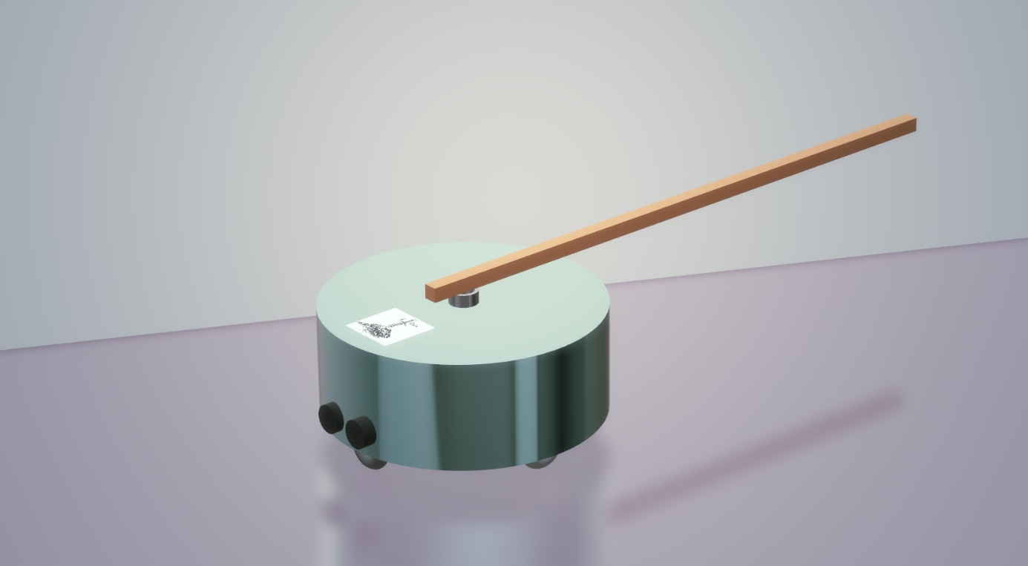

Figure 3: An illustrative design for maze solver robot

## Communication / Sensing

In this project direct communication is forbidden. Thus, sensing and indirect information passing are the only possible understanding the robot’s motion. The information is passed through indirect ways means that one robot cannot tell the other its decision and what the other should do. Communication between the two robots differently from sensing, is to be decided throughout the Standard Committee.

Sensing the other robot can be done by sensing the torque or sensing the tension or compression on the plank so that they can predict their future movements and their current situation.

## Power and Electronic Systems

# Expected Deliverables

The package of our product will include the main body of robot, a plank, user manual, 2 spare tires, a back-up battery and a remote controller deciding the robot to become master or slave.

The size of the robot is not strictly unalterable as the company will not have a stockpiling policy. After your order, your product will be prepared with respect to your requests and sent you in 10 weekdays. During the ordering process, your robot can be specialized for its size, color and some other extra features. Also, there will be an option to purchase the overall system which includes 2 separate robots, a plank and an example maze platform.

Our product will have a low-power consumption so that charging will not be an issue for users. Rechargeable batteries with higher charging cycles will be preferred in the design process. But still, for the degeneration problems due to battery, we are sending a back-up battery within the package.

In the user manual, customers will be able to find all necessary information about the setup of the robot, methods of changing the tires and battery and switching the robot’s duty (master or slave). All this information and some extra contents will be available on our company website http://www.xcali.ml/ . You can easily leave a message from the contact tab to ask anything about our company and products.

Our company cares about customer satisfaction. For this reason, we are offering a 2-year warranty for all products except the batteries. After 2 years, you can extend your existing warranty with a small amount of money. Our maintenance and repair service will be in Ankara. But you can send your broken product with our negotiated logistic partner, a well-known shipping company from all around the world.

# Conclusion

This report is prepared in order to provide detailed information about the design and production process of “maze-solver robot” by X-Cali. Main design issues and their solutions such as maneuverability, main body, electronic parts of the robot and the communication procedure between the master and slave robots are explained in detail. Standards that the product should fulfil are also listed. Further, other than product related information, details about our company, the co-founders and their duties and project timetable are present.

Besides, even if it seems to be hard at first sight, the project definition is far from being a maze solving project since there is no dead-end in the maze. This eliminates one of the biggest issues of the project description and reduces the problem to a collaborative maneuvering while carrying an object.

The solutions may also be further improved by using artificial intelligence and machine learning based solutions, with different types of alternative sensors and the approaches of different point of views.

As the company X-Cali, we believe that we can surely complete this project since we are a team with members of various areas of interest and which makes us advantageous for such a multidisciplinary work. With a well-planned design and production process, a successful project management and co-operation, X-Cali will accomplish the production of the described robot.

# Appendices

## Appendix A-Criteria Weighted Voting



Result: Maze

## Appendix B-Gantt Chart

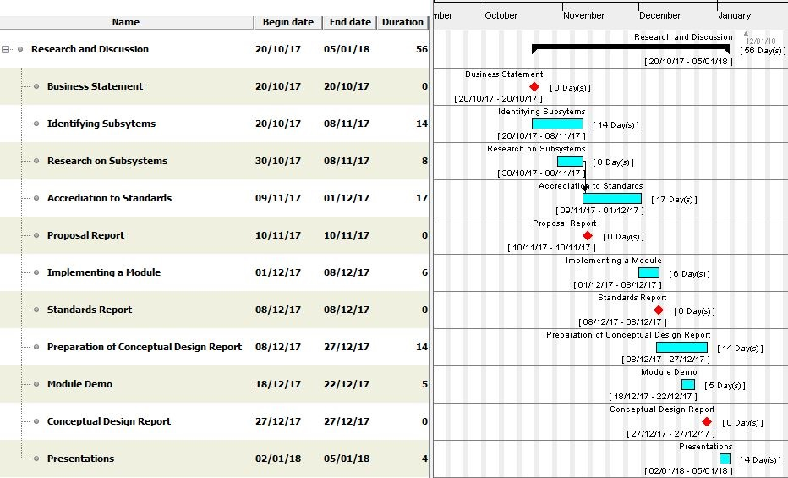

## Appendix C-Cost Analysis Table