**Assignment-6 JAVA2 Worth 7.5%**

Design a program with the following interface using javafx scene builder and File IO.

Following GUI is just an example choose different color, design and font for your GUI interface.

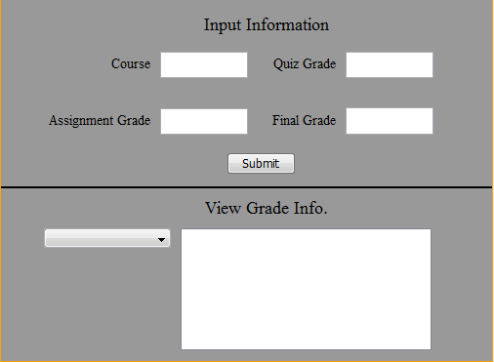

Write program which allows to enter course name, quiz mark, assignment mark and final mark through textboxes and When click on submit button it read value from text boxes and write into file as per follows:

prog24178,quiz,2.0

prog24178,assignment,2.0

prog24178,final,2.0

prog24178,quiz,5.0

prog24178,assignment,5.0

prog24178,final,5.0

prog10082,quiz,5.5

prog10082,assignment,10.0

prog10082,final,20.0

You can enter any course name through text box.

Submit button also add course name in combo box. After adding course name into combo box that combo box allows the user to select which course data they would like to view, in case there is data for more than one course in the data file.

If user select “prog24178” from combo box data should be read from file and calculate total of quiz, assignment and final marks and displayed in text area as per following fig.

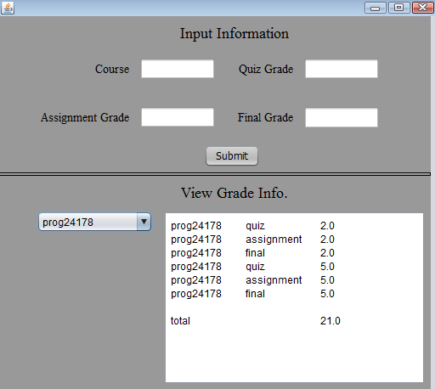

**Submission and Marking Scheme:**

Submit zip file through drop box.

You must also copy and paste all of your source code from all of your classes into a Word document and also submit this document file separately.

Submit this document **in addition to** your source code zip file. **DO NOT add it inside your zip file** - it must be a separate file. This is used for TurnItIn.

Your submissions will be graded with the following consideration:

Marks will be given for originality of the code.

Program is stored in an appropriately named file

Program has the proper header information including your name and program

Program compiles successfully and without warnings

Program is complete and produces correct results

Program uses appropriate indentation to show logical path flows

Program has proper commenting

Marks will be deducted for poor commenting and/or not following Java naming conventions.