**Assignment-7 JAVA2 Worth 7.5%**

You are running a Book shop where you are keeping inventory for all the books.

Design a program with the following interface using javafx scene builder, File IO and ArrayList class.

Following GUI is just an example choose different color, design and font for your GUI interface.

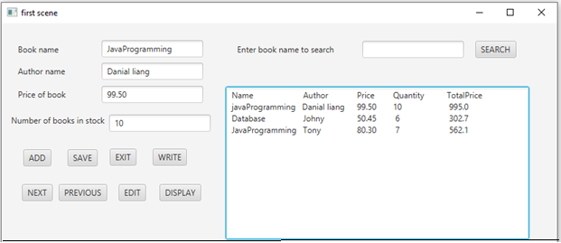

Write program which allows you to enter book name, author, price of each book and number of books in stock of the book through textboxes and store it in arraylist.

Write button reads value from arraylist and write into file as per follows:

javaprogramming,danialliang,99.50,10

database,johny,50.45,6

javaprogramming,tony,80.30

You can choose any different names to store in file.

Also design and write code for add, save, exit, next, previous and edit button as discussed in class.

Design display button which read information from file and display information in text area as per following fig. You can calculate TotalPrice=price of book * number of books in stock.

Design search button as per following fig. Enter the book name you want to search in text field. Search button compare the name you enter in textfield and the book name that stored in file.

If both names are same than print the entire record in text area including Name, Author, Price, Quantity and TotalPrice

If names does not match than print message like match not found in text area.

Use following code to write Book.java class

public class Book

{

private String bookname,author;

private int quantity;

private double price;

public Book() {

}

public Book(String bookname, String author, int quantity, double price) {

this.bookname = bookname;

this.author = author;

this.quantity = quantity;

this.price = price;

}

public String getBookname() {

return bookname;

}

public String getAuthor() {

return author;

}

public int getQuantity() {

return quantity;

}

public double getPrice() {

return price;

}

public void setBookname(String bookname) {

this.bookname = bookname;

}

public void setAuthor(String author) {

this.author = author;

}

public void setQuantity(int quantity) {

this.quantity = quantity;

}

public void setPrice(double price) {

this.price = price;

}

}

**Submission and Marking Scheme:**

Submit zip file through drop box.

You must also copy and paste all of your source code from all of your classes into a Word document and also submit this document file separately.

Submit this document **in addition to** your source code zip file. **DO NOT add it inside your zip file** - it must be a separate file. This is used for TurnItIn.

Your submissions will be graded with the following consideration:

Marks will be given for originality of the code.

Program is stored in an appropriately named file

Program has the proper header information including your name and program

Program compiles successfully and without warnings

Program is complete and produces correct results

Program uses appropriate indentation to show logical path flows

Program has proper commenting

Marks will be deducted for poor commenting and/or not following Java naming conventions.