**Quiz1 JAVA2 Weight 2.5%**

Create following GUI design using javaFXML.

Write button writes book name, description of book, unit price and number of copies which are entered through text boxes and write into file as per following:

JavaProg,ObjectOriented,50.5,3

VB.net,EventDrivan,40.0,3

CProg,Procedural,35.5,10

Read button read data from file, calculate total=price * no of copies and display information in text area as per following fig.

Use any color, font for your interface.

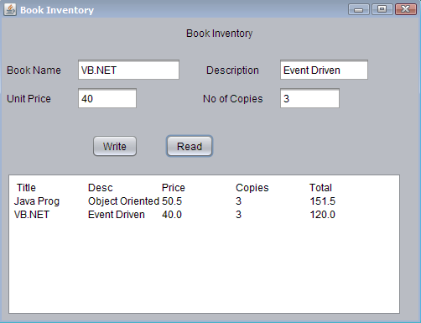

**Submission and Marking Scheme:**

Submit zip file through drop box.

You must also copy and paste all of your source code from all of your classes into a Word document and also submit this document file separately.

Submit this document **in addition to** your source code zip file. **DO NOT add it inside your zip file** - it must be a separate file. This is used for TurnItIn.

Your submissions will be graded with the following consideration:

Marks will be given for originality of the code.

Program is stored in an appropriately named file

Program has the proper header information including your name and program

Program compiles successfully and without warnings

Program is complete and produces correct results

Program uses appropriate indentation to show logical path flows

Program has proper commenting

Marks will be deducted for poor commenting and/or not following Java naming conventions.