MainActivity.kt:

package com.example.calculator  
  
import android.os.Bundle  
import android.widget.Button  
import android.widget.TextView  
import androidx.appcompat.app.AppCompatActivity  
import java.util.*  
  
class MainActivity : AppCompatActivity() {  
  
 private lateinit var display: TextView  
 private val currentInput = StringBuilder()  
 private val history = ArrayList<String>()  
  
 override fun onCreate(savedInstanceState: Bundle?) {  
 super.onCreate(savedInstanceState)  
 setContentView(R.layout.*activity_main*)  
 display = findViewById(R.id.*display*)  
 val buttonIds = *listOf*(  
 R.id.*buttonNum*, R.id.*buttonDivide*, R.id.*buttonMultiply*, R.id.*buttonSubtract*,  
 R.id.*button7*, R.id.*button8*, R.id.*button9*, R.id.*buttonAdd*,  
 R.id.*button4*, R.id.*button5*, R.id.*button6*, R.id.*buttonAdd*,  
 R.id.*button1*, R.id.*button2*, R.id.*button3*, R.id.*buttonEnter*,  
 R.id.*button0*, R.id.*button0*, R.id.*buttonDot*, R.id.*buttonEnter* )  
  
 for (id in buttonIds) {  
 findViewById<Button>(id).setOnClickListener **{** onButtonClick(**it** as Button) **}** }  
 }  
 private fun onButtonClick(button: Button) {  
 val command = button.*text*.toString()  
  
 when {  
 command.*all* **{ it**.*isDigit*() **}** || command == "." -> {  
 currentInput.append(command)  
 display.*text* = currentInput.toString()  
 }  
 command == "Ent" -> {  
 try {  
 val infix = currentInput.toString()  
 val rpn = convertToRPN(infix)  
 val result = evaluateRPN(rpn)  
 display.*text* = result.toString()  
 history.add("$infix = $result")  
 currentInput.*clear*()  
 } catch (ex: Exception) {  
 display.*text* = "Error"  
 currentInput.*clear*()  
 }  
 }  
 else -> {  
 currentInput.append(" $command ")  
 display.*text* = currentInput.toString()  
 }  
 }  
 }  
 private fun convertToRPN(infix: String): String {  
 val output = StringBuilder()  
 val stack = Stack<Char>()  
 for (c in infix.*toCharArray*()) {  
 when {  
 c.*isDigit*() || c == '.' -> output.append(c)  
 c == ' ' -> output.append(' ')  
 else -> {  
 output.append(' ')  
 while (stack.*isNotEmpty*() && precedence(stack.peek()) >= precedence(c)) {  
 output.append(stack.pop()).append(' ')  
 }  
 stack.push(c)  
 }  
 }  
 }  
 while (stack.*isNotEmpty*()) {  
 output.append(' ').append(stack.pop())  
 }  
 return output.toString().*trim*()  
 }  
  
 private fun precedence(op: Char): Int {  
 return when (op) {  
 '+', '-' -> 1  
 '*', '/' -> 2  
 else -> -1  
 }  
 }  
 private fun evaluateRPN(expression: String): Double {  
 val tokens = expression.*split*("\\s+".*toRegex*()).*toTypedArray*()  
 val stack = Stack<Double>()  
  
 for (token in tokens) {  
 when {  
 token.*matches*("-?\\d+(\\.\\d+)?".*toRegex*()) -> stack.push(token.*toDouble*())  
 else -> {  
 if (stack.size < 2) throw IllegalArgumentException("Invalid RPN expression")  
 val b = stack.pop()  
 val a = stack.pop()  
 val result = when (token) {  
 "+" -> a + b  
 "-" -> a - b  
 "*" -> a * b  
 "/" -> a / b  
 else -> throw IllegalArgumentException("Unknown operator: $token")  
 }  
 stack.push(result)  
 }  
 }  
 }  
 if (stack.size != 1) throw IllegalArgumentException("Invalid RPN expression")  
 return stack.pop()  
 }  
}

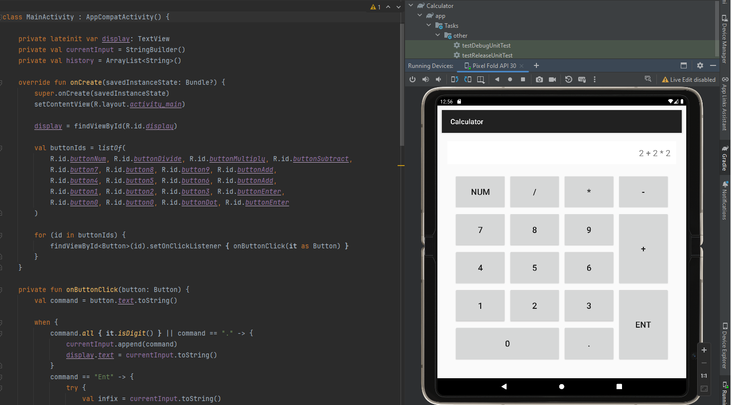

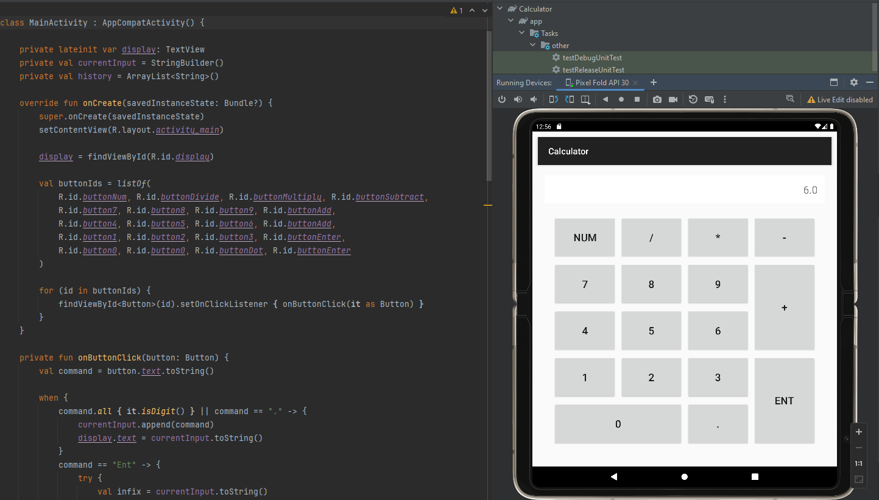

activity_main.xml:

<?xml version="1.0" encoding="utf-8"?>  
<LinearLayout xmlns:android="http://schemas.android.com/apk/res/android"  
 android:layout_width="match_parent"  
 android:layout_height="match_parent"  
 android:orientation="vertical"  
 android:padding="16dp">  
  
 <TextView  
 android:id="@+id/display"  
 android:layout_width="match_parent"  
 android:layout_height="wrap_content"  
 android:textSize="24sp"  
 android:background="@android:color/white"  
 android:padding="16dp"  
 android:text="0"  
 android:gravity="right"/>  
  
 <GridLayout  
 android:layout_width="match_parent"  
 android:layout_height="0dp"  
 android:layout_weight="1"  
 android:rowCount="5"  
 android:columnCount="4"  
 android:padding="16dp"  
 android:layout_gravity="center">  
  
 <!-- Row 1 -->  
 <Button  
 android:text="Num"  
 android:id="@+id/buttonNum"  
 android:layout_row="0"  
 android:layout_column="0"/>  
 <Button  
 android:text="/"  
 android:id="@+id/buttonDivide"  
 android:layout_row="0"  
 android:layout_column="1"/>  
 <Button  
 android:text="*"  
 android:id="@+id/buttonMultiply"  
 android:layout_row="0"  
 android:layout_column="2"/>  
 <Button  
 android:text="-"  
 android:id="@+id/buttonSubtract"  
 android:layout_row="0"  
 android:layout_column="3"/>  
  
 <!-- Row 2 -->  
 <Button  
 android:text="7"  
 android:id="@+id/button7"  
 android:layout_row="1"  
 android:layout_column="0"/>  
 <Button  
 android:text="8"  
 android:id="@+id/button8"  
 android:layout_row="1"  
 android:layout_column="1"/>  
 <Button  
 android:text="9"  
 android:id="@+id/button9"  
 android:layout_row="1"  
 android:layout_column="2"/>  
 <Button  
 android:text="+"  
 android:id="@+id/buttonAdd"  
 android:layout_row="1"  
 android:layout_rowSpan="2"  
 android:layout_column="3"/>  
  
 <!-- Row 3 -->  
 <Button  
 android:text="4"  
 android:id="@+id/button4"  
 android:layout_row="2"  
 android:layout_column="0"/>  
 <Button  
 android:text="5"  
 android:id="@+id/button5"  
 android:layout_row="2"  
 android:layout_column="1"/>  
 <Button  
 android:text="6"  
 android:id="@+id/button6"  
 android:layout_row="2"  
 android:layout_column="2"/>  
  
 <!-- Row 4 -->  
 <Button  
 android:text="1"  
 android:id="@+id/button1"  
 android:layout_row="3"  
 android:layout_column="0"/>  
 <Button  
 android:text="2"  
 android:id="@+id/button2"  
 android:layout_row="3"  
 android:layout_column="1"/>  
 <Button  
 android:text="3"  
 android:id="@+id/button3"  
 android:layout_row="3"  
 android:layout_column="2"/>  
 <Button  
 android:text="Ent"  
 android:id="@+id/buttonEnter"  
 android:layout_row="3"  
 android:layout_rowSpan="2"  
 android:layout_column="3"/>  
  
 <!-- Row 5 -->  
 <Button  
 android:text="0"  
 android:id="@+id/button0"  
 android:layout_row="4"  
 android:layout_column="0"  
 android:layout_columnSpan="2"  
 />  
  
  
 <Button  
 android:text="."  
 android:id="@+id/buttonDot"  
 android:layout_row="4"  
 android:layout_column="2"/>  
  
 </GridLayout>  
  
</LinearLayout>

-If everything shows underlined in red. It’s not mean everything is wrong. It is about to Microsoft Word.

-You can find other codes in the Calculator file.

-Added java version of this app so if you have a problem with android studio (It is not easy to install).

-You can check the java code and see it works.