**LAB 05 – Assignment**

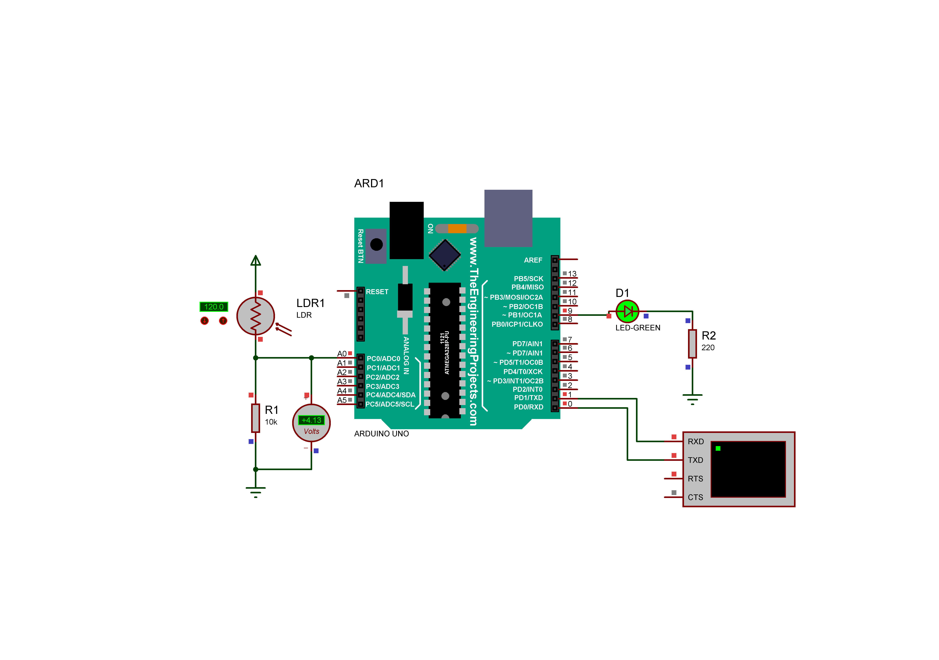

**Figure 1 - The circuit diagram**

The Arduino circuit above consists of following components:

* A LDR (Light Dependent Resistor) sensor which’s resistance value changes with light intensity. Light intensity is the value written on the left side of the LDR sensor and can be changed with the arrows below it. For example, it is 120 in the image).
* A Led
* A virtual Terminal to monitor the data acquired from serial port.

Your task is to develop a system that turns **the LED on if the light intensity is lower 100** (when environment is dark) and **turns the LED off if it is higher than 100** (when the environment is bright). Led intensity is the number just left side of the LDR sensor that you can change the value with the arrows. The LED should be controlled digitally, not with analog output. Virtual terminal must show the analog value at A0 pin and the status of the led continuously (once in a second) as shown below.

**IMPORTANT:** Use the same circuit configuration (pin numbers, resistor values etc.) for me to check your code in my Proteus project. Otherwise, your work will not be evaluated.

