ARDUINO RFID PARKING ACCESS CONTROL

# Materials Used:

* Arduino Nano V3
* RC522 RFID NFC Module
* 16x2 Character LCD
* LCD I 2 C Converter Board
* TowerPro SG90 RC Mini Servo Motor
* LDR
* HCSR04 Ultrasonic Distance sensor

# ARDUINO NANO

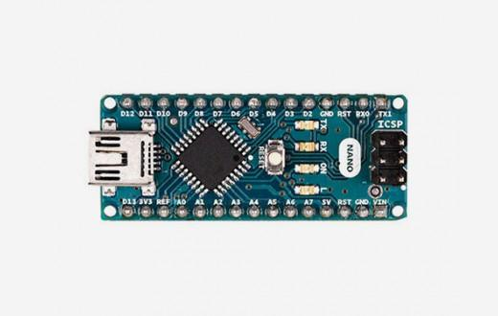

**TECHNICAL SPECIFICATIONS**

**http://www.robotiksistem.com/bullet.jpg Microcontroller:** Arduino ATmega328P in   
http://www.robotiksistem.com/bullet.jpgNano V3 (ATmega168 in previous versions) **Operating voltage:** +5 V DC  
http://www.robotiksistem.com/bullet.jpg **Recommended supply voltage:** 7 - 12 V DC  
http://www.robotiksistem.com/bullet.jpg **Supply voltage limits:** 6 - 20 V  
http://www.robotiksistem.com/bullet.jpg **Digital input/output pins:** 14 (6 of which support PWM output)  
http://www.robotiksistem.com/bullet.jpg **Analog input pins:** 8  
http://www.robotiksistem.com/bullet.jpg Current per **input/output pin :** 40 mA   
http://www.robotiksistem.com/bullet.jpg **EEPROM:** 1 KB for ATmega328, 512 Bytes for ATmega168    
http://www.robotiksistem.com/bullet.jpg **Dimensions:** 18 mm x 45 mm  
http://www.robotiksistem.com/bullet.jpg **Weight:** Approx. 5g 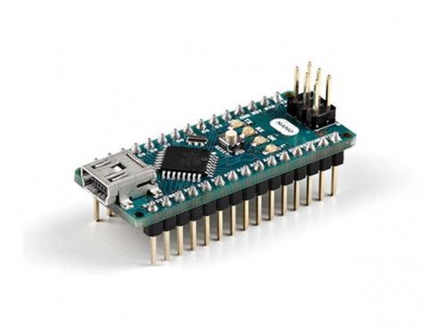

# WHAT IS MODULE - SHIELD (ARMOR/SHIELD)? WHAT IS THE DIFFERENCE?

# İlgili resim İlgili resim

MODULE & SHIELD

# RFID NFC MODULE RC522

RFID and NFC are two closely related wireless communication technologies used worldwide in applications such as access control, asset tracking, and contactless payments. RFID was first patented in 1983 and was the precursor to NFC **. Frequency Radio Frequency Identification (RFID)** typically provides one-way wireless communication between an RFID tag and a powered RFID reader, requiring no external power source. RFID tags can be scanned from up to 100 meters away without direct line-of-sight with the reader. RFID is used globally for warehousing inventory tracking, airport baggage handling, livestock identification, and much more. RFID operates in any radio frequency range provided its established standards and protocols are met.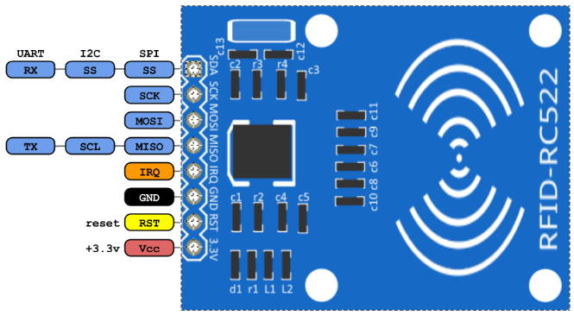

| **RFID Frequency Band** | **Scanning Distance** |
| --- | --- |
| 120 - 150 kHz ( Low Frequency , LF) | up to 10 cm |
| 13.56 MHz (High Frequency , HF) | up to 1 m |
| 433 MHz (Ultra High Frequency , UHF) | 1 – 100 meters |

**Near Field Communication (Near Field Communication) (NFC)** It operates at **13.56 MHz** and is an extension of the High Frequency (HF) RFID standards. Therefore, NFC shares many of RFID's physical characteristics, such as one-way communication and the ability to communicate without direct line of sight.

**However, there are three important differences:**

* NFC is capable of two-way communication and can therefore be used for more complex interactions such as card systems and peer-to- peer (P2P) sharing.
* As a proximity communication technology, NFC is limited to a distance of 5 cm or less.
* Only one NFC tag can be scanned at a time.

These features were primarily developed to enable secure mobile payment systems, and therefore NFC is limited to single, close interactions. NFC is currently used in most current smartphones, and this widespread adoption is arguably the most significant difference from RFID. NFC-enabled phones offer businesses and users seamless and intuitive communication between mobile phones, or between a mobile phone and an NFC tag. For example, Android Using Beam , you can share files, establish instant connections between electronic devices, and connect everyday objects like posters, banners, and billboards with online content. For example, simply tapping a billboard with an NFC-equipped device can connect to the desired online content.

RC522 module we use uses the SPI protocol to communicate with ARDUINO.

The cards we use have a unique UID number. This number is unique to each card. When we hold our card or key fob near the reader, this number is read and the transaction is completed.

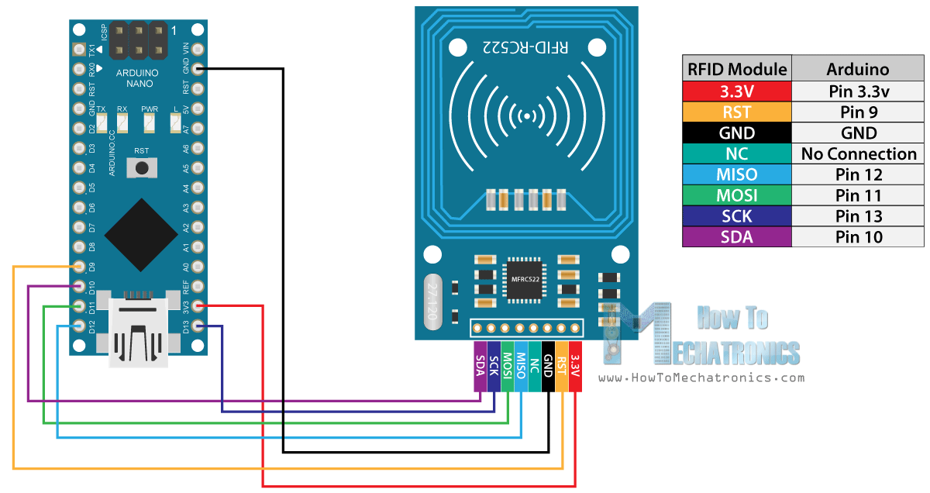

# 16x2 Character LCD

The term "16x2 character" refers to an LCD with two lines, each containing 16 characters. There are also several other LCD types available, such as 20x4.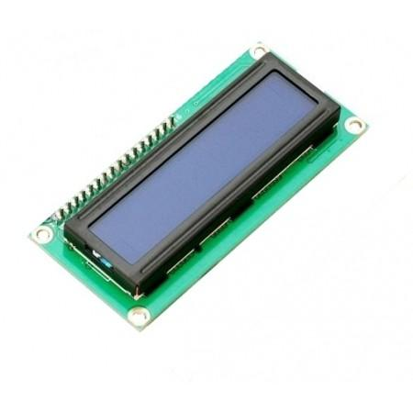

Connecting an LCD to an Arduino without any additional components can be quite challenging. This is because you need to connect approximately nine wires to the Arduino to power the LCD module . This can cause connection problems and also occupies too many pins on the Arduino . You can fix this problem by using the I2C serial communication protocol with an LCD I2C converter board .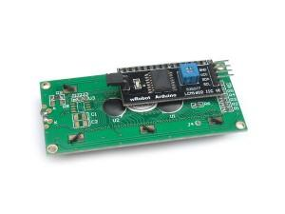

This board allows you to use your LCD with a total of four connections, excluding the power pins. This converter board also includes a potentiometer. This potentiometer allows you to adjust the screen's contrast .

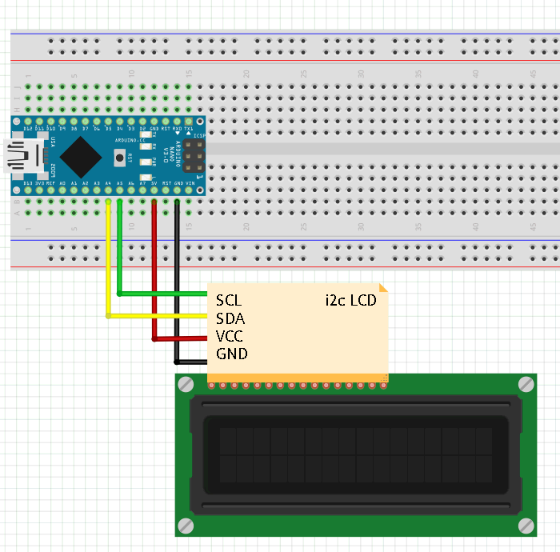

# I 2 C SERIAL COMMUNICATION PROTOCOL

I 2 C (Inter- Integrated Circuit ) is an example of synchronous communication, a type of serial communication. In addition to the ground line, two lines, SDA and SCL, are required for communication.

It is not preferred for long-distance communications. It is generally used in areas where short distances and low data transfer rates are sufficient.

I2C communication, there is a master device that controls the communication . Each communication channel must have a master . To ensure communication , at least one slave device must be connected to the communication line. The master device determines which of the multiple slave devices connected to the line will transmit data . This allows communication with multiple devices without changing the number of lines.

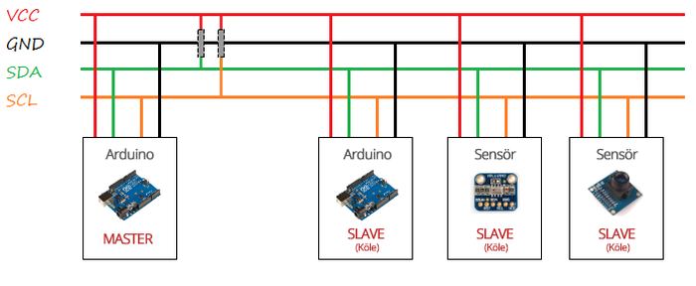

Master and slave devices do not need to be connected to the same power line. However, for communication to occur, the ground lines must be the same. Additionally, SDA ( Serial Data Line ) and SCL ( Serial Data Line) are used for data transfer. There are two communication lines: Clock ( ) and SDA ( ) . Of these lines, SDA is the line that transfers data between devices. This line provides bidirectional data transfer. Synchronization of data transferred along the line is handled by the SCL line. The SCL line contains a clock signal generated by the master device. Communication on the SDA line is regulated by this signal.

To ensure error-free communication throughout the entire line, the SDA and SCL lines should be connected to the VCC line using pull-up resistors. The SDA and SCL pins vary depending on the type of Arduino used. The SDA and SCL pins for each Arduino type are shown in the table below.

| **Arduino type** | **SDA pin** | **SCL pin** |
| --- | --- | --- |
| Arduino Uno | A4 | A5 |
| Arduino Mega | 20 | 21 |
| Arduino Leonardo | 2 | 3 |
| Arduino Due | 20 | 21 |
| **Arduino Nano** | **A4** | **A5** |

# SPI SERIAL COMMUNICATION PROTOCOL

SPI ( Serial Peripheral Interface ) is one of the synchronous serial communication types supported by Arduino . It is similar to I2C in terms of features and usage . It allows an Arduino to communicate with other Arduinos or sensors over short distances. As with I2C , the SPI protocol also has a master device. This device controls the peripheral devices connected to the line.

In) connecting to master and peripheral devices Slave Out ), MOSI (Master Out Slave In ) and SCK ( Serial There are three SPI lines, including Clock .

* **MISO: This is the line where the data sent** from peripheral devices ( slaves ) is transferred to the master device.
* **MOSI: This is the line where** the data sent from the master device is transferred to the peripheral devices .
* **SCK: This is the line containing the clock signal that ensures** synchronization in SPI communication . The clock signal is generated by the master device.

As can be seen from the MISO and MOSI lines, the data lines in the SPI protocol, unlike I2C, are unidirectional. Furthermore, peripheral devices ( slaves ) do not require addresses. Each peripheral device has a selection pin. This pin is called SS ( Slave Select). The number of these pins corresponds to the number of peripheral devices used. A separate SS line originates from the master device for each device . When the SS line is at LOW (0 volts), the peripheral device begins communication with the master device.

pin of the peripheral device it wishes to communicate with to LOW (0 Volts).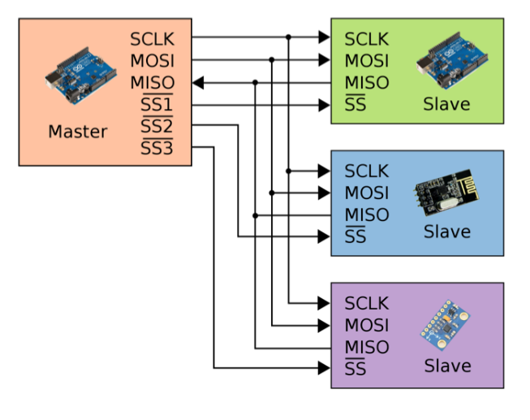

SPI pins vary depending on the Arduino type. These pins are shown in the table below.

| **Arduino type** | **MOSI** | **MISO** | **SCK** | **SS ( slave )** | **SS ( master )** |
| --- | --- | --- | --- | --- | --- |
| **Arduino UNO & NANO** | **11 or ICSP4** | **12 or ICSP1** | **13 or ICSP3** | **10** | **-** |
| Arduino Mega | 51 or ICSP4 | 50 or ICSP1 | 52 or ICSP3 | 53 | - |
| Arduino Leonardo | ICSP-4 | ICSP-1 | ICSP-3 | - | - |
| Arduino Due | ICSP-4 | ICSP-1 | ICSP-3 | - | - |

# I 2 C AND SPI

1. The I2C protocol is immune to short circuits due to its structure. You can short-circuit the I2C pins, separate them, and reuse them, but the SPI pins cannot be short-circuited .
2. SPI is faster because it provides full-duplex communication. However, for this reason, you have to draw a separate line for each slave . I 2 C, on the other hand, provides half-duplex communication with only two lines. It works in duplex mode . Its speed is much lower than SPI . Half In a duplex structure, data cannot be sent and received at the same time.
3. To summarize briefly, the SPI protocol works closer to the hardware, while the I2C protocol works closer to the software.
4. This can be a problem if there's more than one product with the same address on the I2C . For example, if there's more than one of the same sensors, it might be necessary to use an I2C multiplexer like the pca9547.

# SERVO-MOTOR

A servo motor is a type of motor that can rotate between 0 and 180 degrees with a precision of 1 degree. It cannot make a full turn. (For this purpose, a specially produced continuous motor is used.) (Except servos ) It is generally used in applications where precise angles are not required, such as robot arms, where full rotation is not required. The servo motor contains a DC motor. With the help of a gear system connected to the DC motor, the servo shaft can handle a greater load. This process also slows down the servo's rotation speed. The load that servo motors can handle varies depending on the gear system used .

The load a servo can lift is expressed in terms of torque . Servo motor torque is defined as the maximum load a 1 cm rod attached to the motor shaft can lift. Commercially available servos typically have a torque of 1.4 kg/cm . This means that if you have a 1 cm rod attached to your motor shaft and the load at the end of that rod weighs more than 1.4 kilograms, your motor's power won't be sufficient to rotate the shaft. If the rod is 10 cm long, you can lift a maximum of 140 kilograms.

servo motors with high-quality gear systems are also available. The servo motor used in the project should be selected based on the maximum load it will carry.

A servo motor has three connecting cables. These cables are usually red, orange (sometimes yellow), and black (sometimes brown). These colors indicate the cables' functions. Red indicates the power supply (usually 5-volt), while black or brown indicates the ground connection. The remaining orange cable is the data connection, which determines the motor's angle of rotation. Special square wave signals, called PWM, are sent over the data line to determine the motor's rotation angle. A PWM signal is a voltage that is maintained at 5 volts for a specific period and 0 volts for a specific period. The time spent at 5 volts is called the "duty time," and the total time is called the "PWM period." There are specific duty times and PWM periods set for servo motor control . PWM signals outside these settings cannot operate the servo motor properly.

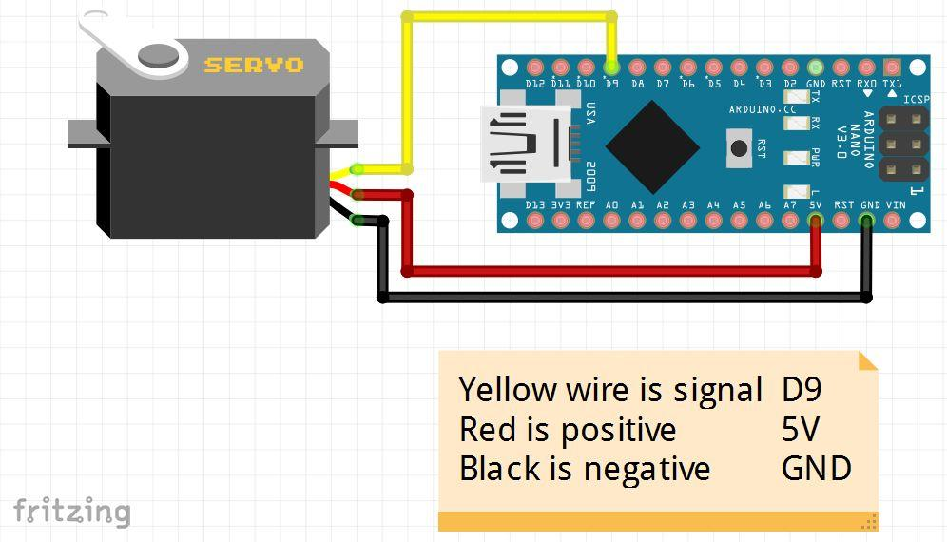

On Arduino There are specialized PWM pins for servo motor control. The number of PWM pins varies depending on the Arduino type. These pins are usually accompanied by a symbol such as a tilde (~). If not, you can find the PWM pins for your specific model from the documentation on the official Arduino website .

# EEPROM

EEPROM is a small storage unit that can hold the variable data we need and can be written to and deleted electrically. We can save our data to the EEPROM , which is internal to the Arduino microprocessor , and reuse it whenever we want.

the Arduino's power is turned off, the data in the EEPROM is not erased. This feature stores the data for the first important tasks the Arduino needs to perform when it starts up. EEPROM storage space varies depending on the type of microprocessor installed on the Arduino . External EEPROMs can also be used to increase memory capacity when this is insufficient .

# Light Dependent Resistor (LDR, Photoresistor)

A photoresistor is an element whose resistance varies depending on the intensity of light falling on it. Its resistance varies inversely proportional to the amount of light falling on it. It is commonly known as a "photocell" in many electronic devices we use daily.

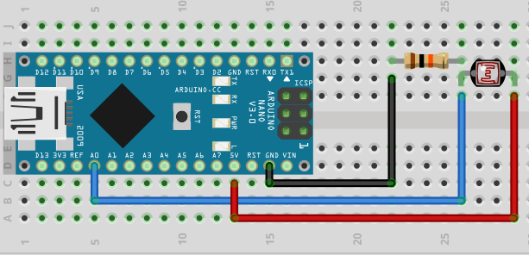

**HC-SR04 ULTRASONIC DISTANCE SENSOR**

Hc-sr04 Ultrasonic sensor sonar (Sound Navigation and Ranging is a source that calculates the distance to an object using communication. The system we call sonar helps us calculate the distance of an object using sound waves.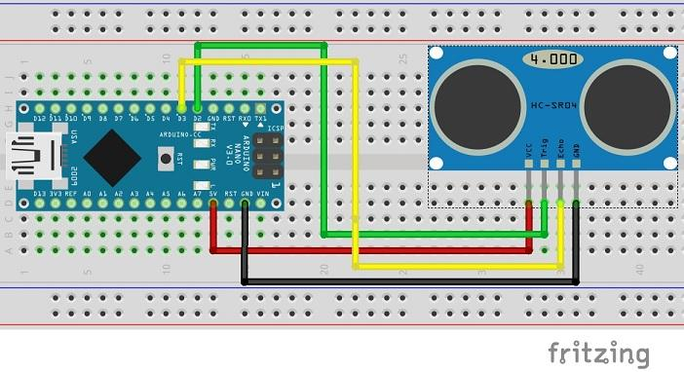

**CIRCUIT DIAGRAM**

