CS224

Section 2

Lab 6

Emrehan Ateş 22003465

**Part A (Dimension of Matrix = 100)**

|  |  |  |  |  |  |
| --- | --- | --- | --- | --- | --- |
| Block Size | 2 | 4 | 8 | 16 | 32 |
| Cache Size |
| 128 | Miss Rate: 97%  Miss Count: 10056 | Miss Rate: 97%  Miss Count: 10030 | Miss Rate: 97%  Miss Count: 10018 | Miss Rate: 97%  Miss Count: 10011 | Miss Rate: 97%  Miss Count: 10008 |
| 256 | Miss Rate: 97%  Miss Count: 10056 | Miss Rate: 97%  Miss Count: 10030 | Miss Rate: 97%  Miss Count: 10018 | Miss Rate: 97%  Miss Count: 10011 | Miss Rate: 97%  Miss Count: 10008 |
| 512 | Miss Rate: 97%  Miss Count: 10054 | Miss Rate: 97%  Miss Count: 10028 | Miss Rate: 97%  Miss Count: 10016 | Miss Rate: 97%  Miss Count: 10009 | Miss Rate: 97%  Miss Count: 10006 |
| 1024 | Miss Rate: 84%  Miss Count: 8654 | Miss Rate: 77%  Miss Count: 7928 | Miss Rate: 97%  Miss Count: 10016 | Miss Rate: 97%  Miss Count: 10009 | Miss Rate: 97%  Miss Count: 10006 |
| 2048 | Miss Rate: 49%  Miss Count: 5054 | Miss Rate: 24%  Miss Count: 2528 | Miss Rate: 76%  Miss Count: 7916 | Miss Rate: 97%  Miss Count: 10009 | Miss Rate: 97%  Miss Count: 10006 |

Tab. 1: Cache data for row major summation

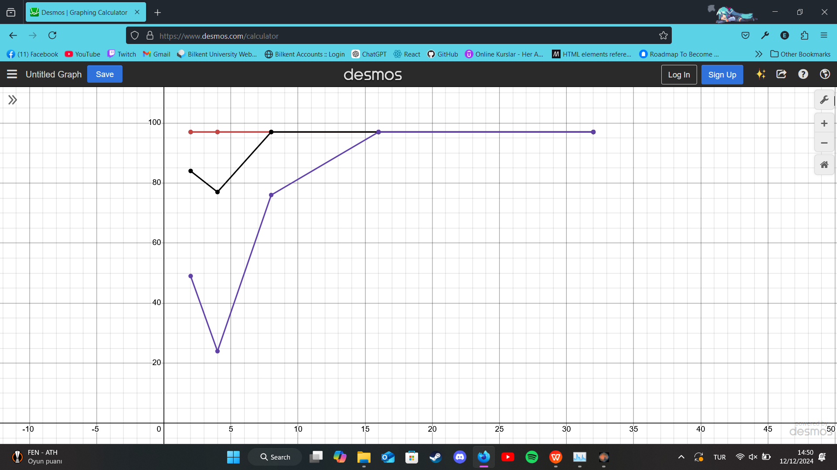

Graph 1: Corresponding graph with miss rate on y-axis and block size on x-axis

Purple is 2048 cache size, black is 1024 cache size, others have the same result

|  |  |  |  |  |  |
| --- | --- | --- | --- | --- | --- |
| Block Size | 2 | 4 | 8 | 16 | 32 |
| Cache Size |
| 128 | Miss Rate: 49%  Miss Count: 5056 | Miss Rate: 24%  Miss Count: 2530 | Miss Rate: 12%  Miss Count: 1268 | Miss Rate: 6%  Miss Count: 636 | Miss Rate: 3%  Miss Count: 321 |
| 256 | Miss Rate: 49%  Miss Count: 5056 | Miss Rate: 24%  Miss Count: 2530 | Miss Rate: 12%  Miss Count: 1268 | Miss Rate: 6%  Miss Count: 636 | Miss Rate: 3%  Miss Count: 321 |
| 512 | Miss Rate: 49%  Miss Count: 5054 | Miss Rate: 24%  Miss Count: 2528 | Miss Rate: 12%  Miss Count: 1266 | Miss Rate: 6%  Miss Count: 634 | Miss Rate: 3%  Miss Count: 319 |
| 1024 | Miss Rate: 49%  Miss Count: 5054 | Miss Rate: 24%  Miss Count: 2528 | Miss Rate: 12%  Miss Count: 1266 | Miss Rate: 6%  Miss Count: 634 | Miss Rate: 3%  Miss Count: 319 |
| 2048 | Miss Rate: 49%  Miss Count: 5054 | Miss Rate: 24%  Miss Count: 2528 | Miss Rate: 12%  Miss Count: 1266 | Miss Rate: 6%  Miss Count: 634 | Miss Rate: 3%  Miss Count: 319 |

Tab. 2: Cache data for column major summation

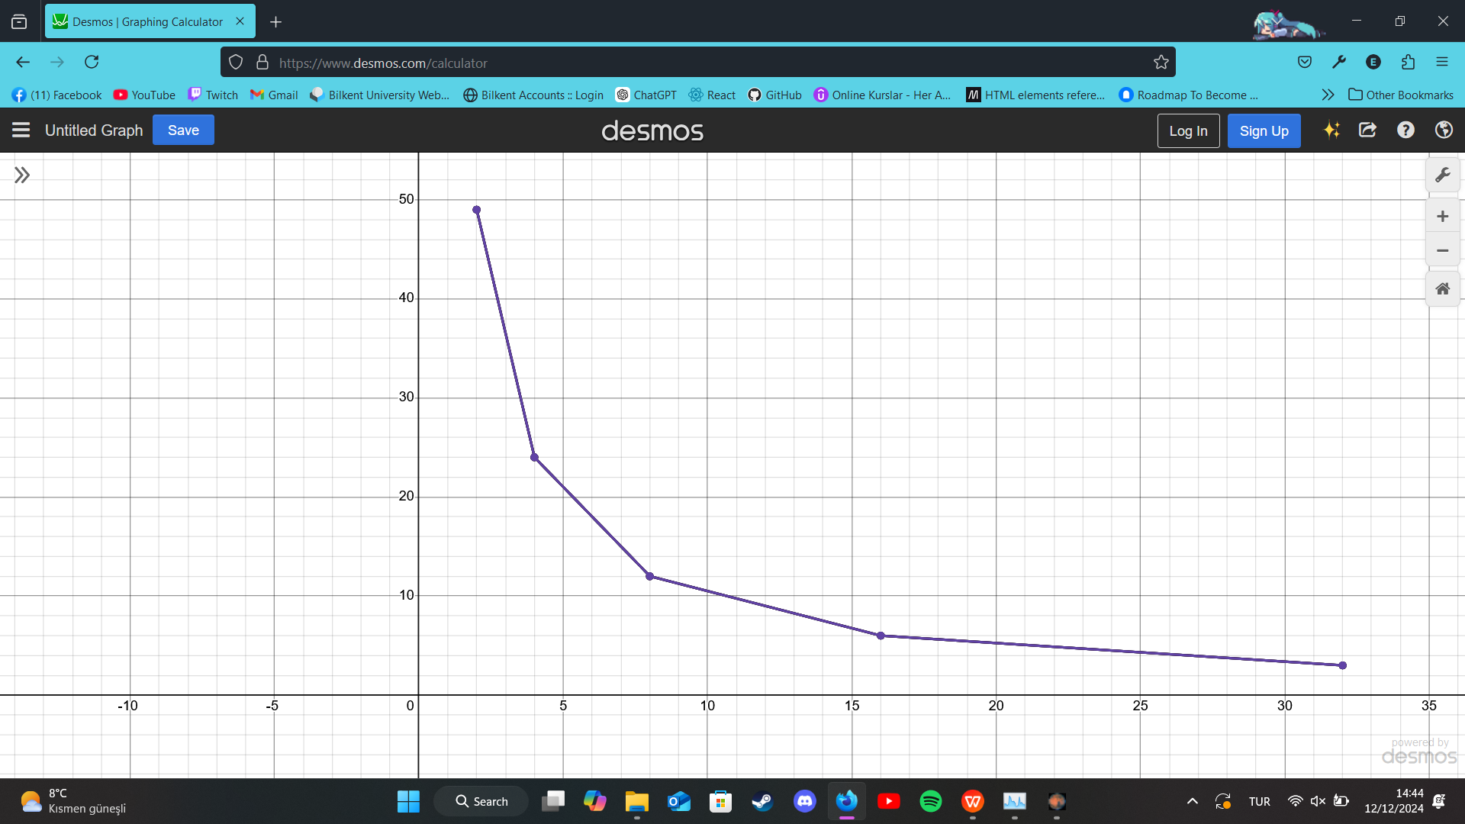

Graph 2: Corresponding graph with miss rate on y-axis and block size on x-axis

(All 5 came as the same so only 1 graph is visible)

**Part B (Dimension of Matrix = 100)**

|  |  |  |  |
| --- | --- | --- | --- |
|  | Good  Cache Size: 2048  Block size: 4 | Mid  Cache Size: 1024  Block size: 4 | Bad  Cache Size: 128  Block size: 4 |
| Fully Associative  with LRU | Miss Rate: 24%  Miss Count: 2528 | Miss Rate: 97%  Miss Count: 10028 | Miss Rate: 97%  Miss Count: 10056 |
| Fully Associative  with Random | Miss Rate: 42%  Miss Count: 4355 | Miss Rate: 73%  Miss Count: 7603 | Miss Rate: 97%  Miss Count: 10056 |
| Direct Map | Miss Rate: 24%  Miss Count: 2528 | Miss Rate: 77%  Miss Count: 7928 | Miss Rate: 97%  Miss Count: 10056 |

Tab. 3: Comparing good-mid-bad results from part A row major sum

**Part C (Dimension of Matrix = 100)**

|  |  |  |  |
| --- | --- | --- | --- |
| Cache Set Size | Good  Cache Size: 2048  Block Size: 4 | Mid  Cache Size: 1024  Block size: 4 | Bad  Cache Size: 128  Block size: 2 |
| 2 | Miss Rate: 32%  Miss Count: 3367 | Miss Rate: 77%  Miss Count: 7933 | Miss Rate: 97%  Miss Count: 10056 |
| 4 | Miss Rate: 36%  Miss Count: 3722 | Miss Rate: 75%  Miss Count: 7751 | Miss Rate: 97%  Miss Count: 10056 |
| 8 | Miss Rate: 39%  Miss Count: 4078 | Miss Rate : 74%  Miss Count: 7693 | Miss Rate: 97%  Miss Count: 10056 |
| 16 | Miss Rate: 40%  Miss Count: 4117 | Miss Rate: 73%  Miss Count: 7593 | Miss Rate: 97%  Miss Count: 10044 |

Tab. 4: Cache results for N-way associative cache

**Part A (Dimension of Matrix = 50)**

|  |  |  |  |  |  |
| --- | --- | --- | --- | --- | --- |
| Block Size | 2 | 4 | 8 | 16 | 32 |
| Cache Size |
| 128 | Miss Rate: 89%  Miss Count: 2556 | Miss Rate: 88%  Miss Count: 2530 | Miss Rate: 88%  Miss Count: 2518 | Miss Rate: 88%  Miss Count: 2511 | Miss Rate: 88%  Miss Count: 2508 |
| 256 | Miss Rate: 77%  Miss Count: 2206 | Miss Rate: 88%  Miss Count: 2530 | Miss Rate: 88%  Miss Count: 2518 | Miss Rate: 88%  Miss Count: 2511 | Miss Rate: 88%  Miss Count: 2508 |
| 512 | Miss Rate: 46%  Miss Count: 1304 | Miss Rate: 63%  Miss Count: 1794 | Miss Rate: 88%  Miss Count: 2516 | Miss Rate: 88%  Miss Count: 2509 | Miss Rate: 88%  Miss Count: 2506 |
| 1024 | Miss Rate: 46%  Miss Count: 1304 | Miss Rate: 39%  Miss Count: 1120 | Miss Rate: 54%  Miss Count: 1540 | Miss Rate: 88%  Miss Count: 2509 | Miss Rate: 88%  Miss Count: 2506 |
| 2048 | Miss Rate: 46%  Miss Count: 1304 | Miss Rate: 39%  Miss Count: 1120 | Miss Rate: 36%  Miss Count: 1028 | Miss Rate: 57%  Miss Count: 1623 | Miss Rate: 88%  Miss Count: 2506 |

Tab. 5: Cache data for row major summation

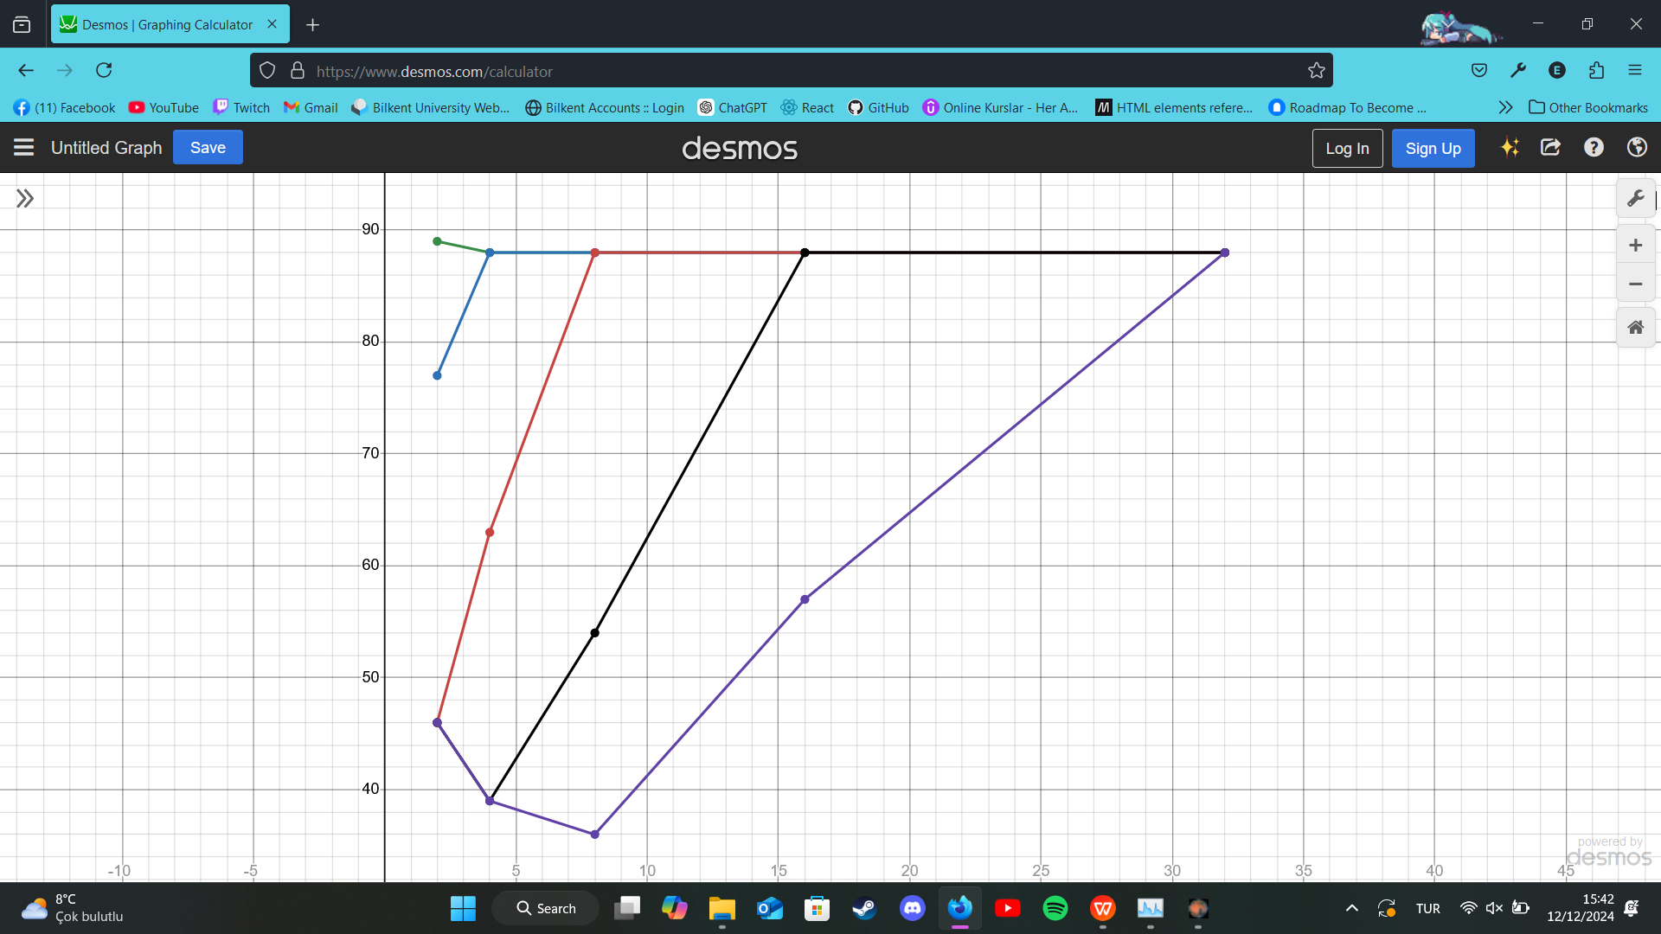

Graph 3: Corresponding graph with miss rate on y-axis and block size on x-axis

Purple-cache size 2048, black-cache size 1024, red-cache size 512, blue-cache size 256, green-cache size 128

|  |  |  |  |  |  |
| --- | --- | --- | --- | --- | --- |
| Block Size | 2 | 4 | 8 | 16 | 32 |
| Cache Size |
| 128 | Miss Rate: 46%  Miss Count: 1306 | Miss Rate: 23%  Miss Count: 655 | Miss Rate: 12%  Miss Count: 331 | Miss Rate: 6%  Miss Count: 168 | Miss Rate: 3%  Miss Count: 87 |
| 256 | Miss Rate: 46%  Miss Count: 1306 | Miss Rate: 23%  Miss Count: 655 | Miss Rate: 12%  Miss Count: 331 | Miss Rate: 6%  Miss Count: 168 | Miss Rate: 3%  Miss Count: 87 |
| 512 | Miss Rate: 46%  Miss Count: 1304 | Miss Rate: 23%  Miss Count: 653 | Miss Rate: 11%  Miss Count: 329 | Miss Rate: 6%  Miss Count: 166 | Miss Rate: 3%  Miss Count: 85 |
| 1024 | Miss Rate: 46%  Miss Count: 1304 | Miss Rate: 23%  Miss Count: 653 | Miss Rate: 11%  Miss Count: 329 | Miss Rate: 6%  Miss Count: 166 | Miss Rate: 3%  Miss Count: 85 |
| 2048 | Miss Rate: 46%  Miss Count: 1304 | Miss Rate: 23%  Miss Count: 653 | Miss Rate: 11%  Miss Count: 329 | Miss Rate: 6%  Miss Count: 166 | Miss Rate: 3%  Miss Count: 85 |

Tab. 6: Cache data for column major summation

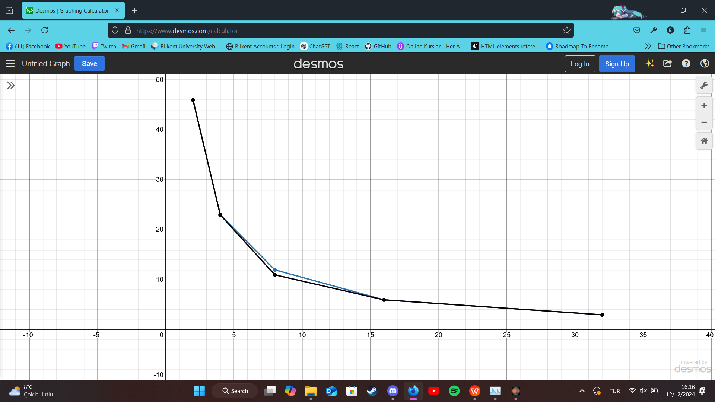

Graph 4: Corresponding graph with miss rate on y-axis and block size on x-axis

Blue is for cache sie 128 and 256 , black is for other 3 cache sizes

**Part B (Matrix dimension = 50)**

|  |  |  |  |
| --- | --- | --- | --- |
|  | Good  Cache Size: 2048  Block size: 8 | Mid  Cache Size: 1024  Block size: 8 | Bad  Cache Size: 128  Block size: 2 |
| Fully Associative  with LRU | Miss Rate: 13%  Miss Count: 366 | Miss Rate: 88%  Miss Count: 2516 | Miss Rate: 89%  Miss Count: 2556 |
| Fully Associative  with Random | Miss Rate: 28%  Miss Count: 802 | Miss Rate: 63%  Miss Count: 1812 | Miss Rate: 87%  Miss Count: 2495 |
| Direct Map | Miss Rate: 36%  Miss Count: 1028 | Miss Rate: 54%  Miss Count: 1540 | Miss Rate: 89%  Miss Count: 2556 |

Tab. 7: Comparing good-mid-bad results from part A row major sum

**Part C (Matrix dimension = 50)**

|  |  |  |  |
| --- | --- | --- | --- |
| Cache Set Size | Good  Cache Size: 2048  Block Size: 8 | Mid  Cache Size: 1024  Block size: 8 | Bad  Cache Size: 128  Block size: 2 |
| 2 | Miss Rate: 25%  Miss Count: 710 | Miss Rate: 62%  Miss Count: 1773 | Miss Rate: 88%  Miss Count: 2525 |
| 4 | Miss Rate: 24%  Miss Count: 700 | Miss Rate: 63%  Miss Count: 1818 | Miss Rate: 87%  Miss Count: 2503 |
| 8 | Miss Rate: 26%  Miss Count: 742 | Miss Rate : 63%  Miss Count: 1793 | Miss Rate: 88%  Miss Count: 2513 |
| 16 | Miss Rate: 27%  Miss Count: 777 | Miss Rate: 62%  Miss Count: 1783 | Miss Rate: 87%  Miss Count: 2496 |

Tab. 8: Cache results for N-way associative cache