# Report on the subject

# Local Culture

# Theme:

# Claudie Haigneré

# Emre Ozan Alkan

# Natalia Shepeleva

“I do not think that there is only one key to open the ***door*** in the future. For me there are lots of ***doors***, lots of opportunities, you just should not be afraid and take risks and push all these ***doors***”

Claudie Haignere

# Door 1. First steps

Claudie Haignere (formerly Claudie Andre-Deshays) – known as a French doctor, politician and astronaut – was born on 13 May 1957, in Le Creusot, Saone-et-Loire, in the Burgundy region of France. She studied medicine at the Faculte de Medecine (Paris-Cochin) and Faculte des Sciences (Paris-VII). In 1982, she obtained certificates in aviation and space medicine. However, it was only start of her career. In 1984, Claudie ended her education in biology and sports medicine and in rheumatology. In 1986, she received a diploma in the biomechanics and physiology of movement. End-point in her medical career were PhD thesis in neuroscience in 1992. [1]

From 1984 to 1992, she worked in the Rheumatology Clinic and Rehabilitation Department at Cochin Hospital in Paris: research and application of diagnostic and therapeutic techniques in rheumatology and sports traumatology. From 1985 to 1990, Claudie also worked in the Neurosensory Physiology Laboratory at the Centre National de la Recherche Scentifique in Paris.

Her research period started in 1988 when she was involved in development of scientific experiments in the field of human physiology in particular with the “Physalie” and “Viminal” experiments flown on the Franco-Soviet “Aragatz” mission to the Mir station. Human adaptation of motor and cognitive systems in weightlessness was selected as a research topic. [2]

# Door 2. Woman – astronaut

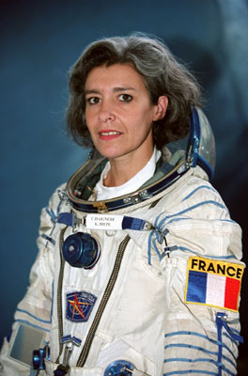Claudie Haignere was selected as a French candidate astronaut in 1985 by CNES, the French Space Agency. From 1990 to 1992, she was responsible for French and international space physiology and medicine programs in the CNES Life Sciences Division in Paris. From 1989 to 1992, Claudie was responsible for scientific coordination of the life sciences experiments aboard the Franco-Russian “Antares” mission, which took place in 1992. In October 1992, she was assigned back-up cosmonaut to Jean-Pierre Haignere for the Franco-Russian “Altair” mission from 1st to 22nd of July 1993.

During this mission, Claudie Haignere was responsible for monitoring the biomedical experiments as a member of the ground team at the Mission Control Centre in Kaliningrad near Moscow. In December 1994, she was assigned to the “Cassiopee” mission as Research Cosmonaut and started training in Star City near Moscow on 1 January 1995.

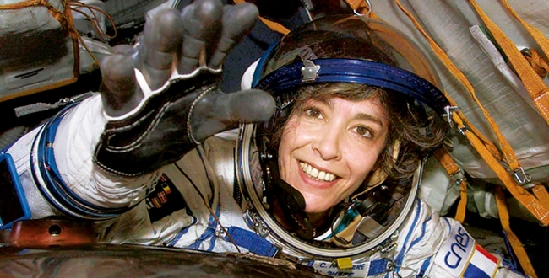

The 16-day mission took place from 17 August to 2 September 1996. Claudie Haignere became the first Frenchwoman in space! However, it was not her first meeting with space. In an interview on the European Space Agency Website, Haignere confessed:

"I looked at the image on the TV screen and then at the moon in the sky. Something inaccessible, that had been just a dream, suddenly became a reality. A door was open. I did not immediately imagine that it was open for me, but the lunar landing gave me a taste for space. I read a lot about the conquest of space, watched every documentary. But I chose to become a doctor - and I was working as a medical professional when my dream became possible" [3]

In July 1999, she became the first woman to qualify as a Soyuz Return Commander, so that she can now command a three-person Soyuz capsule during its return from space.

Furthermore, Claudie Haignere became the first European woman to visit the International Space Station, as part of the “Andromede” mission. She retired from ESA on 18 June 2002.

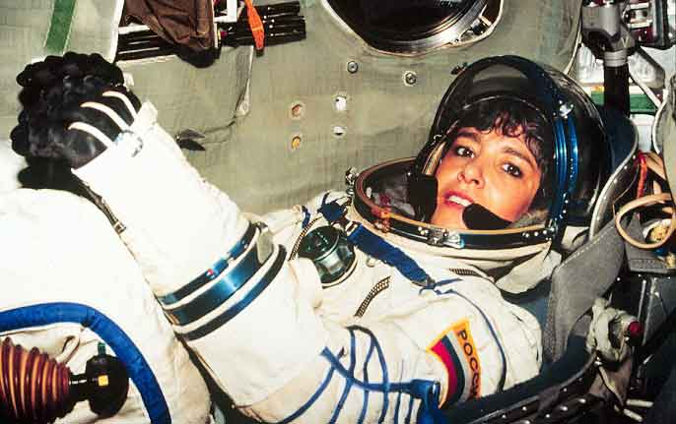

# Door 3. Family

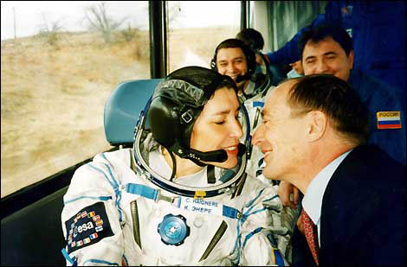

In 1993 Claudie met with Jean-Pierre Haigneré in Star City near Moscow during workouts. Jean-Pierre was a test pilot and in 1985 join became an astronaut National Center for Space Studies. He was a main crewmember and she was a backup crewmember in Altair missions to the station "Mir".

In 1997 they were married. They have one daughter Karla-Anastasia who was born on February 12, 1998.

On September 20, 2001 at Le Creusot Jean-Claude Merlin discovered a Main-belt asteroid. In honor of marriage of the couple, the asteroid was named 135268 Haignere. [4]

To the reporter's question “What is easier: fly into space by yourself or accompany your wife there?” Jean-Pierre admits:

“To be a couple and prepare for a space flight is hard. Need to understand who I am, what role I play now. For myself, I was not afraid in case of emergencies, because that is my profession. But when I'm on Earth, and I know about all the dangers facing Claudie, I have to weigh how important it is for a man to fly in space and whether you need to take risks with your love” [5]

# Door 4. Woman – political

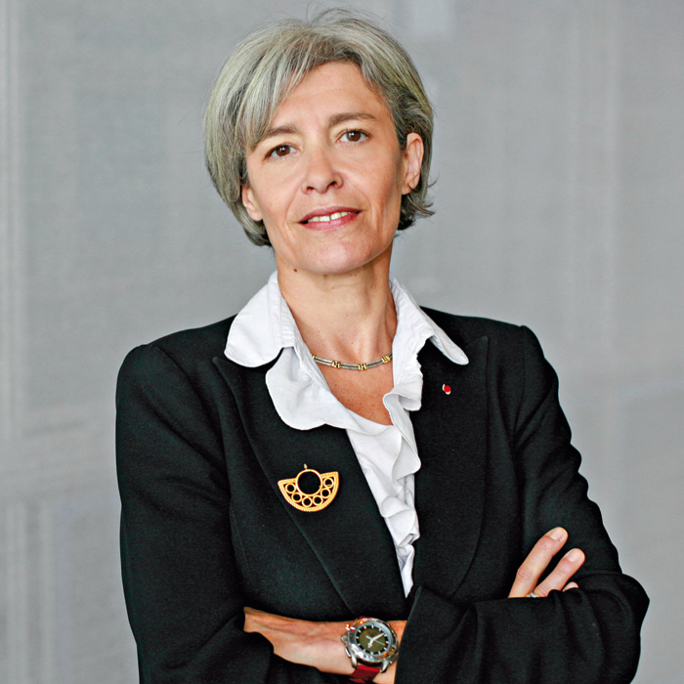

In June of 2002, Claudie Haignere’s career took a different path, when the conservative government of French President Jacques Chirac and Prime Minister Jean-Pierre Raffarin gave her a new mission. The French Prime Minister appointed her, from June 2002 to April 2004, to the post of Minister for Research and New Technologies. Her biggest challenge was to boost the space program and the importance of France’s presence in space while the government was tackling serious budgetary constraints. Claudie Haignere was viewing her new position as apolitical:

“For me, science is not something left-wing or right-wing” [6]

Claudie urged her country to make research careers more attractive. She served in the French Government as Minister for European Affairs and Secretary General for Franco-German Cooperation, from April 2004 to June 2005.

Since November 2005, Claudie Haignere has been employed by ESA as Adviser to the Director General. In this role, she was responsible for European space policy, and participated in the elaboration of ESA’s strategic direction and its adaptation to changes in the geopolitical environment both at international and European level.

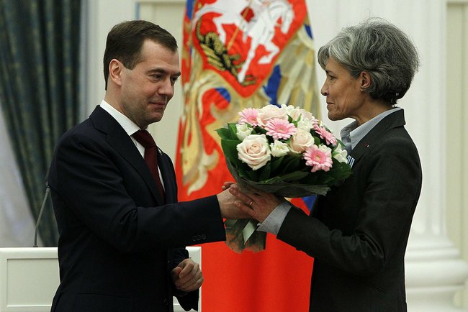

Besides politics, Claudie Haignere had influence in different areas. She was the board member of the Academie des Technologies, the Cite des Sciences et de l’Industrie, the Fondation C. Genial, the Fondation Lacoste, France Telecom, and the Fondation d’Enterprise l’Oeral; was a member of the Academie des Technologies, the Academie de l’Air et de l’Espace, the Academie des Sports, and Vice-President of the IAA (Internaional Academy of Astronautics) and was also Chair of the Grand Jury of the Descartes Prize for European Research. [6]

# Door 5. No exit?

December 24, 2008. Newspapers carried headlines “The first French woman astronaut tried to commit suicide”.

“51-year-old woman found in a semiconscious state of her family, who returned home later than usual: doing holiday shopping. Immediately to the apartment in the 13th district of Paris called "first aid". . . Doctors have established: Claudie Haignere took a life-threatening dose of medication. On-site emergency measures were taken. Received after this agreement astronaut hospitalization, she was taken to one of the best Paris hospital of Val-de-Grâce” [7]

The day after the accident, her husband Jean-Pierre made a statement:

“It is not a suicide attempt. She had a problem, she was in a stressful situation, and she wanted to sleep and took medications that are counter to her. We can talk about an error in dosage when trying to sleep with sedatives, but not the desire to commit suicide. I am convinced that Claudie had not intended to commit suicide” [8]

However, what was the reason of this act? Was it an error in dosage or deliberate intention to commit suicide? Even now, it remains a mystery. Some journalist were talking about problems in a family. However, maybe it was connected with her professional activities? According to the Claudie Haignere words she just burn out.

# Door 5. Nowadays

Since 2009 Claudie Haigneré starts to promote of science among young people. Especially she pays particular attention to the involvement of young women in engineering sciences.

In one of the interview, Jean-Pierre Raffarin said such words:

“In front of me was a woman-fighter. I could see that she knows what she wants. Sometimes she was suffering from an uncompromising policy. She was perfect minister who worked for the public good” [9]

So we hope now that this door would not be the last one in the life of Claudie Haignere. And no matter she was doing in her life, a brilliant success will wait for her.

# References:

1. Claudie Haigneré – <https://en.wikipedia.org/wiki/Claudie_Haigner%C3%A9>
2. Claudie Haigneré (formerly André-Deshays) – <http://www.esa.int/Our_Activities/Human_Spaceflight/Astronauts/Claudie_Haignere_formerly_Andre-Deshays>
3. "An Interview with Claudie Haigneré" – <http://www.esa.int/export/esaHS/ESA2CU0VMOC>
4. 135268 Haigneré – <https://en.wikipedia.org/wiki/135268_Haigner%C3%A9>
5. Поцелуй Клоди – <http://2001.novayagazeta.ru/nomer/2001/78n/n78n-s12.shtml>
6. Claudie Andre–Deshays Haigneré – <http://www.answers.com/topic/claudie-haigner>
7. Первая французская космонавтка Клоди Эньере пыталась покончить с собой – <http://www.rg.ru/2008/12/25/samoubiistvo.html>
8. Муж французской женщины-космонавта Клоди Эньере отрицает, что она пыталась свести счеты с жизнью – <http://www.newsru.com/world/25dec2008/husband_klodi.html>
9. Как образование меняет жизнь женщины – <http://ru.euronews.com/2013/03/08/100-years-after-launch-of-international-women-s-day-the-struggle-continues/>