Introduction to Information Systems

CRN:12289
Name:Emre
Surname:Özdil
ID:150120138

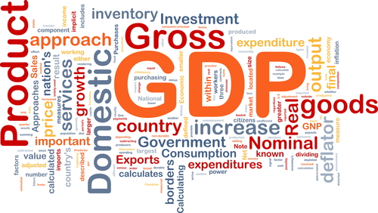
Gross Domestic Product

Table of Contents
1)Introduction 3
1.1)Reason for Report 3
1.2)Brief Description of the Data 3
1.3)Relevant High-level Questions about the Data 3
2)Methods 3
2.1)The formula of Average 3
2.2)The formula of sum 4
2.3)Sketch the Chart 4
3)Results and Conclusions 5

1)Introduction

1.1)Reason For Report
This report was preapared to compare gross domestic product of G8 countries.

1.2)Brief Description Of The Data
The data includes gross domestic product of G8 countries in between 2008 and 2010.

1.3)Relevant High-level Questions About The Data
- Which country did have the most gross domestic product?
- Which country did have the least gross domestic product?
- Which year did have the most gross domestic product?
- Which year did have the least gross domestic product?
- How much were total gross domestic product of G8 countries?

2)Methods

2.1)The Formula Of Average
The table indicate that gross domestic product of France year by year and average gross domestic product from 2008 to 2010.
Country | Years | Value | Value(US dolar)
France | 2008 | 1.933.195.000.000 € | $2.419.393.542.500
France | 2009 | 1.885.763.000.000 € | $2.360.032.394.500
France | 2010 | 1.936.720.000.000 € | $2.423.805.080.000
France | 2008-2010 | 1.918.559.333.333 € | $2.401.077.005.666
Table1

2.2)The Formula Of Sum
The table indicate what was the total gross domestic product of G8 countries.
Country | Value(US dolar)
Canada | $1.444.276.512.000
France | $2.423.805.080.000
Germany | $3.123.994.300.000
Italy | $1.942.184.838.632
Japan | $4.389.698.040.000
Russian Federation | $1.157.713.530.000
United Kingdom | $2.341.964.036.100
United States | $14.419.400.000.000
Total | $31.243.036.336.732
Table2: Gross Domestic Product in 2010

2.3)Sketch The Chart
I used the chart toshow how much were the total gross domestic product for every country.

3)Results and Conclusions
- It can be seen from the Chart 1 that United States has the most gross domestic product and, Russian Federation has the least gross domestic product.
- 2010has the most gross domestic product, and 2009 has the least gross domestic product.
- Table 2 indicate that the total gross domestic product of G8 countries are $31.243.036.336.732 in 2010.
- World Gross Domestic Product Chart is smilar to my data.

Click for link.

