EE 470

Plant Disease Classifica on Challenge

by
Ali Baki TÜRKÖZ
Emre ÖZTÜRK


Faculty of Engineering
Department of Electrical and Electronics Engineering
Istanbul, 2024
Yeditepe University

ABSTRACT

Plant Disease Classifica on Challenge

Cassava (Manihot esculenta) is regarded as a crucial food crop by millions of individuals worldwide, particularly in developing nations. Nevertheless, its cultivation encounters significant hurdles attributed to a spectrum of diseases that adversely affect both yield and quality. Among these maladies, cassava mosaic disease (CMD), cassava brown streak disease (CBSD), cassava bacterial blight (CBB), cassava green mottle disease (CGMD), along with other pathogens, represent formidable threats to global food security.
In this project, an automated system is endeavored to be developed for the early detection and classification of cassava diseases, employing deep learning techniques. Harnessing a dataset comprising 10,965 meticulously curated images of both healthy and diseased cassava leaves, sophisticated image classification algorithms are employed to meticulously discern and differentiate various disease symptoms. The primary objective is to fabricate a resilient model proficient in categorizing cassava leaf images into five distinct classifications: healthy, CMD, CBSD, CBB, and CGMD.
By capitalizing on the synergy between mobile technology and machine learning, this project endeavors to furnish farmers with a tool conducive to expedited disease diagnosis and informed management decisions. Through the implementation of this system, the aspiration is to ameliorate yield losses, enhance crop health surveillance practices, and ultimately foster advancements in food security and agricultural sustainability.

Table of Contents
ACKNOWLEDGEMENTS 2
ABSTRACT 3
LIST OF FIGURES 5
LIST OF TABLES 6
LIST OF SYMBOLS/ABBREVIATIONS 7
INTRODUCTION 1
LITERATURE REVIEW 2
PROPOSED WORK 3
EXPERIMENTAL RESULTS 4
CONCLUSION AND FEATURE WORK 5
REFERENCES 6
APPENDIX A......................................................................................................................17
APPENDIX B......................................................................................................................18

LIST OF FIGURES

Figure 3.1 Caption about first image 10
Figure 3.2 Caption about multiple images. (a) First of multiple image, (b) Second of multiple image, (c) Third of multiple image. 11
Figure 3.3 Growth curves of the wild type (AS102) and recombinant AS102-57 11

LIST OF TABLES

Table 3.1 Sequence of the preliminary 5
Table 3.2 Caption about table 10

LIST OF SYMBOLS/ABBREVIATIONS

A | System matrix
B | Input matrix
G | Plant transfer matrix
G₁ | Plant disturbance matrix
R | A closed and bounded region in E
δR | Boundary of the region R
δR^{s} s=1,…,p | Complementary regular subsurface of the boundary δR, s being a positive scalar
T | Sampling time
U | Control Input
x_{c} | Controller state vector
α_{c,} α_{e} | Controller and estimator characteristics polynomials
Г | Discrete plant control input matrix
Г₁ | Discrete plant noise input matrix
λ | Plant delay time or transportation lag
ADD | Average detection delay
ASN | Average sample number
i.i.d. | independently and identically distributed
JACS | Journal of American Chemical Society

INTRODUCTION
Cassava production, especially in Zambia, is predominantly carried out by small-scale farmers. The Northern region of the country constitutes the majority (78.8%) of production, alongside Luapula and North-Western provinces. In recent years, cassava production has tripled, rising from 360,000 tons in 1985 to 1,114,000 tons in 2013. This increase can be attributed to the withdrawal of maize subsidies, with Zambia consistently producing over 1 million tons of cassava annually since 2005. Yields vary between traditional and improved varieties, with yields ranging from 1 t/ha for traditional varieties to 2–3.5 t/ha for improved ones. However, Zambia's average cassava yield stands at 5.8 t/ha, below the continental average of 8.4 t/ha (Chikoti et al., 2019).

Cassava Mosaic Disease (CMD) is widely regarded as the predominant viral disease in Zambia and is also prevalent in neighboring countries such as Tanzania, Malawi, the Democratic Republic of Congo, Zimbabwe, Mozambique, and Angola. Symptoms include leaf lamina distortion, chlorotic mosaics, and a general decrease in plant size. Variability in symptoms is observed due to seasonal and varietal differences among farmers. Studies have highlighted severe symptoms in plants infected with African Cassava Mosaic Virus (ACMV) and East African Cassava Mosaic Virus (EACMV) in Zambia (Chikoti et al., 2019).

Furthermore, Cassava Mosaic Disease (CMD) is generally acknowledged as the most significant disease causing yield loss in cassava. Included in the top 10 plant virus pathogens published by Molecular Plant Pathology in 2011, this disease has seen some pivotal milestones, from its first report to the role of recombination and mixed infections in the evolution of multiple cassava-infecting begomovirus species and strains (Rey & Vanderschuren, 2017).

Another cassava disease emerging over the last decade, Cassava Brown Streak Disease (CBSD), poses a risk to food security and is a significant threat to the cassava value chain. Plants carrying this disease risk rendering their storage roots inedible due to low quality and palatability, leading to total crop loss (Rey & Vanderschuren, 2017).

Bacterial Blight infections, on the other hand, are most conspicuous towards the end of the rainy season and the beginning of the dry season. Initial observations should focus on abnormal leaf shedding and drying of leaves still attached to the stem. Symptoms include angular leaf spots, blighted areas, dark-brown to black streaks on the green part of the stem, bark swellings, and gummy exudates. Inspections for vascular browning should be carried out by cutting the outer bark between wilted leaves and exudates (Xanthomonas axonopodis pv. manihotis (cassava bacterial blight) | CABI Compendium (cabidigitallibrary.org)).

Another disease type, Cassava Green Mottle Disease (CGMD), is caused by the Cassava Mosaic Virus (CMV) transmitted by whiteflies, affecting cassava plant leaves. Symptoms include green or yellow patches on leaves, distorted leaf growth, and reduced plant growth, with severe cases leading to plant death (Cassava green mottle virus - Wikipedia).

With the global human population projected to surpass 9 billion by 2050, necessitating a 70% increase in food production, addressing challenges in crop health management, particularly for staple crops like cassava, is imperative. Leveraging technologies such as deep learning-based algorithms for disease diagnosis from images holds promise in empowering farmers to mitigate losses and enhance productivity, contributing to broader objectives of food security and sustainable agriculture.
Moreover, leveraging advancements in technology, particularly in the realm of artificial intelligence and image processing, holds promise for revolutionizing disease diagnosis in agriculture. In this context, the development of a deep learning-based algorithm to classify cassava leaf diseases from images represents a significant stride towards precision agriculture. By utilizing a dataset comprising 10,965 meticulously curated images of healthy and diseased cassava leaves, the aim is to achieve high accuracy in disease identification.

The project entails training various image classification algorithms and rigorously evaluating their performance on unseen samples. Ultimately, the goal is to identify the most effective model for practical application in real-world scenarios. Early and accurate disease diagnosis facilitated by such technology can empower farmers, particularly those in resource-limited settings, to take timely and appropriate measures to manage crop health efficiently.

Addressing the critical challenge of cassava disease diagnosis not only enhances food security but also supports sustainable agricultural practices. By minimizing yield losses due to diseases such as Cassava Mosaic Disease (CMD), Cassava Brown Streak Disease (CBSD), Bacterial Blight, and Cassava Green Mottle Disease (CGMD), farmers can optimize productivity and ensure a stable food supply.

In conclusion, the successful implementation of advanced technologies in agriculture, coupled with robust research efforts and knowledge dissemination, holds the key to tackling the looming challenges posed by population growth and climate change. By harnessing the power of artificial intelligence and data-driven approaches, we can usher in a new era of sustainable and resilient agriculture, ensuring food security for future generations.

LITERATURE REVIEW

In the study conducted by Ozichi et al. (2019) and colleagues, machine learning models were proposed for the detection and classification of cassava leaf diseases as blight or mosaic disease. The Cubic Support Vector Machine (CSVM) model was utilized to classify whether a leaf is healthy, while the Coarse Gaussian Support Vector Machine (CGSVM) algorithm was employed to classify the type of disease. An accuracy rate of 83.9% was achieved in predicting the health status of the leaf through the application of the CSVM model, whereas an accuracy rate of 61.6% was obtained in classifying the disease as Blight or Mosaic using the CGSVM algorithm.

In the study conducted by Mrisho et al. (2020), a deep learning approach was employed for image-based cassava disease detection using a dataset of cassava disease images taken in a field in Tanzania. Transfer learning was utilized to train a deep convolutional neural network to identify three diseases and two types of pest damage. The highest accuracy rates achieved by the best-trained models were 98% for brown leaf spot (BLS), 96% for red mite damage (RMD), 95% for green mite damage (GMD), 98% for cassava brown streak disease (CBSD), and 96% for cassava mosaic disease (CMD). An overall accuracy of 93% was achieved for data not used in the training process. While the study employed a deep learning approach to achieve an overall accuracy of 93% compared to traditional machine learning approaches, and utilized transfer learning which offers a fast, affordable, and easily deployable strategy for digital plant disease detection, it failed to address the occurrence of cassava bacterial blight disease.

A project was undertaken by Metlek (2021, #) aiming to classify healthy and four different plant diseases from cassava plant leaf images. For this purpose, the "Cassava Leaf Disease Classification" dataset, which was a current and challenging dataset published in 2020, was utilized. The dataset used comprised a total of 21,397 images consisting of healthy leaves and four different diseases. In the study, the images were initially subjected to the Chan-Vese (CV) Segmentation method in the MATLAB environment to determine the regions of interest. Features were then extracted from the identified regions using deep learning architectures such as ResNet 50 and MobileNetV2. The extracted features were classified using Support Vector Machine and K-Nearest Neighbor algorithms. The images were divided into two groups, namely training and testing, according to the K-fold 5 value. Average highest success rates in training and test data were achieved, with success rates of 85.4% and 84.4%, respectively.

PROPOSED WORK

Cassava is the most popular commercial and industrial crop in Africa and Thailand, primarily due to favorable environmental conditions and soil quality in these regions. However, cassava plants face various challenges such as leaf diseases and fungal infections, leading to decreased production and increased costs. Continuous monitoring of plant diseases in the production environment is economically and physically unfeasible for producers.

Early diagnosis and classification of plant diseases, particularly using non-destructive methods, are crucial. However, taking preventive measures against these diseases is vital for producers. In recent years, significant advancements have been made in techniques for rapid and reliable detection of pathogens, emphasizing the importance of optimizing sample extraction for detection. Therefore, it's crucial to develop practical technologies for real-time disease monitoring that farmers can utilize.

Research has been conducted globally to address this issue. Previous methods of disease detection required manual inspection and diagnosis of plants, followed by annotation by experts. However, this method is labor-intensive and costly in terms of both money and time, especially for farmers in regions with limited access to high-quality cameras and bandwidth.

The aim is to classify each cassava image from the obtained dataset into four common disease categories (Cassava Mosaic Disease (CMD), Cassava Bacterial Blight (CBB), Cassava Green Mottle (CGM), Cassava Brown Streak Disease (CBSD)), or as a healthy specimen. This enables farmers to quickly diagnose affected plants and save their crops from permanent damage without the need for expert intervention. In this context, various imaging techniques have been developed for the detection of diseases caused by various factors in plants.

Recently, there has been a revolution in agriculture automation. Therefore, the introduction of groundbreaking technologies like Artificial Intelligence (AI) plays a significant role in increasing agricultural productivity, particularly in areas such as image processing for detecting cassava leaf diseases.

The chapter describes the evolution of various neural network techniques used in classification and prediction, emphasizing the significance of using Convolutional Neural Network (CNN) over deep neural networks. It focuses on classifying leaf diseases in cassava plants using images acquired from datasets.

3.1. Disease Categories

Four common disease classes that affect the cassava crop are discussed below (Figure 1). Our ultimate goal is to automatically categorize these infections using a deep learning model that interprets the signs and symptoms arising from these distinct diseases.
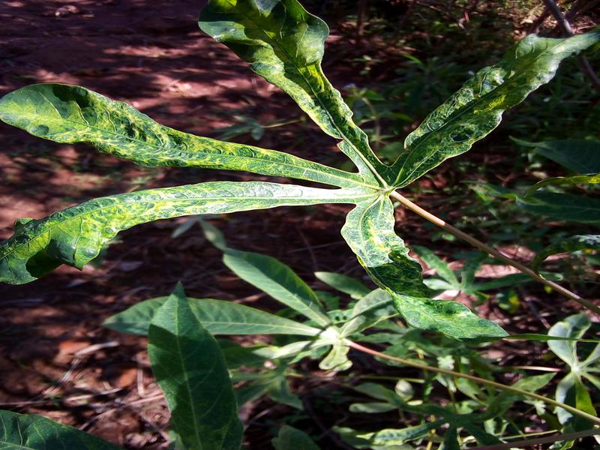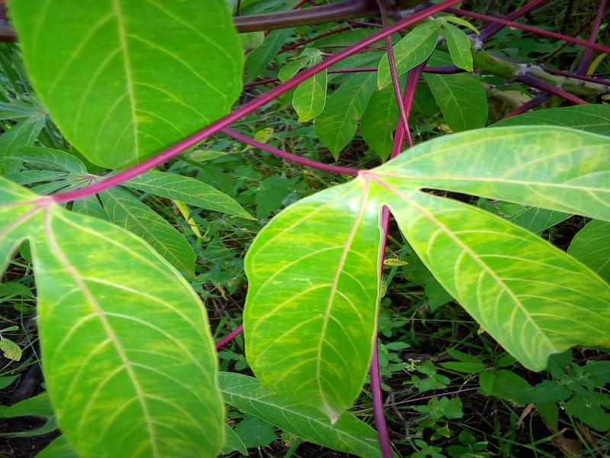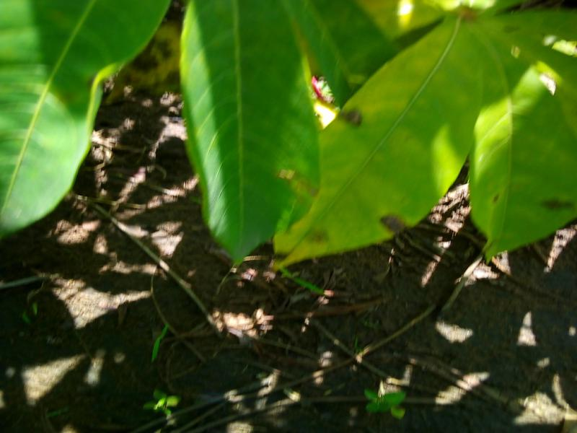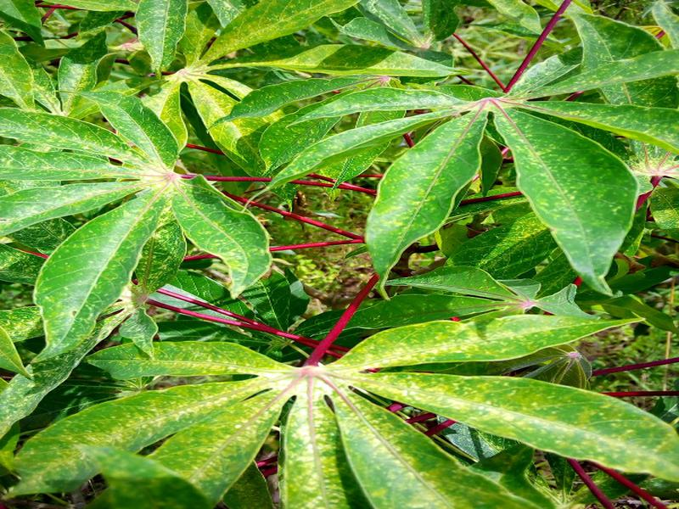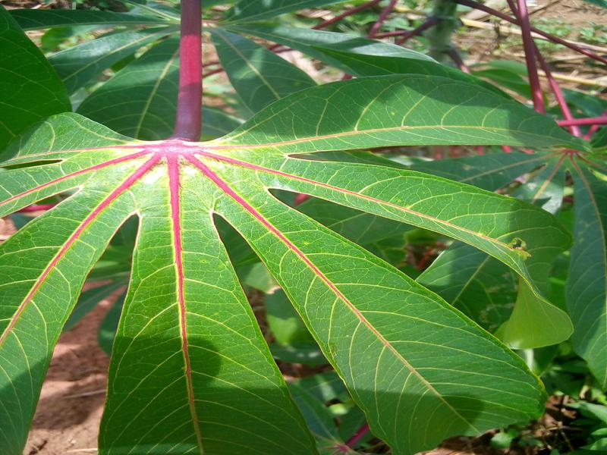
CMD CBSD CBB CGMD Healthy
Figure 1. Classes of train dataset
Label Name | Count
Cassava Bacterial Blight (CBB) | 987
Cassava Brown Streak Disease (CBSD) | 2089
Cassava Green Mottle (CGM) | 2286
Cassava Mosaic Disease (CMD) | 3126
Healthy (Ht) | 2477
Table 1. Classes in the train Dataset
Cassava Bacterial Blight (CBB)
Cassava Bacterial Blight (CBB), as the name suggests, is a bacterial disease that affects the crop. It is favored by moist environmental conditions. Depending on the aggressiveness of the bacterial strains, the crop's location, season, etc., the severity of the disease's symptoms can vary. This causes leaves to wilt and fall prematurely when the infection becomes severe.
The basic features to be used for classification are black and angular spots and dried, fallen leaves(Figure).
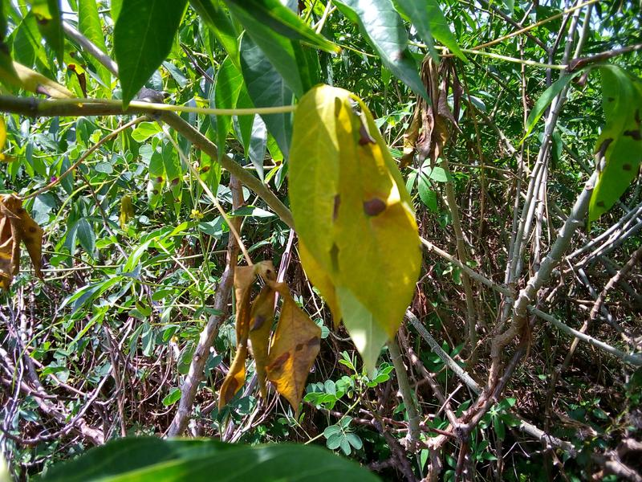
Figure: Example of CBB black and angular spots and dried, fallen leaves
Cassava Brown Streak Disease (CBSD)
CBSD adversely affects the cassava plant. Whiteflies, arguably the most damaging insect pests, are vectors of the virus. CBSD is also transmitted through infected cuttings. In the early stages of infection, symptoms of CBSD appear as yellow striped patches amidst the usual green color. Over time, these yellow spots grow and merge to form larger yellow spots, and the leaves become mottled. Another symptom is the formation of brown lines on the stem of the plant. If the infection becomes severe, it can also cause growth arrest and plant rot.

The basic features to be used for classification are yellow spots, dark streaks on the stem, and stunted leaves/roots(Figure).
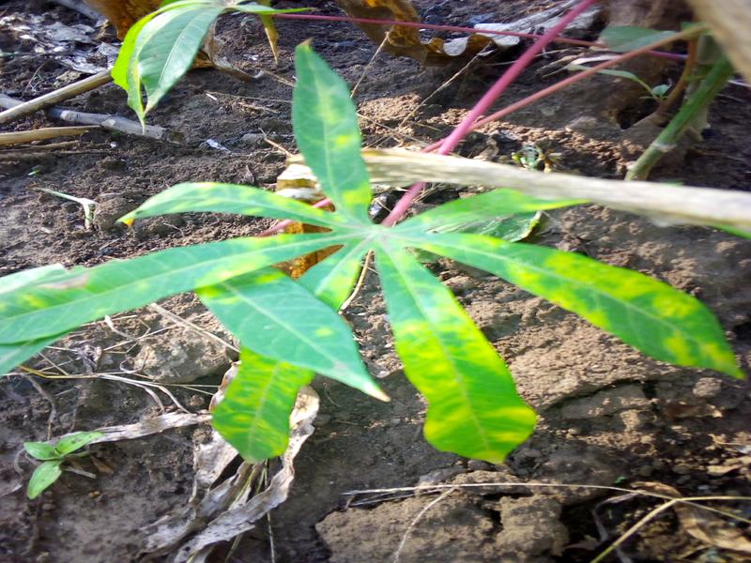
Figure: Example of CBSD black and yellow spots, dark streaks on the stem, and stunted leaves/roots
Cassava Green Mottle Disease (CGMD)
CGDM causes the formation of white spots on the surface of leaves and leads to a loss of chlorophyll during proliferation. Decreased chlorophyll levels affect photosynthesis and thus reduce crop yield. Mottled symptoms are exhibited in leaves affected by Cassava Mosaic Disease (CMD) as well as in those affected by CGDM. Depending on the severity of the infection, leaves may dry, shrink, and fall prematurely.
The basic features to be used for classification are white spots, mottled leaves, and/or stunted leaves(Figure).
Figure: white spots, mottled leaves, and/or stunted leaves
Cassava Mosaic Disease (CMD)
Cassava Mosaic Disease (CMD): CMD is a predominantly found disease that plagues the Cassava crop. Symptoms of CMD include the formation of mosaic-like patterns, yellow-white patches on the leaves, discoloration, and disfiguring of the leaves. The plants and leaves show stunted growth due to the infection.
The basic features to be used for classification are mosaic patterns, severe shape distortion(Figure).
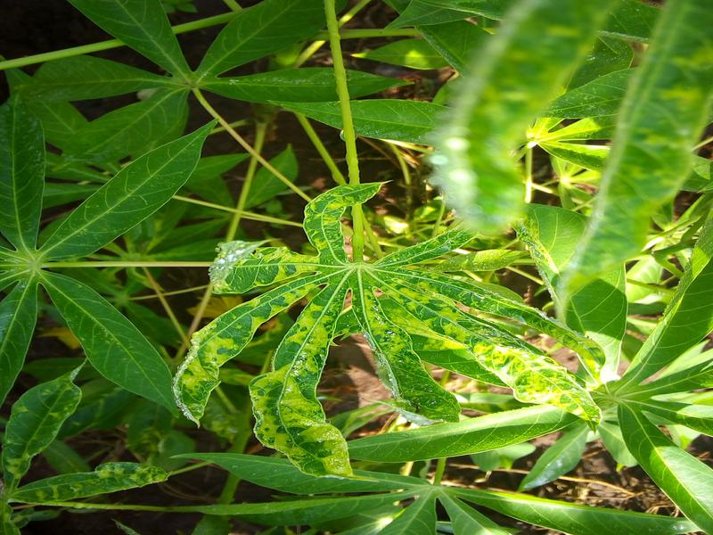
Figure: mosaic patterns, severe shape distortion

3.2. Related Works
The proposed method utilizes a CNN model to identify the type of disease. The model comprises convolutional, max-pooling, batch normalization, dropout, flatten, and dense layers arranged in sequential order, as illustrated in FİGURE. The number of trainable parameters can be determined using the model summary report provided in FİGURE. The convolutional layer is employed to extract features based on filters applied across the image, resulting in the creation of a feature map. Activation functions are utilized to convert the net input into activations, with ReLU (Rectified Linear Unit) commonly used in hidden layers and softmax in fully connected layers within CNNs. It is noteworthy that the dataset chosen for experimentation exhibits a high level of imbalance.
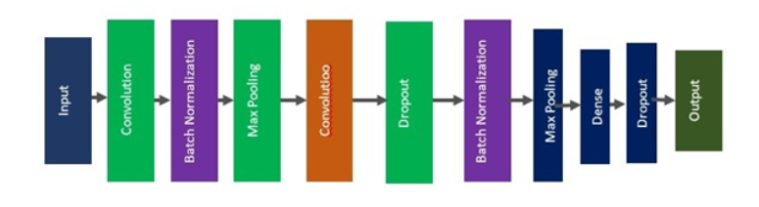
Figure4: Convolutional Neural Network (CNN) Architecture
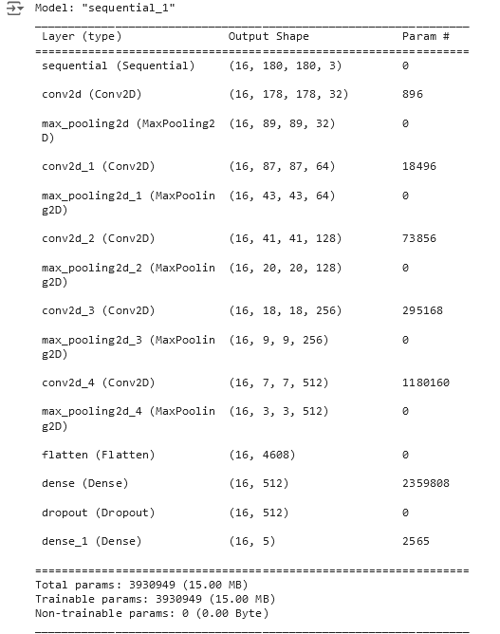
Figure: Model Summary

Recently, applications of deep neural networks can be observed in many different fields, from health to education. In the literature, there are various models, such as trained and pre-trained models. Due to their success in feature extraction, they are frequently preferred in image processing applications. Since they are methods based on convolutional neural networks, they have a layered structure. The layers exhibit different structures due to the connections between them and the filters used in the respective layers. Although the filters and connections used may differ, they ultimately contain the fundamental layers of convolutional neural networks.
The Input Layer is the first layer of convolutional or deep learning algorithms. It is used to adjust the data presented to the network to the dimensions required by the network. Specifically, images must be resized during the training phase of pre-trained deep learning algorithms. Kernels refer to $mxn$-sized K filters circulated over the two-dimensional $ixj$-sized I image (input matrix) (Metlek, 2021).
The user can use these filters as well as some ready-made filters in the literature. In the Convolution Layer, a new convolution matrix $S_{i,j}$ is created by circulating the K kernels on the I matrix from the input layer.This matrix can be as many times as the user wants, as shown in Figure 4 . The operation performed in the convolution layer is shown in detail in Equation
$S_{i,j}=({I*K)}_{i,j}=\sum_{m}{}\sum_{n}{}I_{i,j}K_{i-m,j-n}$
Equation-1
Activation Layer is the layer used to reduce the value (𝑥 = 𝑆𝑖,𝑗) obtained from the convolution layer to certain intervals. In the literature, Rectified Linear Unit (ReLU), Sigmoid and Hyperbolic Tangent functions given in Eq. (2), (3) are used.
$f(x)=max(0,x)=(0 if x<0,x if x≥0)$ Eq.2

$f(x)=\frac{1}{1+e^{-x}}$ eq.3
The Pooling Layer is the layer used to reduce the data from the Activation layer to smaller sized matrices. In this layer, a 2x2 matrix is circulated on the data coming from the Activation layer (𝐴𝑖,𝑗 = 𝑓(𝑥𝑖,𝑗)) as shown in FİGURE ALTTAKİ . This filtering process is sometimes performed by skipping. This jumping process is called “stride”. The maxpooling, averagepooling and minpooling functions presented in Eq. (4), (5) and are used in the Pooling Layer, respectively. As a result, although data reduction in the Pooling layer makes the network work faster, it may cause data loss in some cases

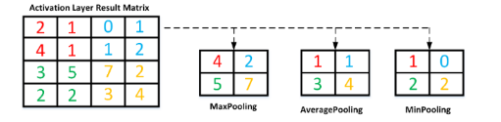
Figure

$f_{max}(A)=\max_{r,s}(A_{i,j})$ Eq.4

$f_{avg}(A)=\frac{1}{r+s}\sum_{i=1}^{r}{}\sum_{j=1}^{s}{}A_{i,j}$ Eq 5.

Output Layer can be created from Flatten Layer, Fully Connected Layer and Classification Layer in itself. The Flatten Layer shown in CNN FİGURE transforms the data from the previous layers into vectors in 1xD dimensions. The data converted to vector is multiplied by the relevant weight values in the full link layer and the bias value is added. The values obtained after this stage are sent to a classifier depending on the initiative of the user. In the literature, the softmax classifier given in eq-6 is generally used in this layer().

$S(y_{i})=\frac{e^{y_{i}}}{\sum_{j=1}^{n}{}e^{j}j}$
Eq6
In FİGURE , $e^{y_{i}^{}}$ represents the probability of the output of the model, and $\sum_{j=1}^{s}{}e^{y_{j}^{}}$ represents the probability sum of all output values of the model.

3.3. System Design

FLOWCHART BURAYA KOYULACAK.

1. Train file downloaded: The training files were downloaded to the computer via a link.
2. Irrelevant images were deleted one by one: At this stage, some images not related to the data classes were removed from the dataset.
3. Training Code Procedure: At this stage, the code writing process was initiated.
4. Load Required Libraries: Required Python libraries are loaded.
5. Define Constants: Constants are defined, such as BATCH_SIZE and IMAGE_SIZE.
6. Load Image Dataset: The dataset is loaded; it contains images and their labels.
7. Split Dataset into Train, Val, Test: The dataset is split into training, validation, and testing subsets.
8. Shuffle: The dataset is optionally shuffled.
9. Normalize and Resize: Images are normalized (scaled between 0 and 1) and resized.
10. Cache and Prefetch: The dataset is cached and prefetched, speeding up the training process.
11. Define Neural Network Model: The neural network model is defined; it consists of input, hidden, and output layers.
12. Compile and Train the Model: The model is compiled and trained; a specified loss function and optimization algorithm are used.

13. Evaluate Model: The model's performance is evaluated; accuracy and loss metrics are calculated.
14. End: The end of the workflow is represented; it's where the program terminates.
15. Save the Trained Model h5 file: The parameters after training have been saved as an h5 file.
16. Testing the model with unseen Test Dataset: A h5 file will be saved and label prediction will be made with previously untrained test images.
17. Evaluate The Model: The trained model was evaluated with images it had not seen before. The model was tested and evaluated with unseen images at this point.
18. Calculate Accuracy Rate and Loss: The accuracy rate and loss values were calculated.

3.4. Model Architecture

- Resize & Rescale
This layer resizes and rescales input images to a specific size, making them suitable for the model. Due to the large volume of data, the input images were resized to a maximum of 200x200 using the resize operation on Google Colab's T4 GPU, which can handle such operations efficiently. This resizing process ensures that the images are compatible with the model's input requirements. By limiting the input size in this manner, computational resources are utilized effectively, enabling the model to process the data efficiently while maintaining performance on the GPU.

- Conv2D
This layer forms the basic building block of a Convolutional Neural Network (CNN). It uses a series of filters to extract feature maps from the input. Each filter highlights certain features in the input image. For example, the first Conv2D layer uses 32 filters. These filters highlight certain features in input images, such as edges, corners or texture patterns. ReLU activation adds non-linearity by keeping positive input values unchanged and setting negative values to zero.

- MaxPooling2D
This layer is used to reduce the size of feature maps and computational cost. Max pooling reduces a feature map by taking the maximum value in each region.

- Flatten
This layer flattens a feature map into a vector, necessary for connecting features from convolutional layers.

- Dense
This layer is a fully connected hidden layer. It transforms the incoming feature vector into an output vector of a certain size. ReLU activation adds non-linearity. Applies L2 regularization. The value 0.001 determines the size of the regularization coefficient. The larger this value, the stronger the effect of regularization. Regularization generally makes the network more resistant to overfitting.

- Dropout
This layer is used to reduce overfitting. By randomly dropping (setting to zero) a percentage of data points, it updates the weights.

- Dense (Output)
This layer is used for classification. Softmax activation provides a probability distribution for each class, ensuring the total probability sums to 1.

EXPERIMENTAL RESULTS

4.2. Data Pre-Processing
During the preprocessing stage, images in the train dataset, which consists of five different classes, were individually examined. At this stage, some images not related to the data classes were removed from the dataset, as shown in Figure .

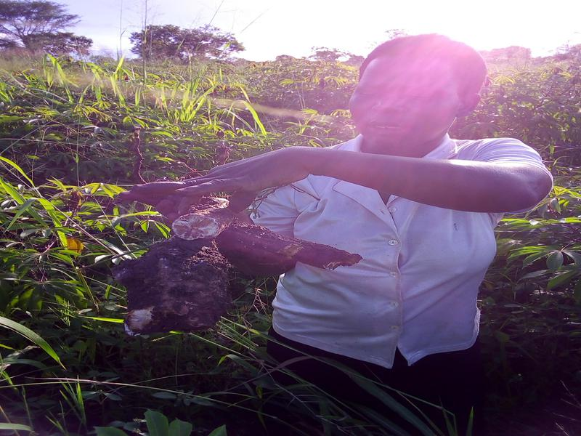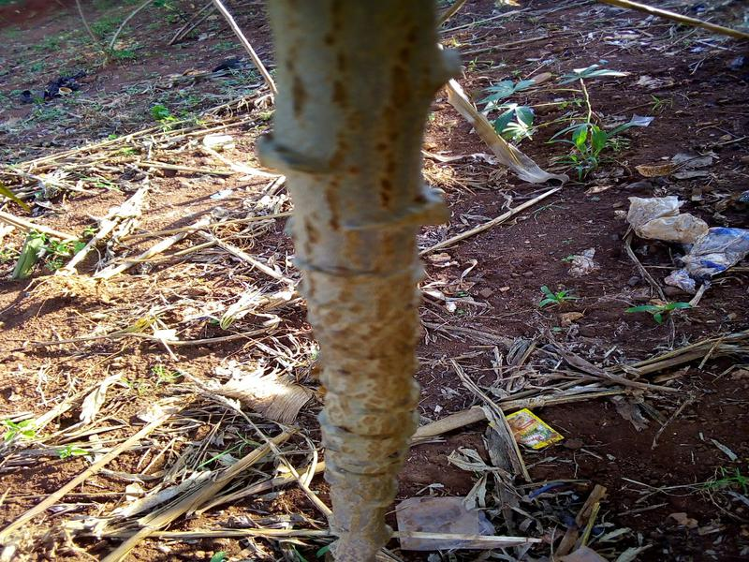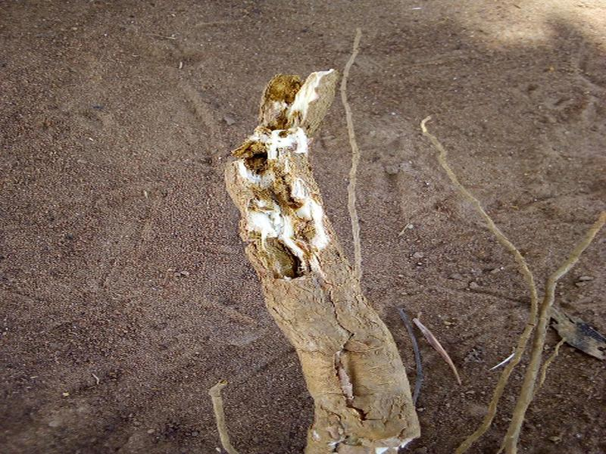
Figure:Irrelevant image examples

Label Name | Count
Cassava Bacterial Blight (CBB) | 987
Cassava Brown Streak Disease (CBSD) | 2005
Cassava Green Mottle (CGM) | 2285
Cassava Mosaic Disease (CMD) | 3123
Healthy (Ht) | 2459
Table 2: After Removal operation

Label Name | Count
Cassava Bacterial Blight (CBB) | 987
Cassava Brown Streak Disease (CBSD) | 987
Cassava Green Mottle (CGM) | 987
Cassava Mosaic Disease (CMD) | 987
Healthy (Ht) | 987
Table 3: After DELETİNG, VERİ SAYILARI AYARLAMA operation

Additionally, when the number of images in the classes provided in Table 1 is examined, it is observed that the number of CBB data is very low, whereas the number of CMD data is significantly higher than that of other classes.

4.3. Result of the Model

Öncelikle data setinden alakasız görseller teker teker kontrol edilerek manuel biçimde kaldırıldı. Data setindeki sınıflar arasındaki veri sayısı farkı düzenlendi. Model eğitimi sırasında veri setinin %80'i eğitim için, %10'i ise doğrulama ve %10'i ise test için kullanıldı. In this code, pre-trained weights, models, and layers were not used. The training of the model from scratch was conducted by creating the layers ourselves.

Experimental grafik sonuçları

Sonuç olarak 3 adet farklı data seti kullanılmıştır. 1.si train dosyasında hiç bir görsel silinmeden tüm görseller eğitilip doğruluk ve kayıp grafikleri bastırılmıştır. 2.si ise tüm sınıflara ait alakasız görseller silinmiş olup model eğitilip doğruluk ve kayıp grafikleri bastırılmıştır. Son data seti ise her sınıftaki veri sayısını en düşük sınıftaki veri sayısı olan 987 data sayısına tüm sınıfları eşitleyip tüm görseller eğitilip doğruluk ve kayıp grafikleri bastırılmıştır.

Tüm_veri_irrevelann_silinmiş_hali_grafik

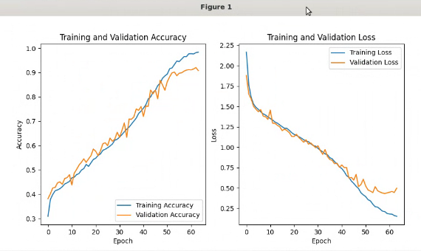
Figure-a Accuracy=87.32 loss=53.95

TAM EKSİKSİZ VERİ TÜM GÖRSELLER

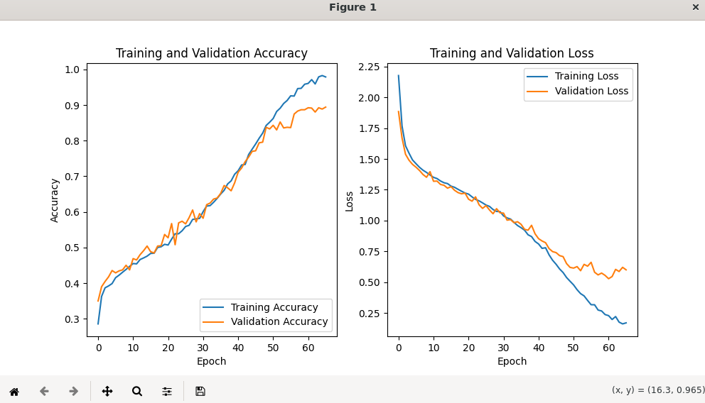
Figure-b
Another copy silinmiş hepsi 987 adet

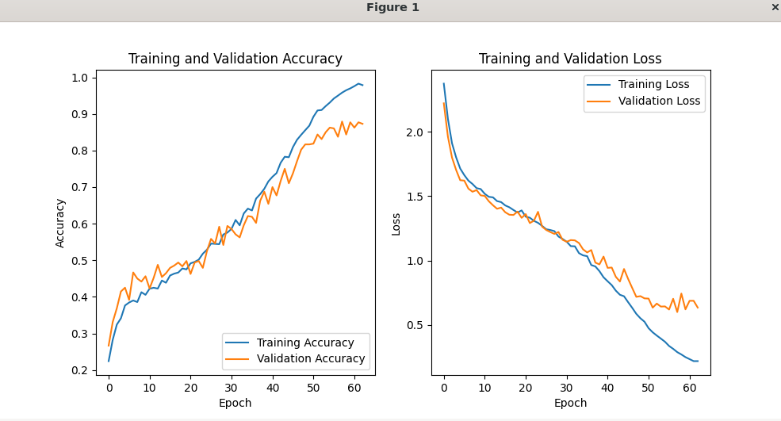
Figure-c

2.kod deneme train(another copy silinmiş hepsi 987 adet),
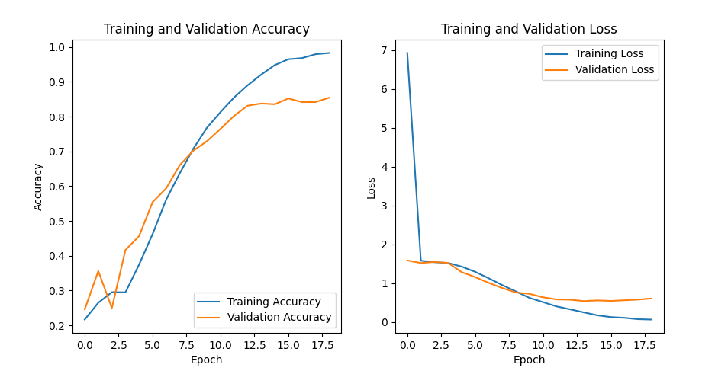
Figure-d

2.kod deneme train( copy) tüm veri_Irrevelant_silinmiş ))
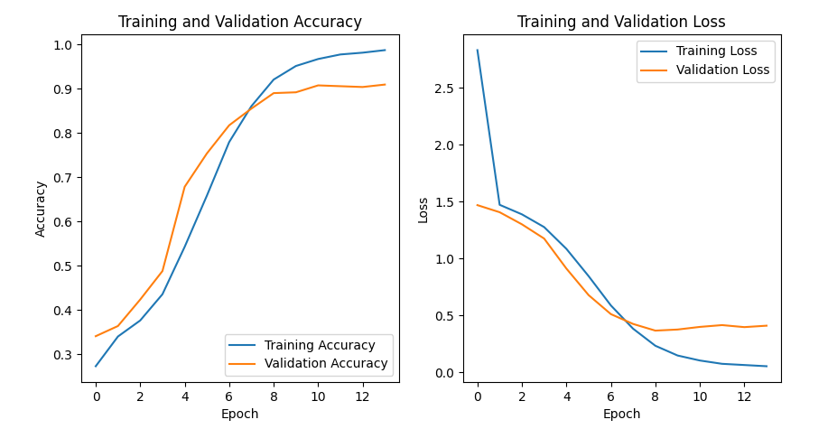
Figure-e

2.kod deneme train(TAM EKSİKSİZ VERİ TÜM GÖRSELLER )

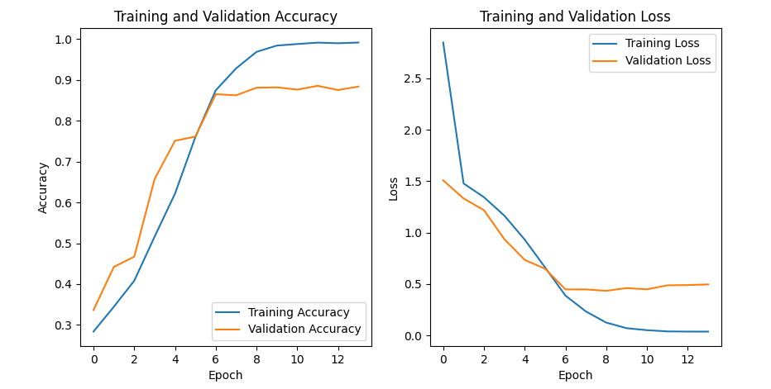

Figure-f

CONCLUSION AND FEATURE WORK

5.1. Conclusıon
The dataset is considered less reliable due to images being directly captured by farmers using their phones in the fields, resulting in exposure to background noise. If the dataset consisted of high-quality images, the robustness of the model could have been further enhanced. Another major limitation in our study was the computational resources. Although our work was conducted on the Google Colab platform, the allocated GPUs were exhausted, and more computational capacity was required to experiment with different model settings and improve the model's performance.

5.2. Evaluating all Outputs
Figure f de görüldüğü gibi, sonuç uzun epochlar boyunca çalışması gerekirken early stopping nedeniyle erkenden kesildi ve epoch çok az sürdü eğitim sırasında ise loss ile validation loss ile aradaki fark çok büyük olduğundan overfitting yaptığını gözlemledik. Bu nedenle o model kullanılmaktan vazgeçildi.Figure e ve d de olduğu gibi alakasız görselleri ve tüm sınıftaki data setleri eşit sayıda veri yapılmasına rağmen herhangi bir iyileşme görülmediği için eğiten model kullanılmadı.
Figure a da görüldüğü gibi eğitilen model uzun epochlar çalışması öngörüldü ve early stopping ile 62. epoch da durdu ve loss ile validation loss arasındaki fark yakındı ve model iyi şekilde başarıyla eğitildi. Figure b-c deki tüm veriyi ve tüm sınıflardaki data setleri eşit sayıda veri yapılmasına rağmen iyileşme görülmedi ve sonuç olarak Figure a’daki alakasız görseller veri setinden kaldırılınca doğruluk oranı ve loss değeri daha azaldığı görüldü.

SONUÇ OLARAK

A deep learning-based architecture was designed with the optimal number of parameters to classify Cassava plant diseases. Initially, the model was trained using the dataset with images resized from 800x600 to 180x180. Sonuçlar aynı zamanda modelin veri kümelerine gereğinden fazla uymadığını da göstermektedir. Diğer bir deyiş ile modelin loss değeri biraz yüksektir. Modelin doğruluk ve kayıp karşılaştırması aşağıda FİGURE DE gösterilmektedir. Kayıp grafiği, doğrulukla uyumlu olarak, beklendiği gibi aşamalı bir düşüş göstermektedir. Doğruluk grafiğinden ise hep artış içinde olduğunu görüyoruz.

5.3. Feature Work

REFENERCES

References

Martis, R., & Panigrahi, R. J. (2020). Application of Deep Learning in Neuroradiology: Brain Haemorrhage Classification Using Transfer Learning”", Computational Intelligence and Neuroscience. 44, 1-1.

