EE 470

Plant Disease Classification on Challenge

by
Ali Baki TÜRKÖZ
Emre ÖZTÜRK


Faculty of Engineering
Department of Electrical and Electronics Engineering
Istanbul, 2024
Yeditepe University

ABSTRACT

Plant Disease Classification on Challenge

Cassava (Manihot esculenta) is regarded as a crucial food crop by millions of individuals worldwide, particularly in developing nations. Nevertheless, its cultivation encounters significant hurdles attributed to a spectrum of diseases that adversely affect both yield and quality. Among these maladies, cassava mosaic disease (CMD), cassava brown streak disease (CBSD), cassava bacterial blight (CBB), cassava green mottle disease (CGMD), along with other pathogens, represent formidable threats to global food security.
In this project, an automated system is endeavoured to be developed for the early detection and classification of cassava diseases, employing deep learning techniques. Harnessing a dataset comprising 10,965 meticulously curated images of both healthy and diseased cassava leaves, sophisticated image classification algorithms are employed to meticulously discern and differentiate various disease symptoms. The primary objective is to fabricate a resilient model proficient in categorising cassava leaf images into five distinct classifications: healthy, CMD, CBSD, CBB, and CGMD.
By capitalising on the synergy between mobile technology and machine learning, this project endeavours to furnish farmers with a tool conducive to expedited disease diagnosis and informed management decisions. Through the implementation of this system, the aspiration is to ameliorate yield losses, enhance crop health surveillance practices, and ultimately foster advancements in food security and agricultural sustainability.

Table of Contents

ABSTRACT 2
Table of Contents 3
LIST OF FIGURES 4
LIST OF TABLES 5
LIST OF EQUATIONS 6
LIST OF SYMBOLS/ABBREVIATIONS 7
1. INTRODUCTION 1
2. LITERATURE REVIEW 4
3. PROPOSED WORK 6
3.1. Disease Categories 7
3.2. Related Works 10
3.3. System Design 14
3.4. Model Architecture 16
4. EXPERIMENTAL RESULTS 18
4.2. Data Pre-Processing 18
4.3. Result of the Model 19
5. CONCLUSION AND FEATURE WORK 22
5.1. Conclusion 22
5.2. Feature Work 23
6. References 24
Appendix A 25
Appendix B 30

LIST OF FIGURES

Figure 1 Classes of Train Dataset 7
Figure 2 Example of CBB 8
Figure 3 Example of CBSD 9
Figure 4 Example of CGMD 9
Figure 5 Example of CMD 10
Figure 6 Convolutional Neural Network (CNN) Architecture 11
Figure 7 Model Summary 11
Figure 8 The System Design Flowchart. 14
Figure 9 Irrelevant Image Examples 18
Figure 10 Irrelevant images removed and results 20
Figure 11 All Train images removed and results. 20
Figure 12 All class images removed and equalised, results. 21
Figure 13 The Other code, All class images removed and equalised, results 21
Figure 14 The Other code, Irrelevant images removed and results 21
Figure 15 The Other code, All Train images removed and results. 22

LIST OF TABLES

Table 1 Classes in the Train Dataset 7
Table 2 The Datasets After Removal Operation 18
Table 3 The Datasets After Synchronising Datasets 19

LIST OF EQUATIONS

Equation 1 Convolution Layer 12
Equation 2 ReLU Activation Function 12
Equation 3 Sigmoid Activation Function 12
Equation 4 Max Pooling Operation 13
Equation 5 Average-pooling Operation 13
Equation 6 The Softmax Classifier 13

LIST OF SYMBOLS/ABBREVIATIONS

CMD:Cassava mosaic disease
CBSD:Cassava brown streak disease
CBB:Cassava bacterial blight
CGMD:Cassava green mottle disease
ACMV:African Cassava Mosaic Virus
EACMV: East African Cassava Mosaic Virus
CMV:Cassava Mosaic Virus
CGSVM:Coarse Gaussian Support Vector Machine
RMD:Red Mite Damage
CV:Chan-Vese
AI:Artificial Intelligence
CNN:Convolutional Neural Network
Rectified Linear Unit:ReLU

INTRODUCTION
Cassava production, especially in Zambia, is predominantly carried out by small-scale farmers. The Northern region of the country constitutes the majority (78.8%) of production, alongside Luapula and North-Western provinces. In recent years, cassava production has tripled, rising from 360,000 tons in 1985 to 1,114,000 tons in 2013. This increase can be attributed to the withdrawal of maize subsidies, with Zambia consistently producing over 1 million tons of cassava annually since 2005. Yields vary between traditional and improved varieties, with yields ranging from 1 t/ha for traditional varieties to 2–3.5 t/ha for improved ones. However, Zambia's average cassava yield stands at 5.8 t/ha, below the continental average of 8.4 t/ha [1].

Cassava Mosaic Disease (CMD) is widely regarded as the predominant viral disease in Zambia and is also prevalent in neighbouring countries such as Tanzania, Malawi, the Democratic Republic of Congo, Zimbabwe, Mozambique, and Angola. Symptoms include leaf lamina distortion, chlorotic mosaics, and a general decrease in plant size. Variability in symptoms is observed due to seasonal and varietal differences among farmers. Studies have highlighted severe symptoms in plants infected with African Cassava Mosaic Virus (ACMV) and East African Cassava Mosaic Virus (EACMV) in Zambia [1].

Furthermore, Cassava Mosaic Disease (CMD) is generally acknowledged as the most significant disease-causing yield loss in cassava. Included in the top 10 plant virus pathogens published by Molecular Plant Pathology in 2011, this disease has seen some pivotal milestones, from its first report to the role of recombination and mixed infections in the evolution of multiple cassava-infecting begomovirus species and strains [2].

Another cassava disease emerging over the last decade, Cassava Brown Streak Disease (CBSD), poses a risk to food security and is a significant threat to the cassava value chain. Plants carrying this disease risk rendering their storage roots inedible due to low quality and palatability, leading to total crop loss [2].

Bacterial Blight infections, on the other hand, are most conspicuous towards the end of the rainy season and the beginning of the dry season. Initial observations should focus on abnormal leaf shedding and drying of leaves still attached to the stem. Symptoms include angular leaf spots, blighted areas, dark-brown to black streaks on the green part of the stem, bark swellings, and gummy exudates. Inspections for vascular browning should be carried out by cutting the outer bark between wilted leaves and exudates [3].

Another disease type, Cassava Green Mottle Disease (CGMD), is caused by the Cassava Mosaic Virus (CMV) transmitted by whiteflies, affecting cassava plant leaves. Symptoms include green or yellow patches on leaves, distorted leaf growth, and reduced plant growth, with severe cases leading to plant death [4].

With the global human population projected to surpass 9 billion by 2050, necessitating a 70% increase in food production, addressing challenges in crop health management, particularly for staple crops like cassava, is imperative. Leveraging technologies such as deep learning-based algorithms for disease diagnosis from images holds promise in empowering farmers to mitigate losses and enhance productivity, contributing to broader objectives of food security and sustainable agriculture.
Moreover, leveraging advancements in technology, particularly in the realm of artificial intelligence and image processing, holds promise for revolutionising disease diagnosis in agriculture. In this context, the development of a deep learning-based algorithm to classify cassava leaf diseases from images represents a significant stride towards precision agriculture. By utilising a dataset comprising 10,965 meticulously curated images of healthy and diseased cassava leaves, the aim is to achieve high accuracy in disease identification.

The project entails training various image classification algorithms and rigorously evaluating their performance on unseen samples. Ultimately, the goal is to identify the most effective model for practical application in real-world scenarios. Early and accurate disease diagnosis facilitated by such technology can empower farmers, particularly those in resource-limited settings, to take timely and appropriate measures to manage crop health efficiently.

Addressing the critical challenge of cassava disease diagnosis not only enhances food security but also supports sustainable agricultural practices. By minimising yield losses due to diseases such as Cassava Mosaic Disease (CMD), Cassava Brown Streak Disease (CBSD), Bacterial Blight, and Cassava Green Mottle Disease (CGMD), farmers can optimise productivity and ensure a stable food supply.

In conclusion, the successful implementation of advanced technologies in agriculture, coupled with robust research efforts and knowledge dissemination, holds the key to tackling the looming challenges posed by population growth and climate change. By harnessing the power of artificial intelligence and data-driven approaches, we can usher in a new era of sustainable and resilient agriculture, ensuring food security for future generations.

LITERATURE REVIEW

In the study conducted [5]by et al and colleagues, machine learning models were proposed for the detection and classification of cassava leaf diseases as blight or mosaic disease. The Cubic Support Vector Machine (CSVM) model was utilised to classify whether a leaf is healthy, while the Coarse Gaussian Support Vector Machine (CGSVM) algorithm was employed to classify the type of disease. An accuracy rate of 83.9% was achieved in predicting the health status of the leaf through the application of the CSVM model, whereas an accuracy rate of 61.6% was obtained in classifying the disease as Blight or Mosaic using the CGSVM algorithm.

In the study conducted [6]by et al., a deep learning approach was employed for image-based cassava disease detection using a dataset of cassava disease images taken in a field in Tanzania. Transfer learning was utilised to train a deep convolutional neural network to identify three diseases and two types of pest damage. The highest accuracy rates achieved by the best-trained models were 98% for brown leaf spot (BLS), 96% for red mite damage (RMD), 95% for green mite damage (GMD), 98% for cassava brown streak disease (CBSD), and 96% for cassava mosaic disease (CMD). An overall accuracy of 93% was achieved for data not used in the training process. While the study employed a deep learning approach to achieve an overall accuracy of 93% compared to traditional machine learning approaches, and utilised transfer learning which offers a fast, affordable, and easily deployable strategy for digital plant disease detection, it failed to address the occurrence of cassava bacterial blight disease.

A project was undertaken by [7]aiming to classify healthy and four different plant diseases from cassava plant leaf images. For this purpose, the "Cassava Leaf Disease Classification" dataset, which was a current and challenging dataset published in 2020, was utilised. The dataset used comprised a total of 21,397 images consisting of healthy leaves and four different diseases. In the study, the images were initially subjected to the Chan-Vese (CV) Segmentation method in the MATLAB environment to determine the regions of interest. Features were then extracted from the identified regions using deep learning architectures such as ResNet 50 and MobileNetV2. The extracted features were classified using Support Vector Machine and K-Nearest Neighbour algorithms. The images were divided into two groups, namely training and testing, according to the K-fold 5 value. Average highest success rates in training and test data were achieved, with success rates of 85.4% and 84.4%, respectively.

PROPOSED WORK

Cassava is the most popular commercial and industrial crop in Africa and Thailand, primarily due to favourable environmental conditions and soil quality in these regions. However, cassava plants face various challenges such as leaf diseases and fungal infections, leading to decreased production and increased costs. Continuous monitoring of plant diseases in the production environment is economically and physically unfeasible for producers.

Early diagnosis and classification of plant diseases, particularly using non-destructive methods, are crucial. However, taking preventive measures against these diseases is vital for producers. In recent years, significant advancements have been made in techniques for rapid and reliable detection of pathogens, emphasising the importance of optimising sample extraction for detection. Therefore, it's crucial to develop practical technologies for real-time disease monitoring that farmers can utilise.

Research has been conducted globally to address this issue. Previous methods of disease detection required manual inspection and diagnosis of plants, followed by annotation by experts. However, this method is labour-intensive and costly in terms of both money and time, especially for farmers in regions with limited access to high-quality cameras and bandwidth.

The aim is to classify each cassava image from the obtained dataset into four common disease categories (Cassava Mosaic Disease (CMD), Cassava Bacterial Blight (CBB), Cassava Green Mottle (CGM), Cassava Brown Streak Disease (CBSD)), or as a healthy specimen. This enables farmers to quickly diagnose affected plants and save their crops from permanent damage without the need for expert intervention. In this context, various imaging techniques have been developed for the detection of diseases caused by various factors in plants.

Recently, there has been a revolution in agricultural automation. Therefore, the introduction of groundbreaking technologies like Artificial Intelligence (AI) plays a significant role in increasing agricultural productivity, particularly in areas such as image processing for detecting cassava leaf diseases.

The chapter describes the evolution of various neural network techniques used in classification and prediction, emphasising the significance of using Convolutional Neural Network (CNN) over deep neural networks. It focuses on classifying leaf diseases in cassava plants using images acquired from datasets.

3.1. Disease Categories
Four common disease classes that affect the cassava crop are discussed below (Figure 1). Our goal is to automatically categorise these infections using a deep learning model that interprets the signs and symptoms arising from these distinct diseases.
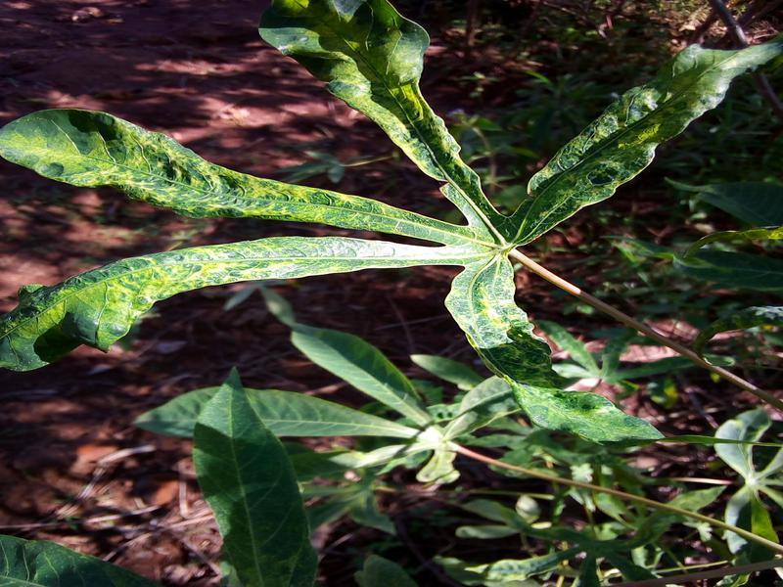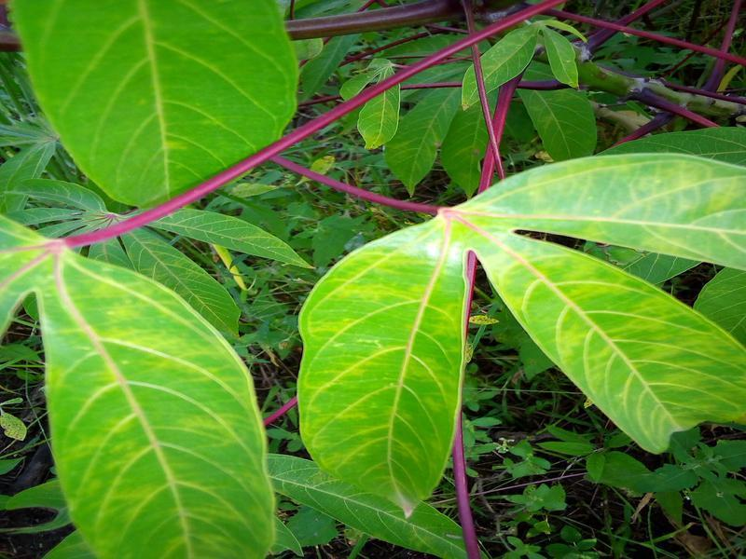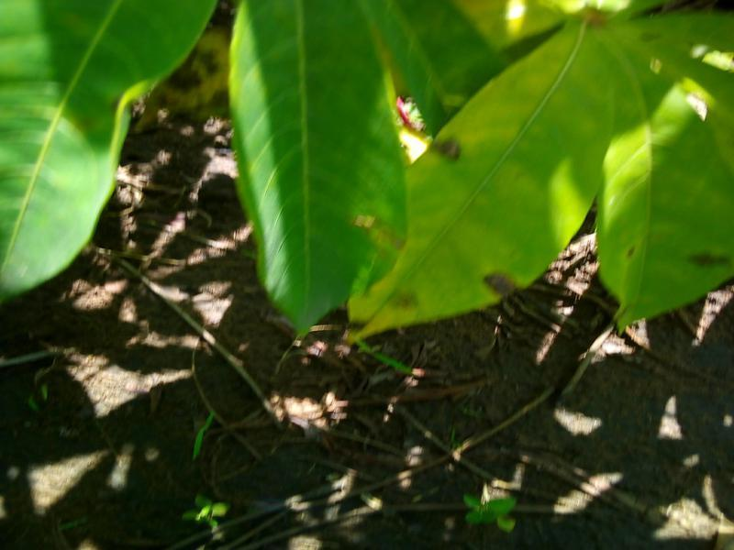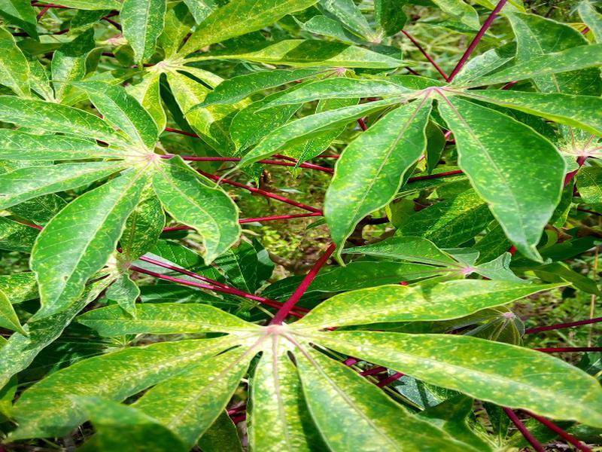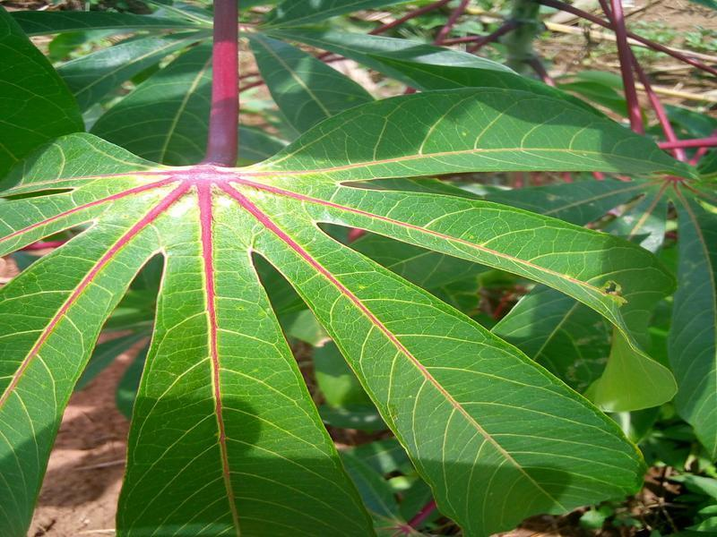
(a) CMD (b) CBSD (c) CBB (d) CGMD (e) Healthy

Figure 1 Classes of Train Dataset
As seen in the table below, the numbers of data belonging to each class have been written (Table 1).
Label Name | Count
Cassava Bacterial Blight (CBB) | 987
Cassava Brown Streak Disease (CBSD) | 2089
Cassava Green Mottle (CGM) | 2286
Cassava Mosaic Disease (CMD) | 3126
Healthy (Ht) | 2477

Table 1 Classes in the Train Dataset
Cassava Bacterial Blight (CBB)
Cassava Bacterial Blight (CBB), as the name suggests, is a bacterial disease that affects the crop. It is favoured by moist environmental conditions. Depending on the aggressiveness of the bacterial strains, the crop's location, season, etc., the severity of the disease's symptoms can vary. This causes leaves to wilt and fall prematurely when the infection becomes severe.
The basic features to be used for classification are black and angular spots and dried, fallen leaves(Figure 2).
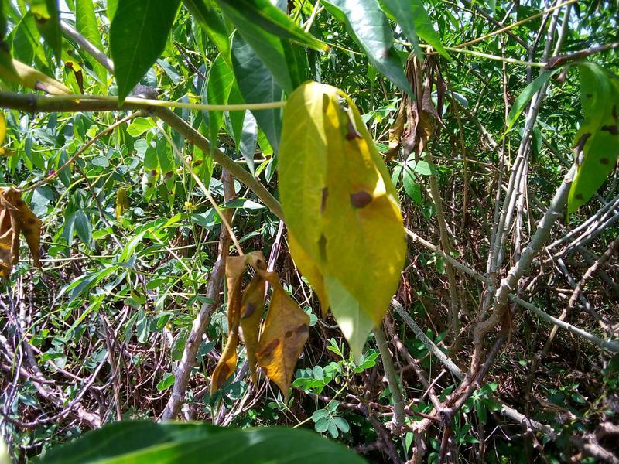
Figure 2 Example of CBB
Cassava Brown Streak Disease (CBSD)
CBSD adversely affects the cassava plant. Whiteflies, arguably the most damaging insect pests, are vectors of the virus. CBSD is also transmitted through infected cuttings. In the early stages of infection, symptoms of CBSD appear as yellow striped patches amidst the usual green colour. Over time, these yellow spots grow and merge to form larger yellow spots, and the leaves become mottled. Another symptom is the formation of brown lines on the stem of the plant. If the infection becomes severe, it can also cause growth arrest and plant rot.

The basic features to be used for classification are yellow spots, dark streaks on the stem, and stunted leaves/roots(Figure 3).
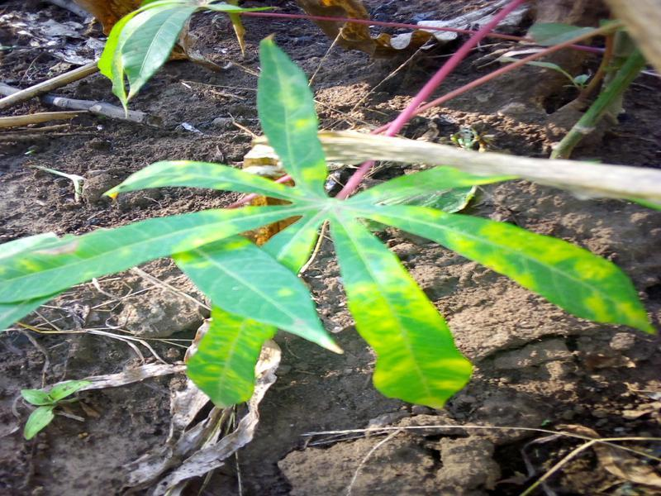
Figure 3 Example of CBSD
Cassava Green Mottle Disease (CGMD)
CGDM causes the formation of white spots on the surface of leaves and leads to a loss of chlorophyll during proliferation. Decreased chlorophyll levels affect photosynthesis and thus reduce crop yield. Mottled symptoms are exhibited in leaves affected by Cassava Mosaic Disease (CMD) as well as in those affected by CGDM. Depending on the severity of the infection, leaves may dry, shrink, and fall prematurely.
The basic features to be used for classification are white spots, mottled leaves, and/or stunted leaves (Figure 4).
Figure 4 Example of CGMD

Cassava Mosaic Disease (CMD)
CMD is a predominantly found disease that plagues the Cassava crop. Symptoms of CMD include the formation of mosaic-like patterns, yellow-white patches on the leaves, discoloration, and disfiguring of the leaves. The plants and leaves show stunted growth due to the infection.
The basic features to be used for classification are mosaic patterns, severe shape distortion(Figure 5).
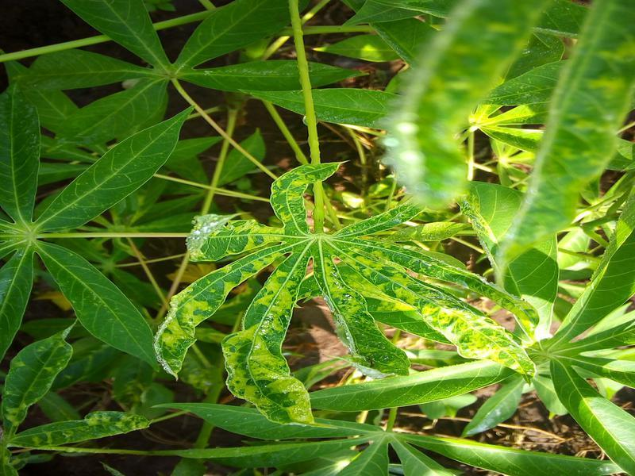
Figure 5 Example of CMD

3.2. Related Works
The proposed method utilises a CNN model to identify the type of disease. The model comprises convolutional, max-pooling, batch normalisation, dropout, flatten, and dense layers arranged in sequential order, as illustrated in Figure 6 . The number of trainable parameters can be determined using the model summary report provided in Figure 7. The convolutional layer is employed to extract features based on filters applied across the image, resulting in the creation of a feature map. Activation functions are utilised to convert the net input into activations, with ReLU (Rectified Linear Unit) commonly used in hidden layers and softmax in fully connected layers within CNNs. It is noteworthy that the dataset chosen for experimentation exhibits a high level of imbalance.
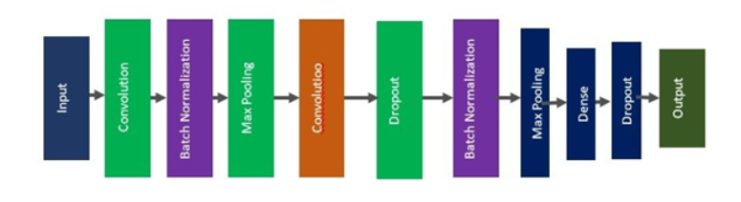
Figure 6 Convolutional Neural Network (CNN) Architecture
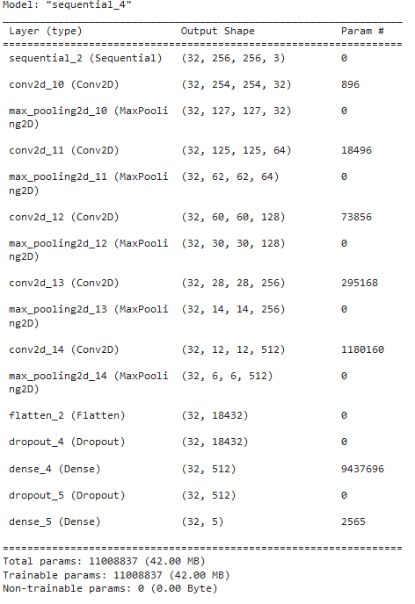
Figure 7 Model Summary
Recently, applications of deep neural networks can be observed in many different fields, from health to education. In the literature, there are various models, such as trained and pre-trained models. Due to their success in feature extraction, they are frequently preferred in image processing applications. Since they are methods based on convolutional neural networks, they have a layered structure. The layers exhibit different structures due to the connections between them and the filters used in the respective layers. Although the filters and connections used may differ, they ultimately contain the fundamental layers of convolutional neural networks.
The Input Layer is the first layer of convolutional or deep learning algorithms. It is used to adjust the data presented to the network to the dimensions required by the network. Specifically, images must be resized during the training phase of pre-trained deep learning algorithms. Kernels refer to $mxn$-sized K filters circulated over the two-dimensional $ixj$-sized I image (input matrix) [7].
The user can use these filters as well as some ready-made filters in the literature. In the Convolution Layer, a new convolution matrix $S_{i,j}$ is created by circulating the K kernels on the I matrix from the input layer.This matrix can be as many times as the user wants, as shown in Figure 6. The operation performed in the convolution layer is shown in detail in Equation 1
$S_{i,j}=({I*K)}_{i,j}=\sum_{m}{}\sum_{n}{}I_{i,j}K_{i-m,j-n}$
Equation 1 Convolution Layer
Activation Layer is the layer used to reduce the value (𝑥 = 𝑆𝑖,𝑗) obtained from the convolution layer to certain intervals. In the literature, Rectified Linear Unit (ReLU), Sigmoid and Hyperbolic Tangent functions given in Equation 2, Equation 3 are used.
$f(x)=max(0,x)=(0 if x<0,x if x≥0)$
Equation 2 ReLU Activation Function

$f(x)=\frac{1}{1+e^{-x}}$
Equation 3 Sigmoid Activation Function
The Pooling Layer is the layer used to reduce the data from the Activation layer to smaller sized matrices. In this layer, a 2x2 matrix is circulated on the data coming from the Activation layer (𝐴𝑖,𝑗 = 𝑓(𝑥𝑖,𝑗)) as shown in Figure below. This filtering process is sometimes performed by skipping. This jumping process is called “stride”. The max pooling, average pooling and minpooling functions are presented in Equation 4, Equation 5 and are used in the Pooling Layer, respectively. As a result, although data reduction in the Pooling layer makes the network work faster, it may cause data loss in some cases.

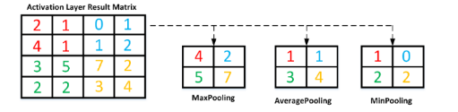
Figure: Pooling Operation

$f_{max}(A)=\max_{r,s}(A_{i,j})$
Equation 4 Max Pooling Operation

$f_{avg}(A)=\frac{1}{r+s}\sum_{i=1}^{r}{}\sum_{j=1}^{s}{}A_{i,j}$
Equation 5 Average-pooling Operation

Output Layer can be created from Flatten Layer, Fully Connected Layer and Classification Layer in itself. The Flatten Layer shown in Figure 6 Convolutional Neural Network (CNN) Architecture transforms the data from the previous layers into vectors in 1xD dimensions. The data converted to vector is multiplied by the relevant weight values in the full link layer and the bias value is added. The values obtained after this stage are sent to a classifier depending on the initiative of the user. In the literature, the softmax classifier given in Equation 6 is generally used in this layer.

$S(y_{i})=\frac{e^{y_{i}}}{\sum_{j=1}^{n}{}e^{j}j}$
Equation 6 The Softmax Classifier
In Equation 6,$e^{y_{i}^{}}$ represents the probability of the output of the model, and $\sum_{j=1}^{s}{}e^{y_{j}^{}}$ represents the probability sum of all output values of the model.

3.3. System Design

The flowchart below illustrates the process from the initial stage to the final stage of the code.

Testing the Model with unseen Test Dataset

Load required Libraries

Import Test Datasets and Define Labels

Shuffle

Import the Trained Model

Evaluate the Model

Calculate Accuracy Rate and Loss

Save the Trained Model a .h5 file

Training Code Procedure

Load required Libraries

Define the constants

Load Image Dataset

Split Datasets into Train,Val and Test

Shuffle

Normalize and Resize the Image

Cache and Prefetch

Define the Neural Network Model

Compile and Train the Model

Evaluate the Model

End

Irrelevant images were deleted one by one.

Train file downloaded.
Figure 8 The System Design Flowchart.

1. Train file downloaded: The training files were downloaded to the computer via a link.
2. Irrelevant images were deleted one by one: At this stage, some images not related to the data classes were removed from the dataset.
3. Training Code Procedure: At this stage, the code writing process was initiated.
4. Load Required Libraries: Required Python libraries are loaded.
5. Define Constants: Constants are defined, such as BATCH_SIZE and IMAGE_SIZE.
6. Load Image Dataset: The dataset is loaded; it contains images and their labels.
7. Split Dataset into Train, Val, Test: The dataset is split into training, validation, and testing subsets.
8. Shuffle: The dataset is optionally shuffled.
9. Normalise and Resize: Images are normalised (scaled between 0 and 1) and resized.
10. Cache and Prefetch: The dataset is cached and prefetched, speeding up the training process.
11. Define Neural Network Model: The neural network model is defined; it consists of input, hidden, and output layers.
12. Compile and Train the Model: The model is compiled and trained; a specified loss function and optimization algorithm are used.
13. Evaluate Model: The model's performance is evaluated; accuracy and loss metrics are calculated.
14. End: The end of the workflow is represented; it's where the program terminates.
15. Save the Trained Model h5 file: The parameters after training have been saved as an h5 file.
16. Testing the model with unseen Test Dataset: A h5 file will be saved and label prediction will be made with previously untrained test images.
17. Evaluate The Model: The trained model was evaluated with images it had not seen before. The model was tested and evaluated with unseen images at this point.
18. Calculate Accuracy Rate and Loss: The accuracy rate and loss values were calculated.

3.4. Model Architecture

- Resize & Rescale
This layer resizes and rescales input images to a specific size, making them suitable for the model. Due to the large volume of data, the input images were resized to a maximum of 256x256 using the resize operation on Google Colab's T4 GPU, which can handle such operations efficiently. This resizing process ensures that the images are compatible with the model's input requirements. By limiting the input size in this manner, computational resources are utilised effectively, enabling the model to process the data efficiently while maintaining performance on the GPU.

- Conv2D
This layer forms the basic building block of a Convolutional Neural Network (CNN). It uses a series of filters to extract feature maps from the input. Each filter highlights certain features in the input image. For example, the first Conv2D layer uses 32 filters. These filters highlight certain features in input images, such as edges, corners or texture patterns. ReLU activation adds non-linearity by keeping positive input values unchanged and setting negative values to zero.

- MaxPooling2D
This layer is used to reduce the size of feature maps and computational cost. Max pooling reduces a feature map by taking the maximum value in each region.

- Flatten
This layer flattens a feature map into a vector, necessary for connecting features from convolutional layers.

- Dense
This layer is a fully connected hidden layer. It transforms the incoming feature vector into an output vector of a certain size. ReLU activation adds non-linearity. Applies L2 regularisation. The value 0.001 determines the size of the regularisation coefficient. The larger this value, the stronger the effect of regularisation. Regularisation generally makes the network more resistant to overfitting.
- Dropout
This layer is used to reduce overfitting. By randomly dropping (setting to zero) a percentage of data points, it updates the weights.

- Dense (Output)
This layer is used for classification. Softmax activation provides a probability distribution for each class, ensuring the total probability sums to 1.

EXPERIMENTAL RESULTS

4.2. Data Pre-Processing
During the preprocessing stage, images in the train dataset, which consists of five different classes, were individually examined. At this stage, some images not related to the data classes were removed from the dataset, as shown in Figure 8

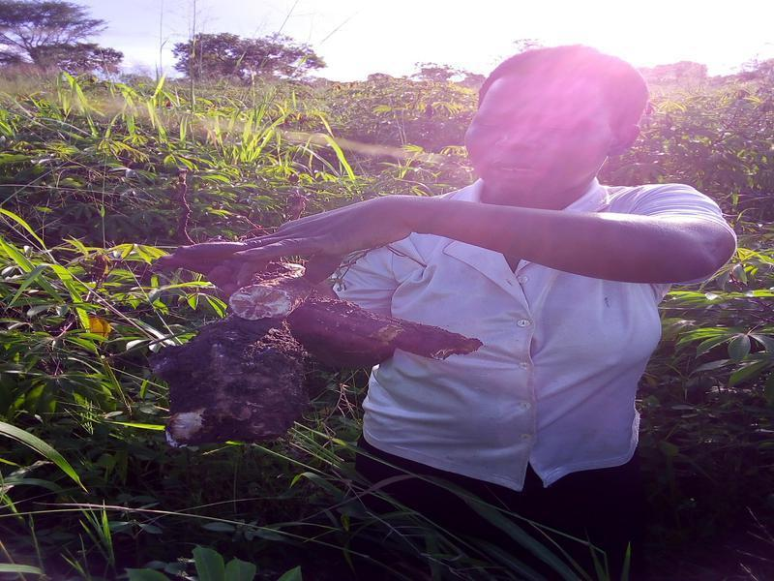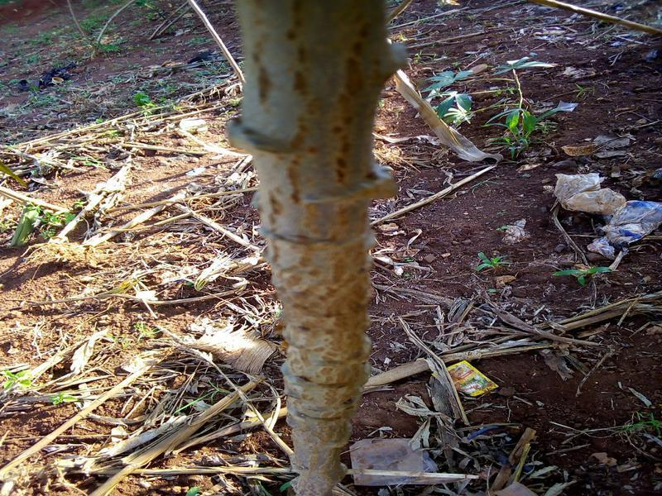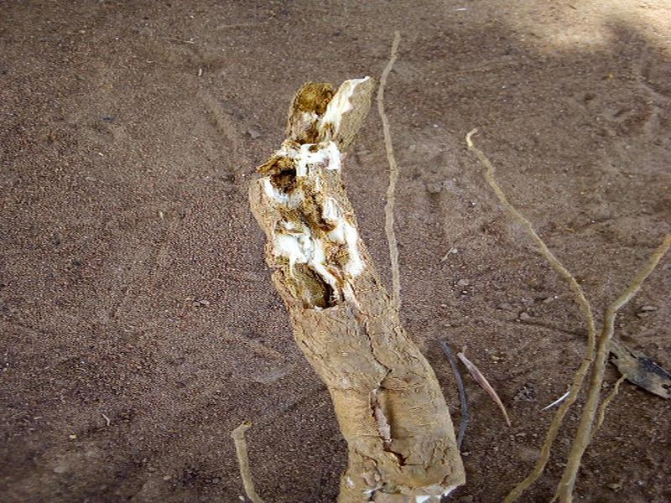
Figure 9 Irrelevant Image Examples
Label Name | Count
Cassava Bacterial Blight (CBB) | 987
Cassava Brown Streak Disease (CBSD) | 2005
Cassava Green Mottle (CGM) | 2285
Cassava Mosaic Disease (CMD) | 3123
Healthy (Ht) | 2459
Table 2 The Datasets After Removal Operation
Label Name | Count
Cassava Bacterial Blight (CBB) | 987
Cassava Brown Streak Disease (CBSD) | 987
Cassava Green Mottle (CGM) | 987
Cassava Mosaic Disease (CMD) | 987
Healthy (Ht) | 987
Table 3 The Datasets After Synchronising Datasets
Additionally, when the number of images in the classes provided in Table 1 is examined, it is observed that the number of CBB data is very low, whereas the number of CMD data is significantly higher than that of other classes.

4.3. Result of the Model

Firstly, irrelevant images were manually removed by individually inspecting them from the dataset. Discrepancies in the number of data points among classes were adjusted. During model training, 80% of the dataset was used for training, 10% for validation, and 10% for testing. Pre-trained weights, models, and layers were not utilised in this code. Instead, the model was trained from scratch by creating the layers ourselves.

As a result, three different datasets were used. The first dataset trained all images without deleting any visuals from the train file, and accuracy and loss graphs were plotted. The second dataset involved removing irrelevant images from all classes, training the model, and plotting accuracy and loss graphs. The final dataset equalised the number of data for each class to the lowest class, which had 987 data points, trained all images, and plotted accuracy and loss graphs.

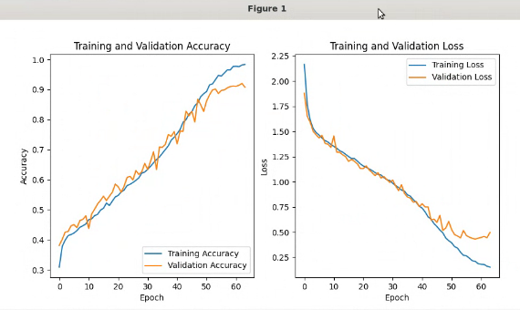
Figure 10 Irrelevant images removed and results

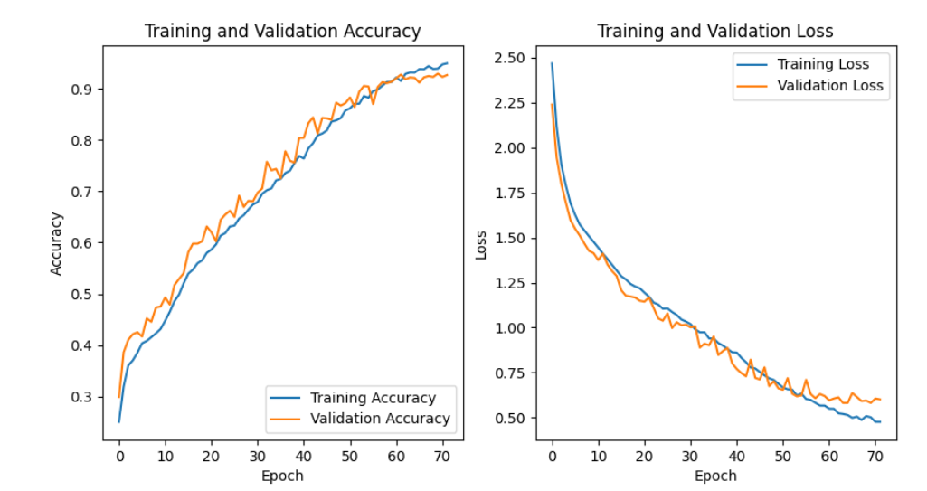

Figure 11 All Train images and results.
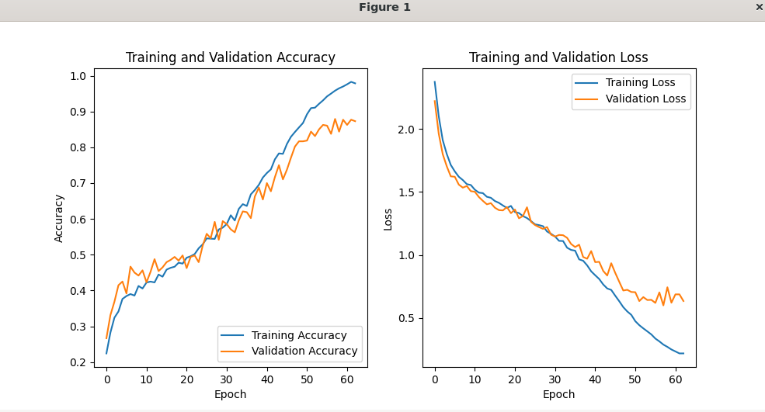
Figure 12 All class images removed and equalized, results.

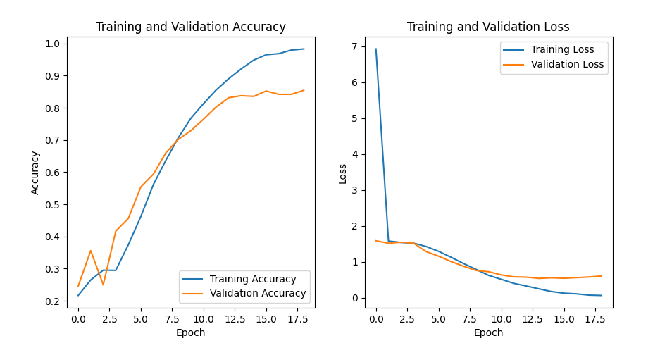

Figure 13 The Other code, All class images removed and equalized, results

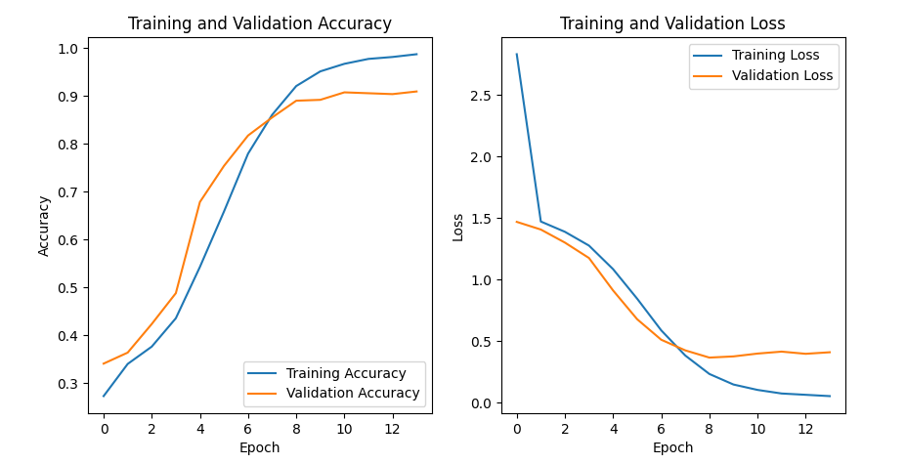
Figure 14 The Other code, Irrelevant images removed and results

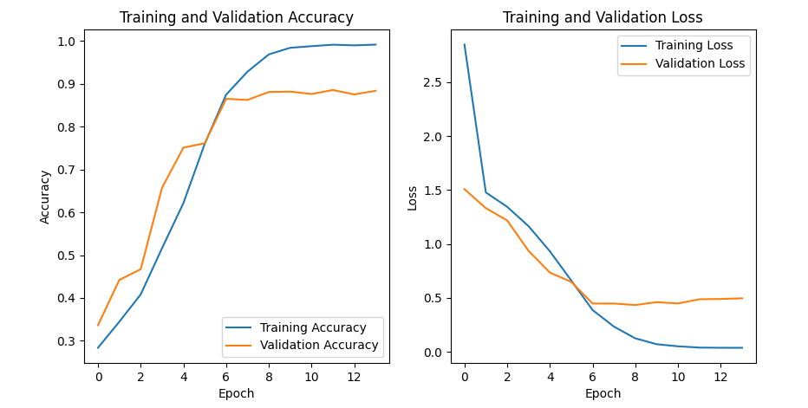

Figure 15 The Other code, All Train images.

CONCLUSION AND FEATURE WORK

5.1. Conclusion
As seen in Figure 13, the process was supposed to run for long epochs, but it was terminated early due to early stopping, resulting in a short duration of epochs. During training, it was observed that there was a significant difference between the loss and validation loss, indicating overfitting. Therefore, the decision was made to abandon the use of that model. Similarly, in Figure 14, Figure 15, despite equalizing the number of irrelevant images and data sets for all classes, no improvement was observed.
Figure 11, the trained model was expected to run for long epochs, and it stopped at the 62nd epoch with early stopping, with the loss being close to the validation loss, indicating successful training of the model. However, in Figure 10, Figure 12, despite equalizing the number of data for all classes, no improvement was observed. As a result, it has been observed that removing irrelevant images from the data set and eliminating data inequalities causes a slight increase in accuracy and loss values, as seen in the figure.
As a conclusion, a deep learning-based architecture was designed with the optimal number of parameters to classify Cassava plant diseases. Initially, the model was trained using the dataset with images resized from 800x600 to 256x256. The results also indicate that the model did not overfit to the datasets. In other words, the model's loss value is slightly higher.

The final decision was made based on the comparison of accuracy and loss of the model, which is shown in the Figure 11 The loss graph exhibits a gradual decrease, consistent with the increase in accuracy, as expected. From the accuracy graph, we observe a consistent improvement over time. As a result, the model was saved as an h5 file, and the accuracy was calculated as 55% with 500 test data, while the loss concluded at 1.6717.

5.2. Feature Work

Early diagnosis is a necessity that should help prevent the complications that delayed diagnosis can lead to. However, with the increased accessibility of large-scale cassava leaf data, the workload for farmers and other experts in the field has also increased. Several deep learning methods have been proposed to provide easier, more accurate, and timely detections, with most achieving great success in these tasks. Recently, portable handheld devices have been equipped with processing capabilities that were previously only imaginable for large computers. However, deep learning applications require higher computations, making it quite challenging to apply them to portable or embedded devices.
The dataset is considered less reliable due to images being directly captured by farmers using their phones in the fields, resulting in exposure to background noise. If the dataset consisted of high-quality images, the robustness of the model could have been further enhanced. Another major limitation in our study was the computational resources. Although our work was conducted on the Google Colab platform, the allocated GPUs were exhausted, and more computational capacity was required to experiment with different model settings and improve the model's performance.
Lastly, the model architecture could have been further expanded, and class-specific preprocessing could have been applied to each disease. Due to the limited time and abundance of data, GPUs did not perform well and accurately enough. Despite all these challenges, even with minimal preprocessing compared to a code trained from scratch, a high accuracy rate and low loss value were successfully achieved.

Note: Sir, we ran the project in vscode(Han Bey system) through a remote desktop connection. We wrote the codes in colab and uploaded them to the system, but there are no outputs, we wanted to let you know.

References

[1] | C. Mulenga, R. M. Tembo and S. P., “Cassava mosaic disease: a review of a threat to cassava production in Zambia,” Journal of Plant Pathology, pp. 467-477, 2019.
[2] | R. Vanderschuren, “ Cassava Mosaicand Brown Strea kDiseases: Current Perspective sand Beyond,” Annual Review of Virology, pp. 429-524, 2017.
[3] | CABI, “Xanthomonas axonopodis pv. manihotis (cassava bacterial blight),” 16 11 2021. [Online]. Available: https://www.cabidigitallibrary.org/doi/10.1079/cabicompendium.56952.
[4] | “Cassava green mottle virus,” 19 11 2023. [Online]. Available: https://en.wikipedia.org/wiki/Cassava_green_mottle_virus.
[5] | Segun and O. Oloyede, “Detection and Classification of Cassava Diseases Using Machine Learning,” International Journal of Computer Science and Software Engineering, pp. 2409-4285, 2019.
[6] | L. Mbilinyi, Mrisho and R. , “Accuracy of a Smartphone-Based Object Detection Model, Plant Village Nuru, in Identifying the Foliar Symptoms of the Viral Diseases of Cassava–CMD and CBSD,” Frontiers in Plant Science, pp. 1-12, 2020.
[7] | S. Metlek, “DISEASE DETECTION FROM CASSAVA LEAF IMAGES WITH DEEP LEARNING METHODS IN WEB ENVIRONMENT,” Metlek/INTERNATIONAL JOURNAL OF 3D PRINTING TECHNOLOGIES AND DIGITAL INDUSTRY, pp. 625-644, 2021.

Appendix A
Training Code:
import numpy as np
import pandas as pd
import tensorflow as tf
import matplotlib.pyplot as plt
import tensorflow as tf
from tensorflow import keras
from keras import layers, Sequential, models
import pathlib
from tensorflow.keras import regularizers

"""### Set all the Constants"""

BATCH_SIZE = 32
IMAGE_SIZE = 256
CHANNELS=3
EPOCHS=400

from tensorflow.keras.layers import Lambda

# Bulanıklık fonksiyonu
def apply_blur(image):
# Görüntüyü bulanıklaştırma işlemi
blurred_image = cv2.GaussianBlur(image.numpy(), (5,5), 0)
return blurred_image

data_augmentation = tf.keras.Sequential([
# layers.RandomFlip("horizontal_and_vertical"),
# layers.RandomRotation(0.2),
Lambda(lambda x: apply_blur(x)), # Bulanıklık uygulama
layers.GaussianNoise(0.1),
layers.RandomContrast(0.2), # Rastgele kontrast değişimi
layers.RandomBrightness(0.2), # Rastgele parlaklık değişimi
layers.RandomZoom(0.2, 0.2), # Rastgele yakınlaştırma
layers.RandomTranslation(0.2, 0.2), # Rastgele çeviri
# layers.RandomAffine(0.2), # Rastgele kaydırma
])

"""### Import data into tensorflow dataset object"""

dataset = tf.keras.preprocessing.image_dataset_from_directory(
"/home/han/Downloads/train",
seed=12,
shuffle=True,
image_size=(IMAGE_SIZE,IMAGE_SIZE),
batch_size=BATCH_SIZE
)

class_names = dataset.class_names
class_names

"""**Train, Test, validation data split**"""

def get_dataset_partitions_tf(ds, train_split=0.8, val_split=0.1, test_split=0.1, shuffle=True, shuffle_size=10000):
assert (train_split + test_split + val_split) == 1

ds_size = len(ds)

if shuffle:
ds = ds.shuffle(shuffle_size, seed=12)

train_size = int(train_split * ds_size)
val_size = int(val_split * ds_size)

train_ds = ds.take(train_size)
val_ds = ds.skip(train_size).take(val_size)
test_ds = ds.skip(train_size).skip(val_size)

return train_ds, val_ds, test_ds

train_ds, val_ds, test_ds = get_dataset_partitions_tf(dataset)

print("Size of Data is :{0} \nBatch size of Training Data is :{1}\nBatch size of Validation Data is :{2} \nBatch size of Testing Data is :{3} " .format(len(dataset), len(train_ds), len(val_ds), len(test_ds)))

"""### Cache, Shuffle, and Prefetch the Dataset"""

train_ds = train_ds.cache().shuffle(1000).prefetch(buffer_size=tf.data.AUTOTUNE)
val_ds = val_ds.cache().shuffle(1000).prefetch(buffer_size=tf.data.AUTOTUNE)
test_ds = test_ds.cache().shuffle(1000).prefetch(buffer_size=tf.data.AUTOTUNE)

"""## Building the Model

### Creating a Layer for Resizing and Normalization
Before we feed our images to network, we should be resizing it to the desired size.
Moreover, to improve model performance, we should normalize the image pixel value (keeping them in range 0 and 1 by dividing by 256).
This should happen while training as well as inference. Hence we can add that as a layer in our Sequential Model.

You might be thinking why do we need to resize (256,256) image to again (256,256). You are right we don't need to but this will be useful when we are done with the training and start using the model for predictions. At that time somone can supply an image that is not (256,256) and this layer will resize it
"""

resize_and_rescale = tf.keras.Sequential([
layers.Resizing(IMAGE_SIZE, IMAGE_SIZE),
layers.Rescaling(1./255),
])

"""### Model Architecture
We use a CNN coupled with a Softmax activation in the output layer. We also add the initial layers for resizing, normalization and Data Augmentation.
"""

input_shape = (BATCH_SIZE, IMAGE_SIZE, IMAGE_SIZE, CHANNELS)
n_classes = 5

model = models.Sequential([
resize_and_rescale,
layers.Conv2D(32, kernel_size=(3, 3), activation='relu', input_shape=input_shape),
layers.MaxPooling2D((2, 2)),
layers.Conv2D(64, kernel_size=(3, 3), activation='relu'),
layers.MaxPooling2D((2, 2)),
layers.Conv2D(128, kernel_size=(3, 3), activation='relu'),
layers.MaxPooling2D((2, 2)),
layers.Conv2D(256, kernel_size=(3, 3), activation='relu'),
layers.MaxPooling2D((2, 2)),
layers.Conv2D(512, kernel_size=(3, 3), activation='relu'),
layers.MaxPooling2D((2, 2)),
layers.Flatten(),
layers.Dropout(0.7),
layers.Dense(512, activation='relu', kernel_regularizer=regularizers.l2(0.001)),
layers.Dropout(0.8), # Dropout for regularization
layers.Dense(n_classes, activation='softmax'),

])

model.build(input_shape=input_shape)

model.summary()

"""### Compiling the Model
We use `adam` Optimizer, `SparseCategoricalCrossentropy` for losses, `accuracy` as a metric
"""

# Compile the model with a lower learning rate
model.compile(
optimizer=tf.keras.optimizers.Adam(learning_rate=0.0001),
loss=tf.keras.losses.SparseCategoricalCrossentropy(from_logits=False),
metrics=['accuracy']
)

# Early stopping tanımlama
from tensorflow.keras.callbacks import EarlyStopping
early_stopping = EarlyStopping(monitor='val_loss', patience=8, restore_best_weights=True)

history = model.fit(
train_ds,
batch_size=BATCH_SIZE,
validation_data=val_ds,
verbose=1,
epochs=EPOCHS,
callbacks=[early_stopping],
)

scores = model.evaluate(test_ds)

# Plotting the Accuracy and Loss Curves
acc = history.history['accuracy']
val_acc = history.history['val_accuracy']
loss = history.history['loss']
val_loss = history.history['val_loss']

plt.figure(figsize=(10, 5))
plt.subplot(1, 2, 1)
plt.plot(acc, label='Training Accuracy')
plt.plot(val_acc, label='Validation Accuracy')
plt.legend(loc='lower right')
plt.ylabel('Accuracy')
plt.xlabel('Epoch')
plt.title('Training and Validation Accuracy')

plt.subplot(1, 2, 2)
plt.plot(loss, label='Training Loss')
plt.plot(val_loss, label='Validation Loss')
plt.legend(loc='upper right')
plt.ylabel('Loss')
plt.xlabel('Epoch')
plt.title('Training and Validation Loss')
plt.show()

model.save("/home/han/Documents/EE470_Model_BEST_5_.h5")

Appendix B
Testing Code
import os
import numpy as np
from sklearn.metrics import accuracy_score, log_loss
from keras.preprocessing.image import load_img, img_to_array
from keras.utils import to_categorical
from tensorflow.keras.models import load_model

# Ana klasör yolu
ana_klasor = "/home/han/Downloads/test"

# Alt klasörlerin isimleri
alt_klasorler = ["/home/han/Downloads/test/bacterial_blight",
"/home/han/Downloads/test/brown_streak_disease",
"/home/han/Downloads/test/green_mottle",
"/home/han/Downloads/test/healthy",
"/home/han/Downloads/test/mosaic_disease"]

# Verileri ve etiketleri depolamak için boş listeler
X = []
y = []

# Alt klasörlerdeki verileri yükleme ve etiketleme
for i, alt_klasor in enumerate(alt_klasorler):
alt_klasor_yolu = os.path.join(ana_klasor, alt_klasor)
for dosya_adi in os.listdir(alt_klasor_yolu):
dosya_yolu = os.path.join(alt_klasor_yolu, dosya_adi)
img = load_img(dosya_yolu, target_size=(180, 180))
img_array = img_to_array(img)
X.append(img_array)
y.append(i) # Her alt klasör için farklı etiket

# Veriyi ve etiketleri Numpy dizilerine dönüştürme
X = np.array(X)
y = np.array(y)

# Verileri karıştırma
sirali_indeksler = np.arange(X.shape[0])
np.random.shuffle(sirali_indeksler)
X = X[sirali_indeksler]
y = y[sirali_indeksler]

# Modeli yükleyip verileri tahmin etme
model = load_model('/home/han/Documents/EE470_Model_BEST_5_.h5') # Kaydedilmiş modeli yükleme
predictions = model.predict(X) # Verileri tahmin etme

# Gerçek etiketlerin ve tahminlerin hazırlanması
true_labels = y
true_labels_cat = to_categorical(true_labels, num_classes=len(alt_klasorler)) # Gerçek etiketlerin kategorik hale getirilmesi
pred_prob_cat = predictions # Tahmin olasılıklarının hesaplanması

# Doğruluk oranını ve kaybı hesaplama
accuracy = accuracy_score(true_labels, np.argmax(predictions, axis=1))
loss = log_loss(true_labels_cat, pred_prob_cat)

print(f"Doğruluk Oranı: {accuracy}")
print(f"Kayıp: {loss}")

