Patoto_kodu, BATCH_SIZE = 32, IMAGE_SIZE = 256, train tek ana klasor: Found 1850 files belonging to 5 classes.

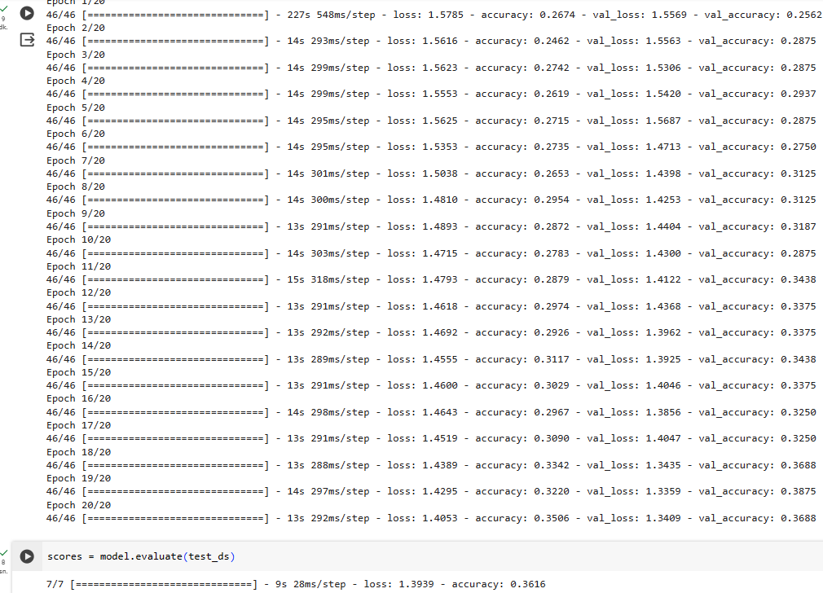

VGG-16 DENEME, layer.trainable = False, target_size=(224,224), batch_size=32),tes, valid ve train ayrı ayrı veri yolları:

