**T.C.**

**BAHÇEŞEHİR UNIVERSITY**

**FACULTY OF ENGINEERING AND NATURAL SCIENCES**

**Gaıt Analysis reporter**

**Capstone Project Proposal**

**Abeer Alhmoud (BME)**

**Bara Yonso (BME)**

**Emre Sarı (SEN)**

**Yağız Kaan Kurtoğlu (SEN)**

**Advisors: Dr. Öğr. Üyesi Yücel Batu Salman (SEN)**

**Asst. Prof. Dr. Burcu Tunç Çamlıbel (BME)**

**ISTANBUL, September 2020**

**STUDENT DECLARATION**

By submitting this report, as partial fulfillment of the requirements of the Capstone course, the students promise on penalty of failure of the course that

* they have given credit to and declared (by citation), any work that is not their own (e.g. parts of the report that is copied/pasted from the Internet, design or construction performed by another person, etc.);
* they have not received unpermitted aid for the project design, construction, report or presentation;
* they have not falsely assigned credit for work to another student in the group, and not take credit for work done by another student in the group.

# TABLE OF CONTENTS

TABLE OF CONTENTS iii

LIST OF TABLES 7

LIST OF FIGURES vii

LIST OF ABBREVIATIONS viii

1. OVERVIEW 1

1.1. Identification of the need 1

1.2. Definition of the problem 1

1.3. Standards and constraints 2

1.4. Conceptual solutions 2

1.5. Physical architecture 3

2. WORK PLAN 4

2.1. Work Breakdown Structure (WBS) 4

2.2 Responsibility Matrix (RM) 4

2.3. Project Network (PN) 5

2.4. Gantt chart 5

3. DESIGN PROCESS 6

3.1. Biomedical Engineering 8

3.1.1 Task clarification 8

3.1.1.1 Definition of the problem and objectives 8

3.1.1.2 Requirement specification 8

3.1.2 Concept generation 9

3.1.3 Embodiment design 9

3.1.4 Detailed design 9

3.1.5 Risk assessment 10

3.1.6 Materialization 10

3.1.7 Evaluation Planning 10

3.2.6. Quantification for the verification and validation 12

3.2.7. Evaluation of results 13

3.9. Software Engineering 17

3.9.1 Interface Requirements 17

3.9.1.1 User Interfaces 17

3.9.1.2 Software Interfaces 17

3.9.2 Functional Requirements 18

3.9.2.1 Behaviors of the Software Application 18

3.9.2.2 Attributes of the Software Application 18

3.9.2.3 Design and Implementation 18

3.9.3 Nonfunctional Requirements 19

3.9.3.1 Performance Requirements 19

3.9.3.2 Safety Requirements 19

3.9.3.3 Security Requirements 19

3.9.3.4 Software Quality Attributes 19

3.9.3.5 Business Rules 19

3.9.4 Use-case Modeling 20

3.9.4.1 Actor Glossary 20

3.9.4.2 Use-case Glossary 20

3.9.4.3 Use-case Scenarios 20

3.9.4.4 Use-case Diagram 21

3.9.5 Data Modeling 21

3.9.5.1 Activity Diagram 21

3.9.5.2 Sequence Diagrams 21

3.9.5.3 Process Diagram 21

3.9.5.4 Data Flow Diagram 22

3.9.5.5 Design/Block Diagram 22

3.9.5.6 Object Diagram 22

3.9.5.7 Class Diagram 22

4. COSTS 22

5. CONCLUSION 23

ACKNOWLEDGEMENT 24

REFERENCES 25

APPENDIX A 26

APPENDIX B 27

# LIST OF TABLES

Table 1. Responsibility Matrix for the team. 5

Table 2. Risk Matrix. 7

Table 3. Risk assessment table. 7

Table 4. Table of costs. 22

# LIST OF FIGURES

Figure 1.Basic data flow of the project 2

Figure 2. Biomedical and Software architecture of the project 4

Figure 3. WBS for the project 6

Figure 4. Project network 7

Figure 5. Timeline for the project 7

Figure 6. Knees ankles and hips flexion/extension plots. 11

Figure 7. Knees, ankles and hips interior/exterior plots 12

Figure 8. FAST Diagram of Gait Analysis 12

Figure 9. Software Interface 15

Figure 10 . Feet contact table 23

Figure 11 . Joint Angles ZXY Table 24

Figure 12 . Ergonomic Joint Angles ZXY Table 24

# LIST OF ABBREVIATIONS

**Imu** Inertial Measurement Unit

**Mokka** Motion Kinematic & Kinetic Analyzer

**GC** Gait Cycle

# 1. OVERVIEW

This project is about gait analysis reporter. Two software engineering students (Emre Sarı and Yağız Kaan Kurtoğlu), two biomedical engineering students (Abeer Alhmoud and Bara Yonso) are responsible of this project. The biomedical engineering students will provide the details needed by the software engineering students, construct a gait report using XSENS and Mokka and test and compare the gait reporter with the gold standard method. The software engineering students will develop an automatic gait report software using the data provided and develop an algorithm to extract the improper data for gait analysis.

## 1.1. Identification of the need

Walking is a basic function humans do on a regular basis without thought however being injured or incapable of moving highly impacts the quality of life. Thus, gait analysis is required to help identify any problems with posture or abnormalities to be able to fix it if possible. It is also used to help athelets run proficiently. Gait anaysis is done by using sensors to study the muscles’ activity and body’s movement of each unique person and notice any abnormalities in their cycle, as well as calculating the gait cycle and analyzing it. This is why a gait analysis software is required to compute the body’s data input and give back a report with detailed information that would help diagnose the patient. We will be using XSENS and work around the data with Matlab to develop this software. After that, the feature extraction and selection process will take place. We will extract the meaningful data from the dataset that we created with essential algorithms. And after that, we will choose our features wisely for the gait analysis. We need to execute this section carefully because it will directly affect our application's performance level. After the feature selection, we will design the interiors part of this application. First, we will define our attributes and back-end code design. For this design, we must create rapid code blocks and a fast runtime environment. Next is the UI/UX design phase, in this part, we will create different design approaches after the examination best approach will be selected for the implementation. In the end, our project will go through the testing phase.

## 1.2. Definition of the problem

Nowadays, people are using healthcare systems actively. These systems will improve their living standards in different ways. For this project, we are going to develop a healthcare application that is based on gait analysis. Gait analysis is an important technique for improving athlete efficiency and treating people with gait disorders and it is a technique that is often used in the literature. In our project, we will collect the data of people and athletes with gait disorders, develop algorithms according to the data we collect and provide them with information about their illnesses or the efficiency of athletes.

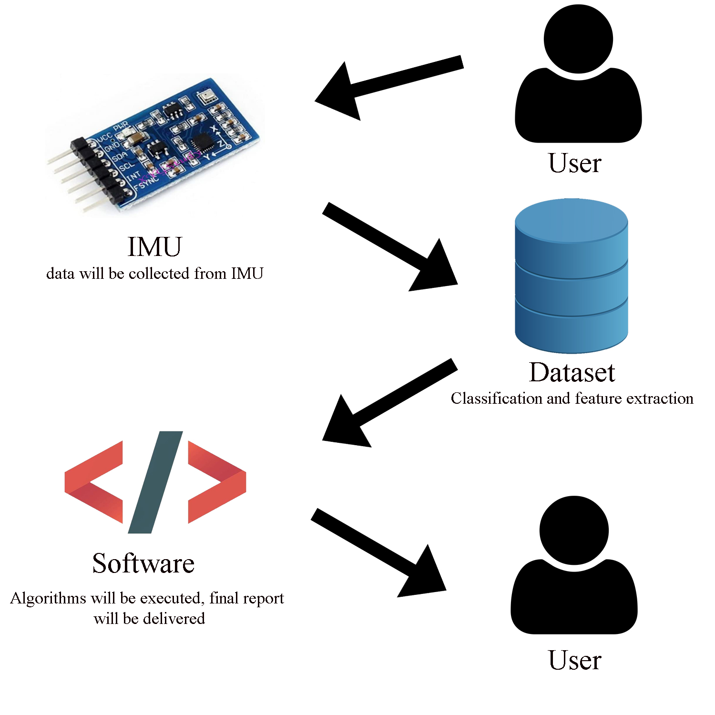

Figure 1. Basic data flow of the project

First of all, this project will be developed for people who have movement-related disease, injuries, and sport athletes. We have different user profiles of all ages. For example, people's locomotor systems can be damaged as they get older our application is suitable for this type of case. On the other hand, this application will be very useful for sports athletes which are aged around 16-38. For the functionality part, our application will get input from the user's gait analysis and provide a meaningful gait report to the user that contains performance and disease data. We will collect all the user's gait reports in one dataset, in the design process, we will give detailed information about our dataset. We will protect each individual's data and our dataset can not be accessed by any third parties. This project can be used in different environments which are sports industries, healthcare programs, hospitals, and many more. It can be a solution or improvement for the identification of diseases, gait efficiency programs, and athlete performance programs. Since it is a Capstone project we will try to keep our budget at a low level.

## 1.3. Standards and constraints

Since we attach great importance to environmental impact and pollution in our project, all materials of the IMU sensor that will be used are reusabale and will be harmless to the environment. Since it will be difficult to perform tests with Covid-19 in our project, if we do not use the IMU sensor, there is no economic situation in our project. We will complete our project by combining it with the algorithms we have developed on it, using the data we collect over the Internet. Our ethical limits are the most important point for an engineer in a project. By not giving the personal information we receive from the user to any 3rd party software, it will always make the data of our users private. In terms of this tag, the user's data cannot be processed by any bad software. In terms of safety, we will detect the errors in our program beforehand by testing our software at the beginning and at the end, and we will detect and remove them beforehand in order to avoid a safety vulnerability when the project is finished. In accordance with the standards of law and engineering standards permitted to us, we will complete our project by organizing alternative ways against any problem that may arise.

ISO12207[1] must be used since we are developing and testing a software, as well as, ISO/IEC9126[1] to ensure software quality.”

## 1.4. Conceptual solutions

Our gait analysis reporter software will be designed to show the parameters of the subject by using IMU XSENS sensors and Mokka. The temporospatial parameters will be measured for both left and right gait cycles are swing and stance times, cadence, the double support, anterior step length, the velocity and mean velocity, stride length and stride width. More parameters like the joint angles during extension, contraction, rotation, abduction, adduction and bending of the hips, pelvis, knees, ankles and ball foot will be measured and calculated, as well as, the range of motions of right and left ankles, knees, hips and pelvis for angles, axis, rotation, abduction and adduction, flexion and extension, and bending. Additional parameters may be included further in the project as well. The report will also include the graphs of these parameters and will be made to exclude out any improper data. Nowadays, pressured sensors (pressure-based systems) and video-imagining based systems are well-known phenomenons for gait analysis and assessment among sanitarians [2],[3]. There are different approaches to pressure-based systems; there is a system that is immobile and permanent which is fixed on the ground on the other hand integrated shoe sensors can make gait analysis and assessment[2]. But there are some bottlenecks about pressure-based systems; these systems are linearly dependent and on the swing phase these systems can not able to provide detailed data[4]. In video-imagining based systems, the system can deliver exhaustive data on mechanical parameters that are speed, acceleration, and bending of the legs[4]. But these systems are very expensive because it demands multiple camera systems, much more computational power, and much more memory size[4]. So, after this examination, IMU-based systems are taking place. IMU-based systems are much cheaper, more portable, and accurate[4]. Based on this, IMU-based systems can be better for the continual gait assessment and analysis, IMUs can be used on activity monitoring[5], can be embedded in a wearable environment[5], and can be connected to Body Sensor Network to ease gait analysis and assessment[6]. On the other hand, in IMU systems, computational resources, and energy needs may cause difficulties[6]. So, we give brief information about gait measurement systems, IMU systems are suitable for this project because this project needs a meaningful budget and continuous data to conclude. For the workflow side, we reviewed and discussed different research papers and found similar results on data diagrams. So, we adapted this data to our project. In the first part, we need trained data, in other words, data collected from multiple participants and new people's data. After this part signal decomposition process will start, which means extracting meaningful data from signals. In the feature extraction part, we are going to take data that are going used on the assessment. We will take this data and store it in our created dataset. In the end, we will analyze and classify our data and provide a detailed report to our users.

## 1.5. Physical architecture

In this diagram, we explained our software architecture. XSENS datasets will collect data from the subject via IMU Sensors. The user is going to insert these datasets into the application. SQL Server will contain the users' information. And the UI layer will be the bridge between the user and our software, it will collect data and represent users' own gait analysis report.

Figure 2. System interface diagram

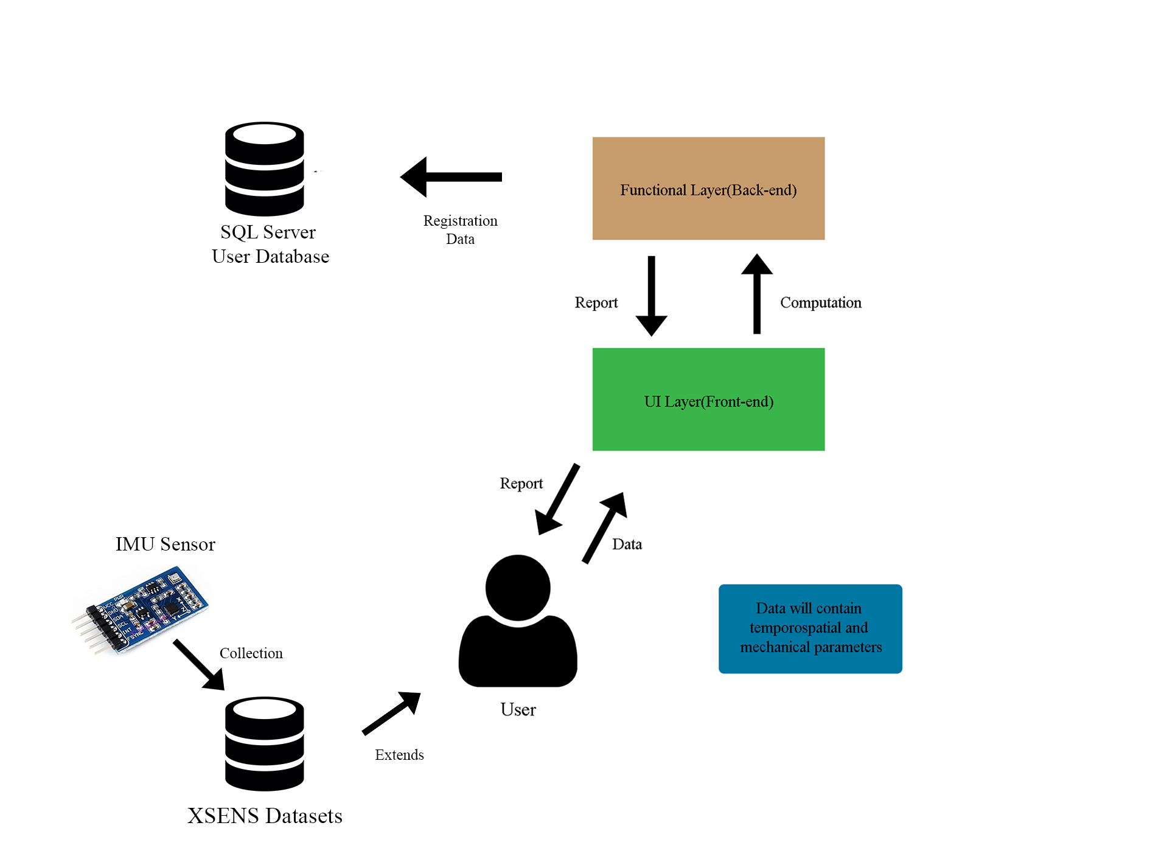

# 2. WORK PLAN

## 2.1. Work Breakdown Structure (WBS)

Figure 3. WBS for the project

|  |
| --- |
| 1 Gait Reporter   * 1. Planning      1. Brainstorm sessions      2. Paper Research      3. Literature Analysis      4. Examination   2. Data Set Exemination      1. Calculate Parameters         1. Left and Right Gait Cycles            1. Swing Stage            2. Stance Stage            3. Stride Time            4. Double Support            5. Velocity            6. Cadence         2. Joint Angles         3. Range of Motions            1. Knee            2. Ankle            3. Hips            4. Pelvis      2. Verify Software         1. Use Matlab to Analyze Data   3. Design      1. Define Attributes and Process      2. Examine Different Use Case Scenarios      3. Prototype a Proper Back-end Code Design      4. Design different UI/UX Solutions      5. Select the Proper UI/UX Design   4. Integration      1. Merge the Data from Different Teams      2. Select the Data Set      3. Push it Into Implementation Process   5. Implementation      1. Database Implementation      2. Back-end Coding      3. Front-end Coding   6. Testing      1. Unit Test      2. Integretion Test      3. System Test      4. User Test      5. Acceptance Test |

## 2.2 Responsibility Matrix (RM)

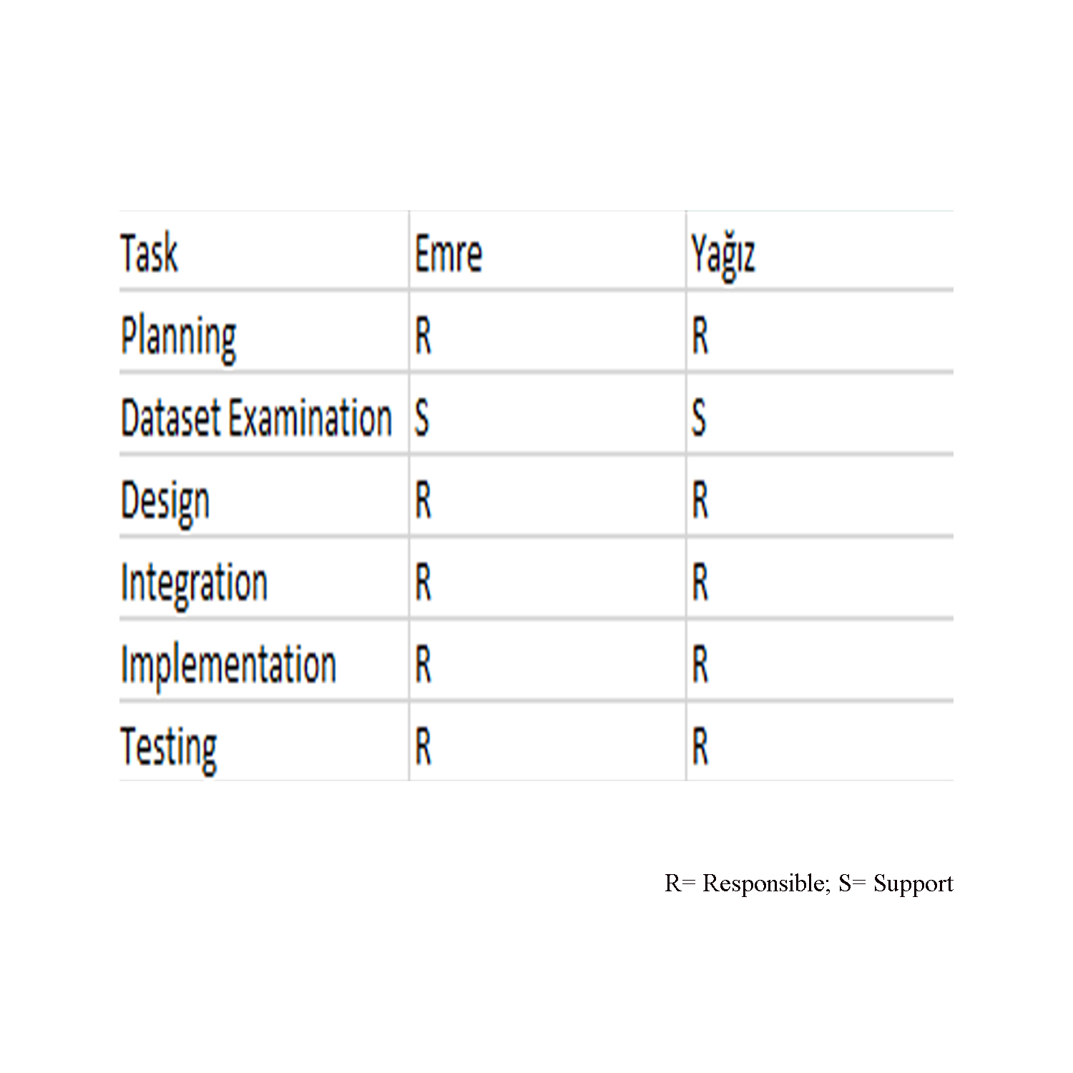 Table 1. Responsibility Matrix for the team.

|  |  |  |
| --- | --- | --- |
| Task | Abeer | Bara |
| 1.1.1.1 | R | S |
| 1.1.1.2 | R | S |
| 1.1.1.3 | S | R |
| 1.1.1.4 | S | R |
| 1.1.1.5 | R | S |
| 1.1.1.6 | S | R |
| 1.1.2 | S | R |
| 1.1.3.1 | R | S |
| 1.1.3.2 | S | R |
| 1.1.3.3 | R | S |
| 1.2.1 | S | R |

## 2.3. Project Network (PN)

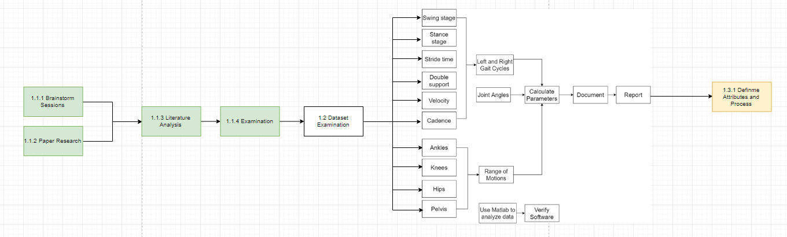

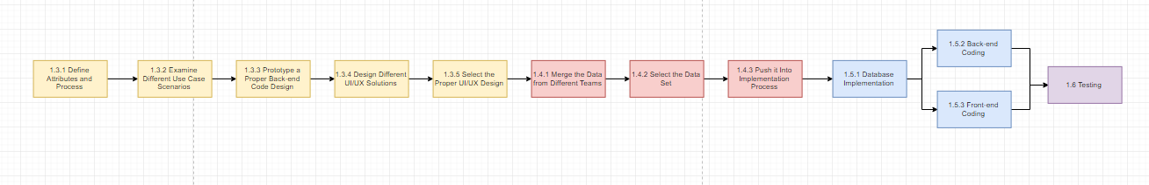

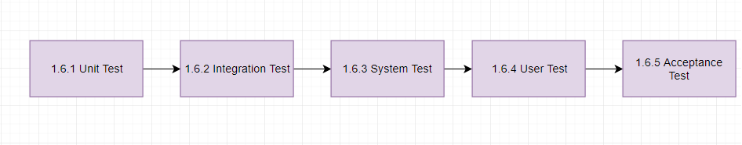

Figure 4. Project network

## 2.4. Gantt chart

Figure 5. Timeline for the project

# 

# 3. DESIGN PROCESS,

|  |  |  |  |  |
| --- | --- | --- | --- | --- |
| **Failure Event** | **Probability** | **Severity** | **Risk Level** | **Plan of Action** |
| Not enough data for the weighted report calculations. | Unlikely | Major | Medium | More subject data can be added from external datasets or can change the calculation algorithms. |
| COVID-19 Lockdown | Likely | Moderate | High | Interactive conferance apps must be used. More meetings should be held. |
| Calculation errors | Possible | Major | High | Can use alternative data normalization techniques. Can work on different sampe of data. |
| Data Leak | Unlikely | Major | Medium | Can create authentication procedures between dataset and the system. Can encrypte codes. |

# 3. DESIGN PROCESS

## 3.1. Biomedical Engineering

### 3.1.1 Task clarification

### 3.1.1.1 Definition of the problem and objectives

This gait reporter software will be used by physicians, specialists and researchers in hospitals, health centers, clinics, and labs to diagnose patients or help athletes improve their performance by giving a detailed report regarding the subject’s gait analysis.

### 3.1.1.2 Requirement specification

**i. Technical requirements**

The gait analysis reporter will be calculating and providing the temporospatial parameters which are necessary for gait analysis. The temporospatial gait analysis parameters are:

* **Stance Time**: It is the time the leg is in contact with the ground from initial contact (foot on) to toe off. This includes the single and double support time.

𝑆tance 𝑃hase = (𝑡𝑜𝑒𝑜𝑓𝑓 − ℎ𝑒𝑒𝑙𝑠𝑡𝑟𝑖𝑘𝑒 / GC) × 100%

* **Swing Time**: the time during which the one foot is in the air.

Swing phase = cycle time – stance phase time.

This can be represented as milliseconds or percentage.

𝑆wing 𝑃hase = (ℎ𝑒𝑒𝑙𝑠𝑡𝑟𝑖𝑘𝑒 − 𝑡𝑜𝑒𝑜𝑓𝑓 / GC) × 100%

* **Step Time** : period of time walking in which one foot heel strikes the ground till when the other foot heel strikes the ground. Therefore, it is calculated as such:

Step time (right foot) = heelstrike of left foot – heelstirke of right foot

Step time (left foot) = heelstrike of right foot – heelstrike of left foot

Normally, the step time of right foot and left foot is equal.

* **Stride Time**: the time spent between the initial contact of two consecutive footsteps of the same foot. The formula used to calculate this parameter is:

stride time = initial contact for footprint n°2 – initial contact for footprint n°1

OR stride time = step time of left foot + step time of right foot

* **Cadence (Step/min)**: is known as the rythm of walking or the frequency. It is calculated by = number of steps / time taken.
* **Double Support Time**: the time where both feet are in contact with the ground both supporting the body weight. This parameter is calculated by finding the intitial double support time and the terminal double support time and adding them together.

Initial double support = (last contact of the previous foot + 1 sample (for 60 Hz, it is

16.667 seconds)) – first contact of the current foot.

Final double support = (last contact of the current foot + 1 sample) – first contact of the next foot. Then, Total double support time = initial + final.

* **Swing Velocity (m/sec)** : the speed in the swing phase. It is calculated as:

Velocity = distance / time.

* **Stride Length (mm)** : is the distance between the point of first contact of one foot and the point of first contact of the opposite foot.

Stride length = the stride time x walking speed (m/s).

* **Step width (mm)** : the distance between the feet heels during the double support phase.
* **Mean Velocity (m/sec)** : the mean value of the velocities. The mean is calculated by summing the values and dividing by the number of values.
* **Toe off** : The point in which the foot is not in contact with the ground.
* **Heel strike** : The point in which the foot begins to touch the ground.

The error percentage is around 5%.

Some of the calculated knee, hip and ankle parameter plots are shown below:

Figure 6. Knees, ankles and hips flexion/extension plots

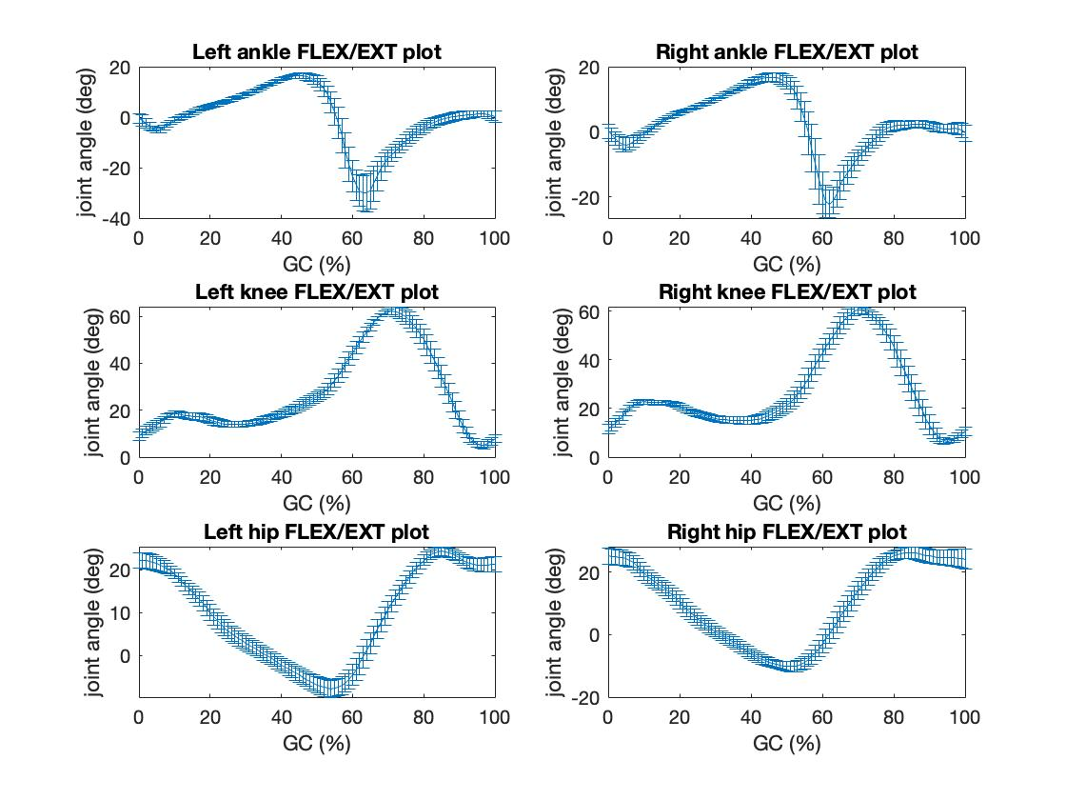

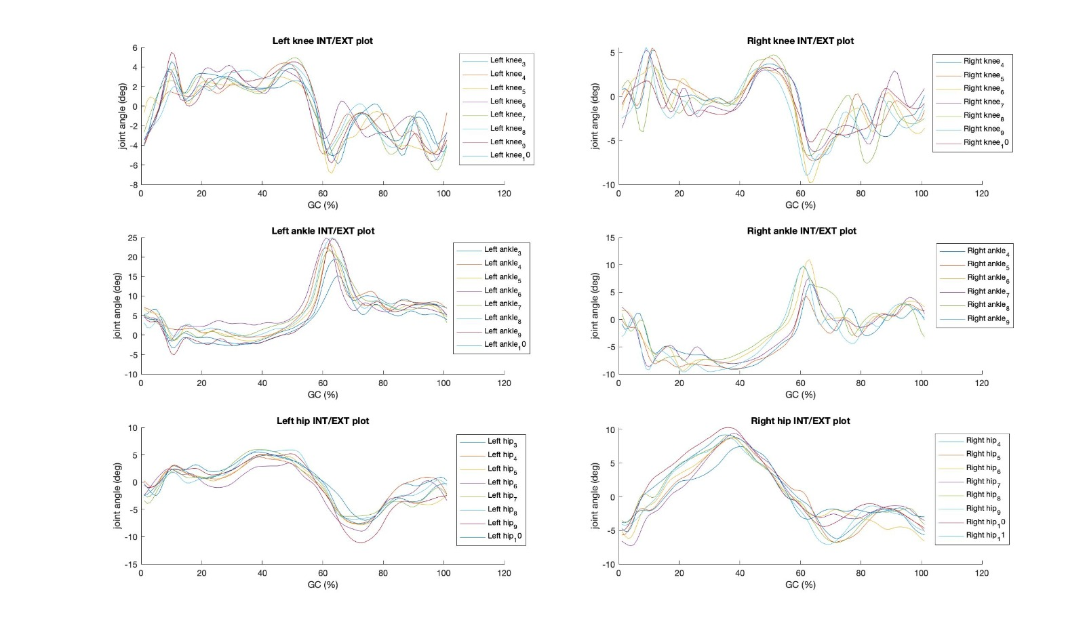 Figure 7. Knees, ankles and hips interior/exterior plots

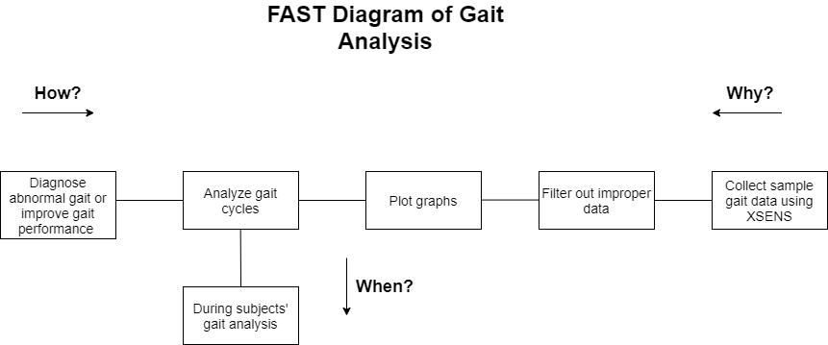

Figure 8. FAST Diagram of Gait Analysis

**ii. Business requirements**

|  |  |  |  |  |
| --- | --- | --- | --- | --- |
| Components |  |  | Price in € | Price in ₺ |
| XSENS DOT Set: | Includes | 1 | 495 | 4462 |
| - | XSENS DOT sensor | 5 | - | - |
| - | Charger and cable | 1 | - | - |
| - | XSENS DOT Software Development Kit (SDK) | 1 | - | - |
| XSENS DOT Strap SET | - | 1 | 100 | 901 |
| Total | - | - | 595 | 5363 |

**iii. Requlatory requirements**

In gait analysis laboratories, several equipments are used to gather and analyze data. Force plates, inertial sensors and motion capture systems are required to collect the kinetic data. Photographic systems and electrogoniometers are motion analysis systems that gather kinematic data. An electromyograph may be used to collect muscle related data and timings. Pedobarography may be used to study the plantar pressure distributions. Walkaways where force plates as well as cameras used together may also be required in labs. Body markers to apply the Oxford foot model method may also be used.

**iv. Device Classification**

For this project, XSENS and Matlab are mainly used. XSENS are 3-D inertial sensors and this device is a class 1 device with low risk.

### 3.1.2 Concept generation

To calculate the temporospatial parameters heel contact, heel off, toe on, and toe off values would be needed. There are two ways to calculate these values. First way is to use the foot velocity provided in the dataset and check if the velocity value is zero, then the heel or toe would be in contact with the ground. And if there is a velocity value then the part required would be off and not in contact with the ground. The second method is by the heel contact and toe contact data that were provided as boolean values in the dataset by using these data the timetable for the major events of the required values to be calculated would be shown. Another point to mention, calculating the step time for right and left feet may be an indicator if the gait is normal or not, since in a normal gait cycle, they must be equal.

### 3.1.3 Embodiment design

The algorithm of the Matlab code to analyze and filter out improper gait is as follows:

* Loading the data file of the subject and the necessary parameters
* Finding the locations of the parameters
* Creating cycles
* Plotting the cycles of the parameters
* Removing unwanted cycles by observing the data and applying limits to filter the proper data
* Plotting the newly adjusted cycles
* Normalizing cycles
* Plotting the normalized cycles for the parameters
* Combining the data
* Combining other parameters all together
* Finding the necessary values to calculate the temporospatial parameters.

### 3.1.4 Detailed design

The interface would startup as a login or sign up page where the credentials are entered. After the user gains access, three windows would be displayed:

* A report window which contains the calculated values and summary of data such as the means, standard deviation, etc.,
* A graph window which shows the appropriate plots
* A compare window in which subjects’ data would be comparable and viewed next to each other

### 3.1.5 Risk assessment

In this project there is no physical device being developed. An algorithm to calculate parameters and more information about gait cycles is being developed, hence there is no risk of dealing with physical issues since the only device that will be used is XSENS and that is already on the market therefore, its risk has been assessed and is a device class 1 so it has low risk and is safe for use. A possible risk may be that this project would require expertise in calculations of parameters so the data might not be as accurate as desired. Due to the unforturnate COVID-19 conditions, the data was not measured by XSENS as we were inable to access the university’s laboratory, therefore, previously measured data was provided to work on. Additionally, using wireless sensors may not capture the data efficiently.

3.1.6 Materialization

(an account of the build process and optimization) *Required only in the Final Report*

### 3.1.7 Evaluation Planning

The calculated plots and parameters will be tested and compared with the gold standards. The gold standard for calculation of temprospatial parameters is Visual3D C-motion which is able to analysis gait data efficiently using its automatic algorithm that detects events of interest such as heel contact and toe contact which can be detected with or without force platform, and the calculated plots will be compared with the gold standard model plots in the Visual3D C-motion.

Data will be gathered using XSENS dot sensors and the data transfer will occur using Bluetooth 5.0 + and android system for ease of data gathering and collecting and best performance however if the Bluetooth type 5.0 isn’t available then the device is compatible with Bluetooth 4.2 and that will affect the data accuracy in a negative way. The XSENS dot sensors are attached to the lower body: around the hips, on the thighs, on the calves, and on the feet by a strap on which will bought separately for the device. For upper body, the subject might wear a suit and wireless sensors are attached around the hands, on the wrists, on the upper arms and around the head.

## 3.9. Software Engineering

### 3.9.1 Interface Requirements

### 3.9.1.1 User Interfaces

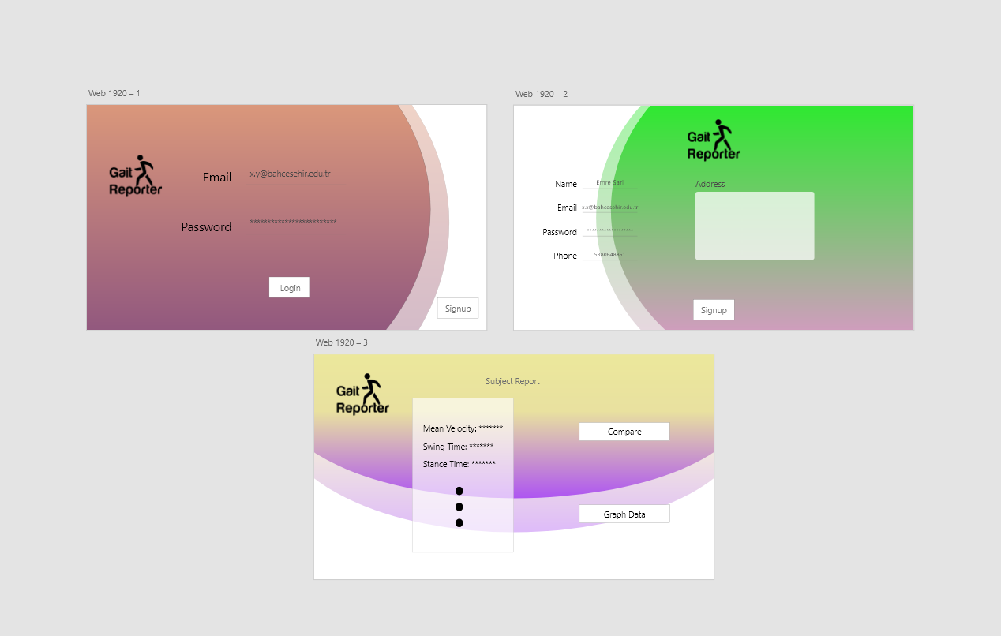

In this project, we have six action pages; signup, login, main page, compare page, feedback, and graph page. The system will be available to reach all of these actions, for the Admins, we have a special procedure that directs admins to the link of the database. And Users will be able to interact with each page. In further parts, we explained the detailed process interaction and activity flows.

### 3.9.1.2 Software Interfaces

Figure 6. Software Interfaces

In Figure 6, we created a software interface schema to visualize our idea. In detail, we used Python (ver. 3.9.1) for the software part. UI, functional part, and more will be designed and integrated using Python. In Python, we used several libraries, for example, we used matplotlib for data visualization, NumPy library used for data initialization, for the GUI we are going to use PyQt and PySide (these GUI libraries can change in the integration process). For the database part, we have five datasets and one database; five of them are from XSENS dataset, mostly Biomedical Engineering students are working on this datasets. In this datasets, we have complex gait data, our Biomedical team working on normalization, validation of this datasets, and calculation of needed parameters for the gait report (these calculations will be provided according to data on the XSENS datasets). SQL Server will be used on user's data, we will store the user's id, name, e-mail, etc. on this database. And our application is developing for PC generally for Windows 10 operating system. For data transmission, the user will give credentials to our software and it will be delivered to the SQL Server. And SQL Server can be used for authentication on the Log-In phase. From the XSENS datasets, we are going to collect measurement data and our software will execute calculation algorithms with this collected data.

### 3.9.2 Functional Requirements

### 3.9.2.1 Behaviors of the Software Application

|  |  |  |
| --- | --- | --- |
| **Actor Name** | **Name of Behavior** | **Description of Behavior** |
| *User* | *isLogin()*  *isSignUp()*  *giveFeedback()*  *showCompareSubject()*  *showDetailedRep()*  *showGraphs()* | *isLogin(); Returns result of login process.*  *isSignUp(); Returns result of SignUp process.*  *giveFeedback();Sends feedback data to SQL Server.*  *showCompareSubject();Returns data from selected subjects.*  *showDetailedRep(); Returns result of Detailed Report process.*  *showGraphs();Returns related data graphs.* |
| *System* | *calculateParameters()*  *listCompareSubject()*  *listDetailedReport()*  *listGraphs()* | *calculateParameters();*  *Returns result of calculation process.*  *listCompareSubjects(); Receive data from XSENS, forward data to UI.*  *listDetailtedReport(); Receive data from calculateParameters(), print it to the user.*  *listGraphs(); Receive data from XSENS, plot graph, print it to the user.* |
| *System Admin* | *listUsers()*  *accessDatabase()*  *removeUser()*  *editUser()* | *listUser(); Returns all User data from SQL Server.*  *accessDatabase();Direct admin to the dataset (XSENS Dataset).*  *removeUser(); Delete User data from SQL Server (for security purposes and management).*  *editUser(); Edit user credentials.* |

3.9.2.2 Attributes of the Software Application

|  |  |  |
| --- | --- | --- |
| **Actor Name** | **Name of Attribute** | * **Description of Attribute** |
| *User* | *user_id*  *user_name*  *user_pass*  *user_email*  *user_address*  *user_phone* | *user_id; ID of the User*  *user_name; Full name of the user*  *user_pass: Password of the User*  *user_email: E-mail of the User*  *user_address: Address of the User*  *user_phone: Phone nuber of the User* |
| *Subject* | |  | | --- | | *VerticalPelvisAxialBending* | | *VerticalPelvisFlexion*  *Extension* | | *RightHipFlxExt* | | *RightHipAddAbd* | | *RightHipIntExt* | | *RightKneeFlxExt* | | *RightKneeAbdAdd* | | *RightKneeIntExtRotation* | | *RightAnkleFlxExt* | | *RightAnkleAbdAdd* | | *RightAnkleIntExtRotation* | | *RightBallFootFlxExt* | | *RightBallFootIntExtRotation* | | *RightBallFootAbdAdd* | | *LeftHipFlxExt* | | *LeftHipAddAbd* | | *LeftHipIntExt* | | *LeftKneeFlxExt* | | *LeftKneeAbdAdd* | | *Left Knee Int/Ext Rotation* | | *Left Ankle Flx/Ext* | | *Left Ankle Abd/Add* | | *Left BallFoot Flx/Ext* | | *Left BallFoot Int/Ext*  *Rotation* | | *Left BallFootAbdAdd* |   *Right AnkleROM*  *Right AnkledfatIC*  *Right PeakAnkledf*  *Right FootProgAngle*  *Left AnkleROM*  *Left AnkledfatIC*  *Left PAnkledf*  *Left FootPorgAngle*  *Knee ROMSagittal*  *Knee flxatlc*  *Mean Knee Abduction/Adduction*  *Mean Knee InternalExternal*  *P Knee Flx*  *PKneeExt*  *PKneeExtAt1060*  *PkneeFlexTime*  *HipROMSagittal*  *PHipFlex*  *PhipExt*  *MeanHipRot*  *MeanHipAbd*   |  | | --- | |  | | *Vertical Pelvis Flexion/Extension – the flexion and extension angles of the pelvis*  *Right Hip Flx/Ext – the bending and extending angles of the right side of the hip*  *Right Hip Add/Abd - the abduction and adduction angles of the right side of the hip*  *Right Hip Int/Ext – the interior and exterior angles of the right hip*  *Right Knee Flx/Ext - the flexion and extension angles of the right knee*  *Right Knee Abd/Add - the abduction and adduction angles of the right knee*  *Right Knee Int/Ext Rotation - the interior and exterior rotation angles of the right knee*  *Right Ankle Flx/Ext - the flexion and extension angles of the right ankle*  *Right Ankle Abd/Add - the abduction and adduction angles of the right ankle*  *Right Ankle Int/Ext Rotation - the interior and exterior rotation angles of the right ankle*  *Right Ball Foot Flx/Ext - the flexion and extension angles of the right ball foot area*  *Right Ball Foot Int/Ext Rotation - the flexion and extension rotation angles of the right ball foot area*  *Right Ball Foot Abd/Add – the abduction and adduction angles of the right ball foot area*  *Left Hip Flx/Ext –* the bending and extending angles of the left side of the hip  *Left Hip Add/Abd –* the abduction and adduction angles of the left side of the hip  *Left Hip Int/Ext–* – the interior and exterior angles of the left hip  *Left Knee Flx/Ext–* – the flexion and extension angles of the left knee  *Left Knee Abd/Add–* the abduction and adduction angles of the left knee  *Left Knee Int/Ext Rotation–* – the interior and exterior rotation angles of the left knee  *Left Ankle Flx/Ext–* the flexion and extension angles of the left ankle  *Left Ankle Abd/Add–* the abduction and adduction angles of the left ankle  *Left Ball Foot Flx/Ext–* the flexion and extension angles of the left ball foot area  *Left Ball Foot Int/Ext Rotation–* the interior and exterior rotation angles of the left ball foot area*)*  *Left Ball Foot Abd/Add–* the abduction and adduction angles of the left ball foot area  *Right Ankle ROM – the movement of right ankle around the sagittal plane. (dorsiflexion and plantarflexion)*  *Right Ankle df at IC – angle of right ankle during dorsiflexion*  *Right Peak Ankle df – angle of right ankle peak dorsiflexion*  *Right Foot Prog. Angle – the foot progression angle of the right ankle*  *Left Ankle ROM - the movement of left ankle around the sagittal plane. (dorsiflexion and plantarflexion)*  *Left Ankle df at IC - angle of left ankle during dorsiflexion*  *Left P. Ankle df - angle of left ankle peak dorsiflexion*  *Left Foot Prog. Angle - the foot progression angle of the left ankle*  *Knee ROM Sagittal – the movement of the knee around the sagittal plane*  *Knee flx at Ic – the knee flexion angle at initial contact*  *Mean Knee abduction/adduction – the calculation of the mean of the knee abduction and adduction angles*  *Mean Knee Internal/External Rotation - the calculation of the mean of the knee internal and external rotation angles*  *Hip ROM Sagittal – the movement of the hip along the sagittal plane*  *Mean Hip rot. - the calculation of mean of the angles of rotation of the hip*  *Mean Hip abd – the calculation of mean of the angles of abduction at the hip* |
| *Weighted Subject* | *StanceTime*  *SwingTime*  *StrideTime*  *Cadence*  *DoubleSupport*  *SwingVelocity*  *StepWidth*  *MeanVelocity* | *Stance Time - It is the time*  *the leg is in contact with the*  *ground from initial contact*  *(foot on) to toe off. This*  *Swing Time - the time*  *during which the one foot is*  *in the air.*  *Stride Time (msec) - the*  *time spent between the*  *initial contact of two*  *consecutive footsteps of the*  *same foot.*  *Cadence (Step/min) - is*  *known as the rythm of*  *walking or the frequency.*  *Double Support Time*  *(msec) - the time where both*  *feet are in contact with the*  *ground both supporting the*  *body weight.*  *Swing Velocity (m/sec) – the*  *speed in the swing phase*  *Step width (mm) - the*  *distance between the feet*  *heels during the double*  *support phase.*  *Mean Velocity (m/sec) : the*  *mean value of the velocities.* |

### 

### 3.9.2.3 Design and Implementation

**Database Management System**

In this application, we are going to use Microsoft SQL Server 2019 for the user database. While we are coding on Python, it is not hard to set the connection between Python and Microsoft SQL Server. We are going to use the DB connection library. On the other hand, we have five different datasets from XSENS. The user is going to import these datasets into the application, we are going to describe these datasets' specifications.

**Database Schema**

This project contains one database and five different datasets from XSENS. The database contains user data; user id, user name, user password, user email, user address, and user phone. On the other hand, we have five different datasets; foot contacts, joint angles ZXY, segment position, segment velocity and ergonomic joint angles ZXY. Foot contacts contain; left foot heel and toe contact and right foot heel and toe contact. Joint angles ZXY contain; Right Hip Abduction/Adduction, Right Hip Internal/External Rotation, Right Hip Flexion/Extension, Right Knee Abduction/Adduction, Right Knee Internal/External Rotation, Right Knee Flexion/Extension, Right Ankle Abduction/Adduction, Right Ankle Internal/External Rotation, Right Ankle Dorsiflexion/Plantarflexion, Right Ball Foot Abduction/Adduction, Right Ball Foot Internal/External Rotation, Right Ball Foot Flexion/Extension, Left Hip Abduction/Adduction, Left Hip Internal/External Rotation, Left Hip Flexion/Extension, Left Knee Abduction/Adduction, Left Knee Internal/External Rotation, Left Knee Flexion/Extension, Left Ankle Abduction/Adduction, Left Ankle Internal/External Rotation, Left Ankle Dorsiflexion/Plantarflexion, Left Ball Foot Abduction/Adduction, Left Ball Foot Internal/External Rotation and, Left Ball Foot Flexion/Extension. In the end, we have ergonomic joint angles ZXY which contain; Pelvis Lateral Bending, Pelvis Axial Bending, Pelvis Flexion/Extension, Vertical Pelvis Lateral Bending, Vertical Pelvis Axial Bending, Vertical Pelvis Flexion/Extension, Vertical Lateral Bending, Vertical Axial Bending, Vertical Flexion/Extension.

**Database Physical Model**

First, let us explain our user database; in this database, we have only one table; the user accounts table. In this table, we are collecting user name as varchar(30), password as varchar(30) but in essential format (password can not contain less than 10 char and it must contain one upper case), address as varchar(250), email as varchar(40) and we defined email as a unique constraint because we don't want multiple accounts in one email address. We have the phone number as int(11) but in essential format (can not be less than 11 char) and again we defined the phone number as a unique constraint. In the end, we have our primary key which is the user id; this id will be generated by the system itself.

For the dataset analysis, we are going to divide this part into three pieces; Foot Contact Table, Joint Angle ZXY Table, Segment Position, Segment Velocity and Ergonomic Joint Angle ZXY Table. Before starting we must say all of these tables contain only double data type. For the Foot Contact Table, we have these parameters;

LeftFoot_Heel - If it is "1" that means left foot heel in contact with the ground and if it is "0" that means no contact.

LeftFoot_Toe - If it is "1" that means left foot toe in contact with the ground and if it is "0" that means no contact.

RightFoot_Heel - If it is "1" that means right foot heel in contact with the ground and if it is "0" that means no contact.

RightFoot_Toe - If it is "1" that means right foot toe in contact with the ground and if it is "0" that means no contact.

For the Joint Angle Joint Angle ZXY Table;

Vertical Pelvis Axial Bending - the angle made by the pelvis bending along the vertical axis

Vertical Pelvis Flexion/Extension – the flexion and extension angles of the pelvis

Right Hip Flx/Ext – the bending and extending angles of the right side of the hip

Right Hip Add/Abd - the abduction and adduction angles of the right side of the hip

Right Hip Int/Ext – the interior and exterior angles of the right hip

Right Knee Flx/Ext - the flexion and extension angles of the right knee

Right Knee Abd/Add - the abduction and adduction angles of the right knee

Right Knee Int/Ext Rotation - the interior and exterior rotation angles of the right knee

Right Ankle Flx/Ext - the flexion and extension angles of the right ankle

Right Ankle Abd/Add - the abduction and adduction angles of the right ankle

Right Ankle Int/Ext Rotation - the interior and exterior rotation angles of the right ankle

Right Ball Foot Flx/Ext - the flexion and extension angles of the right ball foot area

Right Ball Foot Int/Ext Rotation - the flexion and extension rotation angles of the right ball foot area

Right Ball Foot Abd/Add - the abduction and adduction angles of the right ball foot area

Left Hip Flx/Ext – the bending and extending angles of the left side of the hip

Left Hip Add/Abd – the abduction and adduction angles of the left side of the hip

Left Hip Int/Ext – the interior and exterior angles of the left hip

Left Knee Flx/Ext – the flexion and extension angles of the left knee

Left Knee Abd/Add – the abduction and adduction angles of the left knee

Left Knee Int/Ext Rotation – the interior and exterior rotation angles of the left knee

Left Ankle Flx/Ext – the flexion and extension angles of the left ankle

Left Ankle Abd/Add – the abduction and adduction angles of the left ankle

Left Ball Foot Flx/Ext – the flexion and extension angles of the left ball foot area

Left Ball Foot Int/Ext Rotation – the interior and exterior rotation angles of the left ball foot

area

Left Ball Foot Abd/Add – the abduction and adduction angles of the left ball foot area

For the Ergonomic Joint Angles ZXY;

Mean Hip rot. - the calculation of mean of the angles of rotation of the hip

Mean Hip abd – the calculation of mean of the angles of abduction at the hip

Vertical Pelvis Axial Bending – the angle made by the pelvis bending along the vertical axis

Vertical Pelvis Flexion/Extension – the vertical angle of flexion and extension of the pelvis

Vertical Pelvis Lateral Bending – the angle made by the pelvis bending laterally

For the Segment Position;

Right foot x – the position of the right foot on the x-axis plane

Right toe x – the position of the right toe on the x-axis plane

Right foot y – the position of the right foot on the y-axis plane

Right toe y – the position of the right toe on the y-axis plane

Left foot x – the position of the left foot on the x-axis plane

Left toe x – the position of the left toe on the x-axis plane

Left foot y – the position of the left foot on the y-axis plane

Left toe y – the position of the left toe on the y-axis plane

For the Segment Velocity;

Head x – the velocity of the head in the x-axis plane

Right foot y – the velocity of the right foot in the y-axis plane

Left foot y – the velocity of the left foot in the y-axis plane

Right toe x – the velocity of the right toe in the x-axis plane

Left toe x – the velocity of the left toe in the x-axis plane

**Completed Database Screenshots**

User Database;

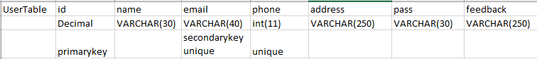

XSENS Datasets;

*Foot Contacts Table;*

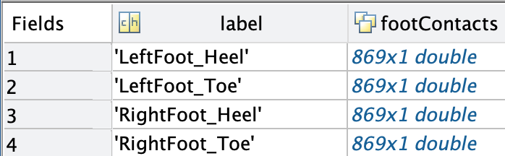

Figure10. Foot contacts table

Figure 11. Joint Angles ZXY Table;

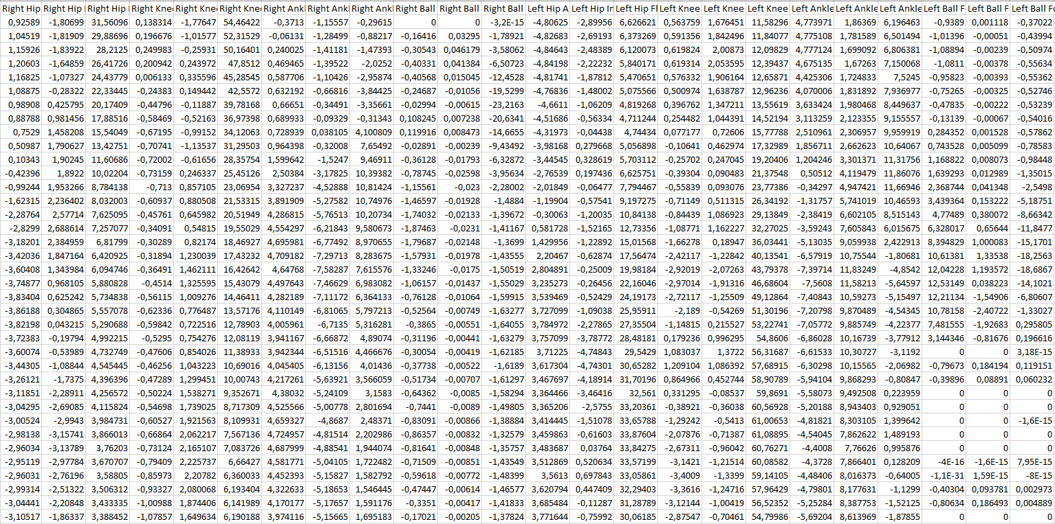

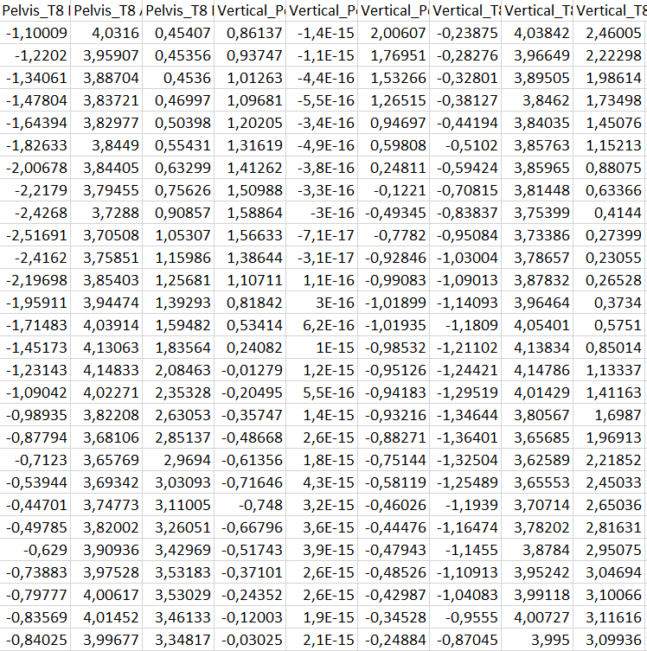 Figure 12. Ergonomic Joint Angles ZXY Table;

### 3.9.3 Nonfunctional Requirements

### 3.9.3.1 Performance Requirements

For the user to have a good impression during the opening of the application, the opening time of the application should not exceed 2-3 seconds. If the application responds to the requests of the users late, it will affect the application usage extremely badly and the shorter the response time, the more the user will be satisfied. The workload of a system must be high. If the users increase, this situation will decrease, but the fact that the data in the system is not well-written and the application infrastructure established on a good server will help to overcome this situation. The fact that there is a lot of trouble in the application will affect the performance very badly and cause complaints in the system. The user interface being very comfortable and understandable is a very important factor for performance. If the interface is mixed and not user friendly, it can decrease the performance. Backup time is very important in the system. This time should not exceed 1 day. Otherwise, it may lead to bad reasons for performance. In such cases, the user must be informed beforehand.

### 3.9.3.2 Safety Requirements

Some factors can be dangerous in our product. It is an important security factor for us to steal the items in our database and sell people's data to 3rd party applications, except for Bahcesehir University students or faculty members. Instead of presenting the database in our product in a public way, we are planning to define it privately by giving some competencies to the users in our system and to move beyond this situation. The data of the users will be stored in our system in accordance with the data processing law and will not be shared in any way with a 3rd party application. On this reliability factor, we will provide security and reliability according to **ISO/IEC 9126** certification quality standards. In the Software Engineering department, we classify these requirements as "quality in use requirements". In light of this, we must define reasonable levels of risk of harm to people, businesses, and any environment. For this reason, we created a close-end system for the University members and our application will not allow any unknown login into the system.

### 3.9.3.3 Security Requirements

For security requirements, we will keep our users safe by preventing the breach of passwords after any cyber attack on our system by putting a lower or uppercase letter requirement and a password creation ban of fewer than 10 digits. The user ids and passwords entered by the users to log into the system will be kept in the database by the system, and nobody will be allowed to access this area. Since the passwords will be changed in case of a possible cyberattack, authentication will be sent to the user's mail and this situation will be avoided. Since data confidentiality is very important, the sharing of these data will be prevented and everyone can only view their own data. The security policy will be determined according to **ISO / IEC 27001** standards and security will be provided according to these standards.

### 3.9.3.4 Software Quality Attributes

In the Software Engineering environment, we classify our quality attributes into two titles; external attributes and internal attributes. Internal attributes are based on the software itself, flexibility, portability, and attributes like readability are belong to this category. In other words, we can clearly say this category is mostly related to the development side of the application. On the other hand, external attributes are based on the use of the software. Correctness, usability, and attributes like efficiency belong to this category. While we are doing a calculation based application, we have some priorities. First of all, our application must have the correct results. In this aspect of correctness, we need to generate accurate calculation algorithms, need to delete corrupted and un-usable data from our database/dataset. On the other hand, we must provide a high-level reliability process to our users. Our application will be used in the sports and medical environment, so the application must maintain its level of performance. It is important because in this environment you need to be accurate otherwise, the application can provide incorrect information to the user and the user (in this example doctors and etc.) can misdiagnose and it can affect the patient in a bad way. In short, this application directly affects the health of the patient, it must be accurate. For efficiency, we need to define our calculations briefly and need to write code in the most efficient way. In that case, we simplified our algorithms and tried to get less LOC on this project. This attribute is not much important as reliability and correctness but in any software application efficiency is an essential attribute. As I mentioned before, we tried to get simplified algorithms for our project, and on the other hand, we don't have complex code blocks in our application and these code blocks are flexible so developers can easily make a change on code/software. This will provide a high level of maintainability and flexibility. According to this information, we can clearly say testability is sub characteristic of maintainability. Testability is necessary for this project because we need to be accurate and we are working in the health environment. So we need to test each part easily and produce an application with the least possible error/bug. For the portability part, we have an adaptable and easy to install application but we can't say it is portable because the application will work in a closed environment. In the case of usability, we defined a simple UI and clarified actions on our application. It is easy to learn and use. Users can find and execute everything easily in our application. In the end, for further works, we can talk about readability, reusability, and understandability. As we mentioned before, we tried to simplify our algorithms as much as we can and we didn't create complex code blocks on our application. Within the necessary permissions, this application will be easily re-used in any related work.

### 

### 3.9.3.5 Business Rules

* The user's email must be an "bahcesehir university" mail.
* The user's password must contain a minimum of 10 characters and at least 1 uppercase letter.
* The user cannot access the system database.
* The system name is used to fix the system when a problem occurs in the system.
* The admin has to make the database private against cyber attacks.
* The admin has to keep the user's passwords in the system in a way that nobody can access it.
* The admin is obliged to block the persons trying to access the system, except for "Bahcesehir University" members.
* The user has to accept the processing of his data.
* The protection of the user's data will be protected in accordance with the data protection law.

### 3.9.4 Use-case Modeling

### 3.9.4.1 Actor Glossary

* User; Customer, Sports Analyst, Doctor and etc. Generally user of our application.
* System Admin; In this Project, developers. Admin can access everything related to the system.
* System; Functional part of our software application
* Subject; Subjects that we collected gait data from.

### 3.9.4.2 Use-case Glossary

|  |  |  |
| --- | --- | --- |
| **Use-case Name** | **Description** | **Participating Actors** |
| *Log-in* | *User will log-in to the system* | *User, System* |
| *Sign-up* | *User will sign-up to the SQL Server* | *User,System* |
| *Show Detailed Report* | *User will list the selected subject’s report* | *User,System* |
| *Show Performance Graphs* | *User will list the selected subject’s graph report.* | *User,System* |
| *Feedback* | *User will send feedback to the system.* | *User,System* |
| *Compare* | *User will compare two selected subjects.* | *User,System* |

### 3.9.4.3 Use-case Scenarios

|  |  |
| --- | --- |
| **Use-case Name** | *Sign-up* |
| **Use-case Description** | *Signing up into our software application system with needed parameters.* |
| **Actors** | *User*  *System* |
| **Pre-Condition** | *User’s device must be connected to a network*  *User must be the part of “Bahcesehir University”*  *System must be available* |
| **Post-Condition** | *Registered successfull*  *User directed to the log-in page* |
| **Normal Flow** | *Step1: Application started*  *Step2: User accessed the sign-up page*  *Step3: User entered credentials and information.*  *Step4: Credentials recieved by System*  *Step5: Credentials are accepted by System*  *Step6: SQL Server fetch the user data*  *Step7: Successful report recieved by the System*  *Step8:* User registered  *Step9:* *Main-page provided* |
| **Alternate Flow** | *Alter-Step5:Unvalid credentials recieved*  *Alter-Step6: Unvalid information provided to user.*  *Alter-Step7: Unvalid parts cleared by System*  *Alter-Step8: User directed to the Step3.* |
| **Business Rules** | *User must be the part of “Bahcesehir University”*  *User must have a password with at least 10 characters and at least one upper case*  *User mut provide correct contact information*  *Username can not include ASCII characters*  *Password can not include ASCII characters*  *Phone number should be in valid form and cannot be more than 11 digit.* |

|  |  |
| --- | --- |
| **Use-case Name** | *Login* |
| **Use-case Description** | *Logging into our software application system with credentials.* |
| **Actors** | *User*  *System* |
| **Pre-Condition** | *User’s device must be connected to a network*  *User must be signed up*  *User must remember his/her credentials*  *System must be available* |
| **Post-Condition** | *Transaction is registered in the activity log*  *Authentication successful*  *Application main-page access.* |
| **Normal Flow** | *Step1: Application started*  *Step2 : User enters username and password*  *Step3 : SQL Server validates user’s username and password*  *Step4: Authentication successful report received by Python/System.*  *Step5: System will allow user to show mainpage*  *Step6: Main-page provided* |
| **Alternate Flow** | *Alter-Step4/1: Invalid user-name report received by Python/System.*  *Alter-Step5/1: System provided invalid user-name information to the user*  *Alter-Step6/1: System directed User to the Step2.*  *Ater-Step4/2: Invalid password report received by Python/System.*  *Alter-Step5/2: System provided invalid password information to the user.*  *Alter-Step6/2: System directed User to the Step2.*  *Alter-Step5/5/2: 3 Invalid password attempts*  *Alter-Step5/6/3: System will block log-in action for 15 min.* |
| **Business Rules** | *User can not enter his/her password wrong more than 5 times.*  *User must be signed-up.* |

|  |  |
| --- | --- |
| **Use-case Name** | *Show Detailed Report* |
| **Use-case Description** | *In this use-case, user will select one of the subject from XSENS datasets, and system will print detailed report of the subject* |
| **Actors** | *User, System* |
| **Pre-Condition** | *User must be signed-up.*  *User must logged-in.*  *System must be available.*  *User’s device must be connected to a network.* |
| **Post-Condition** | *Detailed report of the selected subject printed.* |
| **Normal Flow** | *Step1: The user accessed the mainpage.*  *Step2: The system send “browse” action to the user for the dataset selection.*  *Step3: The user selected datasets.*  *Step4: The system showed a message box “Dataset succesfully imported”.*  *Step5: The user selected the subject.*  *Step6: The system fetched selected subjects data from datasets.*  *Step7: The system run the calculation method*  *Step8: The system printed detailed report to the user.* |
| **Alternate Flow** | *Alter-Step5/1: The user selected subject that did not exist.*  *Alter-Step5/2: The system printed a message box to the user “Subject did not found”.*  *Alter-Step5/3: The system directed the user to the Step2.*  *Alter-Step4/1: The system showed a message box “Invalid dataset format”.*  *Alter-Step4/2: The system directed user to the Step2.* |
| **Business Rules** | *User can not share printed data without permission.* |

|  |  |
| --- | --- |
| **Use-case Name** | *Show Performance Graphs* |
| **Use-case Description** | *In this use-case, user will select one of the subject from XSENS dataset, and system will get the data from datasets and generate graph report of the data.* |
| **Actors** | *User, System* |
| **Pre-Condition** | *The user must be signed-up.*  *The user must logged-in.*  *System must be available.*  *User’s device must be connected to a network.* |
| **Post-Condition** | *Graph data of the selected subject generated and listed.* |
| **Normal Flow** | *Step1: User accessed the main page.*  *Step2: The system send “browse” action to the user for the dataset selection.*  *Step3: The user selected datasets.*  *Step4: The system showed a message box “Dataset succesfully imported”.*  *Step5: The user selected the subject.*  *Step6: The system fetched selected subjects data from datasets.*  *Step7: The system run the plotgraphs function.*  *Step8: System printed detailed graphs to the user.* |
| **Alternate Flow** | *Alter-Step5/1: User selected subject that did not exist.*  *Alter-Step5/2: System printed a message box to the user “Subject did not found”.*  *Alter-Step5/3: System directed the user to the Step2.* |
| **Business Rules** | *The user can not share printed data without permission.* |

|  |  |
| --- | --- |
| **Use-case Name** | *Feedback* |
| **Use-case Description** | *The user gives a feedback to the system.* |
| **Actors** | *User, System* |
| **Pre-Condition** | *The user must be signed-up.*  *The user must logged-in.*  *System must be available.*  *User’s device must be connected to a network.* |
| **Post-Condition** | *It is detected by the feedback system and kept in the database.*  *After the evaluation, the thanks message is shown to the user.* |
| **Normal Flow** | *Step1:* The user accessed the main page.  Step2: The user clicked on the "give feedback" button.  *Step3: System provided feedback interface to the user.*  *Step4:* The user typed his/her comment, recommendation, etc. about the application.  Step5: The user clicked on the “send” button.  Step6: The system transferred the feedback data to the SQL Server.  *Step7: The system showed message box to the user; Thanks for the feedback.* |
| **Alternate Flow** | *Alter-Step6: The system detected more than 250 characters on feedback text.*  *Alter-Step7: The system showed message box to the user; Feedback can not be more than 250 characters.*  *Alter-Step8: The system directed user into Step4.* |
| **Business Rules** | *The user can not share printed data without permission.*  *The user can not compare more than two subjects.* |

|  |  |
| --- | --- |
| **Use-case Name** | *Compare* |
| **Use-case Description** | In this use case, weighted parameters from two different subjects will be printed. |
| **Actors** | *User, System* |
| **Pre-Condition** | *The user must be signed-up.*  *The user must logged-in.*  *System must be available.*  *User’s device must be connected to a network.* |
| **Post-Condition** | The weighted scores and difference between the subjects printed. |
| **Normal Flow** | *Step1:* The user accessed the main page.  *Step2: The user clicked on “compare” button.*  *Step3: The system generated “browse” action for subject 1.*  *Step4: The user selected first subject’s datasets.*  *Step5: The system generated “browse” action for subject 2.*  Step6: *The user selected second subject’s datasets.*  Step7: The user clicked on the “compare now” button.  Step8: The system accessed the datasets and fetch subjects’ data.  *Step9: The system calculated weighted parameters for the both subjects.*  *Step10: The system printed compare data to the user.* |
| **Alternate Flow** | *Alter-Step7/1/1: The system showed message box to the user;*  *“First subject’s datasets are invalid”*  *Alter-Step7/1/2: The system directed user to the Step3.*  *Alter-Step7/2/1: The system showed message box to the user;*  *“Second subject’s datasets are invalid”*  *Alter-Step7/1/2: The system directed user to the Step3.* |
| **Business Rules** | *The user can not share printed data without permission.*  *The user can not compare more than two subjects.* |

### 3.9.4.4 Use-case Diagram

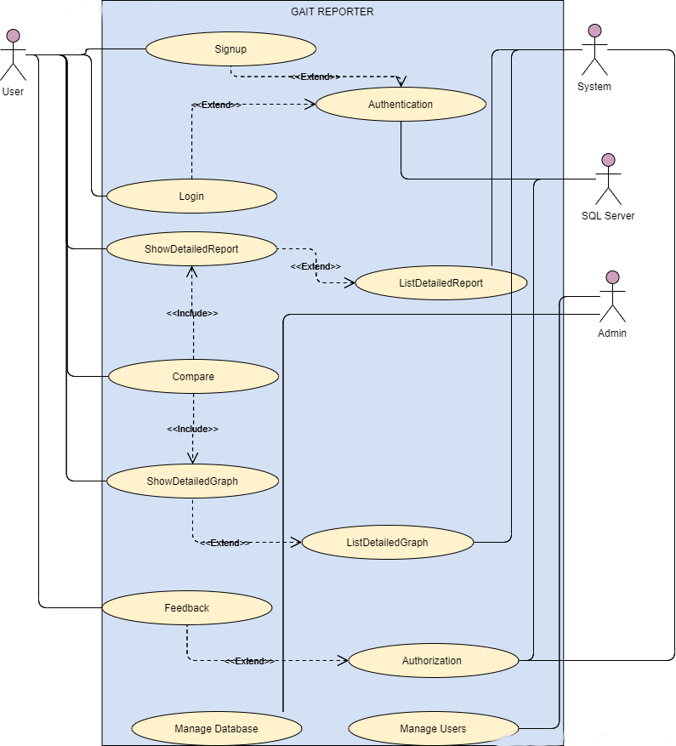

### 3.9.5 Data Modeling

### 3.9.5.1 Activity Diagram

Activity Diagram 1: Signup

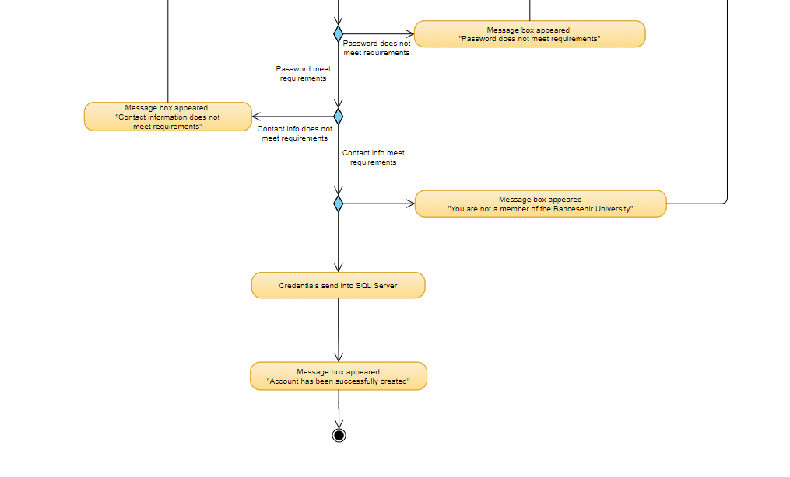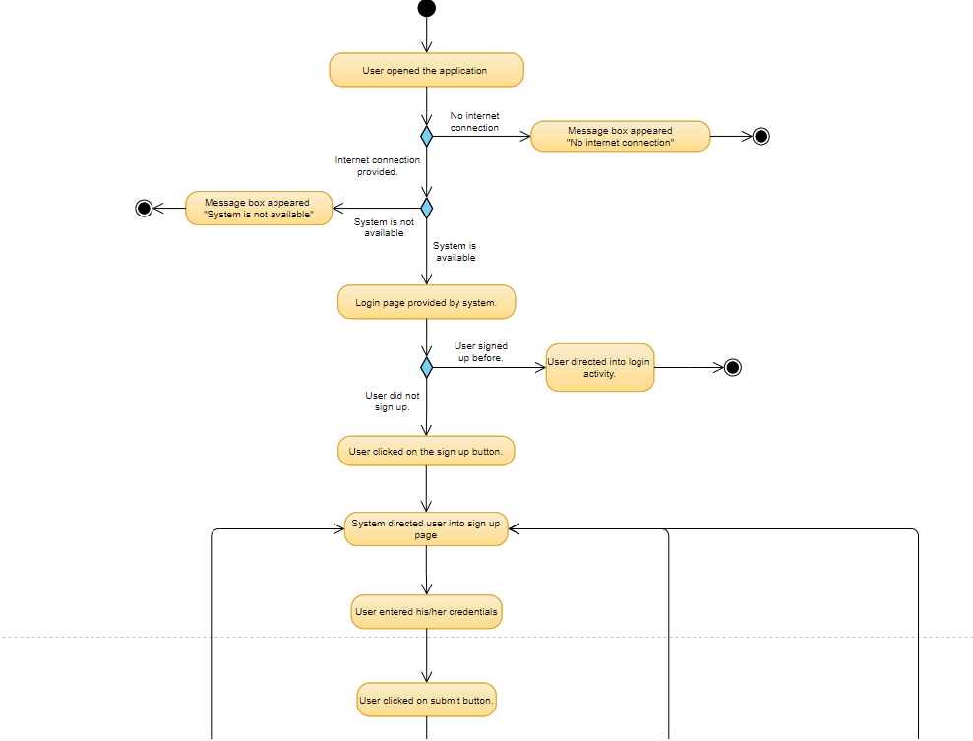

Activity Diagram 2: Login

### 

Activity Diagram 3: Show Detailed Report

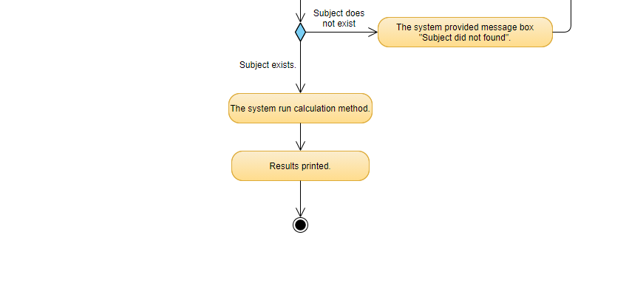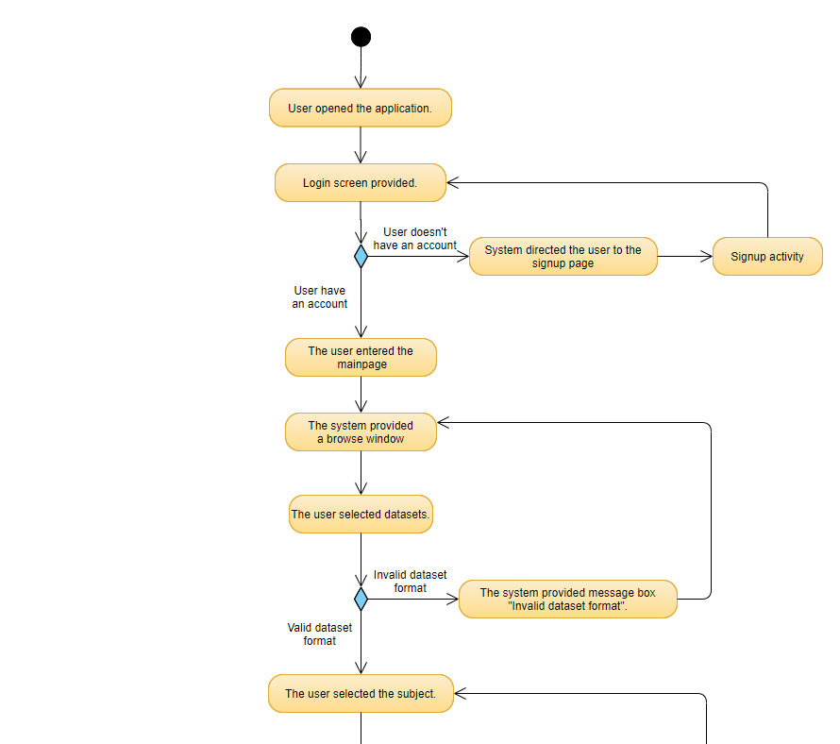

Activity Diagram 4: Show Detailed Graphs

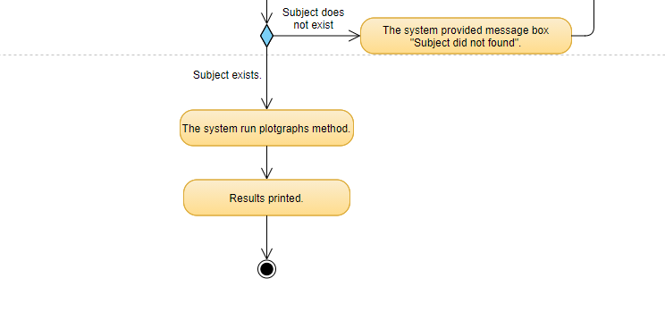

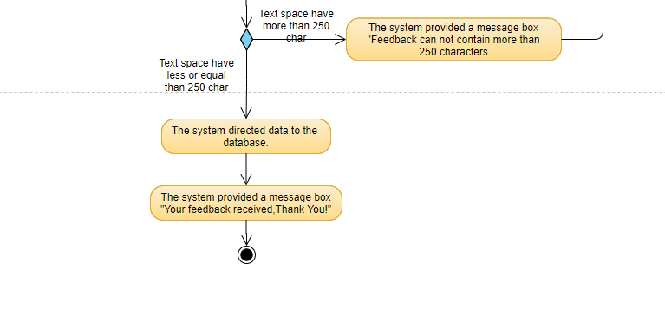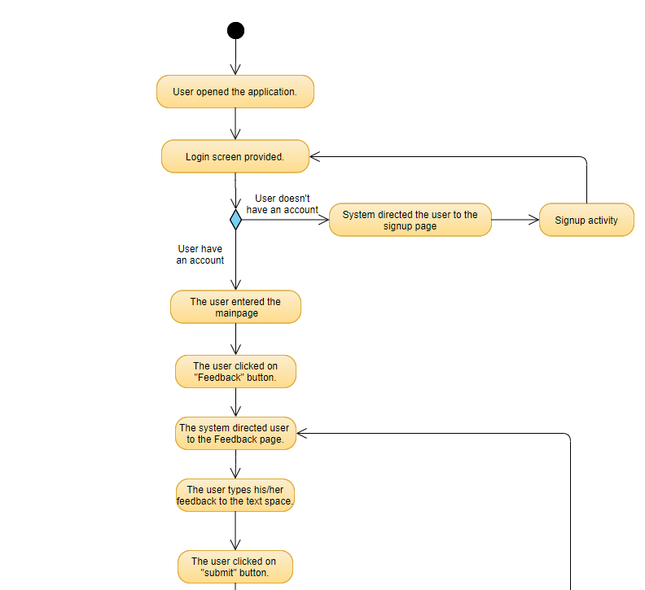Activity Diagram 5: Feedback

Activity Diagram 6: Compare

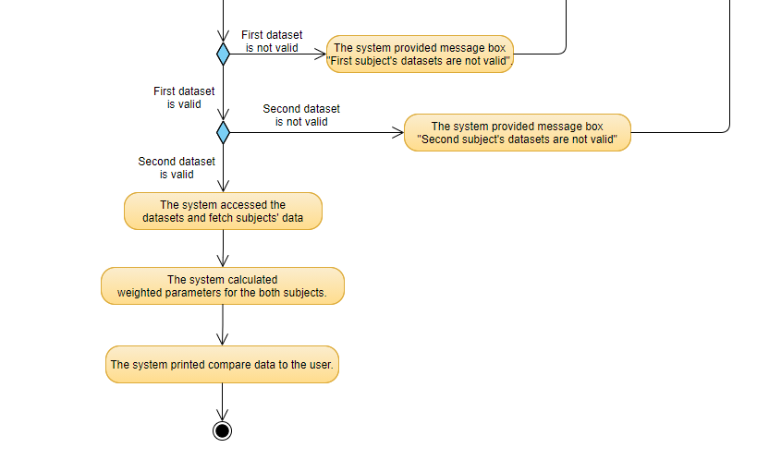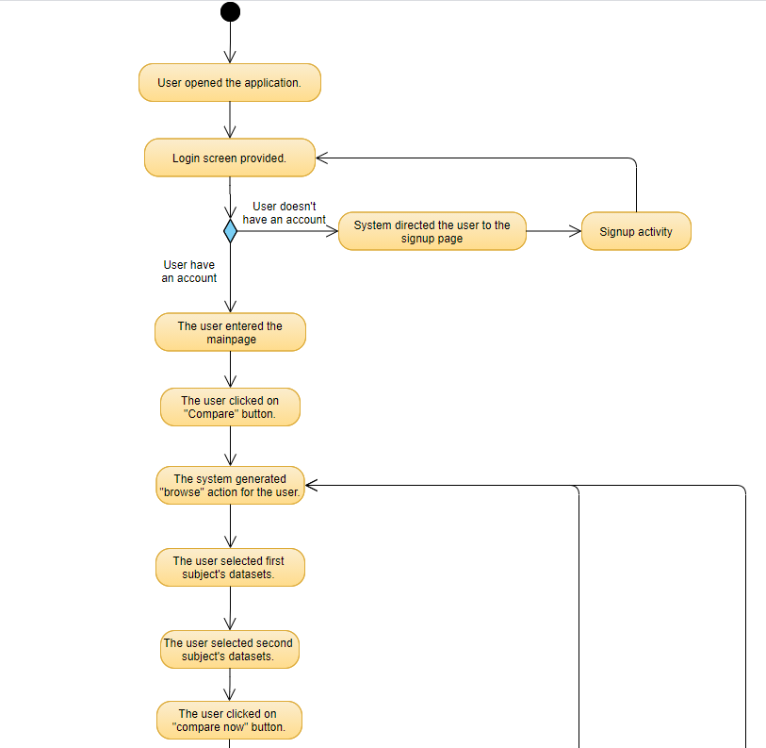

### 3.9.5.2 Sequence Diagrams

Sequence Diagram 1 Signup:

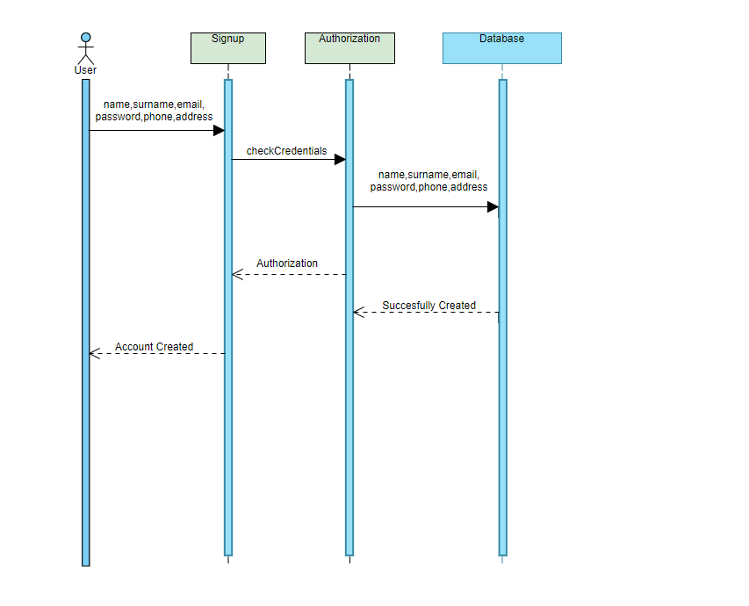

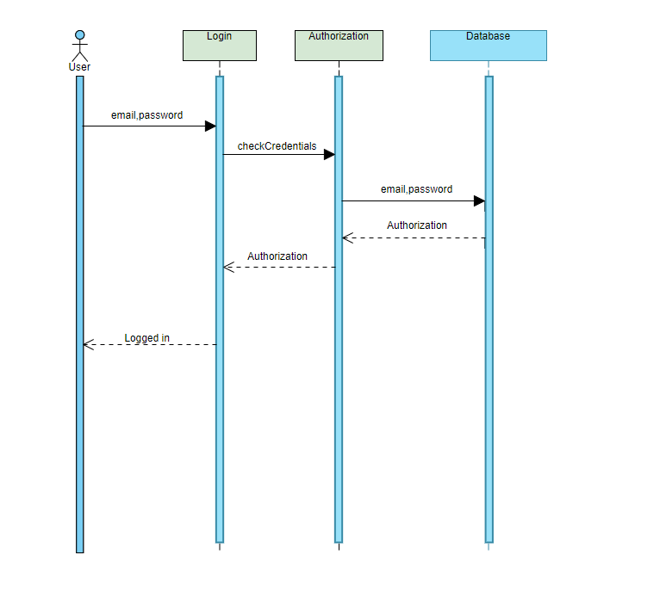Sequence Diagram 2 Login:

### 3.9.5.3 Process Diagram

Sequence Diagram 3 Show Detailed Report:

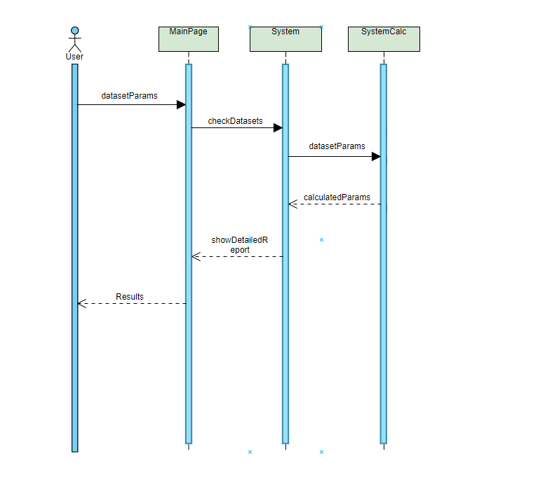

Sequence Diagram 4 Show Detailed Graph:

### 

Sequence Diagram 5 Compare:

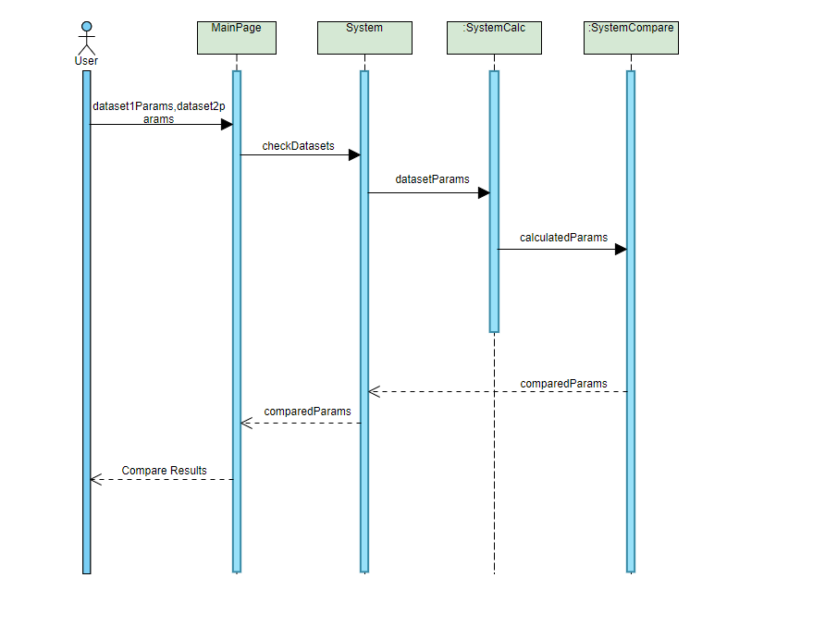

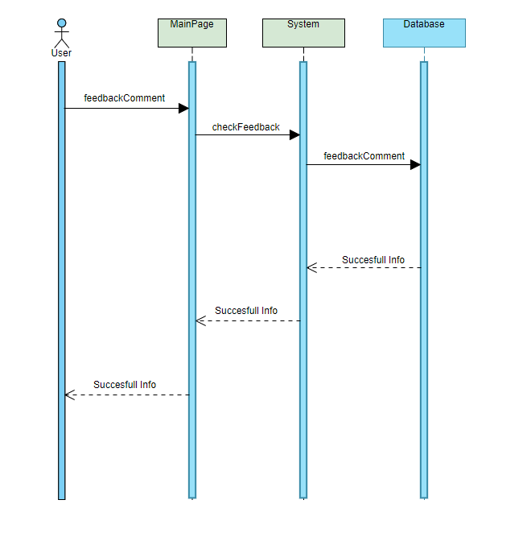Sequence Diagram 6 Feedback:

### 3.9.5.4 Data Flow Diagram

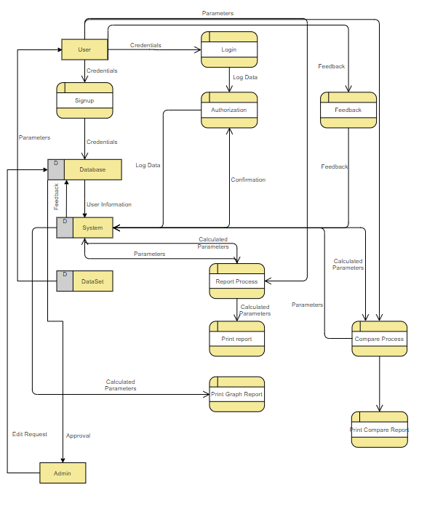

### 3.9.5.5 Design/Block Diagram

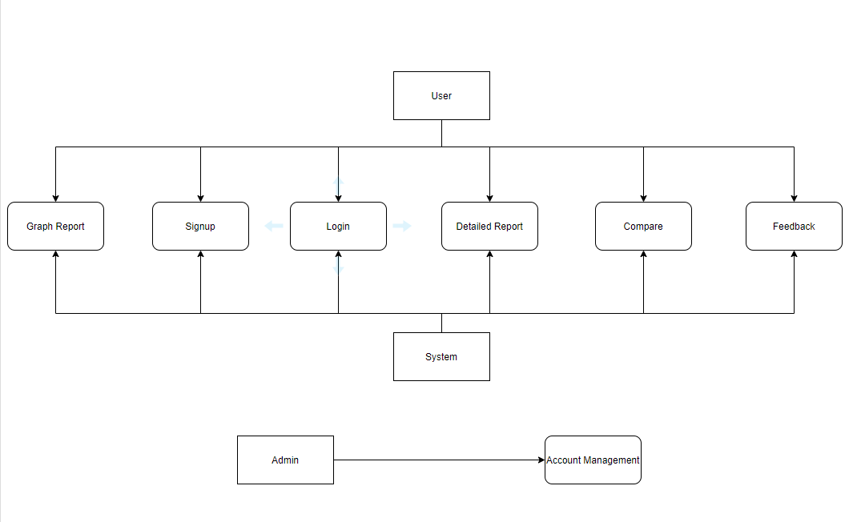

### 3.9.5.6 Object Diagram

### 3.9.5.7 Class Diagram

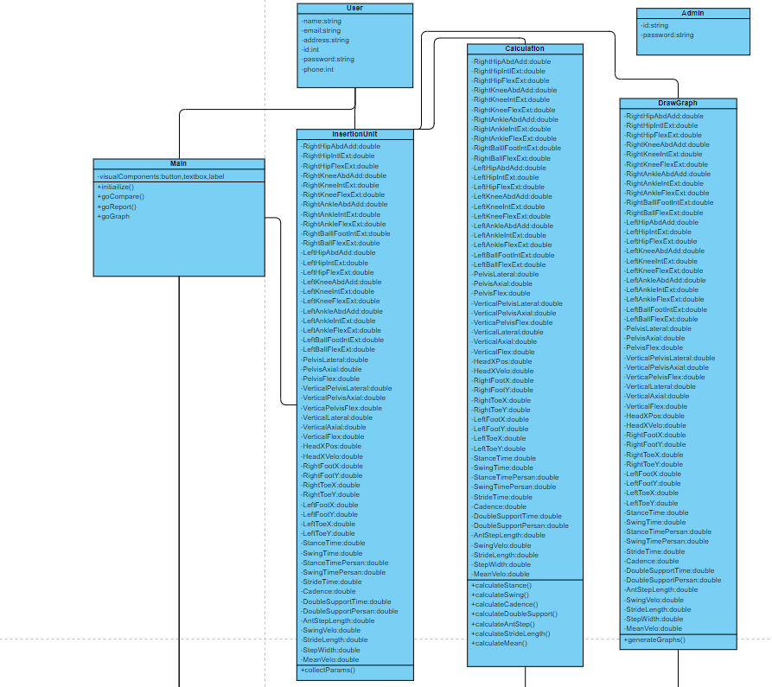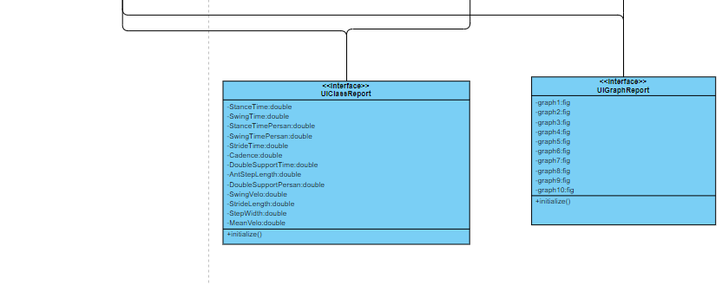

# 4. COSTS

|  |  |  |  |  |
| --- | --- | --- | --- | --- |
| Components |  |  | Price in € | Price in ₺ |
| XSENS DOT Set: | Includes | 1 | 495 | 4462 |
| - | XSENS DOT sensor | 5 | - | - |
| - | Charger and cable | 1 | - | - |
| - | XSENS DOT Software Development Kit (SDK) | 1 | - | - |
| XSENS DOT Strap SET | - | 1 | 100 | 901 |
| Total | - | - | 595 | 5363 |

# 5. CONCLUSION

A gait analysis reporter is being developed by several stages. An algorithm that calculates the temporospatial parameters and plots the graphs of the parameters is created. The data is provided through XSENS. The algorithm has been created through Matlab. In the upcoming semester, the project will be further expanded by using it with more subjects and the accuracy will be adjusted better. As well as comparing the calculated data to the gold standard by visual 3-D C- Motion. For the software application, the general design concept of the software is planned, user interfaces generated, each use case defined, dataset and database model defined, and at the end, a general design plan of the gait reporter application has been created. For the further, created equations will be translated into code for the functional part of the application, then the user interface will be integrated next semester.

# ACKNOWLEDGEMENT

# REFERENCES

1. ISO website (<https://www.iso.org/>).
2. A.H.A.Razak, A. Zayegh, R.K. Begg, and Y.Wahab, “Foot plantar pressure measurement system: A review,” Sensors, vol. 12, no. 7, pp. 9884–9912, 2012.
3. P. Gope and T. Hwang, “BSN-care: A secure IoT-based modern healthcare system using body sensor network,” IEEE Sensors J., vol. 16, no. 5, pp. 1368–1376, Mar. 2016.
4. Sumit Majumder , Tapas Mondal, and M. Jamal Deen, “A Simple, Low-Cost and Efficient Gait Analyzer for Wearable Healthcare Applications”, IEEE SENSORS JOURNAL, VOL. 19, NO. 6, Mar. 2019.
5. S. Majumder, T. Mondal, and M. J. Deen, “Wearable sensors for remote health monitoring,” Sensors, vol. 17, no. 1, p. 130, 2017.
6. G. Fortino, R. Giannantonio, R. Gravina, P. Kuryloski, and R. Jafari, “Enabling effective programming and flexible management of efficient body sensor network applications,” IEEE Trans. Human-Mach. Syst., vol. 43, no. 1, pp. 115–133, Jan. 2013.
7. <https://www.researchgate.net/publication/232173052_Technology_Overview_The_Gait_Analysis_Laboratory>
8. <https://www.obl.msu.edu/gait.htm>
9. <https://www.protokinetics.com/measuring-spatiotemporal-parameters-time-stance-phase/>
10. <https://www.sciencedirect.com/topics/immunology-and-microbiology/stride-time#:~:text=Stride%20time%20may%20be%20calculated,right%20and%20left%20step%20times.&text=Thus%2C%20an%20athlete%20who%20produces,is%20completed%20every%201.2%20seconds>).
11. <https://c-motion.com/products/visual3d>
12. [https://buy.XSENS.com/products](https://buy.xsens.com/products)
13. [https://base.XSENS.com/hc/en-us/articles/360011043959-Frequently-asked-questions-](https://base.xsens.com/hc/en-us/articles/360011043959-Frequently-asked-questions-)
14. <https://www.hindawi.com/journals/crim/2010/417806/tab1/>
15. <https://core.ac.uk/download/pdf/154470261.pdf>
16. Kinetic gait analysis using inertial motion capture by angelos karatsidis
17. https://aokhealth.securestand.com/xq/ASP/ProductID.614/qx/PDF/Using%20a%20Goniometer%20Effectively.pdf

# APPENDIX A

# APPENDIX B