**Purpose of the Project:**

You can upload your excell documents the TestRail with this application at once.

**How does it work?**

By logging into TestRail, you can view projects defined for yourself. After choosing the project, the suites to which test cases can be loaded are listed here. You can select the suite and then select all the csv files you want to upload from your computer. Finally, the process is completed with the Upload button.

**User Interface TestRailApp**

1. **Login Page**

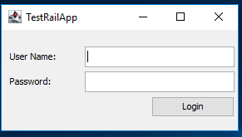

User Name : Testrail user name

Password : Testrail password

1. **Import Page**

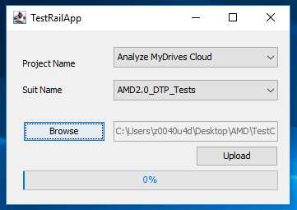

Project Name : List of projects defined for you

Suit Name : Suites created under the projects

Browse : Area to select csv files from your computer

Upload : Starts the upload process

1. **Finish Message**

If you see the this pop-up, Upload is completed successfully

