1. Install the AVRDUDESS-2.13-setup.exe program.
2. JP1(BOOT JUMPER ) and JP2(USB POWER JUMPER) on Spark EFI V1.1 board must be plugged in.
3. Connect Spark EFI V1.1 to USB.
4. Open AVRDUDESS.
5. Select the hex file you need.

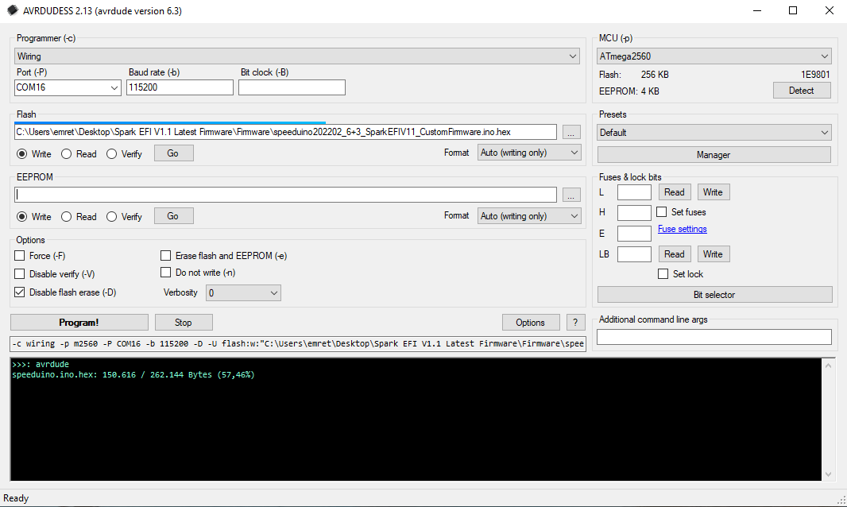

1. **Port (-P)** make sure you select the correct port.
2. **Program!** Press the button.
3. If you have done all the steps correctly, the hex file will be uploaded successfully.

**Which hex file is it?**

1. **speeduino202202_1+8_SparkEFIV11_CustomFirmware.ino.hex**
   1. Your board has up to 1 cylinders of sequential fuel injection and up to 8 cylinder of sequential ignition output.
2. **speeduino202202_3+6_SparkEFIV11_CustomFirmware.ino.hex**
   1. Your board has up to 3 cylinders of sequential fuel injection and up to 6 cylinder of sequential ignition output.
3. **speeduino202202_4+5_SparkEFIV11_CustomFirmware.ino.hex**
   1. Your board has up to 4 cylinders of sequential fuel injection and up to 5 cylinder of sequential ignition output.
4. **speeduino202202_5+4_SparkEFIV11_CustomFirmware.ino.hex**
   1. Your board has up to 5 cylinders of sequential fuel injection and up to 4 cylinder of sequential ignition output.
5. **speeduino202202_6+3_SparkEFIV11_CustomFirmware.ino.hex**
   1. Your board has up to 6 cylinders of sequential fuel injection and up to 3 cylinder of sequential ignition output.
6. **speeduino202202_8+1_SparkEFIV11_CustomFirmware.ino.hex**
   1. Your board has up to 8 cylinders of sequential fuel injection and up to 1 cylinder of sequential ignition output.

**NOTE 1 : SELECT YOUR BOARD BMW PNP ON TUNERSTUDIO.**

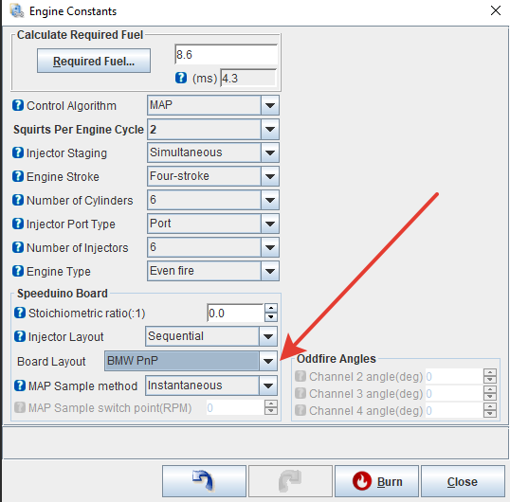

**NOTE 2 : If you want to edit and install the original Speeduino 202202 software yourself,**

**replace the code**

**"pinVSS = 3; //VSS input pin"**

**on line 1820 of the init.ino file with**

**"pinVSS = 20; //VSS input pin".**

**NOTE 3 : If you want to edit and install the original Speeduino 202202 software yourself,**

**replace the code**

**#define INJ_CHANNELS 5**

**#define IGN_CHANNELS 4**

**on line 43-44 of the globals.h file with**

**#define INJ_CHANNELS 6 (Edit it according to your needs.)**

**#define IGN_CHANNELS 3 (Edit it according to your needs.)**

**For Support :** [**info@sparkefi.net**](mailto:info@sparkefi.net)