Time series data must be UNIQUE

In a time series data, there must not be a missing date

Time series data must be sorted – ordered

The additive model is Y[t] = T[t] + S[t] + e[t]

The multiplicative model is Y[t] = T[t] \* S[t] \* e[t]

25 December 2023

Next 30 days

1-24 January 2024

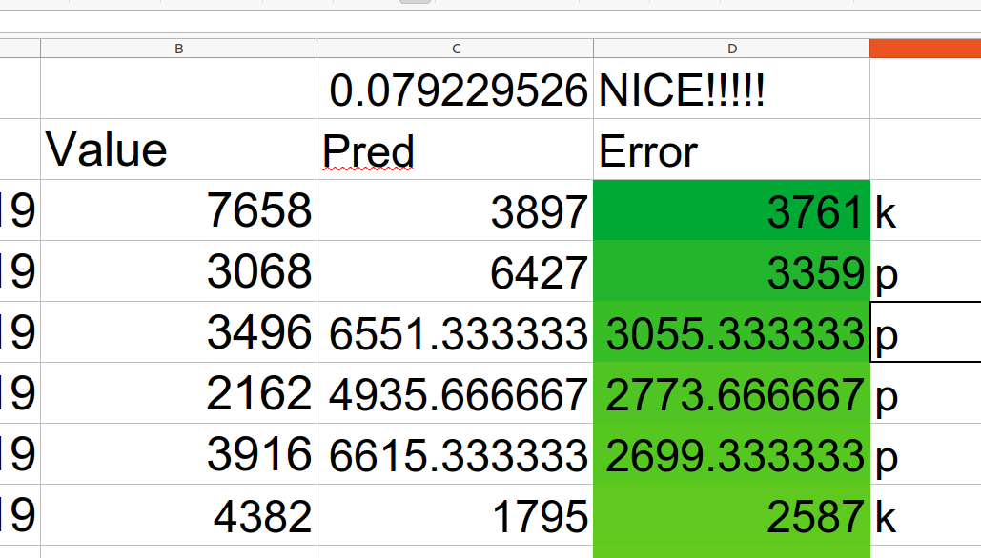

Error must be RANDOM, must be unpredictable!!! ERROR MUST BE NORMALLY DISTRIBUTED

If there is no correlation (very low) between target and error ===> means ==> NICE OUTPUT, because the error is random. ERROR IS NOT RELATED TO TARGET