

Ali Aydın YAMANDAĞ

Tel: +90 506 668 08 50 mail: aliaydinyamandageee@gmail.com

Emre YILMAZ

Tel: +90 506 888 77 42 mail: emreyilmazeee@gmail.com

Gürkan Durmuş YILMAZ

Tel: +90 554 612 27 66 mail: gurkandy@gmail.com

Hakkı GÜLCÜ

Tel: +90 534 397 29 66 mail: hakkigulcu35@gmail.com

Sonay ULUKAYA

Tel: +90 506 138 94 38 mail: sonayulukaya@gmail.com

**WEEKLY REPORT-II**

Last week, we were able to implement hector slam on the raspberry pi. Hector slam is a slam algorithm which does not require odometry data from the wheels. Therefore, it was our first choice to implement. We did some tests and the algorithm works just fine if the robot moves in a line and slowly. However, as the robot starts rotating the localization becomes problematic especially if the speed of rotation is high. To solve this problem, we are considering another slam package in ROS which is called gmapping. Different from hector slam gmapping uses odometry data. Therefore, we expect better results from gmapping.

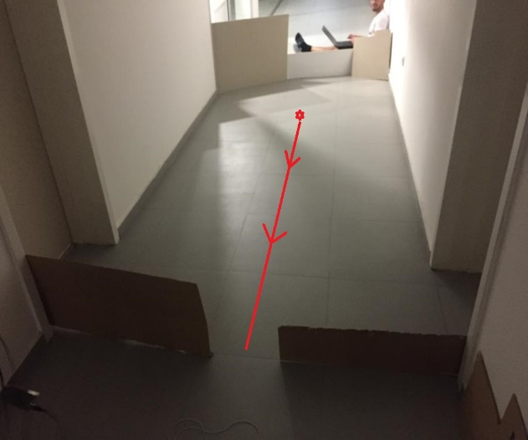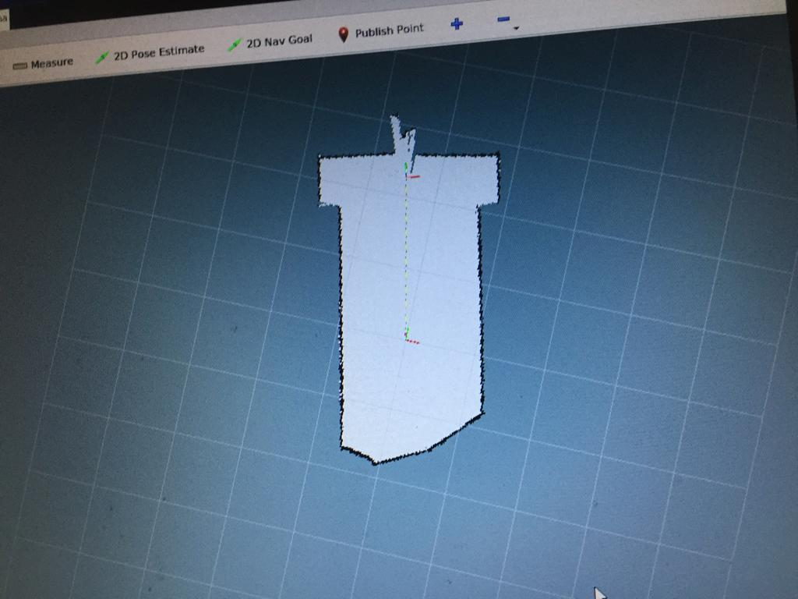

Figure 1: The testing area(left) and its map(right) of hector slam on ROS

In Figure 1, we placed the LIDAR at the red point on the testing area and moved it on the straight red line in the arrow direction and we observed the map ROS.

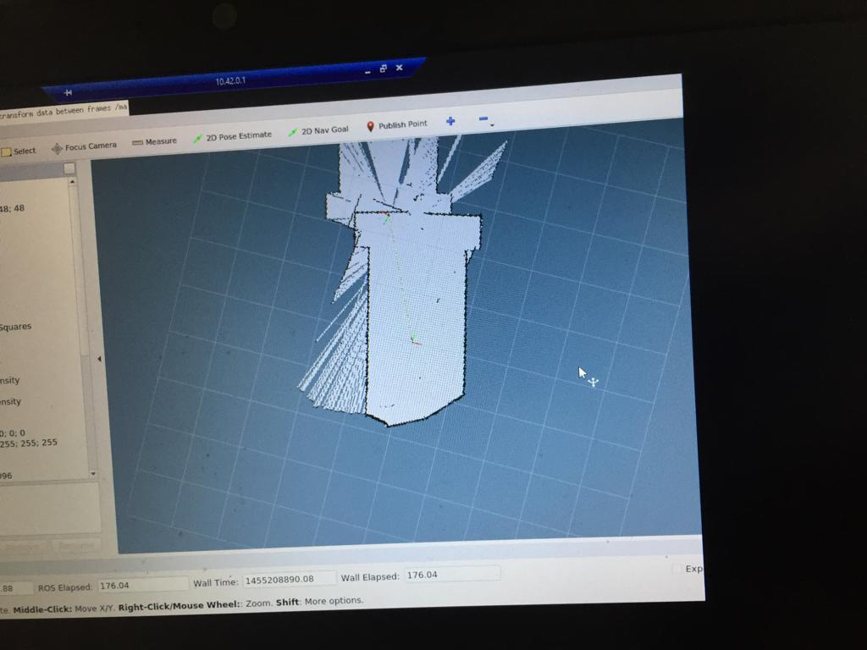

Figure 2: The map when LIDAR was rotated fastly around itself

In Figure 2, when we try to rotate the LIDAR location update was not done properly as mentioned above. However, if we make this motion slowly, we observed no error on the map.

In order to try gmapping we need to construct the robot since we need encoder data from the wheels. Therefore, we bought the motors as wells as some other parts. We also worked on the general shape of the robot.

Next week we will work on two things namely the mechanical design of the robot and ROS packages that we can use in addition to gmapping. Furthermore, we will investigate a package named navigation stack which will control the robot and autonomously drive it around.

We decided to use a circular shape base with double floor for our robot design. Our initial idea is that the diameter of the robot is 20 cm. Below, the design for the first and second floor can be seen, respectively.

