Orientation Guide to Collegeville / Grandville

For Amateur Radio Operators
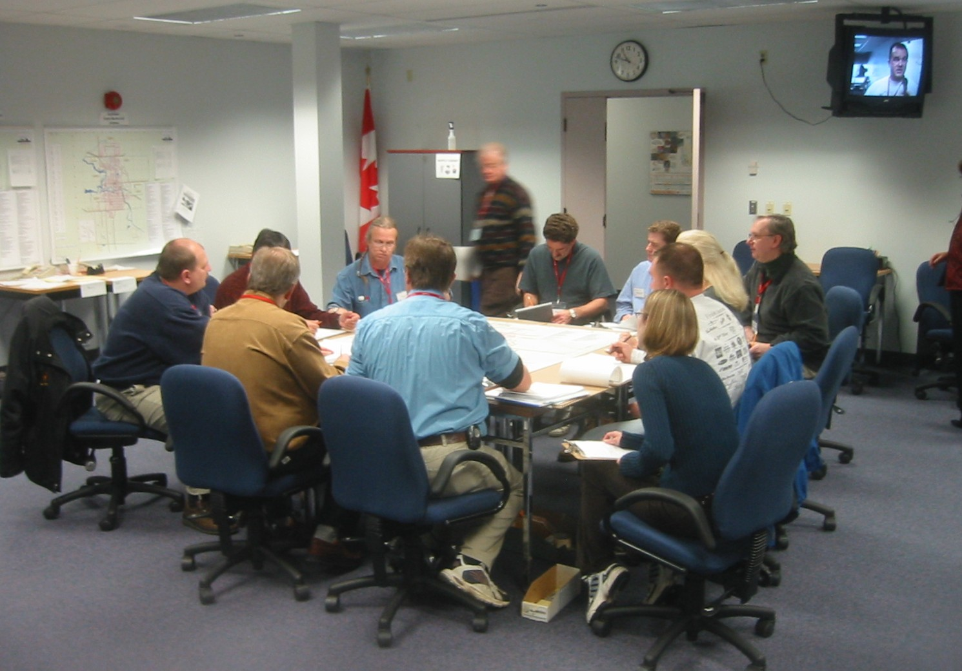

Table of Contents

Table of contents 2
Purpose 3
Collegeville Overview 3
Courses 3
Staff 3
Amateurs 4
Students 4
Access 5
Room Layouts 5
EOC Layout 6
Site Command Post Layout 7
Simulation Room Layout 8
Exercise Conduct 9
Amateur Radio in Exercises 9
Post Exercise Critique Format 10
Communication Flow 10
Equipment 11
Radio Frequencies 11
Net Control 11
Tactical Callsigns and Identification 11

Messages and Logging 12
Message Form 13
Precedence 13
Fax/copy machine 14
Glossary 15
Schedule 17
Site map 18

Version | Author | Comments
1.0 | Mike Kelly | Creation
1.1 | Mike Kelly | Additions to Glossary
1.2 | Mike Kelly | Added access process, door, badge, book etc.
1.3 | Mike Kelly
1.4 | Mike Kelly | Added “NO DUFF” protocol for real emergencies
1.5 | Mike Kelly | Revised access process, updated schedule 2008-2010, added more words to glossary
1.6 | Mike Kelly | Revised access process again, added fax procedure, added site access map
1.7 | Mike Kelly | Added Incident Commander, startex and endex to Glossary, added FAX instructions
1.8 | Mike Kelly | Minor revisions. Updated Table of Contents page
1.9 | Mike Kelly | Reworded “Amateur Radio in the Exercises” and minor changes throughout
2.0 | Mike Kelly | Added HUSAR, Sirep to Glossary, added Header, added more Grandville info
2.1 | Tyler Tidman | Formatting changes, updated fax preamble, included some new photos

Purpose
This document is intended to be a general guide of operations, amateur radio operator duties and items to watch for, for those hams at Collegeville for the first time. It may also be a refresher to the seasoned veterans who have not attended in a long time.

Overview
What is now called the Canadian Emergency Management College is probably best known under one of its former names, Emergency Preparedness College, or perhaps as part of the federal Emergency Measures Organization. They used to be located in Arnprior, but are now located at 1495 Heron Rd., in Ottawa. Whatever you call it, they run three courses that have amateur radio participation built into them. Information on the courses can be found at

http://www.publicsafety.gc.ca/prg/em/cemc/04pgc-eng.aspx

Courses and their exercises
The training courses with amateur involvement are "Emergency Operations Centre Management" for both the fictitious town of Grandville (Pop 5,574) and the fictitious city of Collegeville (Pop 137,500), and "Emergency Site Management" for Collegeville. For exercise purposes, both municipalities are considered to be in the Province of "United" in the county of "Plains." The provincial capital is Worthington. It is outside of the county.

The title of the courses “Emergency Operations Centre Management” and “Emergency Site Management” clearly outline the purpose of each of the courses. They are run at the same time, and their exercises interlock. Courses are offered at the College about 10 times per year. They are about a week long, and they typically run two or three exercises over two days near the end of the course. The simulated exercise dates remain fixed, no matter what time of year the course is offered. For example even if a course is offered in January, a particular exercise may be thought of as occurring on July first. The EOC course for Grandville has just the EOC and Simulation rooms active (no “site”), but is otherwise similar to the Collegeville courses from the amateur point of view. When numbers warrant, the Grandville course may split in two, with two parallel EOCs in operation, each working with their own SIM room.

Staff
Courses are run by a Course Coordinator. They have a Course Officer in charge of each of the EOC (Emergency Operations Centre) and ESM (Emergency Site Management) courses. There is a team leader for each of the three rooms (EOC, SITE, and SIMulation room for Collegeville, or EOC1 and SIM1 / EOC2 and SIM2 in the case of Grandville).
There are Service Coaches for each of Fire, Police, EMS (Emergency Medical Services (Ambulance)), Public works, Transportation, Health, EMO (Emergency Measures Organization), HR (Human Resources), public information (media) and Social Services. In addition to the amateurs playing the role of amateurs, there is also a present or past Mayor or other municipal head of government who acts in the role of Mayor for the exercises. There may be others serving as understudy (trainee) for any of these positions. Those who are not attached permanently to the College are called "Visiting Staff". Various staff members will be pressed into service in the simulation room to act as people not directly written into the exercise, such as military liaison, humane society, construction company president or airport manager if required by the actions of the students.
Volunteer scheduling and maintenance of the volunteer amateur radio operator the responsibility of the registrar, Carole Michaud,

In practice, amateur radio operators are scheduled by Mike Kelly VE3FFK.
His E mail is his callsign at rac dot ca / phone 613 322 O669 (cellular)

Amateurs
Amateur radio is involved during exercises conducted on two consecutive days during the course. A minimum of three amateurs are required for Grandville (two in EOC, one in SIM), and four for Collegeville exercises (two amateurs in EOC and one each in SITE and SIM) The second op is in EOC to help with increased traffic there. There may also be understudies participating while learning the job. It is preferred that there be two amateurs in each of the SITE and EOC, so students come to expect a team of operators for each shift. The optimum level is six amateurs, of which two are understudies.

Students:
Students are typically municipal officials and emergency responders who have a management responsibility in the event of an emergency occurring in their municipality.
They come from all over Canada for a week at a time to attend these courses. They have been sponsored by their municipalities and have already passed a preliminary course called Basic Emergency Management. They are highly competent in their day to day roles and motivated to excel at their course. They understand their reaction to events will make the difference in casualty counts and how well a community will survive a disaster.
About 30 to 50 students from across Canada take part in each of these courses. They live at the college residence on site while attending the courses.

Access Procedure:
The building entrance is on the East side, near the back and is clearly marked “RECEPTION”. (See diagram on last page). Typically that is where most of the cars are parked within the lot. If you are there for the first time, it is best to call one of the other amateurs on 146.550 or 146.880- as you arrive, so they can escort you in. Upon arrival, let the commissionaire know who you are and that you are there for the course. They will issue you with your name tag and access badge. You will also have to sign in. The access badge must be returned at the end of each day as you sign out. Proceed down the glassed in hall to the right (north). Follow the signs to the EOC. The college is willing to pay mileage and may also be able to provide accommodations on site for amateurs who are assisting at courses.

Room Layouts
An exercise is conducted in three rooms as follows: An Emergency Operations Centre with attached telecommunications room, a room representing an Emergency Site Command Post, and a room used to run the simulation. For Grandville, only the EOC and simulation rooms are active. Grandville students spend some time in the simulation room as well as the EOC, but there is no “site” in their exercises. The photo on the cover of this document is a typical update meeting in the EOC. After the meeting around the central map table students return to their stations around the perimeter of the room.

Emergency Operations Centre (EOC)
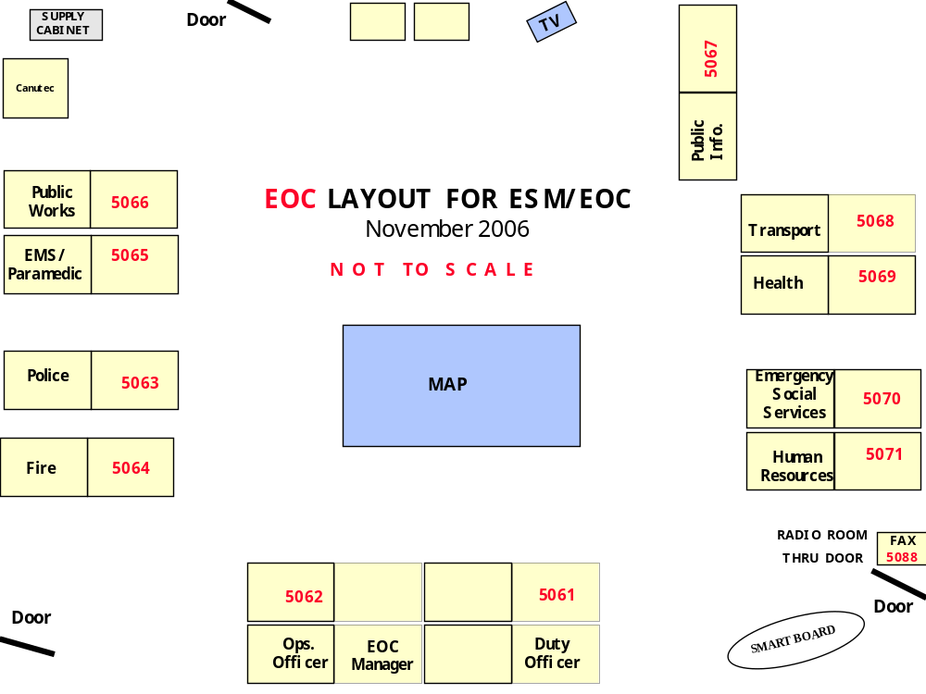
The 4 digit numbers in the above diagram are the telephone numbers for the various services.
Emergency Site Command Post (SITE)

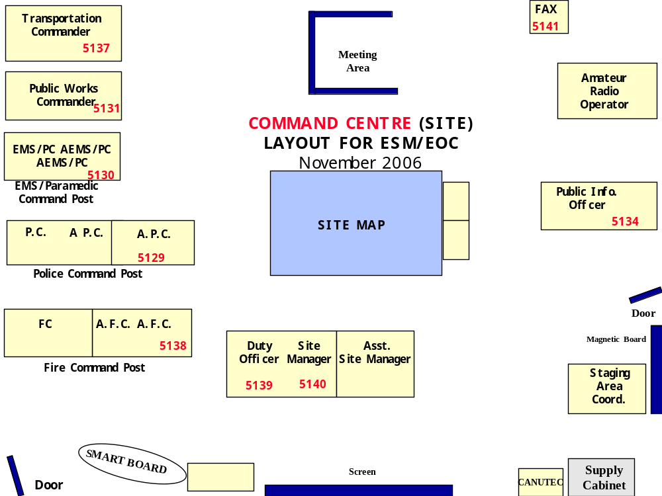
The 4 digit numbers in the above diagram are the telephone numbers for the various services. Note that
under the incident command system, the titles of Site Manager and Assistant Site Manager are now
Incident Commander and Assistant Incident Commander.
Simulation room (SIM)

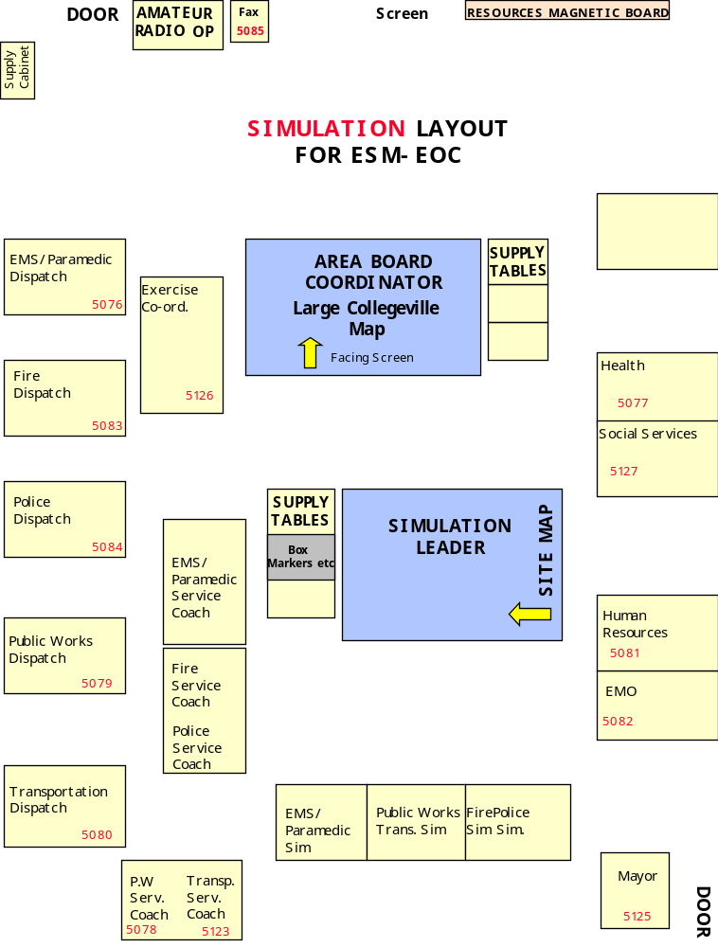
The 4 digit numbers in the diagram are the telephone numbers for the various services.

Each room has maps of the area on the wall next to each work table, as well as the central map. Each work table has a placard on the wall over it, indicating what service operates there. The EOC and SITE rooms have a large screen connected to a computer. This is used by students to keep a "Master Event Log" that is their record of large scale events occurring during the exercise. There is an overhead television in the room. The digital clocks in each room are synchronized to each other, but differ slightly from "real" time. There is a fax /copy machine near the radio operator.

Exercise Conduct
Students are in either the SITE or EOC room. They receive "inputs" (telephone, radio or other messages) from staff in the Simulation room (SIM) at various times, and are required to respond to them in a manner that deals with the developing emergency. Things happen faster than in real time. For example, a damage assessment that may take a day would be provided in ten minutes. From time to time they are shown simulated “breaking news” reports via a closed circuit TV system. Some of them will have to go to media interviews or press conferences occasionally. As the exercise progresses students are called to meet around the map table to share information around the room.

Amateur Radio in the Exercises
Amateur radio personnel are required in all three rooms of the exercise. The amateurs decide among themselves which person is assigned to which location. Newcomers are rotated among the various spots over the duration of the exercises, to give them experience at all locations.

The duties of the amateur radio operators are to:
- On arrival, introduce yourself to the Team Leader in your room.
- Forward incoming information received by radio or fax to the appropriate person.
- Pass outgoing messages by fax, radio or runner to the appropriate person in another part of the exercise.
- Show by example what amateurs are capable of in an emergency situation.
- Maintain a log of activities, messages in and out, etc. (see samples).
- Maintain the Input log and input board, (a large (60x60CM) chart containing the numbers 1 through 100 on it). The board is maintained by crossing off the number of the Input being introduced into the exercise. These "inputs" are sent by radio from SIM. The input board is used by the course instructors to keep track of the elements of the exercise. (more about this later)
- Acknowledge receipt of the Input once you have crossed it off the chart.
- Be prepared to provide a list of unused inputs, your logs, or information from your logs if you are asked for it.
- Conduct various other technical duties related to your position as telecommunications official for the municipality. These may include simulation of checking the backup generators at the EOC, or simulated dispatch of amateurs to other locations around the city. - You never know what students will ask for.
- Make photocopies as required, using the copy feature of the fax machine.
- Bring any problems related to participants to the attention of the Team Leader.
- After the exercise, provide feedback to the students on how well they performed in tasks related to communications.
- Generally be helpful in the conduct of the exercises.

Post Exercise Critique Format.
Suggested format for the post-exercise telecommunications debriefing.
- Did they use amateur radio or other means to make contact when they encountered problems with their normal communications means?
- Did they follow proper procedure with regard to the routing of messages?
- Were there obvious communications problems within the room?
- Were their faxes readable?
- Did they clearly state the origin and destination on them?
- Did they use cover sheets for their faxes?
- Did they assign precedence (priorities) to messages?
- Did they close the loop after originating communications?
- Were they proactive, pulling in required information rather than passively waiting for it to arrive?

Communication Flow
Incoming:
Information coming into the EOC through the radio room (by formal message or by fax) should be directed to the "head table", preferably to the operations officer. This person is responsible for the operation of the room. It is their job to determine who, in addition to the addressee, should receive the information and to get it delivered within the room.

Information coming into the SITE (by formal message or by fax) should be directed to the "head table", usually to the Emergency Site Manager, (ESM) / Incident Commander (I/C) , their designated assistant, or the Duty Officer (DO).

Outgoing:
If a message is destined for the media, or someone outside the municipal organization, such as the Provincial EOC via amateur radio or fax, it should be approved by the official assigned that task, (usually the EOC Manager or Incident Commander, for SITE) or their delegate before transmission. This ensures the decision makers know what information has been released. Tactical traffic between site and EOC need not be approved before transmission, since it all stays within the municipality and its agencies. This approval is also necessary to ensure that when communications are disrupted, high priority messages go out before routine ones. When normal means of communication go down, a student will be tasked to control the flow of messages to the amateurs. Note that this does not stop the amateurs from becoming overwhelmed by the flood of messages. While this overload is normal and a part of what really happens in an emergency, it is frustrating to the amateurs and learning to deal with it is part of the reason the courses are of value to amateurs.

Communications from the simulation room (SIM) need not be scrutinized as closely, as that from the other rooms, since the outgoing messages originate with the instructors. If there is a problem with a message, the problem will be handled by the course staff.

Equipment
The list below is a guideline. Any questions or concerns regarding required radio equipment should be directed to an amateur who has been there before. It is easier to get equipment than volunteers, so don't let a lack of equipment stop you from coming out. If you need a piece of equipment to participate, we will find it for you to use.

- Radio - hand held with earphone or preferably with a headset. It is not practical to have a speaker going when the exercise is being conducted. A speaker/mic with an earphone connected will work. In the worst case, an earphone can be used but it is a nuisance to have to pick up the radio each time to speak into its built in microphone.
- Manual for your radio. If your radio has an automatic power off after a period without activity, you have to be able to disable this "feature". There are other features, such as “WIRES”, RX battery save, etc. that need to be disabled. If you can't do that without reading the manual, then bring it.
- Spare batteries - you must be able to sustain operations for two work days. Although this shouldn't be hard, many first timers run out of battery after a day and a half. This is unacceptable. Bring spares. An alkaline pack is recommended but not mandatory.
- Clock - Although there is a clock in each room it is sometimes difficult to see. Since Collegeville time varies slightly from local time, it is easiest just to bring a clock and set it to Collegeville time.
- NOTE: Water, coffee and snacks are provided periodically, so you needn't bring them. Lunch is provided if the operator is working both before and after the lunch break. Breakfast is available on the morning of day two.

Radio Frequencies
Typically we use 146.550 simplex. If there is someone else using this frequency, we may change frequencies. Since we are all within the same building, it is not too difficult to change frequencies on the fly. We may also be monitoring 146.880- for incoming hams.

Net Control
There is no net control. There are only three stations on frequency. If a double is heard, the third station will call out "double". Stations simply make their call. For example "EOC from SITE" (note FROM, not "TO") Keep transmissions short and leave breaks.

Tactical Callsigns and Identification
Tactical callsigns used are "SITE", "SIM, and "EOC. Amateurs must also send their Industry Canada assigned call sign once every half hour. Typically one person remembers to do this and the other stations follow. At that time we announce "this is an exercise" to prevent any outside listeners to our communications from thinking there is a real emergency. Note: should a REAL emergency occur during the conduct of an exercise, the words “NO DUFF” will be used in the message.

Messages and logging
Stations must log input number and time for "Inputs" received by radio. They are then posted on a wall chart by drawing a line through the input number.

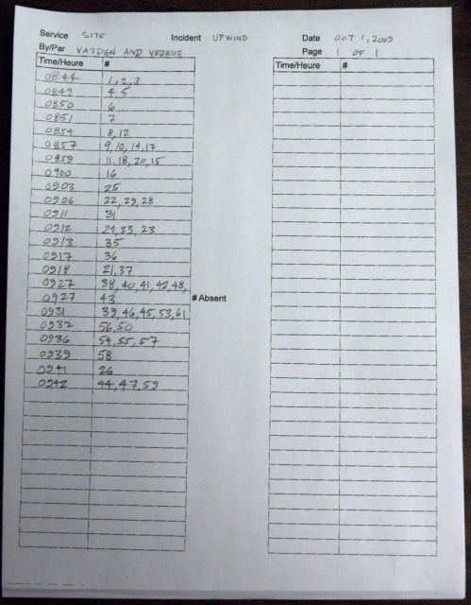
INPUT LOG SHEET
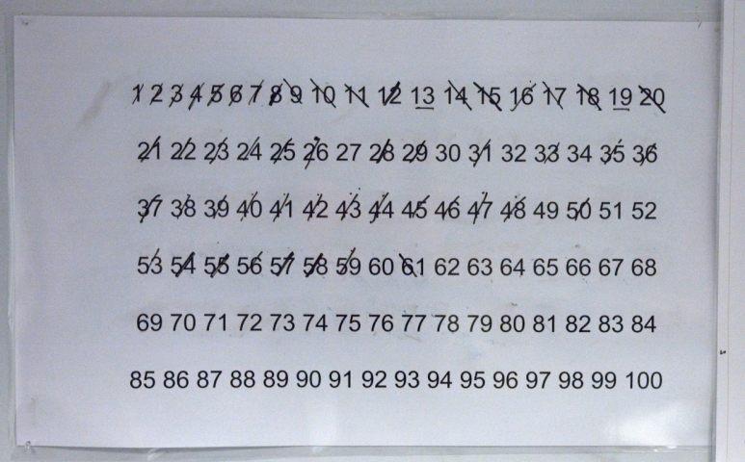
INPUT WALL CHART

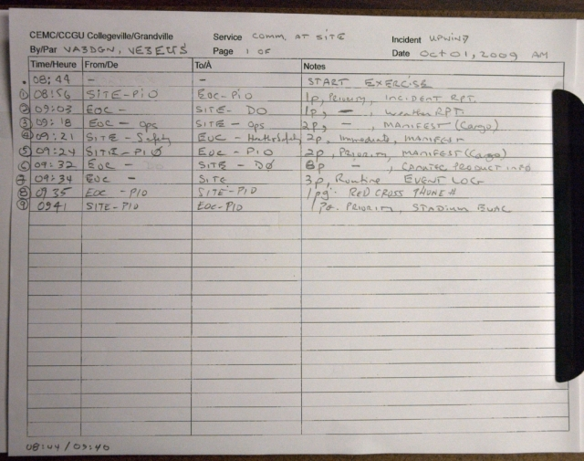
SERVICE LOG SHEET

Stations must log messages sent and received either by fax or by radio. Note that the time on the fax machine will differ slightly from both local and Collegeville time. Use Collegeville time for all log entries. Occasionally formal traffic will be received by radio and sent to its destination using the three part message form. (see next page)
Mark the time sent or received on messages before forwarding to their destination within your room. They are typically passed through the ops officer.

NOTE: If a fax call is made to a busy fax machine the originating machine will re-dial about ten minutes later. This is too long to wait in a time compressed exercise. To get around this problem the sending station should radio the receiving station both to inform them there is an incoming fax and to ensure that their machine is not busy with other traffic. Please be sure to announce the precedence of any faxes when notifying the receiving station and allow other stations time to break-in if they have faxes of higher precedence to send.
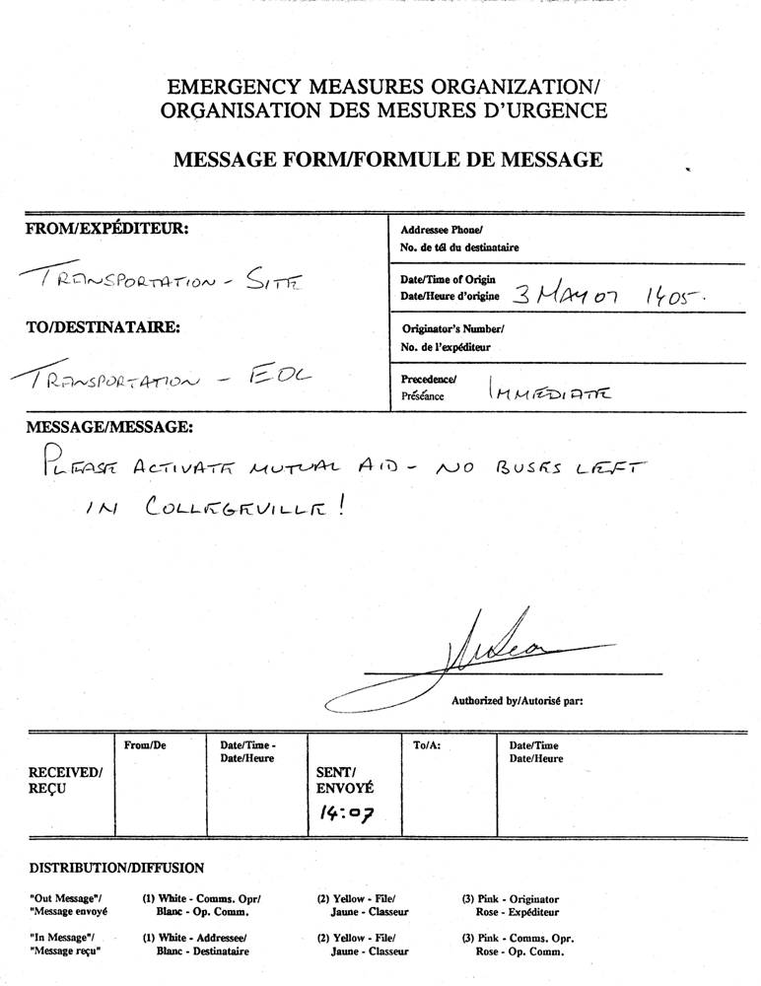
MESSAGE FORM
PRECEDENCE
For formal traffic we use the following precedence’s:
Immediate: Somebody will die if this message is lost or delayed (Like EMERGENCY in Amateur formal traffic)
Priority: Serious harm or property damage will occur if this message is lost or delayed
Routine: This can be sent after higher precedence messages are cleared.

Note: "Urgent" is not a precedence. Neither is "High" or "RIGHT AWAY"
When a message with a precedence above Routine is received, try to get a message back to the originator when the message is in the hands of the final recipient.

Messages going by fax should have a recipient clearly specified. The originator should also be clearly readable. If this is not done, you should inform the person once. If they continue to offer messages with vague destinations on them, it is fair game to "lose" the message. Just remember that the object is to educate, not humiliate the student. Similarly, if they fail to clear the outgoing messages with the operations officer when appropriate send the first one, with a warning and refuse to send subsequent messages without proper authorization.

An "input" message just tells the operator that a particular input to the exercise has been put into play by the staff. It should be logged as noted above and acknowledged. The transmission from SIM will sound like "input three seven." The acknowledgement takes the form of, "SITE roger three seven." You may receive several inputs during the same transmission so you may want to write them down in the log before updating the wall chart and acknowledging the transmission. Remember to keep all transmissions short.

FAX/COPY Machines:
To send a fax, place face down in top of machine, dial the 4 digit number of the destination and hit green send button.
To make copies, place original face down, press number of copies (if more than one), then press “copy”. The copier is slow, so encourage the student to return to their post. Deliver the copies to them when the machine finishes. Some of the machines will jam if they have too much paper in the tray, so the paper level needs to be checked often.
It is likely that the students will want multiple copies of some items like weather reports. It is a good idea to make multiple copies ahead of time, before the students ask for them. Saving time is more important than saving paper.

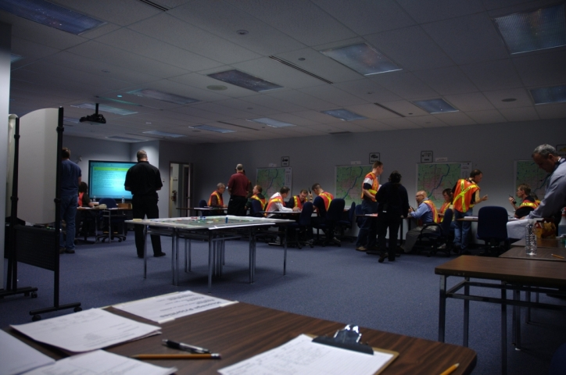
Glossary

ARES Amateur Radio Emergency Service - Qualified Amateur Radio Volunteers
BLEVE "boiling liquid expanding vapour explosion". A type of explosion that can occur when a vessel containing a pressurized flammable liquid is ruptured.
CANUTEC: an outside resource that provides information on hazardous materials
CLCF Collegeville Long Term Care Facility
Consist -Synonym for Manifest, the list of goods or people on a vehicle
DHS Director, health services
EMO Provincial Emergency Measures Organization or local EMO also called PEMO
EMRG Emergency Measures Radio Group-The name of the City of Ottawa ARES group.
EMS Emergency Medical Services - primarily ambulance
EMSC - Emergency Medical Services Commander - highest ranking EMS officer on site Endex: End of Exercise has been declared
EOC Emergency Operations Centre
EOC Manager - a participant who is responsible for overall operations within the EOC.
EOCT Emergency Operations Centre Team
ESM Emergency Site Manager =Incident Commander - Typically a senior police or fire official at the site.
ESS Emergency Social Services - responsible for organizing emergency shelters, other victim services
Exercise Director - Staff member responsible for overall conduct of the exercise.
FC - Fire Commander - highest ranking fire official at the site
FPO Fire Prevention Officer
Green: See triage
HR Human Resources - responsible for worker safety, union issues, management of volunteers etc.
HUSAR Heavy Urban Search and Rescue
Incident Commander (I/C): Person in charge of everything at the site of the emergency.
Inner Perimeter - The extreme danger zone. Only fully protected first responders may enter.
Input – Something that has been entered into the exercise, such as a weather forecast, the playing of a news broadcast, or a phone call saying the water is rising in the river.
Learning Pause -Short break in the exercise to regroup, and go over some lesson points.
Manifest -List of goods or people on a vehicle
MOH Medical Officer of Health
MSDS: Material Safety Data Sheet. Describes how to deal with a particular hazardous substance
NO DUFF: A REAL emergency is in progress. All stations to listen for instructions.
Outer Perimeter - Danger zone. No unauthorized personnel are permitted within the outer perimeter.
PC - Police Commander - highest ranking police officer at the site
PEMO: Provincial Emergency Management Office (the EOC in the provincial capital)
PIO: Public Information Office(r) - the person or group that interfaces with the media
PSA: Public service announcement. Typically a press release.
PW: Public Works - Cares for water and other infrastructure. Amalgamated into TUPW in smaller municipalities
PWC: - Public Works Commander - highest ranking public works person at the site
Red: See triage
SC: Service Coach - Instructor responsible for one of the services (PIO, Transport, etc.)
SIM: Simulation room, where the inputs to the exercises originate.
SITREP: Situation Report
SOE: State of Emergency (as in Declaration of a state of emergency)
SOLE: State of Local Emergency (see above)
Startex : Start of exercise has been declared
Triage: GREEN: Walking wounded, who can survive without immediate assistance.
Triage: RED: Seriously wounded, needing immediate medical care to survive
Triage: YELLOW: Wounded, needing medical care as soon as possible, but not before RED
TUPW: Transportation, Utilities and Public Works Department of the municipality.
Team Leader - Instructor responsible for all participants within one of the three areas: EOC/Site/Sim.
Visiting Staff - Also know as Service Coaches/Instructors. Staff not permanently at the training centre. Amateurs are equivalent to visiting staff.
Yellow: See triage

Schedule
Amateur radio operators are required as follows:

Time on station for Collegeville is typically a half hour before the times listed below, Especially if you haven’t been there before, and need to learn your way around a bit.
Lunch is provided.

2009-10 schedule CHECK FOR CHANGES or CANCELLATIONS

"COLLEGEVILLE" COURSE EXERCISES ARE WEDNESDAY / THURSDAY
"GRANDVILLE" COURSE EXERCISES ARE THURSDAY / FRIDAY

SEP 30,OCT 1 2009 COLLEGEVILLE ENGLISH
NOV 4,5 2009 COLLEGEVILLE ENGLISH
NOV 19,20 2009 GRANDVILLE FRENCH
DEC 9,10 2009 COLLEGEVILLE ENGLISH

JAN 20,21 2010 COLLEGEVILLE FRENCH
FEB 4,5 2010 COLLEGEVILLE ENGLISH
FEB 24,25 2010 COLLEGEVILLE ENGLISH
MAR 11,12 2010 GRANDVILLE ENGLISH

Exercise times for ESM-EOC Collegeville course:  Wednesday: 1:00 to 3:15  Thursday: 8:00 to 10:15  1: 1:00 to 3:15  NOTE: THE TIMES MAY BE INCORRECT. COURSES OFFERED COULD BE CANCELLED. CHECK PRIOR TO COMMITTING TO ATTEND. | Exercise times for EOC Grandville course:  Thursday: 8:30 to 2:30  Friday: 8:00 to 1:30  NOTE: THE TIMES MAY BE INCORRECT. COURSES OFFERED COULD BE CANCELLED. CHECK PRIOR TO COMMITTING TO ATTEND.

Site Map:

