Rideau Lakes Cycle Tour 2011:
Communication Volunteer Event Overview

(June 9 & 10, 2012 – Saturday/Sunday)

Route Map
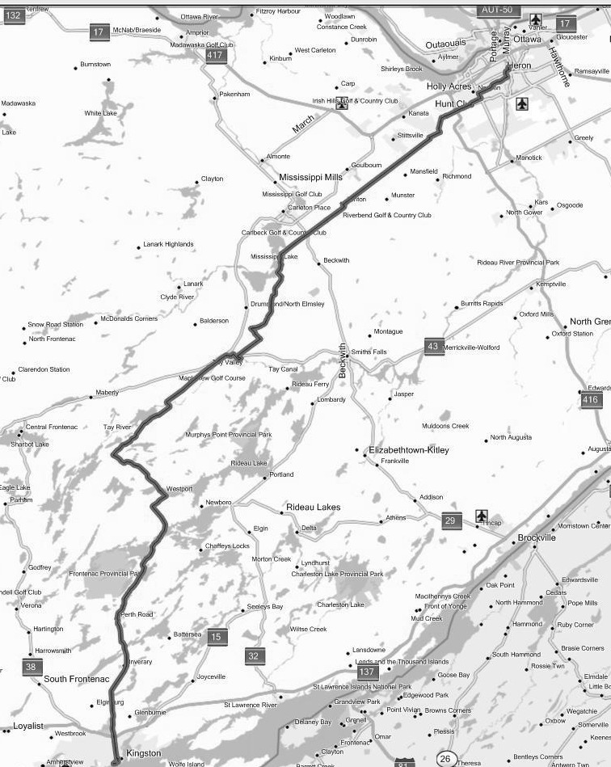

Perth

Ashton

Westport

Kingston

Ottawa

6 & 36

Loon Lane

Cemetery Sideroad

Blacks Corners

Macphails Rd.

Munster Rd.

Huntley Rd.

Hopeside Rd.

Merivale Rd.

Knoxdale Rd.

West Hunt Club

Last Duel Park

+ Curling Club

Inverary

Perth Road Village

McAdoo’s Lane

Buck Lake

(Clear Lake Rd.)

Glenburnie

Dewitt’s Corners

North Crosby Recreation Centre
Event Background
Every year, the Ottawa Bicycle Club (OBC) organizes and runs the Rideau Lakes Cycle Tour (RLCT). This is a one-weekend event in early June that has bicycle riders cycle from Carleton University in Ottawa to Queen’s University in Kingston , and back, a round-trip distance of over 350 km. The outbound trip starts early on the Saturday morning departing from Carleton, and finishing at Queen’s University later in the day. Riders stay overnight at Queen’s, and return along the same route on the Sunday. There are four specified routes, of which two are supported by repair vehicles, communication and designated rest and refreshment stops. There can be as many as 2000 riders taking part in the RLCT, coming from across Canada and many other countries, with over 1000 on the supported routes. This event takes place rain or shine.

More information can be found about the RLCT at their website http://www.ottawabicycleclub.ca/

Communication Purpose
Given the large number of riders, the range in departure time and variation in speed, the tour can be spread out over a great distance. Providing communication spanning the full distance of the tour enables the support team to co-ordinate, and to render assistance to riders in need. With such a large number of riders and bicycles involved, it is inevitable that breakdowns and accidents will occur, and both do every year. Communication along the route enables accident location for emergency support, and the most effective deployment of the two repair vehicles to get bicycles repaired, and back on the road as soon as possible. In addition, identification and tracking of the last rider enables the organizers to ensure that no rider is left behind. There may be other requests for communication related to riders dropping out, lost items, etc., as well. Persons participating in communication support are not there to provide any form of traffic control, or to enforce rules and regulation of the Ottawa Bicycle Club.

Communication Overview
The communication services for this event are limited to the supported route, and are provided by radio amateur volunteers from Ottawa to Kingston. Overall communication co-ordination responsibility lies with VE3IHI (Rick Furniss), who works with the OBC executive. The Ottawa team’s coverage zone goes from Carleton University to about 10 km west of Blacks Corners, which is south of Carleton Place on Highway 15.

Time Commitment
Although each day the tour is an all day event for the riders, communication volunteers participate from three regional groups to cover the whole route (Ottawa EMRG, Lanark ARES and Frontenac ARES), so the time commitment required for each group is constrained. For volunteers at the Ottawa end of the tour, participation is typically about 3 to 6 hours maximum during Saturday morning, and/or Sunday afternoon. As the event starts out from Ottawa on the Saturday, most volunteers are needed at their assigned stations by 7:00 a.m. For the Sunday return trip, most volunteers are expected to be at their stations by 11:00 a.m. Once the last cyclist passes by their station, a communications official (usually via net control) will release that volunteer for the day.

Equipment Requirements
It is not necessary that every communications volunteer have his or her own equipment, just an amateur radio license. Volunteers who do not have equipment will be paired with those who do. Those with equipment will need to be able to operate on 2 metre FM mobile or fixed portable. While the ability to monitor two 2m frequencies simultaneously (dual watch) is desirable, it is not essential. A 50W transmit capability is ideal, but those with lower power can certainly be used as well.

Route Synopsis (Ottawa to Perth)
The Classic Tour leaves Carleton U. via Colonel By Drive on Saturday morning, turns right onto Hog’s Back/Meadowlands Drive and follows this to Woodroffe. It then turns left on Woodroofe and goes down to Knoxdale, where it turns right. Following Knoxdale to West Hunt Club, it turns right onto West Hunt Club and follows that to Richmond Rd., where it turns left. Richmond is followed a short distance to Hopeside. Hopeside is followed to Eagleson. There is a short jog on Eagleson to Flewellyn Rd. Flewellyn Rd. is followed all the way into Ashton. The tour leaves Ashton on the 9th Line, which it follows through Blacks Corners to Loon Lane. At Loon Lane the road changes into Tennyson Rd., which is followed to Hands Rd. A left on Macphails Rd. takes the tour a short while later into Perth.
Role of the volunteer
Communication along the route enables general co-ordination, including the effective deployment of the repair vehicle, pickup (SAG) vehicles, and accident location for support. The roles of the volunteers are as follows:
- Establish a station at your assigned location. Find a suitable place to park/set up, and to ask for any permission that may be required (usually none needed).
- Display your sign in a location that will be visible to riders. A printable sign will be provided.
- Be familiar with the route: to track tour progress, and in case of redeployment (route maps available).
- Support Communication Requests: e.g. calls for repair vehicles, accident reporting, rider pickup requests, rider info. for cases of location-unknown riders, lost item reports, etc. Typically, you will be approached by riders with such requests.
  - Identify the rider’s bib number, when making requests. [No bib – no service!]
- Identify the bib-numbers of the last riders past your station -- to ensure that no rider is left behind.
- Watch for accidents/riders needing assistance and report.
- Supplementary: In addition to providing communications, volunteers may be asked for: directions, the use of tools, band aids (for minor issues like blisters), to stay with people awaiting pickup, etc. – being able to accommodate such requests is a bonus.
- You are NOT there to provide any form of traffic control.
- You are NOT there to enforce rules and regulation of the Ottawa Bicycle Club.

Operations Summary
- Cell Phone Use: We are in the age of the cell phone, and amateur radio is not the only method used for trouble reporting along the route. The riders have, in the past, been provided a cell phone number that will give them a direct line to OBC management to report accidents/incidents. In many cases, this will provide the quickest response to an emergency situation. However, many riders do not carry their cell phones with them, and coverage is inconsistent along the route. So, this form of reporting is often not dependable, and most reports do end up relying on the amateur radio support.
- Communications co-ordinator (overall): VE3IHI (Rick Furniss)
- Ottawa Control: All amateur radio communications for the event will take place via a controlled net on repeaters designated in this document. Net start times: Sat. 7:00 a.m.; Sun. 11:00 a.m.
- Lanark ARES: Lanark control is typically done from Westport using VE3KJG (Tactical Call: Westport Mountain)
- Lanark “Bridge”: One station on the Ottawa side is designated as a “bridging” station. This station will monitor the Lanark net to pass any traffic destined to the Ottawa net. Any location that provides good reliable communication into both nets is suitable for this purpose, but the optimal locations tend to be between Hopeside Road and Blacks Corners.
- Last rider location & radio station shutdown: Ottawa Control will coordinate operations and provide permission for shut down and departure.
- OPP: The OBC usually contracts OPP motorcycle police officers to patrol the route to provide Traffic Act enforcement (for both cyclist and motorists), and assist with emergencies.
- Pickup and assistance for riders: “SAG” ( Support And Gear) refers to vehicles that are used to transport riders/bikes as required. “SAG” can be used as a verb or noun, e.g. “a person has asked to be sagged”, or “we have a sag request”. There are two SAG vehicles (radio equipped): SAG1 & SAG2.
- Repair: Two mobile repair vehicles are generally in place for the tour
- “Repair 1” is mobile with Tx/Rx capability on 2 metres
- “Repair 2” is a Kunstadt Sports repair vehicle, which is Rx-only and responds to direction from net control. Although the communication is open loop, it has worked fairly effectively in the past.
- Rider Bibs -- No bib, no service policy: Each registered rider will have a numbered bib. Due to the number of non-registered riders who tag along, the OBC have decreed that except in extreme emergency “no bib, no service”.
- Signs (Radio Stations): You will be provided, in a separate printable file, a sign reading “Cycle Tour Radio Communications”. Display one or more of these in visible locations for ease of identification.
- Signs (Tour Route): There will be directional signs placed along the route. The people who put these up or take them down are referred to as “Uppers” or “Downers” respectively (really!).
- Tactical Calls: Tactical call signs may be used during the tour to identify your location or function. Examples of such calls are “Repair 1”, “Admin 1”, “SAG 1”, “Westport Mountain”, Blacks Corners, etc.. Remember to identify using your amateur radio call sign periodically, per the regulations.
- APRS is sometimes installed temporarily on the OBC mobiles to allow for position tracking during the event.

Repeaters/Frequencies
Primary communications take place through 2 metre repeaters, as shown below. In the extremely unlikely event of a failure of both the primary and backup repeaters, operators should revert to simplex communication on 146.520 MHz.

Ottawa area
VE2CRA: 146.940MHz (-), CTCSS 100.0 Hz, IRLP Node: 2040 Location: Camp Fortune north of Ottawa
Backup: VA3EMV/W: 145.210 (-), CTCSS 123.0 Hz, no IRLP Location: Stittsville area

Perth area
VE3KJG: 146.640 MHz (-), no CTCSS, IRLP Node: 2947 Location: Lavant – north of Perth
VA3TEL: 145.230 MHz (-), no CTCSS, (Radio linked to VE3KJG) Location: Christie Lake

Kingston area
VE3FRG: 146.805 (-), CTCSS 203.5 Hz, IRLP Node 2088 Location: Frontenac County south
Backup: VE3KBR: 146.940MHz (-), CTCSS 151.4 Hz, IRLP Node: 2750 Location: (~ Kingston N. of 401)

Rider Knowledge of the Radio Operators
Some riders seem unaware of who the radio operators are or what they are about. This is simply a case of them not reading the information provided. The route map that every registered rider receives as part of their package contains the following statement:

"The Amateur Radio Emergency Service (ARES) is once again providing communications services for the Rideau Lakes Cycle Tour. If you need a mechanic for bicycle repairs, or if you need sag wagon service because of injury or a health problem contact one of the radio vehicles or one of our tour volunteers. You will see us at Carleton University, at refreshment stops, along the route, in Perth and at Queen's University."

Rider Numbers
Typically, there are about 2000 riders engaged in the tour. For reference, the 2008 rider figures were as follows (similar numbers in 2009/2010/2011):
Total registration, 2141: Challenge route 82; Classic 1250; Century 472; Cruise 249; Cancellations 88
2053 departed from Carleton plus Perth (the Century route initiates from Perth) on Saturday.

Rider Road Behaviour
Although the vast majority of riders exhibit good behaviour, there are always some who are less than ideal. The Ottawa Bicycle Club does issue notes to the riders highlighting this, and asking for their co-operation in making the tour go smoothly.

(NOTE: The following is typical of what is included in the riders' confirmation package, on the website (to be read before being able to access the application form), in the newsletter and in other miscellaneous correspondence.)

“ATTENTION ALL RIDERS: In recent years, an increasing number of complaints have been received concerning the poor conduct of individuals and/or groups on the Tour. These complaints originate from town officials along the route, the Police, the public and even fellow riders.
They list instances where cyclists flout traffic laws, are inconsiderate or even hostile towards drivers, residents and other riders. Other cases involve acts of trespassing on private property, littering, foul language and inexcusable use of public and private areas as toilets.
This situation has reached the point where it puts the very existence of the Tour in jeopardy. While a few identifiable individuals or groups may be barred from future Tours, realistically, the organizers cannot control the behaviour of the majority of riders en route.
It is then up to you, fellow riders, to act and speak out when you witness objectionable conduct, on or off the bike. Only by applying this peer pressure will you ensure the continued existence and success of your Tour. “

The OBC (Ottawa Bicycle Club) have also stated that they will encourage the OPP escort officers and other police forces along the route to be more aggressive in enforcing the rules of the road.
Ottawa Station Information
The following is a list of station locations and key related information.

Note: Perth (Last Duel Park) is a major rest stop for the riders, and the next one after/before Ashton. Riders are sometimes interested in knowing how far it is from where they are to the next rest stop etc.

Carleton University (Lat. & Long. N45 23 07.3 W75 41 36.5) Tactical Call: Carleton U
Location detail: Note: Sunday mornings, Colonel By Drive is often closed for recreational use (access Carleton U via Bronson Ave.) Near Norm Fenn Gymnasium
Purpose: Start and finish of the tour. Particularly at the finish this is an important site for co-ordinating with the OBC officials. On Saturday, the mobile units start from Carleton U.
Nearest public washroom: Carleton U.

Merivale Rd. @ Meadowlands (Lat. & Long. N45 21 01.8 W75 44 01.4) Tactical Call: Merivale
Location (Saturday): Parking lot on NW corner of intersection opposite the Stay Organized store
Location (Sunday): Esso station parking lot on SW corner of intersection (Meadowlands side)
Purpose: Safety and tour coverage. First/last radio support point along the route.
Nearest washroom: Tim Horton’s on N.E. corner of intersection + other restaurants nearby

Knoxdale Rd. @ West Hunt Club (Lat. & Long. N45 19 23.8 W75 46 21.0) Tactical Call: Knoxdale
Location detail: Super Dome (191 Knoxdale Rd.) parking lot adjacent to Knoxdale Rd.
Purpose: Safety and coverage. This is a high traffic area.
Location of nearest washroom: Super Dome washrooms ? + Tim Hortons on Greenbank (see below)

West Hunt Club @ Stony Swamp P11 (Lat. & Long. N45 18 24.2 W75 49 00.8) Tactical Call: Hunt Club
Location detail: Stony Swamp Parking Lot 11 on south side of West Hunt Club, 1.7 km west of Cedarview Rd. (Park out of the way of traffic – on grass beside stop sign is one possibility.)
Purpose: Coverage. Good visibility up and down the road.
Nearest washroom: P11 outhouse; Tim Hortons on Greenback north of Hunt Club opposite police station

Hopeside Rd. (Lat. & Long. N45 16 34.2 W75 50 17.5) Tactical Call: Hopeside
Location detail: Hopeside Rd. (pull off at Bell Hut – white metal structure) – also alternate possibilities
Purpose: Coverage. About half way to Ashton. Excellent visibility.
Nearest washroom: McDonald’s at Stonehaven and Richmond Rd. (0.7 km away)
Equipment: As for all sites, a good antenna, e.g. a 5/8 or similar, is recommended. Reliable communications to the Ottawa net will not usually require 50 watts, but if it is required to tie into the Lanark net from here, a 10 feet or greater mast and vertical or beam are recommended with 50 watts.

Eagleson Rd. @ Flewellyn Rd. (Lat. & Long. N45 16 07.7 W75 51 26.9) Tactical Call: Eagleson
Location detail (Saturday): Gravel pull-off about 100m south of Hopeside Rd. on Eagleson (west side)
Location detail (Sunday): Gravel pull-off about 100m south of Hopeside Rd. on Eagleson (east side)
Purpose: Coverage to ensure no problems at Eagleson/Flewellyn junction – not visible from Hopeside.
Nearest washroom: McDonald’s at Stonehaven and Richmond Rd. (2.6 km away)
Equipment: As for all sites, a good antenna, e.g. a 5/8 or similar, is recommended.

Huntley Rd. @ Flewellyn Rd. (Lat. & Long. N45 14 05.8 W75 54 24.4) Tactical Call: Huntley
Location detail (Saturday): NW corner of intersection in front of the brown Bell Canada box
Location detail (Sunday): Pull-off onto the grass area on the SW corner of the intersection
Purpose: Coverage – about half way between Hopeside and Ashton
Nearest washroom: Tim Hortons in Stittsville (north end of town) 4.4 km from Flewellyn
Equipment: As for all sites, a good antenna, e.g. a 5/8 or similar, is recommended.

Munster Rd. @ Flewellyn Rd. (Lat. & Long. N45 11 35.0 W75 58 26.8) Tactical Call: Munster
Location detail: SW corner of the intersection. Pull-off area in front of metal gates joined by chain
Purpose: Coverage – about half way between Huntley and Ashton
Nearest washroom: Ashton Community Centre – see below
Equipment: As for all sites, a good antenna, e.g. a 5/8 or similar, is recommended. Munster Rd. is the highest location around and typically allows for good signals into the Ottawa and Lanark nets.

Ashton Community Centre (Lat. & Long. N45 09 29.8 W76 01 47.5) Tactical Call: Ashton
Location detail: Ashton Community Centre (parking area + field + block building) – in Ashton on Flewellyn Rd. (south side) Note: Flewellyn goes straight into Ashton, but the road curves around Ashton changing names from Flewellyn to Ormrod to Ashton Station Rd. to the north of Ashton.
Purpose: Official rest stop. Key support point with a lot of bicycle traffic.
Nearest washroom: On-site Johnny’s-on-the-spot + washroom in the block building
Equipment: Signal strength from Ashton has been quite variable, and very sensitive to antenna/vehicle location, even at 50 watts. A good (e.g. 5/8) antenna is adequate, but a 10 ft. plus mast & vertical or small beam is recommended.

Cemetery Sideroad. @ 9th Line (Lat. & Long. N45 07 54 W76 04 03) Tactical Call: Cemetery Rd.
Location detail: On shoulder of Cemetery Sideroad, just off of the 9th Concession
Purpose: Challenge Tour Rider Count on Cemetery Sideroad. The Challenge tour riders leave the 9th Concession and follow Cemetery Sideroad on the Saturday, and do the reverse on the Sunday.
Nearest washroom: Ashton Community Centre – see above
Equipment: Signal strength from Cemetery Road has been quite variable, even at 50 watts. A good (e.g. 5/8) antenna may be adequate, but a 10 ft. plus mast & vertical or small beam is recommended.

Blacks Corners (Lat. & Long. N45 06 26.1 W76 06 19.7) Tactical Call: Blacks Corners
Location detail: 9th Line (also called 9th Concession) & Hwy 15 -- Beckwith Township Municipal Offices - Parking beside mailboxes is one option
Purpose: Coverage and safety. Highway intersection.
Nearest washroom: May be able to use washroom at gas station across the road if you ask nicely. Alternate: Carleton Place, about a 10 minute drive north of Blacks Corners (Tim Hortons etc.on north side of Hwy. 7 just east of Hwy. 15). Or Ashton Community Centre – see above.
Equipment: Signal strength from Blacks Corners has been problematic, even at 50 watts. A good (e.g. 5/8) antenna may be adequate, but a 10 ft. plus mast & vertical or small beam is recommended.

Loon Lane @ 9th Line (Lat. & Long. N45 02 34.7 W76 09 58.2) Tactical Call: Loon Lane
Location detail: Loon Lane @ 9th Concession where it becomes Tennyson Rd. There is a wide shoulder area where Loon Lane joins the main road. Easy to pull off and back in. This should provide good visibility of riders in both directions. (9.4 km west of Hwy. 15 at Blacks Corners along the 9th Concession)
Purpose: Coverage over a long section between Blacks Corners and Hands Rd. where the Lanark team picks up the support.
Nearest washroom: Perth (Last Duel Park + restaurants in town, Tim Hortons on Hwy 7 (west end of Perth on the south side of the road) plus Tim Hortons on 136 Gore Street East in the town.
Equipment: Signal strength from Loon Lane is usually problematic, even at 50 watts. A good (e.g. 5/8) antenna may be adequate, but a 10 ft. plus mast & vertical or small beam is recommended.

