 | Emergency Measures Radio Group  Ottawa ARES  Two Names - One Group - One Purpose | 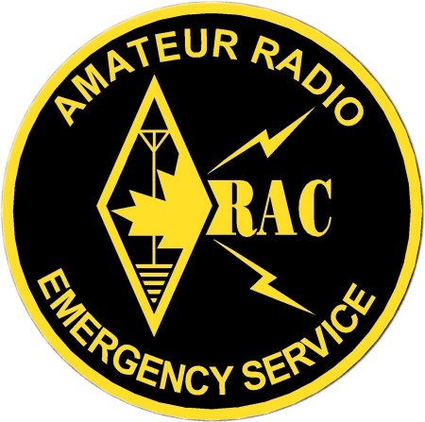
2008-01-19

Agenda Topics

- PRE-MEETING
- Grab a coffee, find a place to sit and talk with other people

- INTRO & UPDATES 9:00 AM Start
Peter Gamble [10 Min]
- Welcome, review of agenda, comment on Pizza order
- Did everyone get the EMRG mailing this month?
- PART 1: Training – Exercise on Logging
Mike Kelly [45 Min]
- Logging – What to log and why
- Practice logging, how did it go?
- BREAK [20 Min]

- PART 2: Training – Exercise on Logging
Mike Kelly [45 Min]

- Ten Years After The Ice Storm
Peter Gamble. [15 Min]
- A look back at what Amateur radio had in place 10 years ago and what is in place now.
- BREAK [20 Min]

- Activation Plan
Peter Gamble. [5 Min]
- Updated Activation Plan (EMRG-105) & Worksheet (EMRG-512)

- UHF Antenna Installation
Rick Furniss [15 Min]
- A look at the UHF antenna installation at Fire Dispatch last summer.
Pizza Lunch 12:00
For anyone interested in a chat after the meeting, a group purchase of Pizza will be made, based on those at the meeting who show an interest. The cost is divided by the number of people.

