Rideau Lakes Cycle Tour:
Communication Volunteer Event Overview

(June 8 & 9, 2013 – Saturday/Sunday)

Route Map
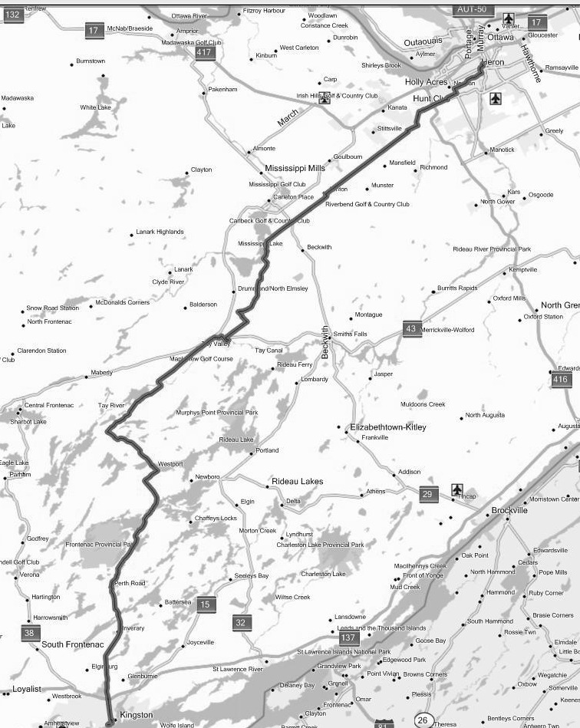

Perth

Ashton

Westport

Kingston

Ottawa

6 & 36

Loon Lane

Cemetery Sideroad

Blacks Corners

Richardson & 10

Munster Rd.

Huntley Rd.

Fallowfield

Knoxdale Rd.

Stoney Swamp

Last Duel Park

+ Curling Club

Inverary

Perth Road Village

McAdoo’s Lane

Pine Haven

Glenburnie

Dewitt’s Corners

North Crosby Recreation Centre

Lakeside

Karters Korners

Christie Lake
Event Background
Every year, the Ottawa Bicycle Club (OBC) organizes and runs the Rideau Lakes Cycle Tour (RLCT). This is a one-weekend event in early June that has bicycle riders cycle from Algonquin College in 2013 (previously from Carleton University) in Ottawa to Queen’s University in Kingston , and back, a round-trip distance of over 340 km. The outbound trip starts early on the Saturday morning departing from Carleton, and finishing at Queen’s University later in the day. Riders stay overnight at Queen’s, and return along the same route on the Sunday. There are four specified routes, of which two are supported by repair vehicles, communication and designated rest and refreshment stops. There can be as many as 2000 riders taking part in the RLCT, coming from across Canada and many other countries, with over 1000 on the supported routes. This event takes place rain or shine.

More information can be found about the RLCT at their website http://www.ottawabicycleclub.ca/

Communication Purpose
Given the large number of riders, the range in departure time and variation in speed, the tour can be spread out over a great distance. Providing communication spanning the full distance of the tour enables the support team to co-ordinate, and to render assistance to riders in need. With such a large number of riders and bicycles involved, it is inevitable that breakdowns and accidents will occur, and both do every year. Communication along the route enables accident location for emergency support, and the most effective deployment of the two repair vehicles to get bicycles repaired, and back on the road as soon as possible. In addition, identification and tracking of the last rider enables the organizers to ensure that no rider is left behind. There may be other requests for communication related to riders dropping out, lost items, etc., as well. Persons participating in communication support are not there to provide any form of traffic control, or to enforce rules and regulation of the Ottawa Bicycle Club.

Communication Overview
The communication services for this event are limited to the supported route, and are provided by radio amateur volunteers from Ottawa to Kingston. Overall communication co-ordination responsibility lies with VE3IHI (Rick Furniss), who works with the OBC executive. The Ottawa team’s coverage zone goes from Carleton University to about 10 km west of Blacks Corners, which is south of Carleton Place on Highway 15.

Time Commitment
Although each day the tour is an all day event for the riders, communication volunteers participate from three regional groups to cover the whole route (Ottawa EMRG/ARES, Lanark ARES and Frontenac ARES), so the time commitment required for each group is constrained. For volunteers at the Ottawa end of the tour, participation is typically about 3 to 6 hours maximum during Saturday morning, and/or Sunday afternoon. As the event starts out from Ottawa on the Saturday, most volunteers are needed at their assigned stations by 7:00 a.m. For the Sunday return trip, most volunteers are expected to be at their stations by 11:00 a.m. Once the last cyclist passes by their station, a communications official (usually via net control) will release that volunteer for the day.

Equipment Requirements
It is not necessary that every communications volunteer have his or her own equipment, just an amateur radio license. Volunteers who do not have equipment will be paired with those who do. Those with equipment will need to be able to operate on 2 metre FM mobile or fixed portable. While the ability to monitor two 2m frequencies simultaneously (dual watch) is desirable, it is not essential. A 50W transmit capability is ideal, but those with lower power can certainly be used as well.

Route Synopsis (Ottawa to Perth) *** Changed in 2013 due to construction
The Classic Tour leaves Algonquin College via Woodroffe Avenue and proceeds south toward West Hunt Club, where it turns right, and follows that to Richmond Rd. At Old Richmond Rd. it turns left continues on to Fallowfield Rd, passing through the village of Fallowfield along the way. At Fallowfield Rd. the route goes to the right, and follows Fallowfield along until Huntley Rd. At Huntley, it turns right and goes up to Flewellyn Rd., where it turns left, and follows that into Ashton. The tour leaves Ashton on the 9th Line, which it follows through Blacks Corners to Loon Lane. At Loon Lane the road changes into Tennyson Rd., which is followed to Macphails Rd. where it goes left, and this takes the tour a short while later into Perth.

Note: The Ottawa Bicycle Club has provide detailed route instructions and maps at the following internet addresses, for reference.

Classic Route (Ottawa to Kingston- Saturday) http://ridewithgps.com/routes/2304358

Classic Route (Kingston to Ottawa - Sunday) http://ridewithgps.com/routes/2304483

Role of the volunteer
Communication along the route enables general co-ordination, including the effective deployment of the repair vehicle, pickup (SAG) vehicles, and accident location for support. The roles of the volunteers are as follows:
- Establish a station at your assigned location. Find a suitable place to park/set up, and to ask for any permission that may be required (usually none needed).
- Display your sign in a location that will be visible to riders. A printable sign will be provided.
- Be familiar with the route: to track tour progress, and in case of redeployment (route maps available).
- Support Communication Requests: e.g. calls for repair vehicles, accident reporting, rider pickup requests, rider info. for cases of location-unknown riders, lost item reports, etc. Typically, you will be approached by riders with such requests.
  - Identify the rider’s bib number, when making requests. [No bib – no service!]
- Identify the bib-numbers of the last riders past your station -- to ensure that no rider is left behind.
- Identify to Net Control when the various mobiles visit/pass your location (if you are able to identify them).
- Watch for accidents/riders needing assistance and report.
- Supplementary: In addition to providing communications, volunteers may be asked for: directions, the use of tools, band aids (for minor issues like blisters), to stay with people awaiting pickup, etc. – being able to accommodate such requests is a bonus.
- You are NOT there to provide any form of traffic control.
- You are NOT there to enforce rules and regulation of the Ottawa Bicycle Club.

Operations Summary
- Cell Phone Use: We are in the age of the cell phone, and amateur radio is not the only method used for trouble reporting along the route. The riders have, in the past, been provided a cell phone number that will give them a direct line to OBC management to report accidents/incidents. In many cases, this will provide the quickest response to an emergency situation. However, many riders do not carry their cell phones with them, and coverage is inconsistent along the route. So, this form of reporting is often not dependable, and most reports do end up relying on the amateur radio support.
- Communications co-ordinator (overall): VE3IHI (Rick Furniss)
- Ottawa Control: All amateur radio communications for the event will take place via a controlled net on repeaters designated in this document. Net start times: Sat. 7:00 a.m.; Sun. 11:00 a.m.
- Lanark ARES: Lanark control is typically done from Westport using VE3KJG (Tactical Call: Westport Mountain)
- Lanark “Bridge”: One station on the Ottawa side is designated as a “bridging” station. This station will monitor the Lanark net to pass any traffic destined to the Ottawa net. Any location that provides good reliable communication into both nets is suitable for this purpose, but the optimal locations tend to be between Hopeside Road and Blacks Corners.
- Last rider location & radio station shutdown: Ottawa Control will coordinate operations and provide permission for shut down and departure.
- OBC Mobiles: There are six Ottawa Bicycle Club support mobiles that travel the route. They are designated with tactical calls as follows: SAG 1 and SAG 2 (see Pickup and assistance for riders – below); Repair 1 and Repair 2 (see Repair – below); and Admin 1 plus Ops 1. The latter two carry the route manager and the overall OBC tour coordinator respectively. Ops 1 is our primary interface into the OBC. All but Repair 2 travel with amateur radio operators. Repair 2 is Rx-only (see Repair).
- OPP: The OBC usually contracts OPP motorcycle police officers to patrol the route to provide Traffic Act enforcement (for both cyclist and motorists), and assist with emergencies.
- Pickup and assistance for riders: “SAG” ( Support And Gear) refers to vehicles that are used to transport riders/bikes as required. “SAG” can be used as a verb or noun, e.g. “a person has asked to be sagged”, or “we have a sag request”. There are two SAG vans (radio equipped): SAG1 & SAG2.
- Repair: Two mobile repair vans are generally in place for the tour
- “Repair 1” is usually mobile with Tx/Rx capability on 2 metres
- “Repair 2” is usually a Kunstadt Sports repair vehicle, which is Rx-only and responds to direction from net control. Although the communication is open loop, it has worked fairly effectively in the past. We may equip Repair 2 with APRS to allow us to monitor its location.
- Rider Bibs -- No bib, no service policy: Each registered rider will have a numbered bib. Due to the number of non-registered riders who tag along, the OBC have decreed that except in extreme emergency “no bib, no service”.
- Signs (Radio Stations): You will be provided, in a separate printable file, a sign reading “Cycle Tour Radio Communications”. Display one or more of these in visible locations for ease of identification.
- Signs (Tour Route): There will be directional signs placed along the route. The people who put these up or take them down are referred to as “Uppers” or “Downers” respectively (really!).
- Tactical Calls: Tactical call signs may be used during the tour to identify your location or function. Examples of such calls are “Repair 1”, “Admin 1”, “SAG 1”, “Westport Mountain”, Blacks Corners, etc.. Remember to identify using your amateur radio call sign periodically, per the regulations.
- APRS is sometimes installed temporarily on the OBC mobiles to allow for position tracking during the event.

Repeaters/Frequencies
Primary communications take place through 2 metre repeaters, as shown below. In the extremely unlikely event of a failure of both the primary and backup repeaters, operators should revert to simplex communication on 146.520 MHz.

Ottawa EMRG/ARES
VE2CRA: 146.940MHz (-), CTCSS 100.0 Hz, IRLP Node: 2040 Location: Camp Fortune north of Ottawa
Backup: VA3EMV/W: 145.210 (-), CTCSS 123.0 Hz, no IRLP Location: Stittsville area

Lanark ARES
VE3KJG: 146.640 MHz (-), no CTCSS, IRLP Node: 2947 Location: Lavant – north of Perth
VA3TEL: 145.230 MHz (-), no CTCSS, (Radio linked to VE3KJG) Location: Christie Lake

Frontenac ARES
VE3FRG: 146.805 (-), CTCSS 203.5 Hz, IRLP Node 2088 Location: Frontenac County south
Backup: VE3KBR: 146.940MHz (-), CTCSS 151.4 Hz, IRLP Node: 2750 Location: (~ Kingston N. of 401)

Rider Knowledge of the Radio Operators
Some riders seem unaware of who the radio operators are or what they are about. This is simply a case of them not reading the information provided. The route map that every registered rider receives as part of their package contains the following statement:

"The Amateur Radio Emergency Service (ARES) is once again providing communications services for the Rideau Lakes Cycle Tour. If you need a mechanic for bicycle repairs, or if you need sag wagon service because of injury or a health problem contact one of the radio vehicles or one of our tour volunteers. You will see us at Carleton University, at refreshment stops, along the route, in Perth and at Queen's University."

Rider Numbers
Typically, there are about 2000 riders engaged in the tour. For reference, the 2008 rider figures were as follows (similar numbers in 2009/2010/2011/2012):
Total registration, 2141: Challenge route 82; Classic 1250; Century 472; Cruise 249; Cancellations 88
2053 departed from Carleton plus Perth (the Century route initiates from Perth) on Saturday.

Rider Road Behaviour
Although the vast majority of riders exhibit good behaviour, there are always some who are less than ideal. The Ottawa Bicycle Club does issue notes to the riders highlighting this, and asking for their co-operation in making the tour go smoothly.

(NOTE: The following is typical of what is included in the riders' confirmation package, on the website (to be read before being able to access the application form), in the newsletter and in other miscellaneous correspondence.)

“ATTENTION ALL RIDERS: In recent years, an increasing number of complaints have been received concerning the poor conduct of individuals and/or groups on the Tour. These complaints originate from town officials along the route, the Police, the public and even fellow riders.
They list instances where cyclists flout traffic laws, are inconsiderate or even hostile towards drivers, residents and other riders. Other cases involve acts of trespassing on private property, littering, foul language and inexcusable use of public and private areas as toilets.
This situation has reached the point where it puts the very existence of the Tour in jeopardy. While a few identifiable individuals or groups may be barred from future Tours, realistically, the organizers cannot control the behaviour of the majority of riders en route.
It is then up to you, fellow riders, to act and speak out when you witness objectionable conduct, on or off the bike. Only by applying this peer pressure will you ensure the continued existence and success of your Tour. “

The OBC (Ottawa Bicycle Club) have also stated that they will encourage the OPP escort officers and other police forces along the route to be more aggressive in enforcing the rules of the road.

Ottawa Station Information
The following is a list of station locations for 2013.

