 | EMERGENCY MEASURES RADIO GROUP
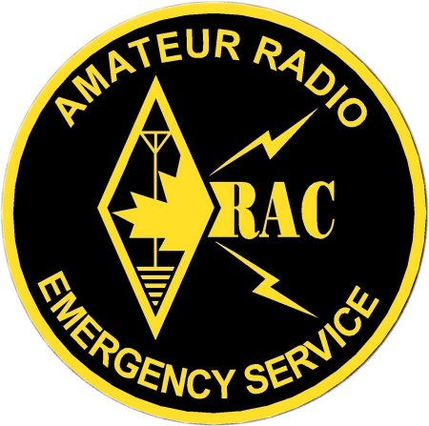 | OTTAWA ARES
Two Names - One Group - One Purpose

EVENT NAME HERE
Lessons Learned
EMRG-7XX

Version: 0.1

(remember to change the header on P1 and P2 use the "view" menu )

EMRG PUBLIC
This document is classified as PUBLIC, meaning the document can be copied and shared by the documents recipient. Public documents do not contain any personal information or other information such as site details that should not be circulated outside of EMRG or its partners.
Public Documents may be posted on the EMRG WEB site without modification.

Written by: NAME HERE for the EMRG Management Team
TABLE OF CONTENTS

1.0 REVISION SUMMARY
2.0 PURPOSE OF THIS DOCUMENT
3.0 DESCRIPTION OF EVENT
4.0 PROBLEMS ENCOUNTERED
4.1 CONTACT
4.2 Equipment
4.3 Net Control
4.4 other
5.0 Solutions proposed and comments
5.1 CONTACT
5.2 Equipment
5.3 Net Control
5.4 other
6.0 Lessons learned
6.1 there is a lot of gum out there
6.2 net control needs to keep things moving
6.3 contacting people can be difficult and time consuming
5.0 Solutions proposed and comments
5.1 solutions and or comments on FIRST PROBLEM
5.2 solutions and or comments on SECOND PROBLEM
5.3 solutions and or comments on THIRD PROBLEM
5.4 if there is no solution visible, say so
5.5 unrealistic proposed solutions don't help
4.6 so don't recommend that EMRG buy a helicopter
6.0 Lessons learned
6.1 most important lesson learned
6.2 next most important
6.3 remember to add these to EMRG 707

7.0 SUMMARY

REVISION SUMMARY

Date of  Change | Revision Number | Summary of Changes  (Section #, type of change)
2012-02-24 | 0.1 | Made initial template for future documents -VE3FFK

PURPOSE OF THIS DOCUMENT
This document is to capture what happened, what went wrong and how to fix it, from EMRG exercises and activations. There is supposed to be another single document that captures all of the lessons learned from all events, for routine review.

DESCRIPTION OF EVENT

- There are unlikely to be any sub headings here, as you describe what happened to get us called out, whether an emergency or an exercise. In the case of an exercise, describe the scenario and what we did.
For example:
- Exercise Bubblegum was a callout tree and response exercise where members were telephoned and asked to count the number of pieces of bubble gum on the sidewalk in front of their house and report on the air as soon as possible. A net control was set up and recorded the responses. This exercise simulates a request for on - the - ground neighbourhood damage reports following an earthquake or weather event. The exercise was conducted on Murfday Monthuary 2X, 20XX.

PROBLEMS ENCOUNTERED

CONTACT
- In exercise Bubblegum not everyone had up to date information on file with EMRG.
- Many people were away from home at the time
- Messages left on answering machines were not heard until after the exercise

Equipment
- Some only had hand held radios, and the batteries were discharged.

Net Control
- Net control got overwhelmed when those who heard of the exercise ahead of time responded before the net was ready to open
- Time was lost because net control had a wall map instead of a flat one, and could not place markers on it.

other
- Some operators had no sidewalk in front of their house
- Some oprators were mobile at the start of the exercise and didn't know what space to use for their gum count

Solutions proposed and comments

CONTACT
- Ask everyone to check their contact info before each exercise, and in January when the list will be updated.
- People are often away from home. In this case, if they responded after hearing the net, they were asked to participate using any available location near them at the time.
- Answering machines often won't work in a power outage. (although Telco voice mail systems may, if you can reach them) All we can do is get people to LISTEN to the net frequency if a potential emergency happens.

Equipment
- We can only stress preparedness so much. In an emergency they may be asked to contact their nearest ham neighbour, or find some other means of communicating their damage (or bubblegum) report.

Net Control
- Net control should expect to be occasionally overwhelmed and just try to keep order as well as they can.
- Operators trained as net controlers should be told to expect that they will have to put information on a map, either temporarily or permanently, and to prepare accordingly with sheet maps and markers, sticky notes or push pins.

other
- In an emergency this would not be a problem. Damage reports would come from where ever the operators are at the time. In the exercise, they were asked to select a 1x 20 metre piece of road side and use that for their report.

Lessons learned

there is a lot of gum out there
- Gum doesn't break down very quickly

net control needs to keep things moving
- Some people insist on telling you what colour the gum is, who they think left it there, and how long it has been there, even though you only want a count

contacting people can be difficult and time consuming
- All we can do is keep reminding people they need to keep their contact information current. We can ask our members to keep reminding each other to keep their info current. That way if someone changes their email address, their friends can remind them to tell us as well as their buddy.
- text
SUMMARY
- We're great. We got away with another one. Next time we will count cigarette butts.
- text

