 | Emergency Measures Radio Group  Ottawa ARES  Two Names - One Group - One Purpose | 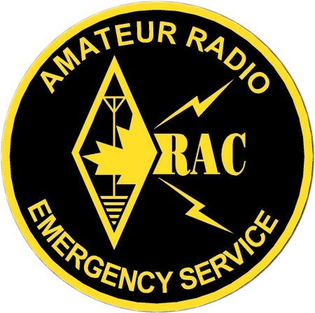

GENERAL MEETING
Date: Saturday Jan 28, 2006
Time: 9:00 AM – 12:00 PM
Location: Ottawa Fire Training Centre
898 Industrial Avenue
(Behind the fire station)
COFFEE: Of course
Agenda:
This meeting is being planned and presented by the EMRG management team
- Introductions, brief updates
- Things to do, things to learn and things to see

Everyone Welcome – Please pass the message on to other amateurs!

ARE YOU PREPARED?
Winter is here, which always has the potential for storms, power outages and closing of roads. Everyone watched what happened in New Orleans when people had no water, food, radios to listen to, or flashlights to see with.
We expect immediate action from our Municipalities, but all emergency planners are constantly reminding people that as individuals we should be prepared to support ourselves for 3 days (72 hours)
ARE YOU READY!

Emergency Preparedness Starts With You

TEAM LEADER’S MESSAGE
This fall I am starting my 11th year as team leader. There were some ups and downs over the years and I certainly have learned a lot. Many of you kept me going with your encouragement and participation. Thanks!
The last few years have been better planned and we have kept EMRG moving forward, without periods of going backwards. Having a management team in place makes a big difference for sharing the workload. We plan to add another face or two to the management team and work to get you more involved in EMRG activities.
While you may not have seen a lot happen this fall, there have been a lot of behind the scenes activities These activities are important, unfortunately they do take away from our time to plan more exercises and project work. Here are some of the things happening this fall;
- I met with John Ash, the manager for the City of Ottawa, Office of Emergency Management (OEM). We want closer links between what EMRG does for planning and projects, and what the City requires from us.
- Based on my meeting with John Ash, I was given the opportunity to speak to the City’s Emergency Planning Working Group. This is a team of people from all City departments, including First Responders, who meet one day a week to work on the City 5 year emergency response plan development. The message I put forward is that we need to know what they require, in order to ensure we can deliver it in an emergency.
- Over a year ago I started the design for a radio cabinet for the Red Cross. There are 5 radios and they must fit in a space 14 inches wide x 18 inches deep x 5 ft high. Since I designed the cabinet, I also built it, but I got delayed a lot along the way.
Meanwhile, John Senez applied for and got a $1200 grant from RAC for new Red Cross radios. The Red Cross added some money and now has three new Alinco radios for 144 – 220 – 440 MHz along with a tri-band antenna and tri-plexer. They also have a second VHF radio, a TNC and their Hospital radio.
Getting the new radios has put on the pressure to compete the cabinet and the wiring design to go with it. The wiring includes the EMRG Standard Radio Interface and a DC power system with battery backup.
- The EMRG Standard Radio Interface is my idea originally and I have been the primary developer and document writer for the standard. The need to finish the Red Cross cabinet, the development work being done by the Algonquin students for a remote interface and the need to wire up the EMRG communications room at Randall Ave, have all put pressure on me to review and update the standard. This work includes completing the wiring diagrams for several radios and TNCs, in order to make sure the standard works for each application. The updated Standard Radio Interface (SRI) document should be released by January.
- On Saturday Nov 12, all the team leaders for the Ottawa District ARES got together in Ottawa to discuss common issues, meet some new faces and prepare for our District meeting in February. The Ottawa District includes 2 ARES groups in Renfrew (recent change), Cornwall, Stormont-Dundas-Glenngary, United Counties of Prescott Russell and the City of Ottawa.
Each of these items takes time and presentations require a lot of time and effort to deliver an effective message.
This general meeting is a first for me, in that I am not involved in the preparation of the agenda or the delivery of the meeting. This is important in terms of me shedding some of the load, development of the management team and for you to see more of the other people who are working to make EMRG a success.

Peter -VE3BQP
Team Leader – EMRG

GEL CELL BATTERIES
It has been over a year since I was able to provide 4 Ah and 7.5 Ah gel cell batteries for sale. I am currently taking names for anyone that would like to get one or more batteries. The price will be $10.00 for 4 Ah and $15.00 for 7 Ah. These are new batteries, fresh out of the box.
If you told me in the past that you wanted a battery please tell me again, I am starting a new list.
I will take the batteries to the January EMRG meeting. If you will not be at the meeting send me a note or give me a call and we can work out a time and place to make the exchange.
Peter Gamble – VE3BQP (ve3bqp@rac.ca)

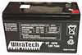
CTCSS TONES
Some just call then Tones, Motorola called them PL (Private Line), GE called them CG (Channel Guard), RCA called them QC (Quiet Channel), some people refer to them as sub-audible and some call them CTCSS (Continuous Tone Coded Squelch System) tones. No matter what name you use, they are the same and they play an important role in EMRG repeaters.
Contrary to popular belief, the requirement of a tone to access a repeater does NOT mean it is closed. A tone is frequently used to reduce interference in high RF environments and to allow the same repeater frequencies to be re-assigned within a shorter distance.
Some repeaters may also generate a tone on the repeater output so that repeater users who are equipped with a radio capable of decoding the tone will not hear other interference on the channel that would otherwise open the squelch on the user's radio.
- The frequency that a user transmits to access a repeater is the Repeater CTCSS Encode Frequency.
- The frequency that the repeater transmits to the user is the Repeater Decode Frequency.
Today most radios support tone encode, often referred to as TONE. Some radios have both tone encode and decode built in, while others support it, but require an optional CTCSS board to be installed. If you buy a new radio, make sure it supports tone Encode AND Decode.
When equipped with a CTCSS decoder, a radio receiver will remain muted in the presence of carrier unless the carrier contains the proper CTCSS code. This will effectively block out unwanted transmissions from other radios or repeaters on the same channel. When the correct tone code is received, the radio will unmute for the duration of the transmission. Because the tone is continuous, CTCSS provides positive control of the radio’s squelch circuit during each transmission. Because the tone is sub-audible (below 250 Hz), it is filtered out of the radio’s audio path and does not interfere with normal voice communication.
Not all radios support all CTCSS tones. The Electronics Industries Alliance (EIA) defined a list of 37 tones. Motorola defined a list of 42 tones, which includes the 37 EIA tones plus 5 additional tones. There are other additional tones that have been defined by different manufacturers. For simplicity and to ensure interoperability, use a tone from the EIA list.
CTCSS TONES FOR EMERGENCY USE
There are many people who believe that a repeater should not have an input tone because there are amateurs who cannot support CTCSS tone encode and so in an emergency, these people would not be able to get into the repeater.
In reality this is not an issue for 4 reasons. (1) Most amateurs can encode a CTCSS tone on their radio.
(2) Many people will be partnered with someone and will be using the other persons equipment.
(3) Some will be at a location with a permanent radio such as the EOC, Red Cross or EMRG communications centre.
(4) EMRG is building a supply of radios to fill in gaps as required.
CTCSS tones should be used on repeaters to limit interference or to allow a frequency to be re-used, such as the EMRG East and West community repeaters.
The Saint Lawrence Valley Repeater Council (SLVRC) will require CTCSS tones on the input and output of any new 144 or 440 repeaters assigned in order to allow closer repeater spacing due to the lack of available frequencies to assign.

PIONEERS
The Pioneer Amateur Radio Club (PARC) has come to an end. The group will remain as a social club meeting once per year. The VE3TEL VHF repeater has been shut down and moved, to be re-activated as a single site repeater in the West end.
The UHF repeater at the Bell building on Bank street (Beside the Sunoco, near Randall Ave) was also shut down. The UHF repeater was part of the EMRG operations plan, due to its close proximity to the core of the City and the ability of UHF signals to penetrate buildings better. After some discussion, PARC donated the UHF repeater (less the controller) to EMRG.
EMRG has a 4 bay UHF antenna that was donated previously, so the antenna will eventually be installed on the tower at Fire Dispatch and the UHF repeater will now operate as an EMRG repeater. The new location is close to the old one, so the coverage should remain the same.

FINANCIAL REPORT
EMRG continues to purchase materials for projects and now has several completed as well as a good supply of parts.
There is $500 remaining from the original $5000 grant. This money will be used for replacement of the countertop and painting of the radio room at Randall Ave.
EMRG will soon receive an additional $1000 from the City of Ottawa for funding projects over the next year.
Team Leader, Peter Gamble is currently acting as treasurer. The rules for EMRG financial management are posted in the Official Document section of the web site.

EMRG REPEATERS
The EMRG repeater strategy is starting to come together. The objective is to ensure we have enough channel capacity to meet the needs of our partners and to ensure we can provide coverage across the City.
Here is a list of EMRG repeaters:
East Community Repeater (VA3EMV/E)
- Installed & working 146.985 (-)
- 100.0Hz Input & Output tone
South Regional Repeater (VA3OFS)
- Installed & working 146.670 (-)
- 136.5Hz Input & Output tone or Carrier Squelch Input & 136.5 Hz Output tone
Central UHF Repeater (VE3OCE)
- Under construction 443.800 (+)
- Output tone 136.5 Hz
Wide Area VHF Repeater (VE3OCE)
- Upgrades planned, new Motorola repeater and battery backup
- 146.880 (-) Output tone 136.5 Hz
West Community Repeater (VA3EMV/W)
- Under Construction 146.985 (-)
- Will use equipment from central repeater once upgrades complete
- 123.0Hz Input & Output tone
Portable Repeater (VA3EMV/P)
- Fully functional 20W portable repeater, stored at Fire Dispatch
- 145.110 (-)
- 136.5 Hz Input and Output tone
Packet Repeater (VE3OCE)
- Upgrades planned, new Motorola repeater and battery backup
- 145.030 MHz

WHO CAN USE EMRG REPEATERS
There is some confusion in the Amateur community about who can use the EMRG repeaters. All EMRG repeaters are open for use by anyone in the Amateur community under the following understanding;
- The purpose of the repeaters is for emergency communications, so EMRG has priority for exercises and emergencies.
- Conversations should be useful, Amateur radio related and free from personal opinions. The repeaters are on City of Ottawa property and are occasionally monitored by City staff.
- If the repeater is not working, tell someone. Notify any member of the EMRG management team, or send an email to ve3oce@rac.ca

East Community Repeater (VA3EMV/E)
The East end Community Repeater is located at the Fire Station on Charlamagne, just off 10th line Rd. The purpose of the repeater is to link key sites within the Eastern portion of the City. Key sites means buildings that could be used in an emergency, such as Sports Centres, Community Centres or Schools that might be used as shelters, the Orleans Police Station, etc.
The repeater operates on 146.985 (-) with a CTCSS Input and Output tone of 100Hz. The CTCSS tone allows the same frequency to be used in the West end of the City, on a different tone.
The East Community Repeater is meant to cover from Blackburn Hamlet, East to the edge of the City. Some locations near the edge would require an extended antenna or cross-band repeater.

West Community Repeater (VA3EMV/W)
The final location for the West repeater looks like it will be in Carp. Some work is required to install a new repeater for the main 146.880 frequency first, to free up equipment for the West end repeater.
The repeater will operate on 146.985 (-) with a CTCSS Input and Output tone of 123Hz. The CTCSS tone allows the same frequency to be used in the East end of the City, on a different tone.
This repeater is meant to provide coverage in most of the former West Carleton area as well as into the Stittsville area.

UHF Repeater (VE3OCE)
The UHF repeater will be installed at Fire Dispatch on Randall Ave in Alta Vista. The repeater will provide excellent coverage of the City core, with some wider area coverage as well.
The repeater will operate on 443.800 (+) with a CTCSS Output tone of 136.5 Hz. This frequency is the old VE3TEL UHF frequency.
The repeater provides a solution for linking the EOC at City hall with Police, Fire and Paramedic services. This could be used to share logistics information if phones were down. The repeater could also be used to link the hospitals.
The repeater will require some work to add a new controller and wire it to the EMRG standard interface.

Wide Area Repeaters (VE3OCE)
The Centre repeater is located at Ottawa Fire Dispatch and provides wide area VHF voice (146.880 -) and data (145.030). The current repeaters are mobile radios, which will be replaced by commercial duty Motorola repeaters, capable of true continuous duty operation.
These repeaters cover most of the City, with some locations requiring a crossband repeater or small beam for reliable communications.

South Wide Area Repeater (VA3OFS)
The South Repeater is located at the Barrhaven Fire Station, using the tower formerly used for Nepean Dispatch. This repeater will cover the Southern portion of the City, while also providing an alternate to VE3OCE VHF in the City core.
The repeater operates on 146.670 (-) MHz. The input operates with carrier squelch only or with a CTCSS Input tone of 136.5Hz. This will be a test to see if the repeater has greater sensitivity when using a tone on the input, rather than just carrier squelch. The Output tone is 136.5Hz.
This site has generator backup and a new 100Ah battery in case the generator fails.

RED CROSS RADIOS
EMRG has been working on a multi phase radio improvement project with the Ottawa Branch of the Red Cross. The branch moved from Plymouth street to Catherine street a couple years ago, so they were starting with a clean slate.
Through donations, Red Cross funding and a grant from RAC, the Red Cross will have a multi radio solution allowing them to communicate on several nets and packet radio.
The radios are mounted in a vertical cabinet because there is no more space. In reality this will not be a problem for heat, because not all the radios will be operational at once and most of the communications will be through repeaters, so very low power will work.
There are three antennas on the roof, one Comet Tri-Band for 144/220/440 with a matching tri-plexer at the radio cabinet, one Sinclair 210-C single loop commercial VHF antenna that covers 138-174 MHz and a ¼ wave UHF antenna for the Hospital radio.
Once this is complete, there will be an training session / exercise to show people how to use the equipment.
The equipment will be laid out in the cabinet as shown. The cabinet is built, the radios have arrived and cables are being built to connect it all together.

MORE FUN WITH POWERPOLES
By Mike Kelly – VE3FFK
Once you start to use Powerpoles, you may find that just adapting from your standard DC connector to and from them isn't enough for you.
Here are a few other things you can do with them.

Simple Y Connector
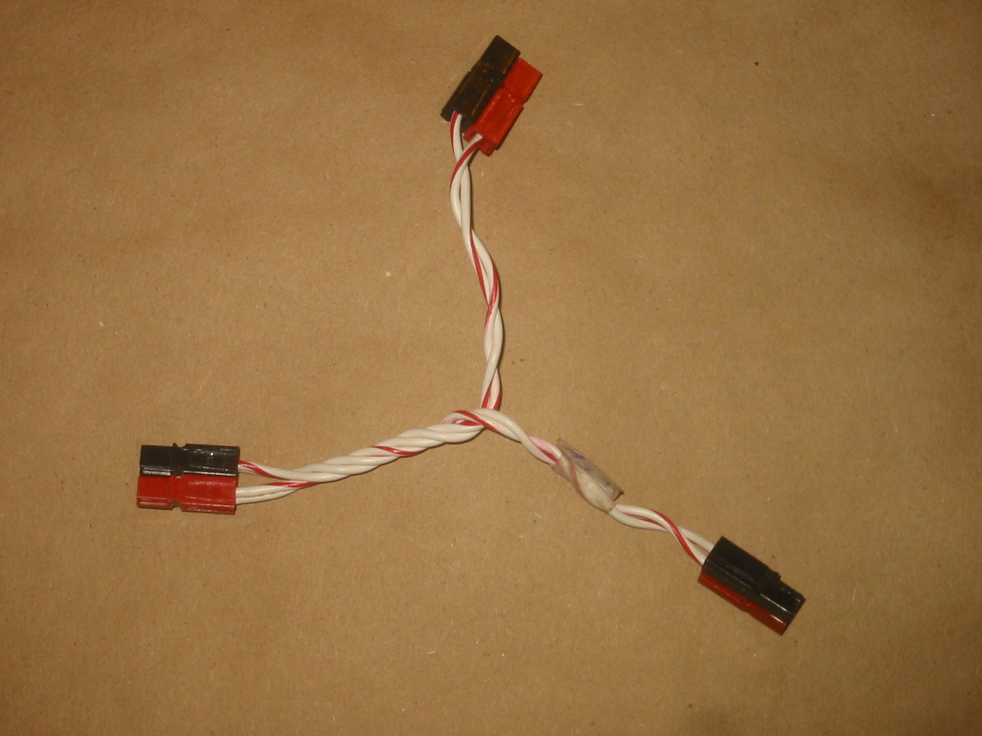

Multiple Y Connector
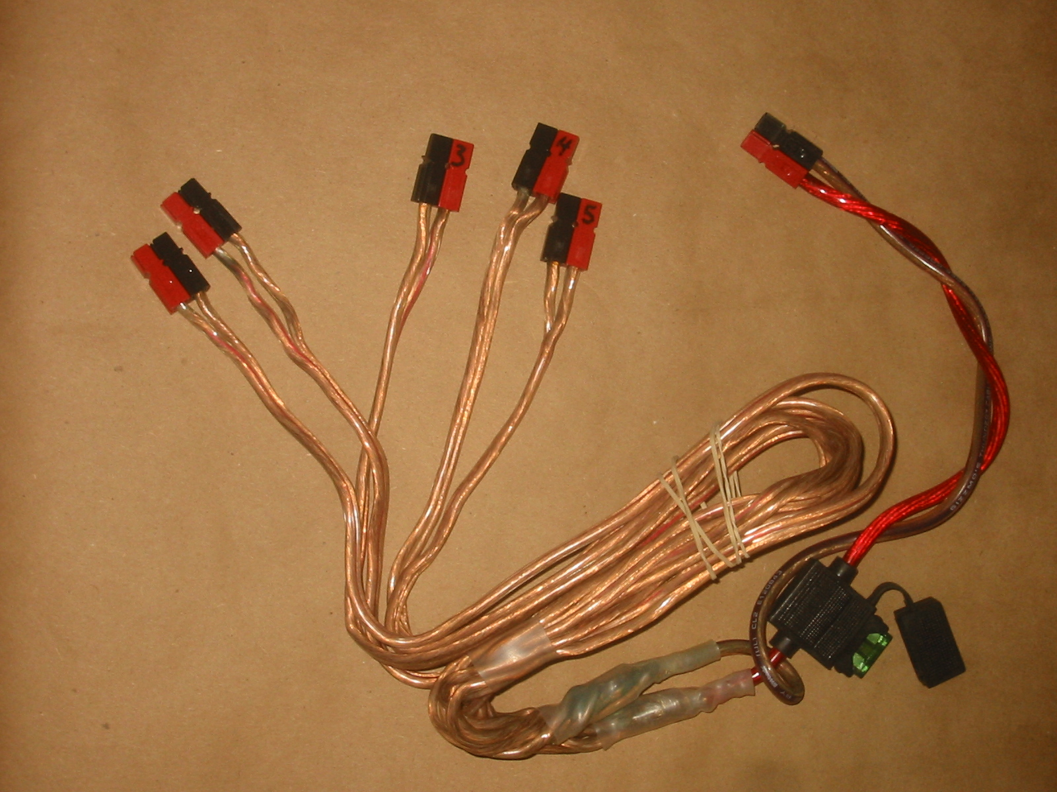
In my case, each arm of the Y is a different length, so I can connect various pieces of gear to the power supply without piling them on top of each other.

Splitters & Extension Cords
I added powerpoles to my 3 way splitter and to my 2 way extension cord/
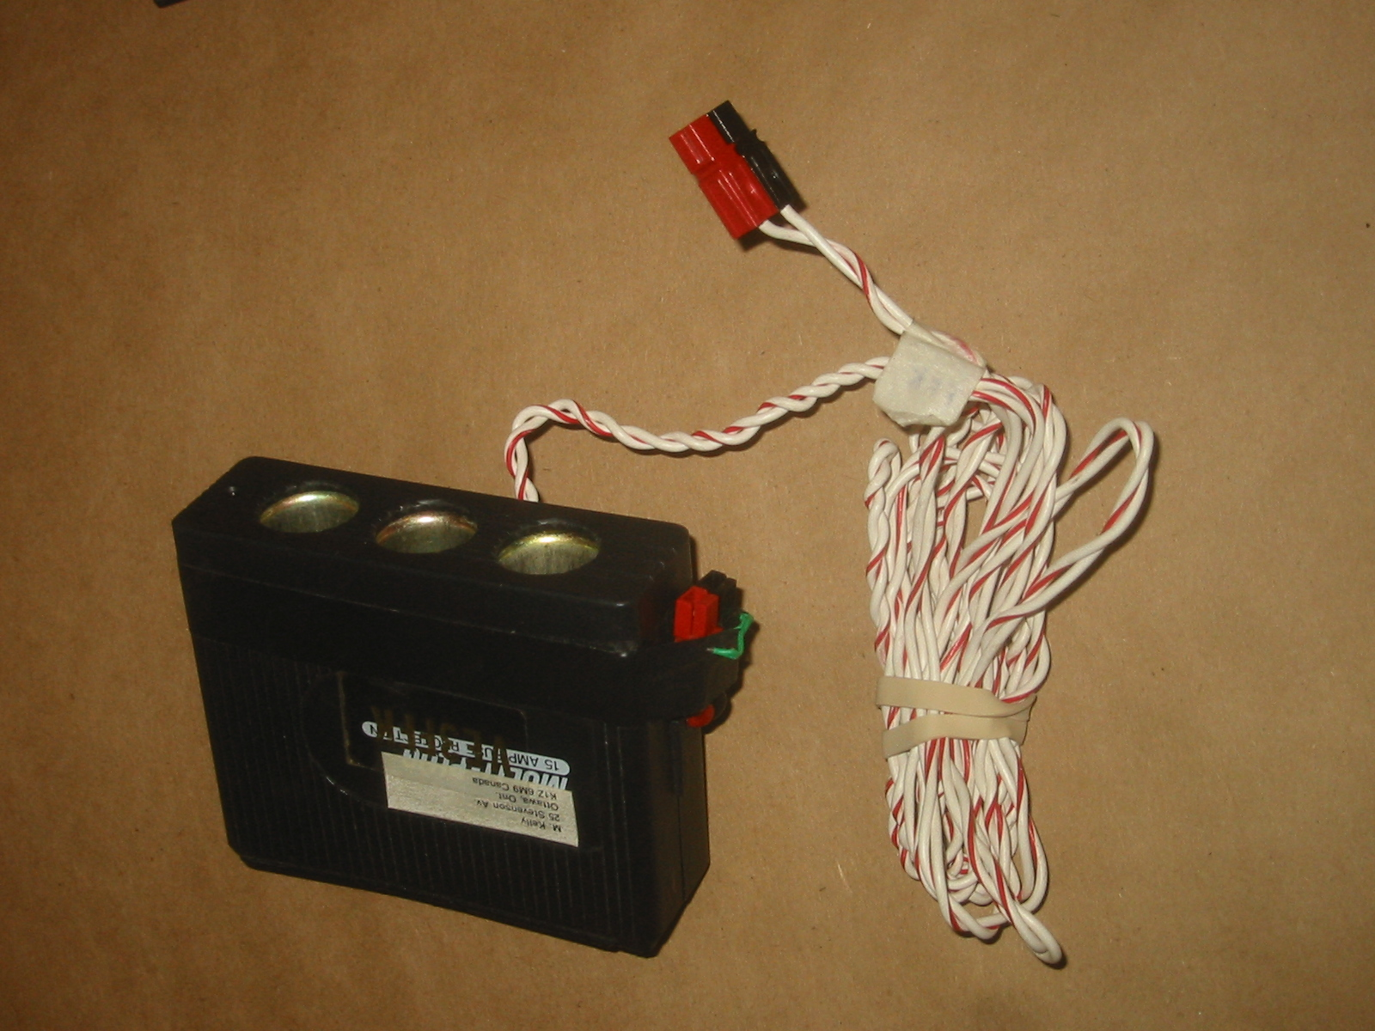

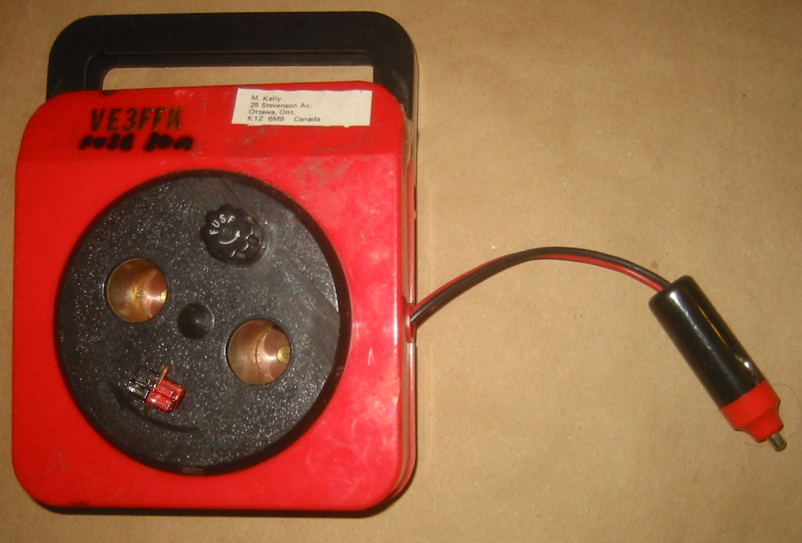

Fuse holder
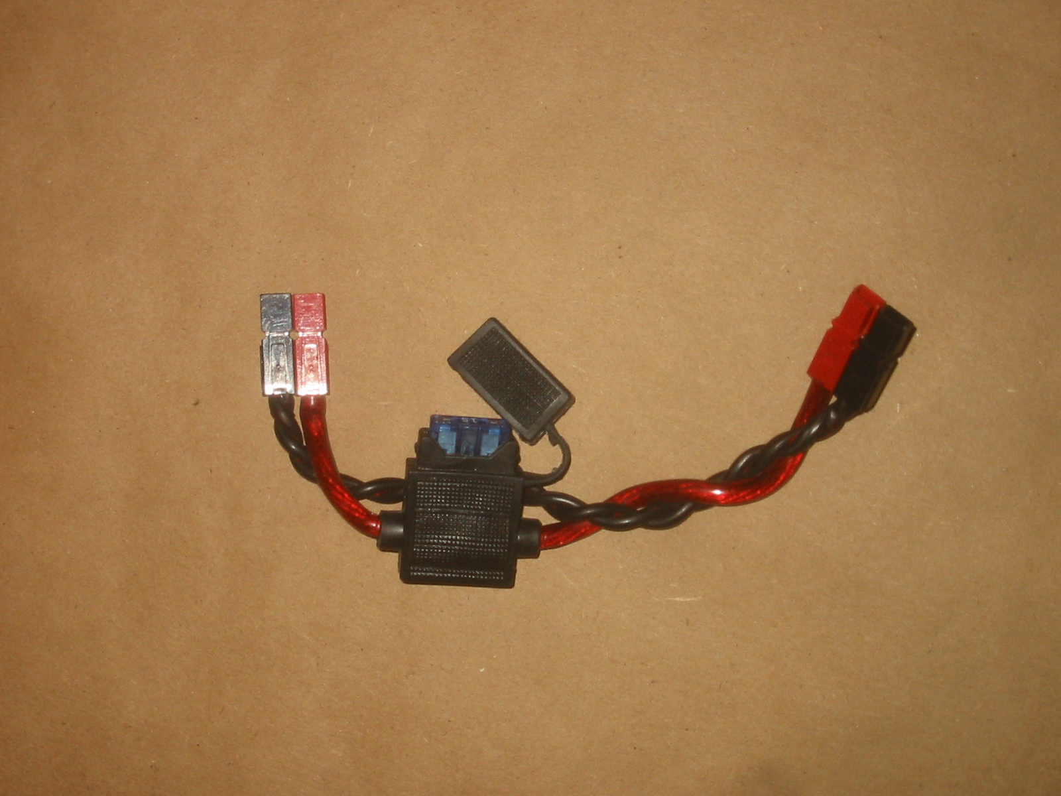
This lets you add a fuse to a piece of equipment that doesn't have one. It also lets you put in one fuseholder for multiple rigs, rather than changing them all.
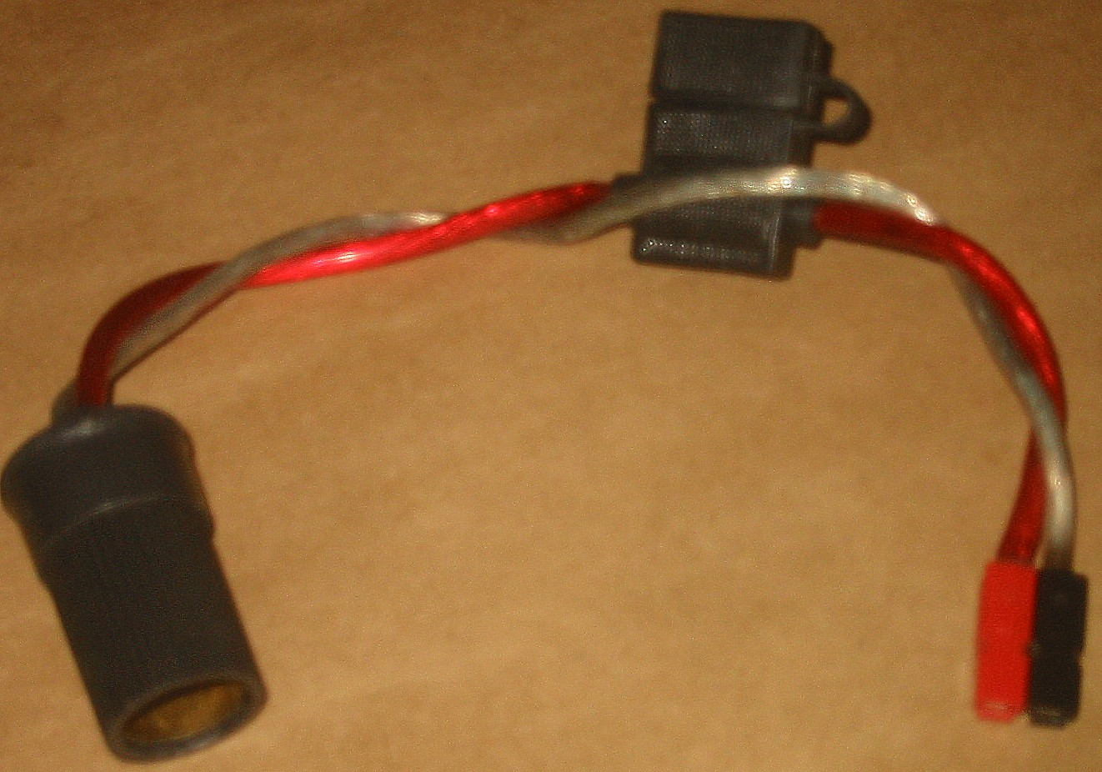

Fuse holder/Ammeter
This could be an addition to the fuseholder insert above. You can also add a voltmeter, or just test points for one. I use this one in series with my battery charger.
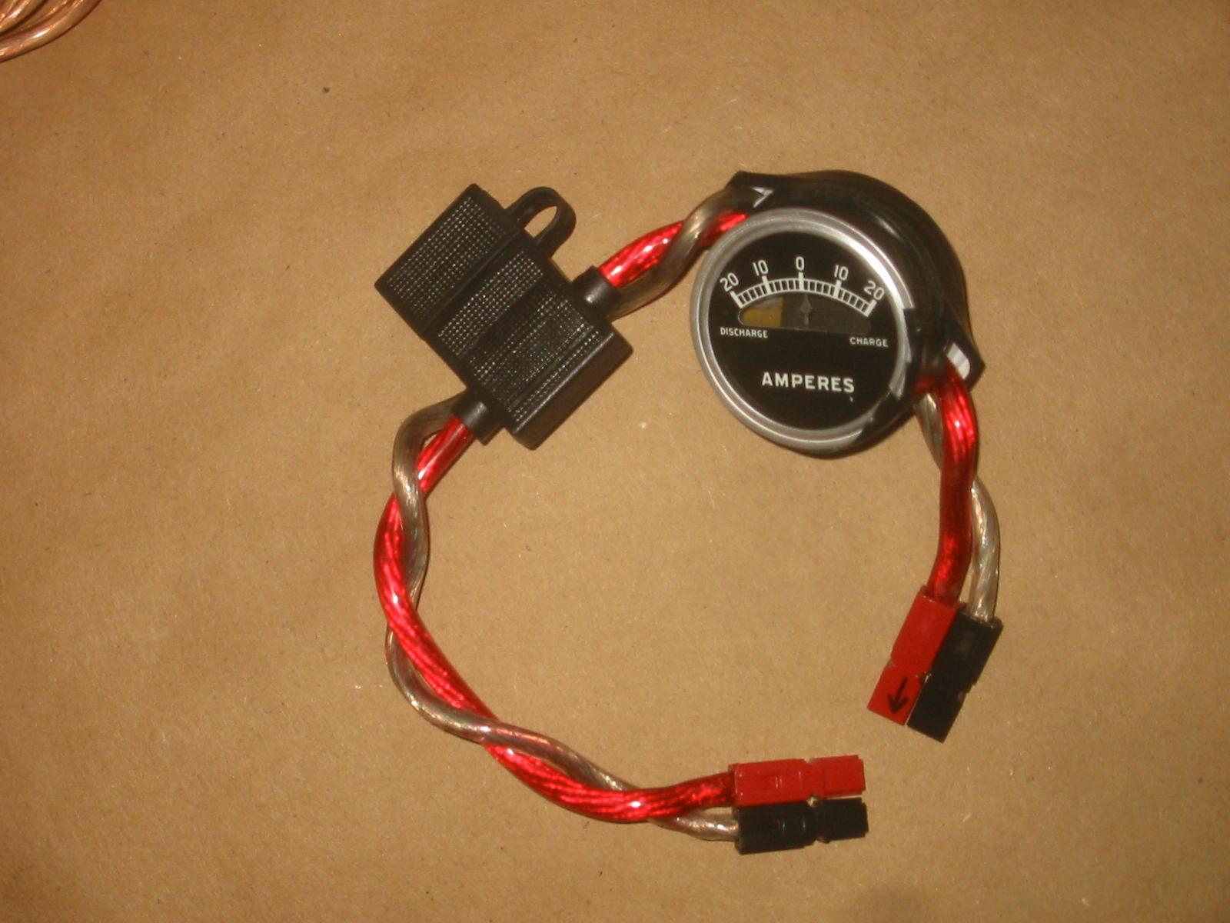

Special Adapter
I have Yaesu rigs that use 4 pin Jones connectors for their power. Adding a Powerpole to this cord lets me use the same cable for the Yaesu and another 12V accessory (Typically my DSP box or a second rig.
This cable COULD be used to feed my Yaesu rigs via the power pole, but in this case, the lighter plug has to be insulated. Otherwise Murphy will ensure that the center pin of the lighter plug hits ground.
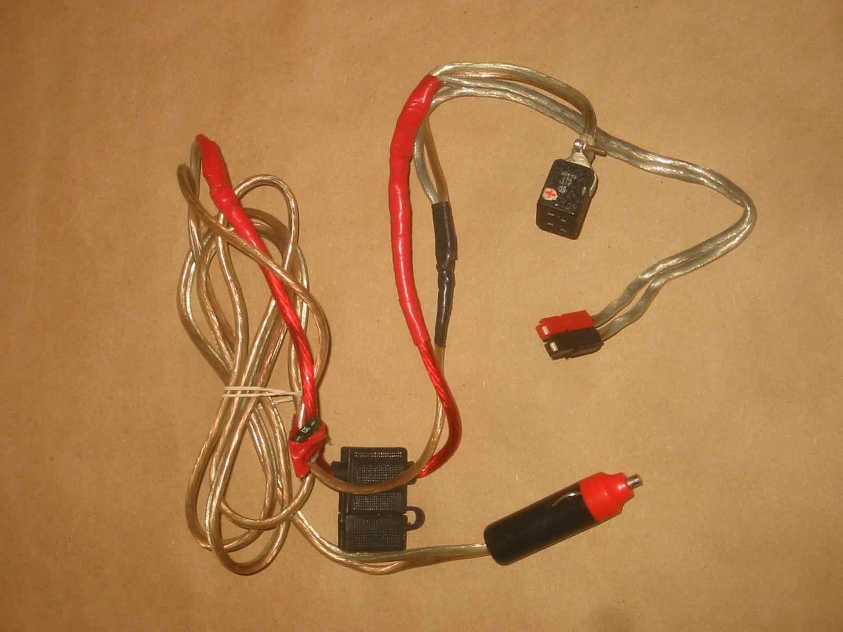

Speaking of Murphy, note that most of the fuseholders have spare fuses taped near them.

mk ve3ffk

WHEN TO ADD FUSES
Installing fuses for DC wiring uses the same logic as household AC wiring.
- Every source of DC power, such as a power supply, battery, or potato, should have a fuse in line to protect the source.
- Every load that consumes DC power, such as a radio or inverter, should have a fuse in line to protect the device.
- Extension cords or adapter cables do not require fuses.

KEEP LOTS OF SPARE FUSES ON HAND
12 Volt Battery Case with Anderson Powerpoles®
Richard Hagemeyer, VE3UNW

This article describes a battery case which has been outfitted with Anderson Powerpoles® and a self-resetting fuse. It is a simple project with easy to obtain parts and can be put together in an evening.
This list of parts required is as follows:
1 | 12 V Deep Discharge Battery | Marine batteries cost $90-$180
1 | Vented Battery Box | Group 24 (CT:79-0312-2) or 28 (CT:79-0314-8)
1 | Self-resetting fuse or circuit breaker | 20 or 30 Amp $7-$20 (Canadian Tire)
1 | Fuse holder | Not needed for circuit breaker (Canadian Tire)
6’ | Heavy duty stranded wire
10 | Anderson Powerpoles® | 30 Amp connectors (EMRG)
1 | Heavy duty 5-way binding post | Canadian Tire or Radio Shack
4 | Ring connectors | Battery connection(Canadian Tire or Radio Shack)
6 | Tie wraps
 | Solder
 | Hardware
The parts can be found at either Canadian Tire or Radio Shack. You might want to try Princess Auto or Active Electronics as well. Use tie wraps inside to neaten up the wires; after all, you’ll be showing your project to all sorts of fellow hams soon!

DESCRIPTION
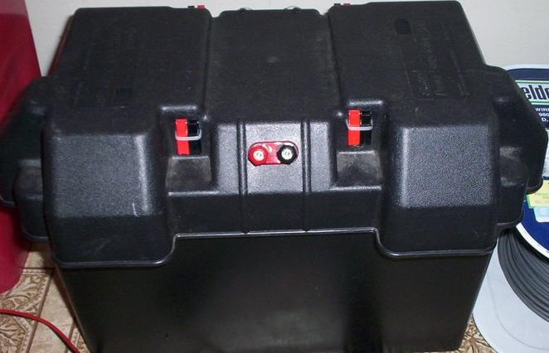 | The battery case as shown is a group 24 (car size) marine deep discharge battery. The case has 4 sets of powerpoles mounted, although only 2 can be clearly seen in the picture.  The case also features a heavy duty binding post. Inside the case is a 2 foot wire with powerpoles direct connected to the battery. I use this mostly for charging. It really should have a fuse on it, but none is installed currently.

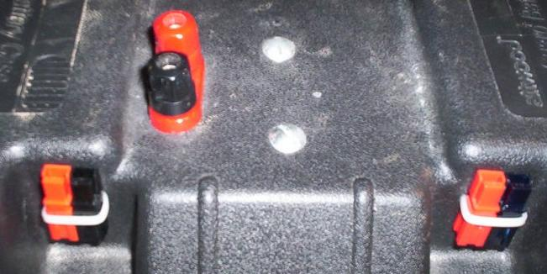 | The previous picture with the binding post in the center, is a case with the self-resetting fuse. The case on the left has the binding post offset from the center and uses a heavy duty circuit breaker. The circuit breaker mounting screws can be seen in the center-line.

Regular fuse in the holder with a self-resetting fuse in front. >  If the fuse option is chosen, you will have to bring the connections together from the powerpoles and solder them together. It is a lot of wire and will require a fair amount of heat to solder. Afterwards, wrap electrical tape around generously. Remember, what is in the box is out of site and a poor job can be disastrous!  If a heavy-duty circuit breaker is chosen, ring terminals can be used inside the box and bolted to the circuit breaker on one side and the 5-way binding post on the other. | 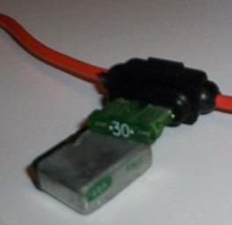

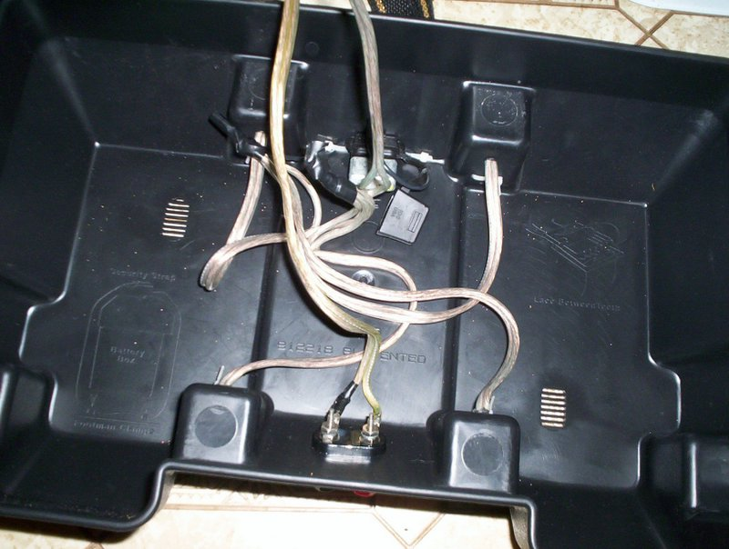  Inside view with fuse holder in upper middle | 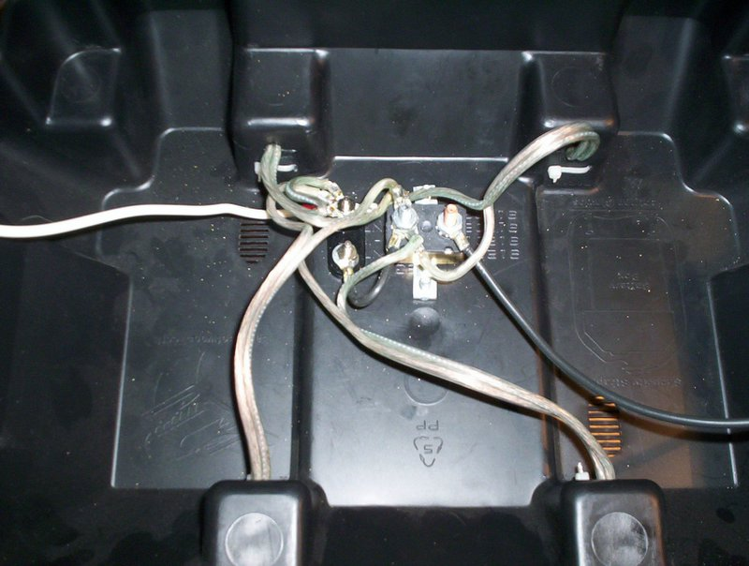  Inside view with circuit breaker in upper middle

CONSTRUCTION
Start by deciding on the connector layout for your box. The only downside I can see to my choice is the fact that the connector faces up and could trap dirt and debris over time.
Use an electric drill with a sharp bit on slow speed to drill wire and mounting holes. Use the template on the package as a guide to mount the binding posts. If using the circuit breaker, you can use the device to mark the centers.
Solder about one foot of heavy duty wire to each of the four powerpole connectors. Pay attention to polarity of your wire; at least be consistent.
Each of the powerpoles will need a larger hole for the wire feed and two smaller holes for accept the plastic wire wrap. You may want to drill one and try out the mounting before drilling all the holes. That way you can adjust bit size or placement as required. Mount the binding post and if chosen, the circuit breaker. Finish up by mounting the remaining powerpoles.
Trim the wires, but not too tight. The only wire that really needs to be a bit long is the wire(s) from the battery to the top of the case. If it’s too short, you’ll swear every time you need to take of the cover. The wires from the powerpoles to the binding post and circuit breaker can be shorter. Make them too short and you’ll have difficulty getting them all together.
Dress the wires with ring connectors as appropriate and make the final connections. If you are soldering really pay attention to polarity; it’s harder to fix!

