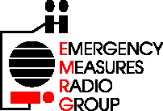 | EMERGENCY MEASURES RADIO GROUP
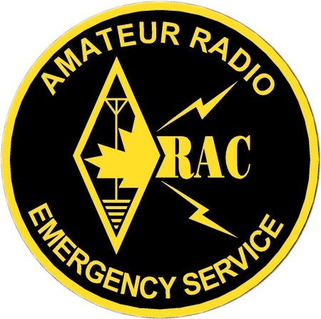 | OTTAWA ARES
Two Names - One Group - One Purpose

Inventory Management Guidelines

Version: 1.0

PURPOSE OF THIS DOCUMENT
The purpose of this document is to explain how EMRG manages equipment that is donated. EMRG is interested in any surplus radio system parts or components. This includes, VHF & UHF radios (base, mobile or handheld), antennas (base & mobile), repeaters, cable & connectors, cavities and actually anything remotely related to radio.
Using surplus equipment maximizes EMRG's capability to serve the City of Ottawa, while keeping costs low. Many EMRG members work in technical jobs or have a technical background, which allows EMRG to modify or integrate various pieces of surplus equipment, to create useful radio communications solutions.
The EMRG equipment tracking guidelines are rules to ensure that donated equipment is used for EMRG purposes. Used radio equipment has value to its owner and EMRG appreciates this.
- Any equipment donated to EMRG is entered into a database for tracking purposes. This identifies the equipment, where it came from and where it is stored or in use.
- Once equipment is ready for use (programming & wiring is complete), an inventory sticker is applied and the equipment will either go into the EMRG storage area at the Fire Dept Alta Vista dispatch or will be installed at a City of Ottawa site.
- The agency or company donating the equipment can specify if the equipment donated is for EMRG use only, or if EMRG can release portions of the equipment to the greater amateur radio community. This is all tracked in the EMRG database.
- In some cases, EMRG may be able to sell unused components to local amateur radio operators, to provide money to buy project parts that must be purchased.
- In some cases, the agency or company donating the equipment may be concerned about the equipment returning to commercial service. If this is a concern, any left over equipment can be returned, or destroyed if EMRG is unable to use it.
- Equipment donated for specific projects is identified in the database. The agency or company donating the equipment can request status updates on the project and where applicable, a demonstration of the completed project.

