Buka web config :

<connectionStrings>

<add name="DefaultConnection" connectionString="Data Source=(LocalDb)\v11.0;AttachDbFilename=|DataDirectory|\aspnet-WebASP-20160521100557.mdf;Initial Catalog=aspnet-WebASP-20160521100557;Integrated Security=True" providerName="System.Data.SqlClient" />

<add name="SForumEntities" connectionString="metadata=res://*/Models.Forum.csdl|res://*/Models.Forum.ssdl|res://*/Models.Forum.msl;provider=System.Data.SqlClient;provider connection string=&quot;data source=DESKTOP-74HE43K\SQLEXPRESS;initial catalog=SForum;integrated security=True;MultipleActiveResultSets=True;App=EntityFramework&quot;" providerName="System.Data.EntityClient" />

</connectionStrings>

Menjadi :

<connectionStrings>

<add name="DefaultConnection" connectionString="data source=DESKTOP-74HE43K\SQLEXPRESS;initial catalog=SForum;integrated security=True;" providerName="System.Data.SqlClient" />

<add name="SForumEntities" connectionString="metadata=res://*/Models.Forum.csdl|res://*/Models.Forum.ssdl|res://*/Models.Forum.msl;provider=System.Data.SqlClient;provider connection string=&quot;data source=DESKTOP-74HE43K\SQLEXPRESS;initial catalog=SForum;integrated security=True;MultipleActiveResultSets=True;App=EntityFramework&quot;" providerName="System.Data.EntityClient" />

</connectionStrings>

**Mengaktifkan Pakcage Manager**

Buka tools -> NuGet Package Manager -> Package Manager Console

enable-migrations



Berarti ada 2 entity, mau yang mana ?

Nah pilih yg web asp

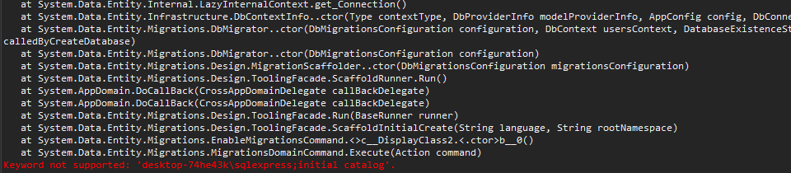

Kalau muncul seperti diatas, coba kembali cek connection string nya

Kalau berhasil maka muncul tampilan seperti ini :



Add-migration admin

Can jelas

**update-database**

Refresh table

**Membatasi Hak Akses**