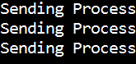Video provides a powerful way to help you prove your point.

Inside
Textbox.

