**For how long theSARS-CoV2 is detectable by PCR tests? A meta-analysis**

**Impetus for project:** I am interested in finding for how long the SARS-CoV-2 is detectable by PCR. Originally, I wanted to create a Kaplan-Meir type of graph with "days" on the x-axis, and "percentage of the detectable infections" in the y-axis. Similar to the following picture:

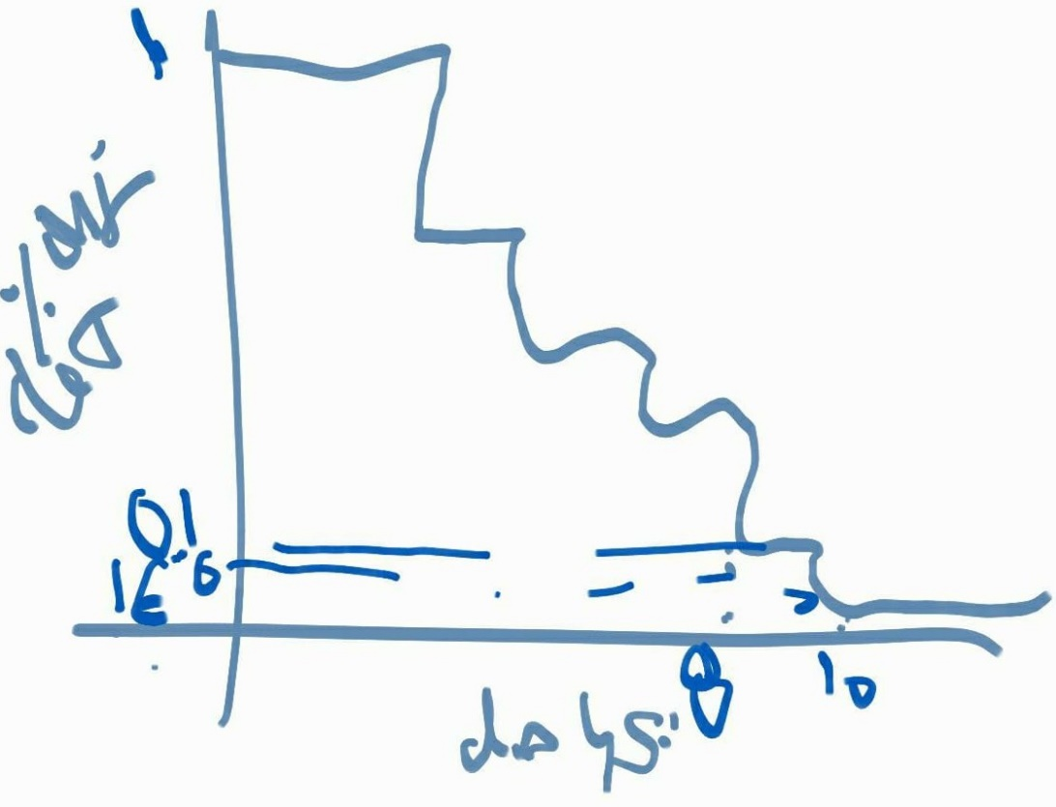

Turns out, there is really not much information to make such a graph - at least that I could find. There are estimates from experts saying that after 8 days, only 10% would be detectable, and after 10 days, almost none will be. But that is it.

What I did find was a paper from the Journal of Infectious Disease (Walsh, et al 20201) where the authors conducted a literature review of detection-period for SARS-COV2 from Upper and Lower Respiratory Tract, and Stool. They reviewed over 100 papers but did not perform a meta-analysis.

Hence, the purpose of this project was to scrap the data from the paper and estimate a pooled estimate for the detection period of SARS-COV2.

**Methods:**

Inclusion criteria for papers. 1. point-estimate (mean or median), 2. uncertainty assessment (95%CI, IQR, or Range). I am only analyzing the data of the Upper Respiratory Tract studies, but certainly a similar analysis is possible for Lower Respiratory Tact and Stool. Would be interesting to compare the results.

Analysis: Meta-analysis with Inverse-variance method for polling fitted into a Random-Effects models. We decided for a RE because there is really no reason to assume that all results stem from the same underlying population. Papers' results arise from different countries and different age/gender groups. Everything was coded on R using the meta package.2

**Results:**

The pooled data showed an estimated duration of virus detection of 15.6 (95%CI 12.3, 18.9) days.

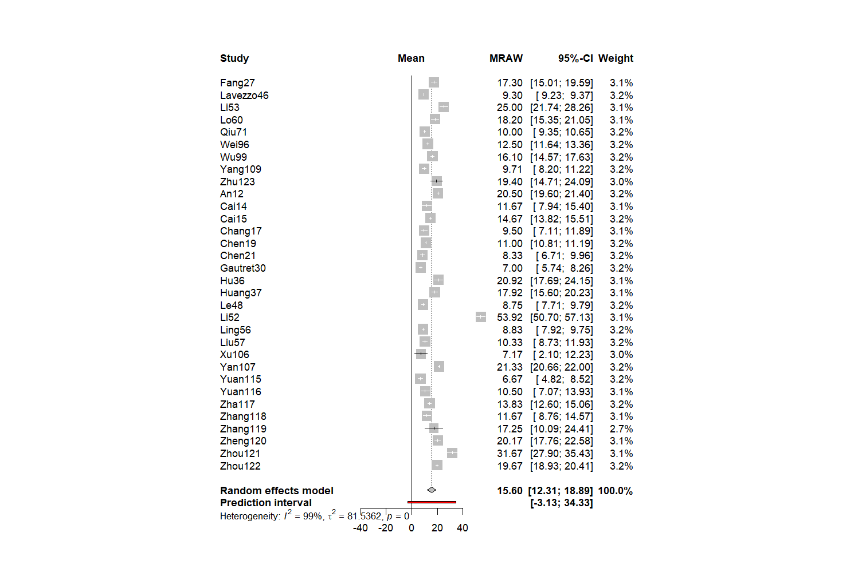

This result  can be interpreted as follows: the SARS-COV2 is detectable by PCR analysis of Upper Respiratory Tract samples for 15.6 days in average. This is consistent with other papers and expert opinion that the virus is undetectable after around 2 weeks of infection.3,4

**Discussion:**

I have concerns about the methodology where your contribution would be great! First, all papers where a median was reported were converted to mean and Standard deviation using the Wang, et al BMC 2014 approximation.5 This approximation makes assumptions about the underlying distribution for the median that might bias the estimated mean. Second, we used means instead of medians for the meta-analysis because the methods are better established for the former. However, there's evidence (see McGrath, Biom J. 20206) that median-based estimations out-perform transformation-based ones. The problem is that out of the 32 studies included in this analysis 9 estimated mean, so a transformation would be needed in any case. Finally, I am using a method for pooling data from single mean studies, which seems to be the best match considering the data I have. However, I am not fully aware of the limitations of this method and under which circumstance a method for Mean Differences (that assumes at least two arms of treatment) would be equivalent or even preferred, if any.

**References**

1. Walsh, K. A. *et al.* SARS-CoV-2 detection, viral load and infectivity over the course of an infection. *J. Infect.* **81**, 357–371 (2020).

2. Harrer, Cuijpers, Furukawa & Ebert. *Doing Meta-Analysis in R*.

3. Yu, F. *et al.* Quantitative Detection and Viral Load Analysis of SARS-CoV-2 in Infected Patients. *Clin. Infect. Dis. Off. Publ. Infect. Dis. Soc. Am.* (2020) doi:10.1093/cid/ciaa345.

4. Huang, J. *et al.* Long period dynamics of viral load and antibodies for SARS-CoV-2 infection: an observational cohort study. *medRxiv* 2020.04.22.20071258 (2020) doi:10.1101/2020.04.22.20071258.

5. Wan, X., Wang, W., Liu, J. & Tong, T. Estimating the sample mean and standard deviation from the sample size, median, range and/or interquartile range. *BMC Med. Res. Methodol.* **14**, 135 (2014).

6. McGrath, S., Sohn, H., Steele, R. & Benedetti, A. Meta-analysis of the difference of medians. *Biom. J. Biom. Z.* **62**, 69–98 (2020).