| create table arp_diagnostics (  id serial primary key,  abonent_id serial,  has_arp boolean not null,  arp_id serial,  time timestamp );  create table district (  id serial primary key,  town text,  district text );  create table employee (  id serial primary key,  name text not null,  surname text not null,  role text not null,  employment_date date );  create table cable_diagnostics (  id serial primary key,  employee_id serial not null,  port_id serial not null,  link_state text,  diagnostics text,  constraint fk_cable_diagnostics_employee_id  foreign key (employee_id)  references employee(id) );  create table executor (  request_id serial primary key,  department text );  create table provider (  id serial primary key,  name text not null,  type_of_connection text );  create table abonent (  id serial primary key,  login text not null unique,  account_number integer not null unique,  name text,  surname text,  phone_number text unique,  email text unique,  status text,  address_id serial not null,  note text,  provider_id serial not null,  constraint fk_abonent_provider_id  foreign key (provider_id)  references provider(id) );  create table vlan (  id serial primary key,  name text not null );  create table switch (  id serial primary key,  ip varchar(16) not null unique,  model text,  port_count integer,  house_id serial,  provider_id serial,  uplink_port integer );  create table commutation (  abonent_id serial,  switch_id serial,  port_id serial,  cable_type text,  primary key (abonent_id, switch_id, port_id) );  create table equipment_connections (  equipment1_id serial,  equipment2_id serial,  speed integer not null check (speed = 100 or speed = 1000 or speed = 10000),  primary key (equipment1_id, equipment2_id) );  create table payment_history (  abonent_id serial primary key,  date timestamp not null,  balance_change integer not null );  create table address (  id serial primary key,  house_id serial not null,  porch integer,  floor integer,  flat integer not null );  create table request (  id serial primary key,  abonent_id serial not null,  author_id serial not null,  create_date timestamp not null,  status text not null,  status_change_date timestamp,  close_date timestamp,  type text not null,  text text,  constraint fk_request_author_id  foreign key (author_id)  references employee(id) );  create table node (  id serial primary key,  model text,  district_id serial,  provider_id serial,  constraint fk_node_district_id  foreign key (district_id)  references district(id)  constraint fk_node_provider_id  foreign key (provider_id)  references provider(id) );  create table mac_address (  port_id serial,  mac_address text,  primary key (port_id, mac_address) );  create table connection_diagnostics (  id serial primary key,  employee_id serial not null,  switch text not null,  port text not null,  has_link boolean,  link_type text,  has_mac boolean,  errors integer,  errors_rise boolean,  correct_vlan boolean,  switch_loss integer );  create table billing (  abonent_id serial primary key,  balance integer not null,  status text );  create table house (  id serial primary key,  district_id serial not null,  street text not null,  number integer not null );  create table router_settings (  abonent_id serial primary key,  ip varchar(16) not null,  mask varchar(16) not null,  gateway varchar(16) not null );  create table arp (  id serial primary key,  create_date timestamp not null,  mac_address_id serial not null,  node_id serial not null,  vlan_id serial not null );  create table comment (  id serial primary key,  request_id serial not null,  date timestamp not null,  text text not null,  employee_id serial not null,  constraint fk_comment_request_id  foreign key (request_id)  references request(id),  constraint fk_comment_employee_id  foreign key (employee_id)  references employee(id) );  create table port (  id serial primary key,  switch_id serial not null,  port_number integer not null,  address_id serial,  vlan_id serial,  port_status text not null,  connection_speed integer check (connection_speed = 0 or connection_speed = 10 or connection_speed = 100 or connection_speed = 1000),  description text,  connection_status text,  constraint fk_port_switch_id  foreign key (switch_id)  references switch(id),  constraint fk_port_vlan_id  foreign key (vlan_id)  references vlan(id) ); |
| --- |

Заполнение

import psycopg2

from sshtunnel import SSHTunnelForwarder

import io

import hashlib

import string

import random

from datetime import datetime

PORT = 5432

REMOTE_USERNAME = 's312637'

REMOTE_HOST = 'helios.cs.ifmo.ru'

REMOTE_SSH_PORT = 2222

REMOTE_PASSWORD = 'XVQI.2552'

server = SSHTunnelForwarder((REMOTE_HOST, REMOTE_SSH_PORT),

ssh_username=REMOTE_USERNAME,

ssh_password=REMOTE_PASSWORD,

remote_bind_address=('192.168.10.80', PORT),

local_bind_address=('localhost', 10022))

def add_address(cursor, town, district, street, house_number, porch, floor, flat):

query = """SELECT id FROM district WHERE town=%s AND district=%s;"""

cursor.execute(query, (town, district))

id = cursor.fetchone()

if not(id):

query = """INSERT INTO district (town, district) VALUES (%s, %s) RETURNING id;"""

cursor.execute(query, (town, district))

district_id = cursor.fetchone()[0]

else:

district_id = id[0]

query = """SELECT id FROM house WHERE district_id=%s AND street=%s AND number=%s;"""

cursor.execute(query, (district_id, street, house_number))

id = cursor.fetchone()

if not(id):

query = """INSERT INTO house (district_id, street, number) VALUES (%s, %s, %s) RETURNING id;"""

cursor.execute(query, (district_id, street, house_number))

house_id = cursor.fetchone()[0]

else:

house_id = id[0]

query = """SELECT id FROM address WHERE house_id=%s AND flat=%s;"""

cursor.execute(query, (house_id, flat))

id = cursor.fetchone()

if not(id):

query = """INSERT INTO address (house_id, porch, floor, flat) VALUES (%s, %s, %s, %s) RETURNING id;"""

cursor.execute(query, (house_id, porch, floor, flat))

return cursor.fetchone()[0]

else:

return id[0]

def get_address(cursor, town, district, street, house_number, porch, floor, flat):

query = """SELECT id FROM district WHERE town=%s AND district=%s;"""

cursor.execute(query, (town, district))

id = cursor.fetchone()

if not(id):

return None

else:

district_id = id[0]

query = """SELECT id FROM house WHERE district_id=%s AND street=%s AND number=%s;"""

cursor.execute(query, (district_id, street, house_number))

id = cursor.fetchone()

if not(id):

return None

else:

house_id = id[0]

query = """SELECT id FROM address WHERE house_id=%s AND flat=%s;"""

cursor.execute(query, (house_id, flat))

id = cursor.fetchone()

if not(id):

return None

else:

return int(id[0])

def add_abonent(cursor, login, account_number, name, surname, phone_number, email, status, address_id, note):

print("Choose provider id (1 - Ростелеком, 2 - Етелеком, 3 - Тиера, 4 - Скайнет):")

provider_id = int(input())

query = """INSERT INTO abonent (login, account_number, name, surname, phone_number, email, status, address_id, note, provider_id)

VALUES (%s, %s, %s, %s, %s, %s, %s, %s, %s, %s) RETURNING id;"""

cursor.execute(query, (login, account_number, name, surname, phone_number, email, status, address_id, note, provider_id))

if __name__ == "__main__":

server.start()

conn = psycopg2.connect(user=REMOTE_USERNAME, database='studs', password='IUkanShc6DhfHo7x', host='localhost', port=10022)

cursor = conn.cursor()

add_abonent(cursor, "fr415", "55566", "Игорь", "Вихорьков", "89123339512", "igor@gmail.com", "действующий",

add_address(cursor, "Санкт-Петербург", "Невский", "Дыбенко", 26, 3, 1, 5),

None)

add_abonent(cursor, "ps466", "11111", "Анна", "Павловна", "89123316323", "anna@gmail.com", "действующий",

add_address(cursor, "Санкт-Петербург", "Шушары", "Школьный", 67, 2, 5, 77),

None)

add_abonent(cursor, "fr108", "374748", "Дмитрий", "Борисов", "89124454635", "dmitry@gmail.com", "действующий",

add_address(cursor, "Санкт-Петербург", "Невский", "Большевиков", 35, 2, 6, 90),

None)

add_abonent(cursor, "pk610", "939503", "Валентина", "Смирнов", "89126670956", "valentina@gmail.com", "действующий",

add_address(cursor, "Санкт-Петербург", "Невский", "Обуховской обороны", 220, 12, 15, 500),

None)

add_abonent(cursor, "kl407", "5830303", "Захар", "Алексеев", "89123774478", "zahar@gmail.com", "действующий",

add_address(cursor, "Санкт-Петербург", "Петроградский", "Кронверкский", 30, 3, 1, 6),

None)

conn.commit()

cursor.close()

conn.close()

| insert into switch(ip, model, port_count, house_id, provider_id, uplink_port) values ('172.22.33.55', 'DGS-3000', 5, 2, 2, 1); insert into switch(ip, model, port_count, house_id, provider_id, uplink_port) values ('172.22.34.55', 'DGS-3000', 5, 5, 3, 1); insert into switch(ip, model, port_count, house_id, provider_id, uplink_port) values ('172.22.35.55', 'DGS-3000', 5, 6, 4, 1); insert into switch(ip, model, port_count, house_id, provider_id, uplink_port) values ('172.22.36.55', 'DGS-3000', 5, 7, 1, 1); insert into switch(ip, model, port_count, house_id, provider_id, uplink_port) values ('172.22.37.55', 'DGS-3000', 5, 8, 2, 1); insert into switch(ip, model, port_count, house_id, provider_id, uplink_port) values ('172.22.38.55', 'DGS-3000', 5, 9, 3, 1); |
| --- |

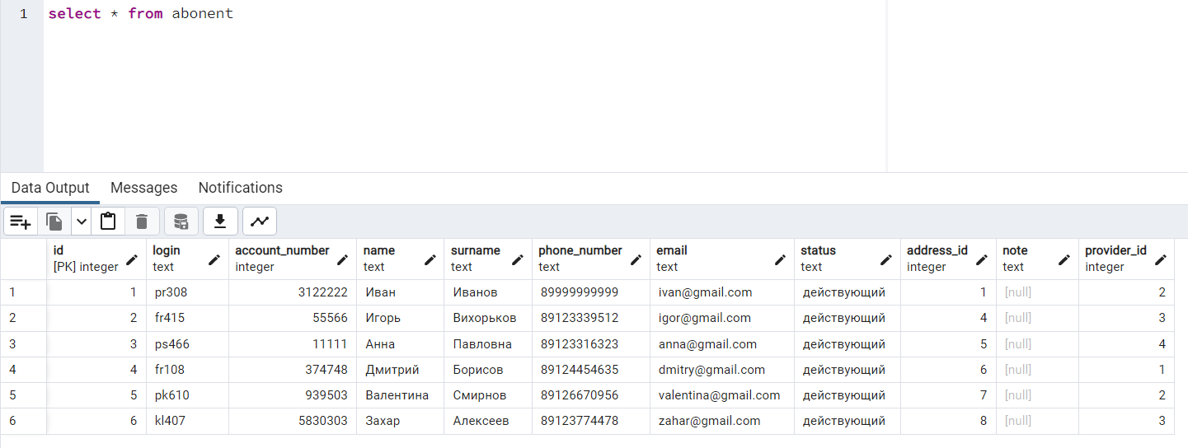

| INSERT INTO equipment_connections(equipment1_id, equipment2_id, speed) VALUES (38, 39, 1000); |
| --- |

def show_abonents(cursor):

cursor.execute(

"""

SELECT

abonent.id,

abonent.login,

abonent.name,

abonent.surname,

abonent.address_id,

abonent.provider_id,

house.id,

district.id

FROM abonent

INNER JOIN address ON abonent.address_id = address.id

INNER JOIN house ON address.house_id = house.id

INNER JOIN district ON house.district_id = district.id

"""

)

results = cursor.fetchall()

cursor.close()

connection.close()

header = ["abonent_id", "login", "name", "surname", "address_id", "provider_id", "house_id", "district_id"]

data = pd.DataFrame(results, columns=header)

print(data)