You are required to use database Y17S3B1 for this solution.

1. Design a screen layout look like

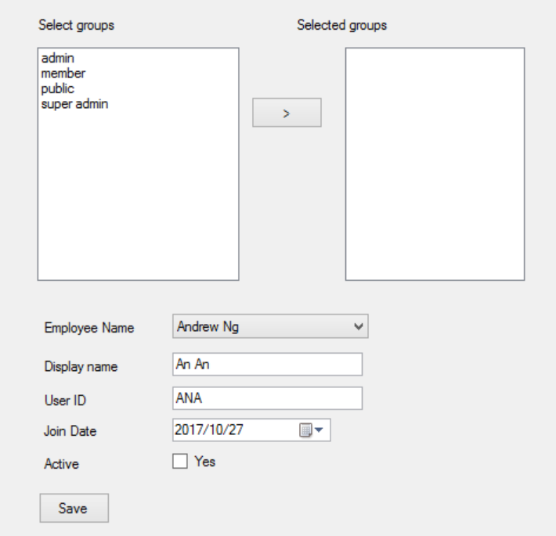

1. The Left List Boxe must be [single selection mode], that you cannot select 2 items on the list.
2. Employees will be loaded from [Employee Table], display EmployeeName
3. Groups will be loaded from [UserGroups Table], display group name
4. When user click [> Button]
   1. Move selectedegroup name to right listbox
   2. Removed selected group name from left listbox
5. When user click [Save Button]
   1. Required values for first 2 textboxs
   2. If data is valid, insert an account to Account table and also insert usergroups (the groups in right listbox) to user_groups table for inserted account.

