**PT :** Build staff management application with description:  
 **Database:**  
Create database DB_Staff with 02 tables:  
- Department (Department_Code (PK), Department_Name)  
- Staff (Staff_Code (PK), Department_Code (FK), Staff_Name, Birthday, Mobile)  
  
**Winform application:**

Create project with name “PT_1” include form.

Execute Add/Update/Delete Staff information

***LOAD Information***

* Department Information : list box display department information (name/code)
* Staff list : list staff information (code,name, Department_name,birthday, mobile)

***Add New/Update :***

* Select Department in Department Information.
* Fill Name, mobile, birthday (by select datetime picker control)
* Click “**Add New”/”Update**” button.

***Delete***

* Select staff and delete

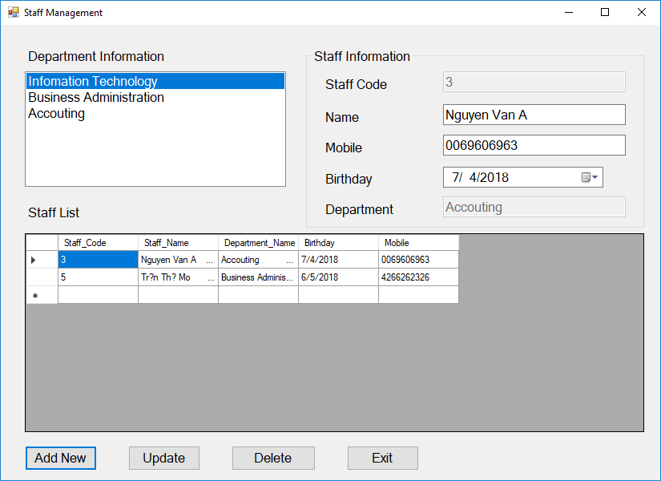

**NOTE:**

**Each student has his own variables. If 02 students have same variable they will be divided mark.**