You are required to use database [Y17S3B1](https://drive.google.com/open?id=0B_7qQuO7T-FrSXVWYzRDNU11a0k) for this solution.

See more, check out [here](https://drive.google.com/open?id=0B_7qQuO7T-FrM0hHMWhwZ3dESG8)

1. Design a screen layout look like

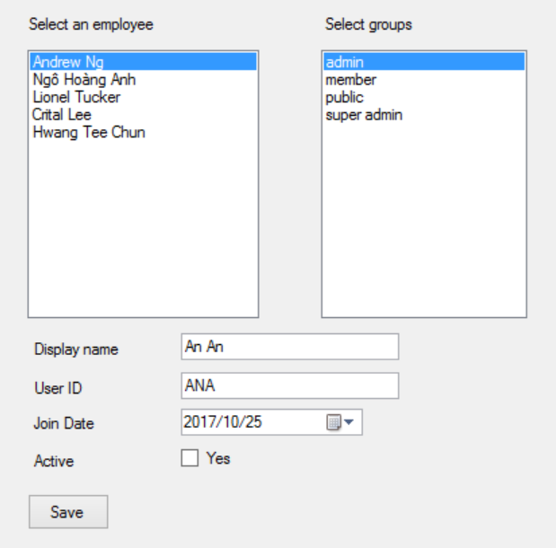

1. The Left List Box must be [single selection mode], that you cannot select 2 items on the list, the right list is multiple selection mode.
2. Employees will be loaded from [Employees Table], display EmployeeName
3. Groups will be loaded from [UserGroups Table], display group name
4. When user click [Save Button]
   1. UserID cannot be duplicated
   2. Required values for first 2 textboxes
   3. If data is valid, insert an account to Account table and also insert usergroups to user_group and Account table for inserted account.

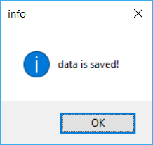

**Solution**

1. Load data to listboxes (here the listbox2 is on the left, other is on the right)

string ConnectionString = ConfigurationManager.

ConnectionStrings["DBI202"].ConnectionString;

public Form5()

{

InitializeComponent();

//output data from project to dropdownlist

string query = "select * from usergroups order by groupname; select * from employees";

SqlDataAdapter da = new SqlDataAdapter(query, ConnectionString);

DataSet ds = new DataSet();

da.Fill(ds);

//bind ds.tables[0] to dropdownlist

listBox2.DataSource = ds.Tables[1];

listBox2.DisplayMember = "EmployeeName";

listBox2.ValueMember = "EmployeeID";

//for list of groups

listBox1.DataSource = ds.Tables[0];

listBox1.DisplayMember = "groupname";

listBox1.ValueMember = "groupid";

}

1. Add data to **Account** table

void AddAccount()

{

SqlConnection conn = new SqlConnection(ConnectionString);

string insert = "insert into Account values(@userid,@displayname,@joinedate,@active,@employeeid)";

SqlCommand cmd = new SqlCommand(insert, conn);

conn.Open();

cmd.Parameters.AddWithValue("@userid", textBox2.Text);

cmd.Parameters.AddWithValue("@displayname", textBox1.Text);

cmd.Parameters.AddWithValue("@joinedate", dateTimePicker1.Value);

cmd.Parameters.AddWithValue("@active", checkBox1.Checked);

cmd.Parameters.AddWithValue("@employeeid", listBox1.SelectedValue);

cmd.ExecuteNonQuery();

conn.Close();

}

//add data to user_group table

void AddGroup(int groupid, string userid)

{

SqlConnection conn = new SqlConnection(ConnectionString);

string insert = "insert into User_group values(@groupid,@userid)";

SqlCommand cmd = new SqlCommand(insert, conn);

conn.Open();

cmd.Parameters.AddWithValue("@userid", userid);

cmd.Parameters.AddWithValue("@groupid", groupid);

cmd.ExecuteNonQuery();

conn.Close();

}

//save button action

private void button2_Click(object sender, EventArgs e)

{

***//make sure that userid can not be repeated***

string sql = "select * from account where userid = '" + textBox2.Text + "'";

SqlDataAdapter da = new SqlDataAdapter(sql, ConnectionString);

DataTable dt = new DataTable();

da.Fill(dt);

if(dt.Rows.Count > 0)

{

MessageBox.Show("User ID cannot be duplicated");

return;

}

***//insert data to Account table***

AddAccount();

***//insert data to user_group table***

foreach(var item in listBox1.SelectedItems)

{

DataRowView d = item as DataRowView;

int groupid = int.Parse(d[0].ToString());//usergroups(id,name) -> first column is id

AddGroup(groupid, textBox2.Text);

}

MessageBox.Show("Data is saved");

}