**==========================================================**

**Windows forms Application**

**Lab 3 (week 5, 6)**

=====================================================================================

**Goals:**

The goal of Lab 3 is to develop a Windows Forms Application named Library system described in document “List of sample projects”.

**System description:**

Your system must have the following functions:

1. Register members (add/edit/delete)
2. Register book and its copies (add/edit/delete)
3. Borrow copies
4. Return copies
5. Reserve a book

Your program output may be look like:

1. Main window form

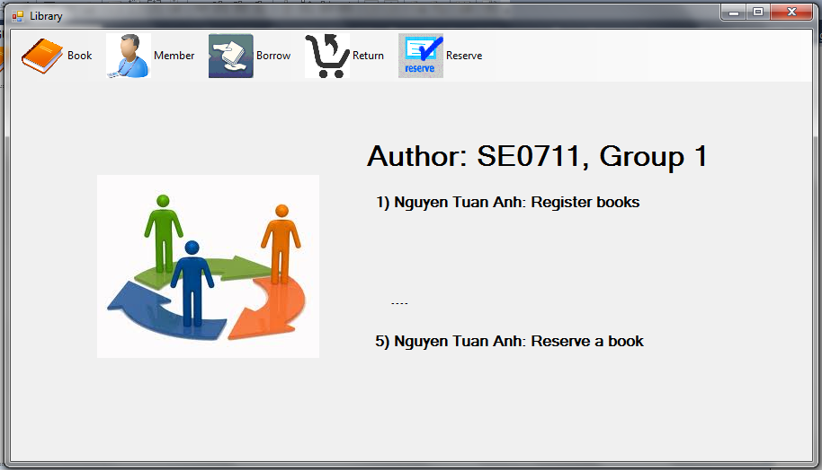

1. Register books and their copies

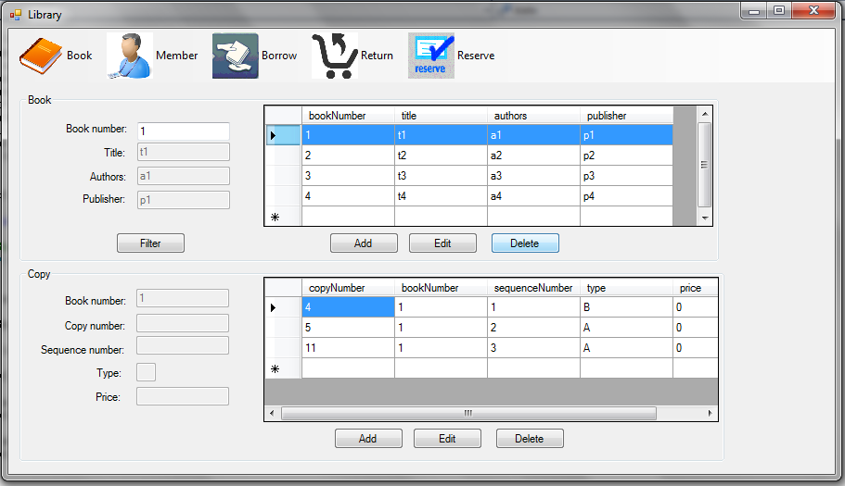

1. Register members

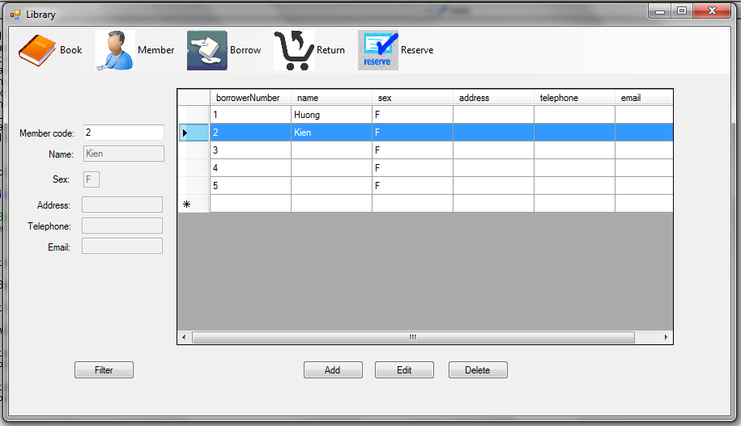

1. Borrow copies

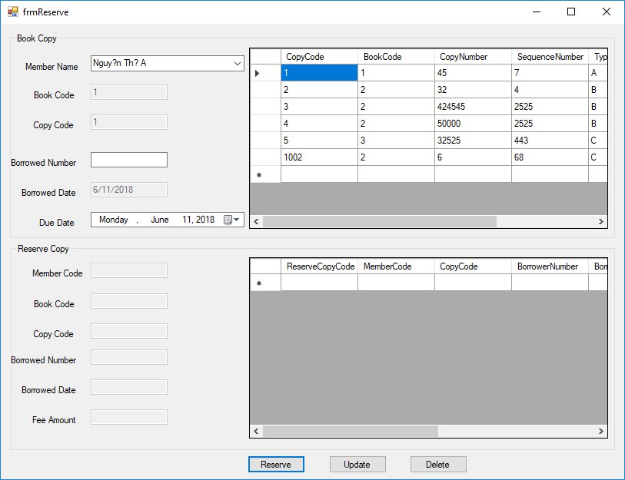

**Requirements:**

* Your system must display Class ID and group number with the list of members (with functions made by them).
* Your system must follow all rules described in Library system.
* Your system must check input data and allow the user to enter again.
* Use Database “Library” given in site “cms” and must use “localhost”, or localhost\SQLExpress” for the name of DB server computer .
* Your solution name: Lab3_GroupN.sln, and file name : ClassID_GroupN_Lab3.zip, where N = 1, or 2…

**References:**

* Document “List of sample projects”.
* Software requirement specification of Library system: “SRS_Library system”.
* Software design of Library system: “SD_Library system”.