

*SALES MANAGEMENT*

**Final Report**

**Project Code: SM**

**Document Code: SM_DOC- v1.0**

**tTeam Gay**

*Hoang Le Thanh Son - SE05415*

*Pham Tung Anh - SE06176*

*Nguyen Gia Huy - SE05752*

*Vu Hai Phong - SE05255*

*Nguyen Thi Hong Mien - SE05583*

**Supervisor:** *Mr. Phạm Ngọc Hà*

**Hanoi, July 26th 2018**

Contents

1. Introduction 4

1.1. Project information 4

1.2.1. Supervisor 4

1.2.2. Team members 4

2. Software Requirement Specification 4

2.1. INTRODUCTION 4

2.1.1. Purpose 5

2.1.2. Scope 5

2.1.3. Definitions, Acronyms, and Abbreviation 5

2.1.4. Reference 6

2.1.5. Overview 6

2.2. OVERALL DESCRIPTION 6

2.2.1. Product Perspectives 6

2.2.2. Product Functions 7

2.2.3. User Requirements 8

2.2.4. User Characteristics 8

2.3. SPECIFIC REQUIREMENTS 9

2.3.5. Supportability 17

2.3.6. Design Constraints 17

2.3.7. User Interfaces 18

2.3.8. Hardware Interfaces 23

2.3.9. Software Interfaces 23

2.3.10. Communications Interfaces 23

2.4. SUPPORTING INFORMATION 24

Appendix 1: Business Laws and Regulations 24

3. Report and diagram 24

Use Case Diagram 24

Class Diagram 25

Database Diagram 26

System Architecture 27

User Interfaces 28

Figure 2 - Search Result 29

Figure 4 - Invoice 31

2. System Architecture Diagram 33

Sequence Diagram 34

4. Product Display 40

# Introduction

## Project information

* Project Name: Sales Management
* Project Code: SM
* Project Type: Web Application
* Timeline: From 1/7/2018 to 27/7/2018
  1. Project members

### Supervisor

|  |  |  |  |
| --- | --- | --- | --- |
| **Full name** | **Phone** | **E-Mail** | **Title** |
| Pham Ngoc Ha | 0988623000 | [hapn@fsoft.com.vn](mailto:hapn@fsoft.com.vn) | Lecturer |

### Team **members**

|  |  |  |  |
| --- | --- | --- | --- |
| **Full name** | **Roll no.** | **Position** | **Work credit** |
| Pham Tung Anh | SE06176 | Leader | Schedule deadlines, write final report document  Code List Guitar display in Homepage  Code Search Product function  Write document |
| Nguyen Thi Hong Mien | SE05583 | Member | Manage database changes  Code View orders function  Coding paging for product display  Make slides for presentation |
| Hoang Le Thanh Son | SE05415 | Member | Write first database version  Code login, product detail and add to cart function |
| Nguyen Gia Huy | SE05752 | Member | Code Check Out page  Code Complete Order page  Code Payment Page |
| Vu Hai Phong | SE05255 | Member | Code front-end.  Code List Other display in Homepage.  Code paging for Other display. |

# Software Requirement Specification

# INTRODUCTION

* **Name**​ :​ **Online**​ ​**Sales Management System (Selling Module)**
* **Description**​ : ​**Online Sales Management System (OSMS)**​ is an online system that helps users, customers purchase their favorite items, product without going to stores, market … ​**OSMS**​ also provides a diversity of payment method such as : cash, banking transaction, credit card. After ordering, product will be shipped to customer’s address.

### Purpose

### - Product’s aims: To help users approach a more convenient way to go shopping than traditional ways. Save an amount of money for users.

### - Functions:

+ Search products by name.

+ Show product information for users

+ Order products

+ Payment after ordering

### Definitions, Acronyms, and Abbreviation

|  |  |  |
| --- | --- | --- |
| **I D** | **Acronym** | **Definition** |
| 1 | **SRS** | **Software Requirement Specification** |
| **2** | **App** | **Application** |
| **3** | **OSMS** | ​**Online Sales Management System (Software’s name)** |
| **4** | **OS** | **Operating System** |
| **5** | **GUI** | **Graphic User Interface** |
| **6** | **CMS** | **Content Manager System** |
| **7** | **DB** | **Database** |

### Reference

- SRS Template, SWE102 (Introduction to software engineering)

### Overview

- This document provides the requirement specifications for the software about its functions, purposes …

# OVERALL DESCRIPTION

### Product Perspectives

SM is for company which wants to automate its sales system.

SM is a web-based app. It should run on any OS with a web browser and Internet supported. This should be an automated modules in a larger sales system.

This app makes it easier for users to see products, add to cart, order and pay all online.

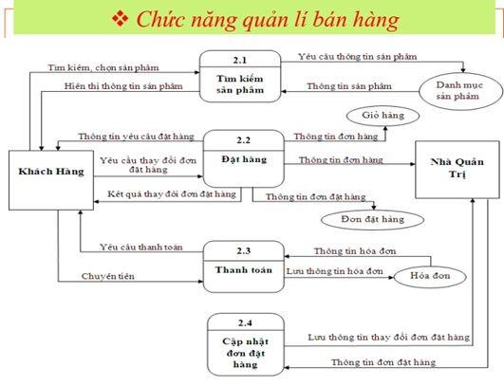

**Figure 2-1**​: Module Overview Of SM

The module has 4 main functions:

* Search products by name.
* Order products
* Payment after ordering
* Update orders

### Product Functions

8 Use cases:

1. Search by name
2. Show list of products
3. Add to cart
4. View cart : edit the amount or delete the product from your cart
5. Confirm buying
6. Choose form of payment
7. Update order status (paid or unpaid)
8. Update orders (delete, edit, update paying status)

### User Requirements

* Be able to view all products and related information and add to cart easily
* Be able to choose to pay online or offline (after the product is delivered to them)
* Reliable and secure (private information and order details)
* Friendly and easy-to-use interface
* Get information about their orders and shipping status

### User Characteristics

The system will have the following categories of the users:

* User: customers who go to the site to buy products
* Administrator: view order information and make direct changes to the database if necessary

##### *Operating Environment*

Software doesn’t require any special characteristics of user. User just needs to have a browser with internet connected.

##### *Assumptions and Dependencies*

* Assumptions:

+ Our module is part of a larger system so we would assume users are logged in and use our own product sets to test our system.

+ Since the application is a web based application, there is a need for the internet browser. It will be assumed that the users will possess decent internet connectivity.

+ It’s also assumed that users got used to online shopping systems and its basic procedures.

+ There would be an intermediate agency (shipper) who takes care of checking shipping status from us (supplier) to customer (online shoppers who visit and order on the system).

* Dependencies:

+ Users need to login to use the system

+ There needs to be products available in stock.

##### *Design and Implementation Constraints*

* Access to the web is required.
* As for the developer constraints, the other module information was not available for security reasons. Many assumptions about the data have to be made.
* The learning curve was steep because we are learning about developing Web App with C#.Net at the same time with working on this module.

# SPECIFIC REQUIREMENTS

* + 1. **Functionality**

#### Use Case 1: Product Search

|  |  |  |
| --- | --- | --- |
| Use-case ID | | UC001 | By AnhPT |
| Use-case Name | | Product Search (by name) |
| Actor | | Customer |
| Description | | Customer searches a product by its name or part of its name in the search bar |
| Precondition | | No |
| Trigger condition | | No |
| Post-condition | | No |
| **Main flows (normal flows)** | | |
| **Step** | **Actor** | **Action Description** |
| 1 | Customer | Customer gets in the front page |
| 2 | Customer | Customer enters word(s) into search bar and press enter |
| 3 | Software | Software gets the entered words and searches in the database to get list of products |
| 4 | Software | Software displays the list of products with requested name on page |

#### Use Case 2: Show List Product

|  |  |  |
| --- | --- | --- |
| Use-case ID | | UC002 | By AnhPT |
| Use-case Name | | Show List Product |
| Actor | | Software |
| Description | | Auto load list of products and display on page when customers visit |
| Precondition | | No |
| Trigger condition | | Show list after doing product’s name search |
| Post-condition | | No |
| **Main flows (normal flows)** | | |
| **Step** | **Actor** | **Action Description** |
| 1 | Customer | Customers load the index page |
| 2 | Software | Display screen with products having following info:   * Product Name * Product Image * Product Price * Product Description |

#### Use Case 3: Add to cart

|  |  |  |
| --- | --- | --- |
| Use-case ID | | UC003 | By PhongVH |
| Use-case Name | | Add to cart |
| Actor | | Customer |
| Description | | Customer add new items to the cart |
| Precondition | | Customer have chosen what item they want to buy |
| Trigger condition | | Customer click on add button |
| Post-condition | | Item which customer have added will be moved to view cart page |
| **Main flows (normal flows)** | | |
| **Step** | **Actor** | **Action Description** |
| 1 | Customer | Customers choose items for shopping |
| 2 | Software | Go to item page with the following fields:   * Picture of the item * Review * Cost * Choose amount of item * Add to cart button |
| 3 | Customer | Choose number of item they want to buy and kick add to cart button after that they have to choose view cart or payment |

#### Use Case 4: View cart

|  |  |  |
| --- | --- | --- |
| Use-case ID | | UC004 | By PhongVH |
| Use-case Name | | View cart |
| Actor | | Customer |
| Description | | Customer can view all the item they have bought and edit the cart like changing the amount of item or deleting them |
| Precondition | | No |
| Trigger condition | | Customer have to click on view cart button |
| Post-condition | | Customer can add new item or move to complete order information page |
| **Main flows (normal flows)** | | |
| **Step** | **Actor** | **Action Description** |
| 1 | Customer | Customer move to view cart page |
| 2 | Software | Display screen with the following fields:   * Cart information:   + Number of items  + Item cost + Ship cost  + Total cost + Payment button   * Products:   + Picture of the item  + Change amount of item  + Delete button |
| 3 | Customer | * Choose number of item they want to edit or choose item to delete * Click home button to continue shopping * Click payment button to pay |

#### Use Case 5: Complete Order Information

|  |  |  |
| --- | --- | --- |
| Use-case ID | | UC005 | By Nguyen Gia Huy |
| Use-case Name | | Complete Order Information |
| Actor | | Customer, Software |
| Description | | The order details include products’ name, amount, total price from the shopping cart. The order page requires customer to choose shipping method or a method is selected by default. Customer’s information is required in order to complete the order’s information.  Customer shall be able to cancel the order or edit order information. |
| Precondition | | Customer should choose their prefered shipping method or a method is selected by default. The shipping cost is added to the order’s price. Customer shall enter all the required information including customer’s name, contact information (email, phone number), and address for shipping. Customer shall check all the order details and click on the Proceed Payment button. |
| Trigger condition | | User click on Proceed Payment button |
| Post-condition | | Customer’s order information is saved to the database and the browser shall navigate to the Payment page. |
| **Main flows (normal flows)** | | |
| **Step** | **Actor** | **Action Description** |
| 1 | Customer | Customer should chooses shipping method (other than default selection). |
| 2 | Software | Shipping cost is added to the order’s price. |
| 3 | Customer | Customer enters all required information |
| 4 | Customer | Customer clicks on Proceed button. |
| 5 | Software | Order is saved to the database |
| 6 | Software | Browser navigates to Payment page. |
| **Alternative flows** | | |
| **Step** | **Actor** | **Action Description** |
| 1 | Software | The information customer entered is invalid. Browser stays on Order page. |
| 2 | Customer | Customer enters correct information and clicks on Proceed button. |
| 3 | Software | Browser navigates to Payment page. |
| Business Rules | | Customer must enter correct and reliable information for contact and shipping. |

#### Use Case 6: Payment

|  |  |  |
| --- | --- | --- |
| Use-case ID | | UC006 | By Nguyen Gia Huy |
| Use-case Name | | Payment |
| Actor | | Customer, Software |
| Description | | The Payment page requires customer to do 2 type of actions. First, customer shall choose their prefered shipping method. Second, customer shall choose their payment method from a list of type of payments (COD – cash on delivery, international credit cards, ATM or internet banking). Customer shall provide required information for the method they have chosen to start purchasing. |
| Precondition | | Customer shall choose their payment method from a list of type of payments (1- COD – cash on delivery, 2- international credit cards, 3 -ATM or internet banking). If customer chose the second and third payment method, they shall provide required information for payment first. Customer click on Purchase button to place order . |
| Trigger condition | | User click on Purchase button |
| Post-condition | | An invoice for second and third payment method is generated, saved and the order information is updated to the database. A message for transaction and the invoice is displayed to the customer. |
| **Main flows (normal flows)** | | |
| **Step** | **Actor** | **Action Description** |
| 1 | Customer | Customer choose their payment method   * First method: COD – cash on delivery * Second method: international credit cards (VISA, Mastercard, JCB) * Third method: domestic cards (ATM) or via internet banking. |
| 2 | Customer | Customer provide required information for credit card and banking |
| 3 | Customer | Customer clicks on Purchase button |
| 4 | Software | If customer chose second or third method, a message for successful money transfering is displayed and an invoice is generated and saved to the database. |
| 5 | Software | Order’s information is updated with type of payment method and payment status to the database. |
| **Alternative flows (for the second and third payment method)** | | |
| **Step** | **Actor** | **Action Description** |
| 1 | Software | The information for credit card or bank account customer entered is invalid. An error message is displayed on the Payment page. |
| 2 | Customer | Customer enters correct information for the specified method and clicks on Purchase button. |
| 3 | Software | A message for successful money transfering is displayed and an invoice is generated and saved to the database. |
| 4 | Software | Order’s information is updated with type of payment method and payment status to the database. |
| **Exception 1** | |  |
| **Step** | **Actor** | **Action Description** |
| 1 | Software | The money in customer’s credit card or bank account is not enough. An error message is displayed on the Payment page. |
| 2 | Customer | Customer enters other valid credit card or bank account or choose another payment method for the specified method and clicks on Purchase button. |
| 3 | Customer | Do Normal Flow |
| **Exception 2** | |  |
| **Step** | **Actor** | **Action Description** |
| 1 | Customer | Customer clicks on Cancel button |
| 2 | Software | The order is removed from the database |
| 3 | Software | Browser navigates to Home page |
| Business Rules | | * Customer must enter valid and reliable credit card’s information and bank account for internet banking * The application must generate an invoice for the money transfer through credit cards and internet banking in successful situation, save and display back to the customer. * For COD – cash on delivery method, an invoice shall be generated and saved until the order is delivered to customer. |

#### Use Case 7: Payment check

|  |  |  |
| --- | --- | --- |
| Use-case ID | | UC007 | By SonHLT |
| Use-case Name | | Payment check |
| Actor | | Admin |
| Description | | Admin checks the payment of the order and changes it if necessary |
| Precondition | | Admin logged in successfully to system |
| Trigger condition | | No |
| Post-condition | | Payment of the order is managed by admin |
| **Main flows (normal flows)** | | |
| **Step** | **Actor** | **Action Description** |
| 1 | Admin | Admin opens order information page |
| 2 | Software | Display screen with the following fields:   * Order ID * Products * Total cost * Payment status (default : not paid yet) |
| 3 | Admin | Check the payment reports, change the status of the payment if the customer has paid before |
| 4 | Software | Update information about order and save to database |

#### Use Case 8: Update Orders

|  |  |  |
| --- | --- | --- |
| Use-case ID | | UC008 | By MienNTH |
| Use-case Name | | Update Orders |
| Actor | | Admin |
| Description | | Admin check if there is some updates (on paper) about order (paid, unpaid, orders edited, orders deleted) and update status of order in database |
| Precondition | | Admin logged in successfully to system |
| Trigger condition | | There’s information from delivery department or shippers about the updated status of orders |
| Post-condition | | Information about order is updated in database and displayed to customers |
| **Main flows (normal flows)** | | |
| **Step** | **Actor** | **Action Description** |
| 1 | Admin | Admin opens order information page |
| 2 | Software | Display screen with the following fields:   * Order ID * Products * Total cost * Payment status (default : not paid yet) * Edit button * Delete button |
| 3 | Admin | Edit any new information sent from intermediate agencies or user special requests and the system automatically makes updates to database |
| 4 | Software | Update information about order and save to database  Display or notify users (in email) about any updated information) |

* + 1. **Usability**

#### Required training time

* For a normal user, specifically a customer shall use the system in no time as user follows the flow of the system.
* For a power user, he/she is required to hold a degree or certification in finance or banking.

#### Required training time

- The system’s GUI conforms to Microsoft’s GUI standards.

#### Graphic User Interface

* The system shall provide image for each product in the product catalog.
* The system shall provide a uniform look and feel between all the web pages.

#### Accessibility

* The system shall provide multi language support.
  + 1. **Reliability**

#### Response time

The maximum response time for the submission of a form request will be less than 1 minute.

#### Capacity

The maximum number of items per product is limited to 10 items for security and preventing fraud; there is no limit for the number of products per order.

#### Money Transfer

* All customer’s credit card information or bank account shall not be saved for security.
* An invoice shall be generated and available to customer when money is successfully transferred.
  + 1. **Performance**

The product shall be based on web and has to be run from a web server.

The product shall take initial load time depending on internet connection strength which also depends on the media from which the product is run.

The performance shall depend upon hardware components of the client/customer.

### Supportability

* Web browser: Google Chrome, Microsoft Edge, Firefox, CocCoc
* Mobile: Android, iOS

### Design Constraints

**Language accepted :** ​English (en).

**Coding convention :** ​ Camel style.

**Programming languages :**

* C#
* Using .NET framework

**Database to be used :**

* MS SQL Server **Tools :**
* MS Visual Studio
* MS SQL Server Management Studio

### User Interfaces

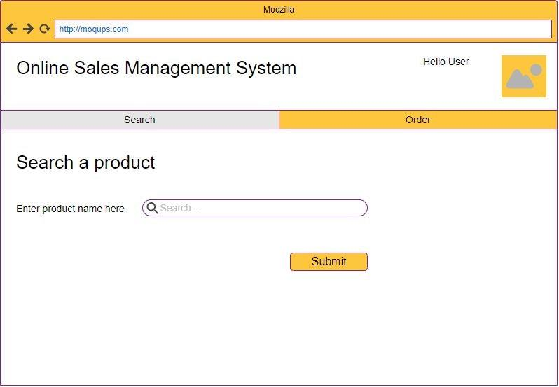

*Figure 1 - Search Page*

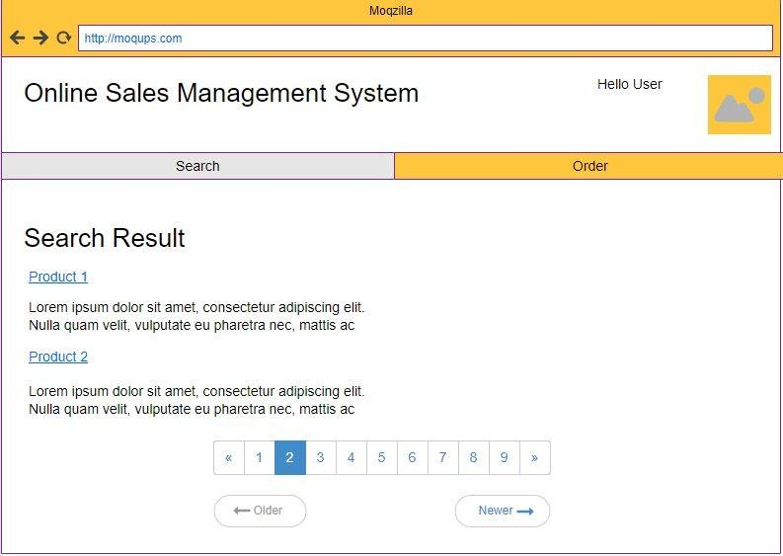

*Figure 2 - Search Result*

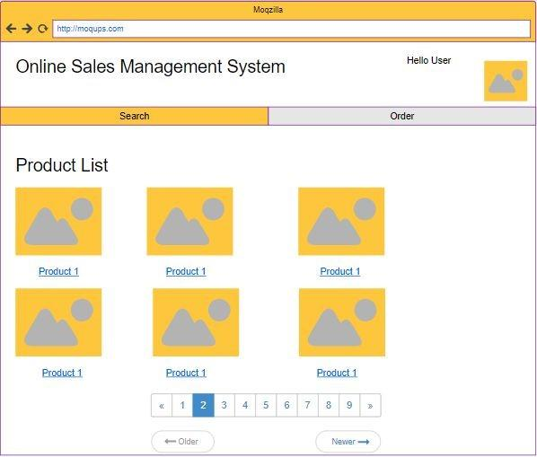

*Figure 3 - Product list*

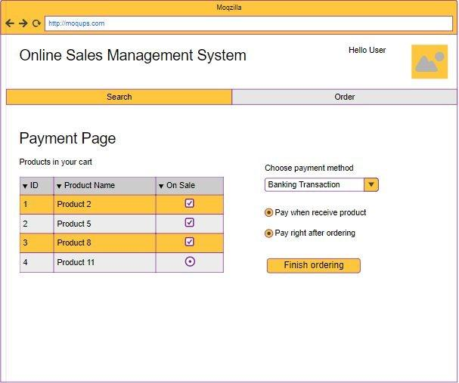

*Figure 4 - Invoice*

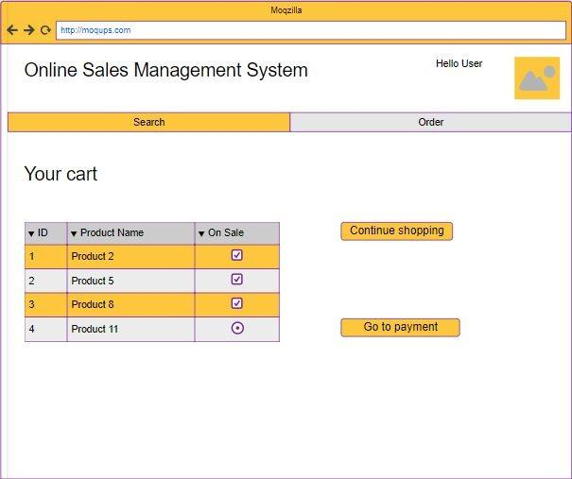

*Figure 5 - Finishing*

### Hardware Interfaces

Since the application must run over the internet, all the hardware shall require to connect internet will be hardware interface for the system. As for e.g. Modem, WAN – LAN.

### Software Interfaces

The SM module system shall communicate with MSSQL database to get all the products and orders information.

The SM module shall communicate Login, Import and Paying modules interface (done by other groups of SE1201).

The SM module shall communicate with billPay system to identify available payment methods , validate the payments and process payment.

The SM module system shall communicate with Sales system for order management.

The SM module system shall communicate with delivery system for tracking orders and updating of shipping methods.

### Communications Interfaces

The SM will have a network server that is web-based and created using the C# language. The server exists to retrieve information from the database and shopping system. The product also calls for a database system that stores user’s order information and transaction history.

Not Applicable

#### Licensing Requirements

Not Applicable

##### Legal, Copyright, and Other Notices

All proprietary trademarks, product names and/or logos used on SM web are trademarks of their respective owners.

##### Applicable Standards

It shall be as per the industry standard.

# SUPPORTING INFORMATION

## Appendix 1: Business Laws and Regulations

All transactions and behavior must follow the Law on Commerce of Vietnam No.36/2005/QH11 and Decree No.52/2013/NĐ-CP About eCommerce

# Report and diagram

# Use Case Diagram

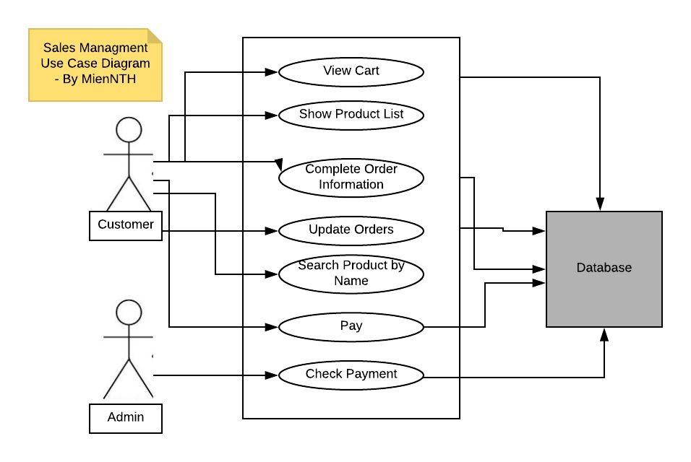

# Class Diagram

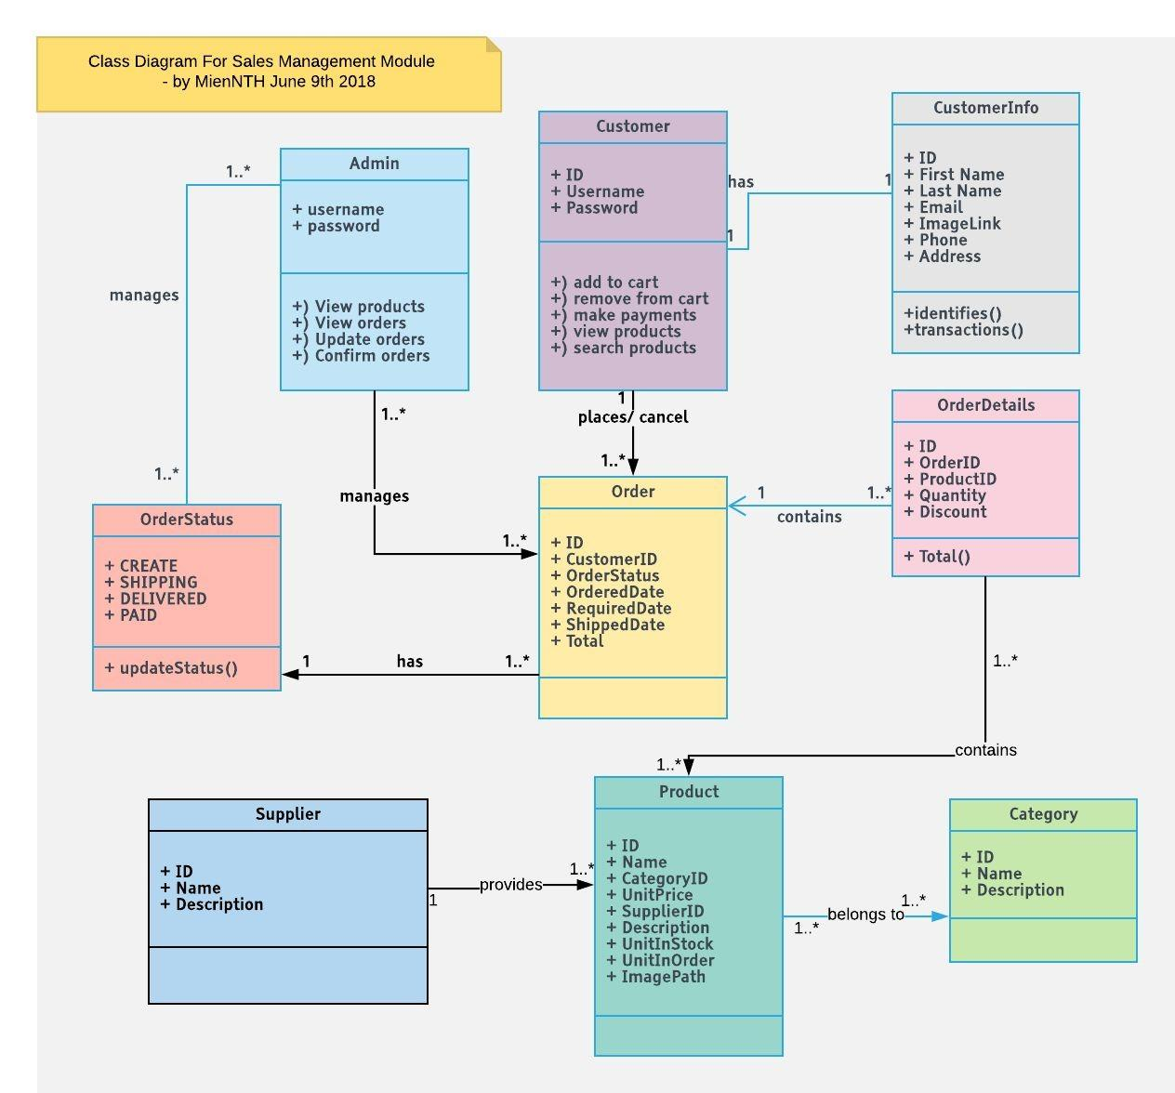

# Database Diagram

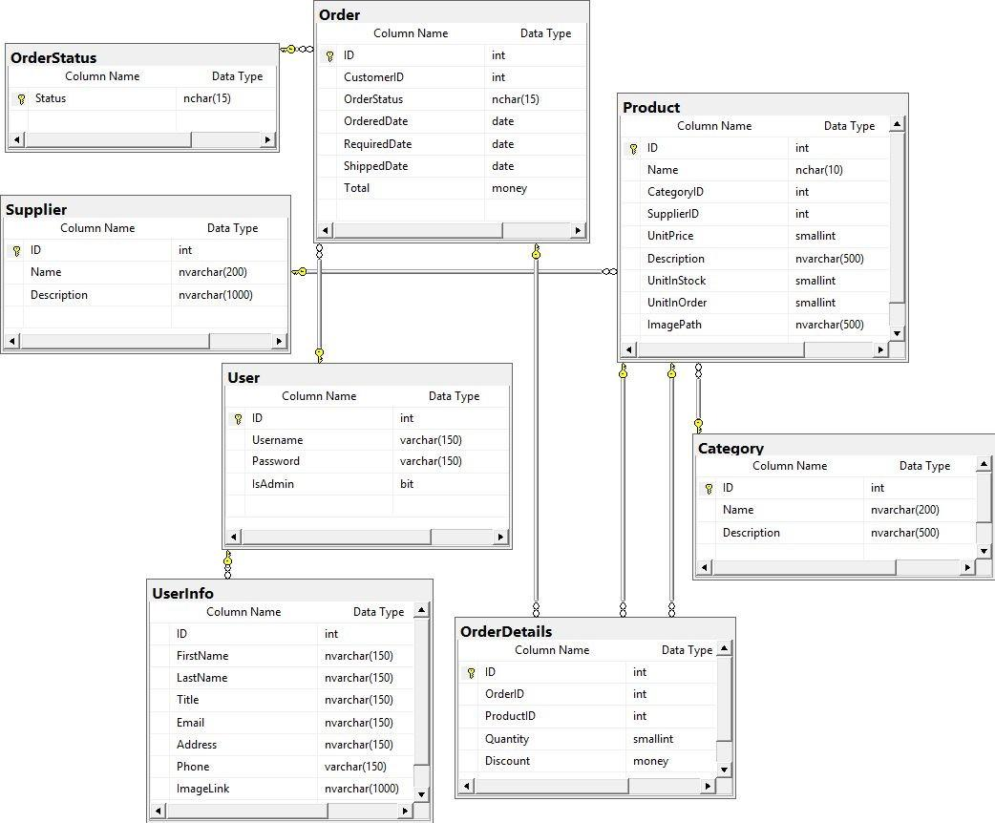

# System Architecture

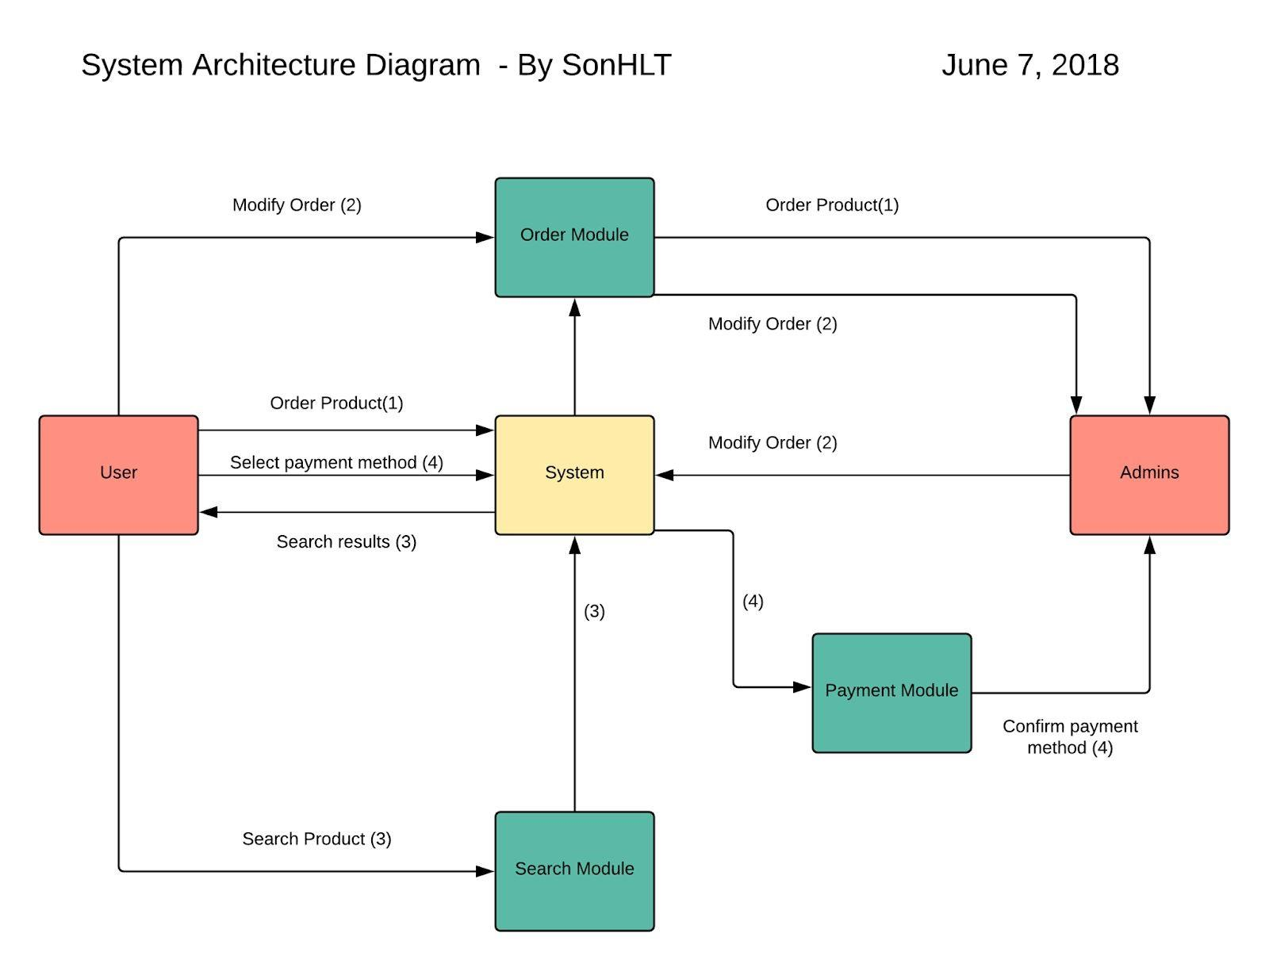

# User Interfaces



*Figure 1 - Search Page*



## Figure 2 - Search Result



*Figure 3 - Product list*



## Figure 4 - Invoice



*Figure 5 - Finishing*

## 2. System Architecture Diagram

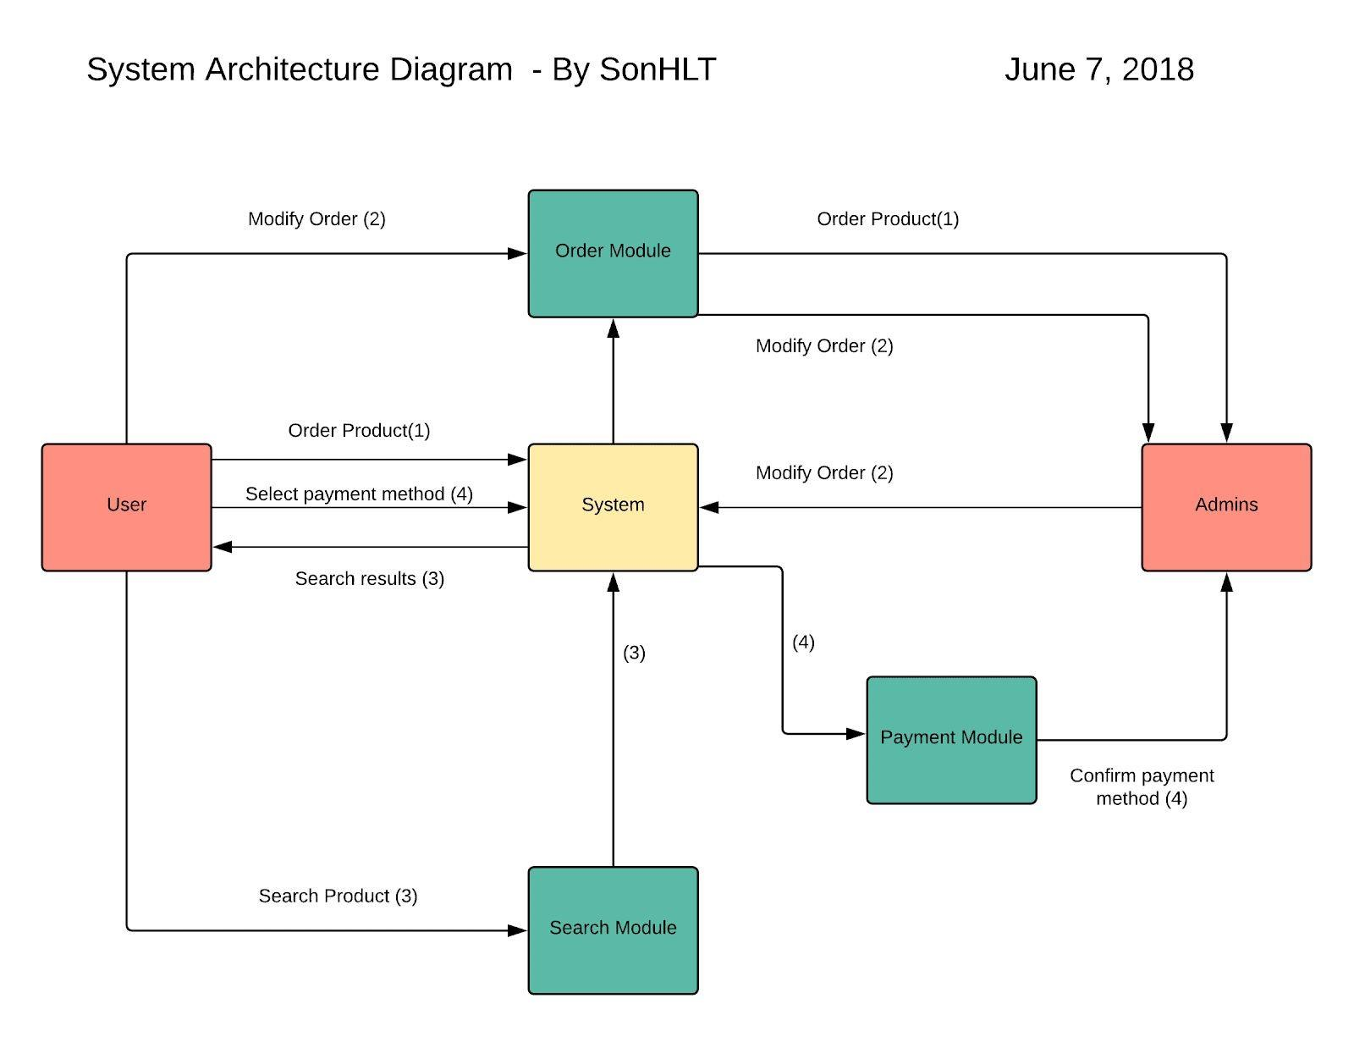

*Figure 6 - System Architecture Diagram*

* **Diagram Analys :**
* Request System has 3 modules :
* Search Module
* Order Module
* Payment Module
* User and admin can perform respective functions with these above modules :
* Make an order, modify and manage order
* Search for any products
* Choose payment method.
* Confirm orders and payments.

# Sequence Diagrams

**UC001 - Search Product (By AnhPT)**

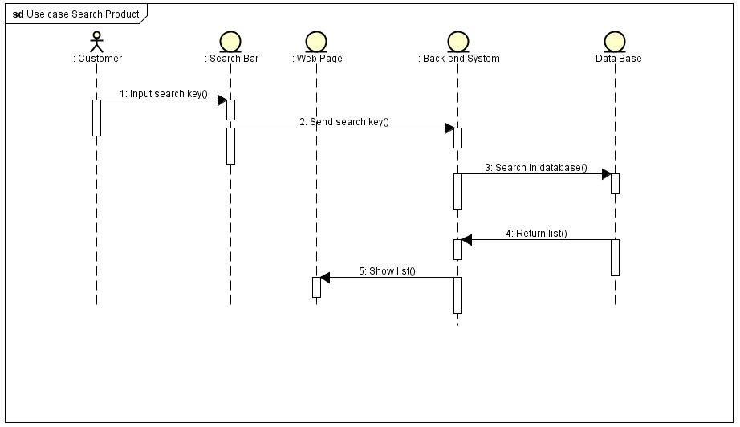

**UC002 - Display (By AnhPT)**

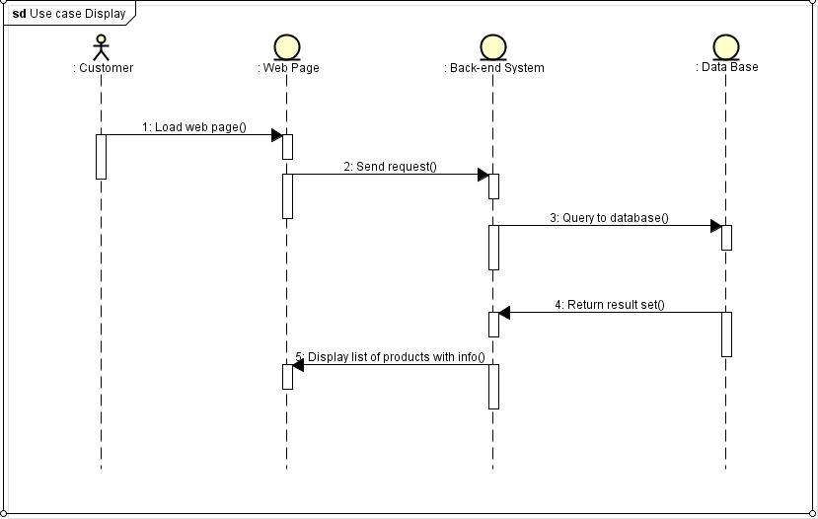

**UC003 - Add Cart (By PhongVH)**

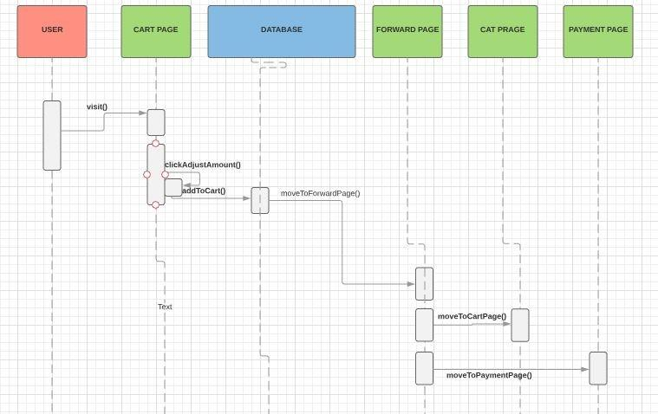

**UC004 - View Cart (By PhongVH)**

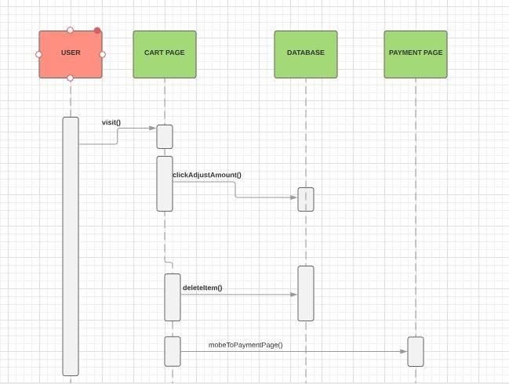

**UC005 - Complete Order Information (By HuyNG)**

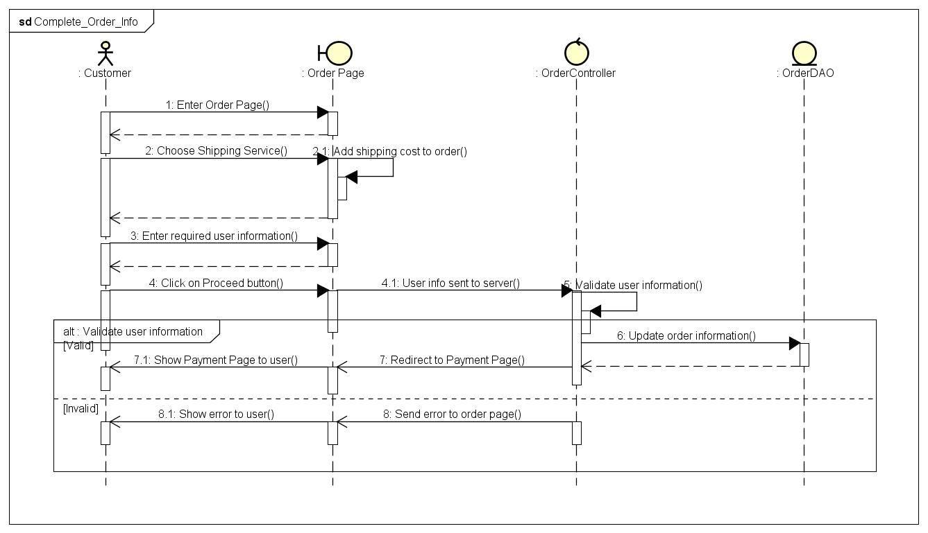

**UC006 - Payment (By HuyNG)**

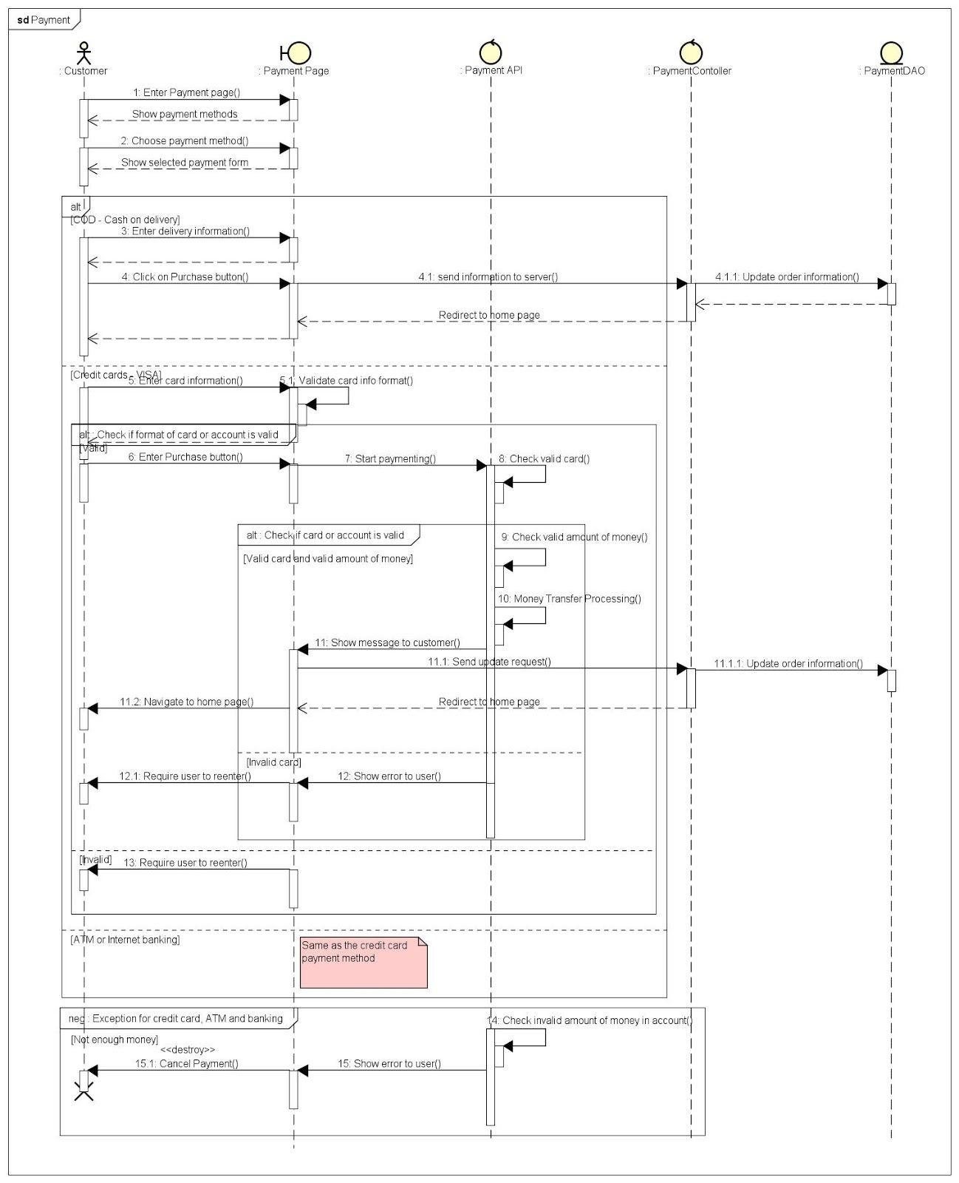

**UC007 - Payment check (By SonHLT)**

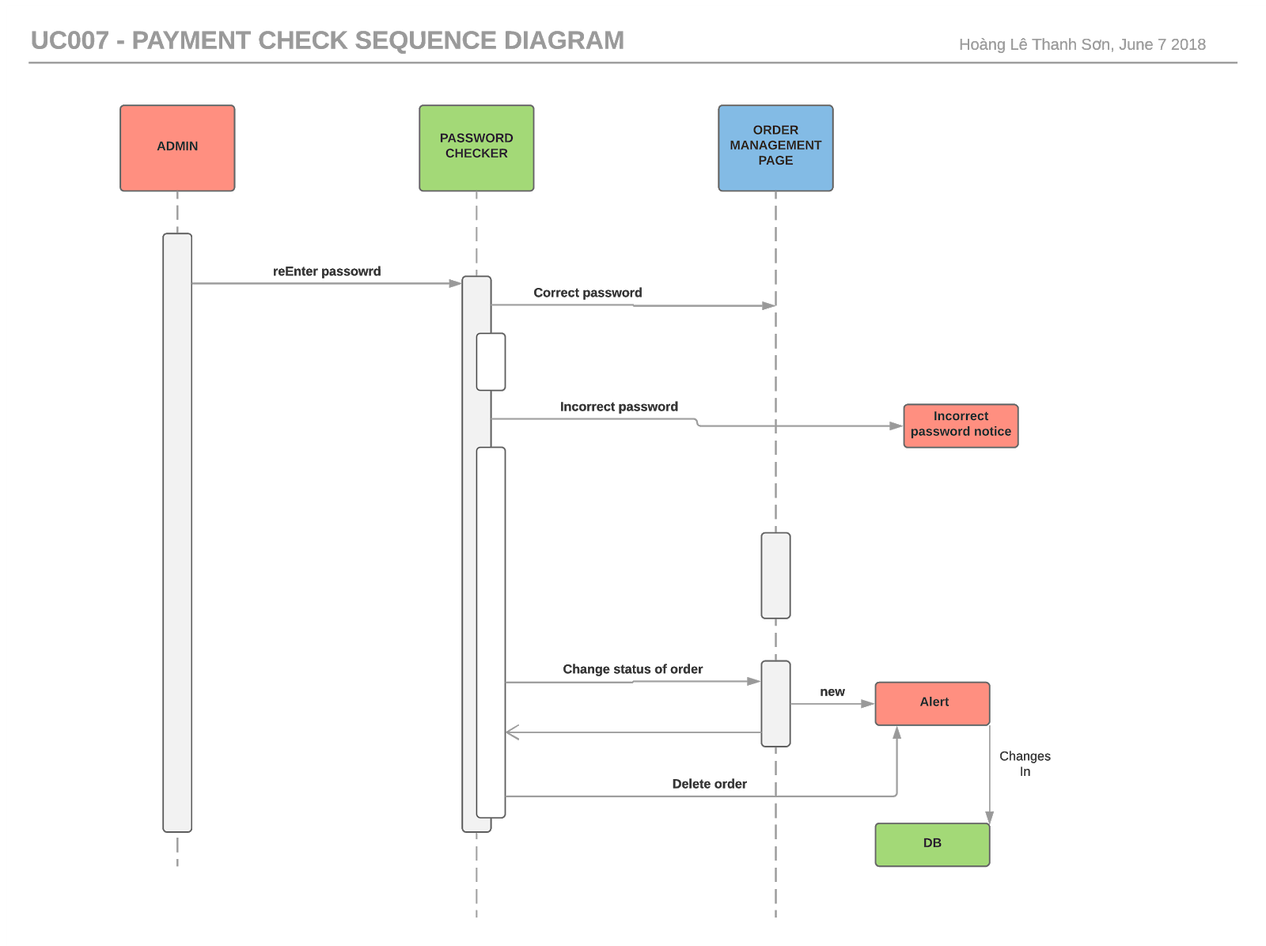

**UC008 - Update Orders (By MienNTH)**

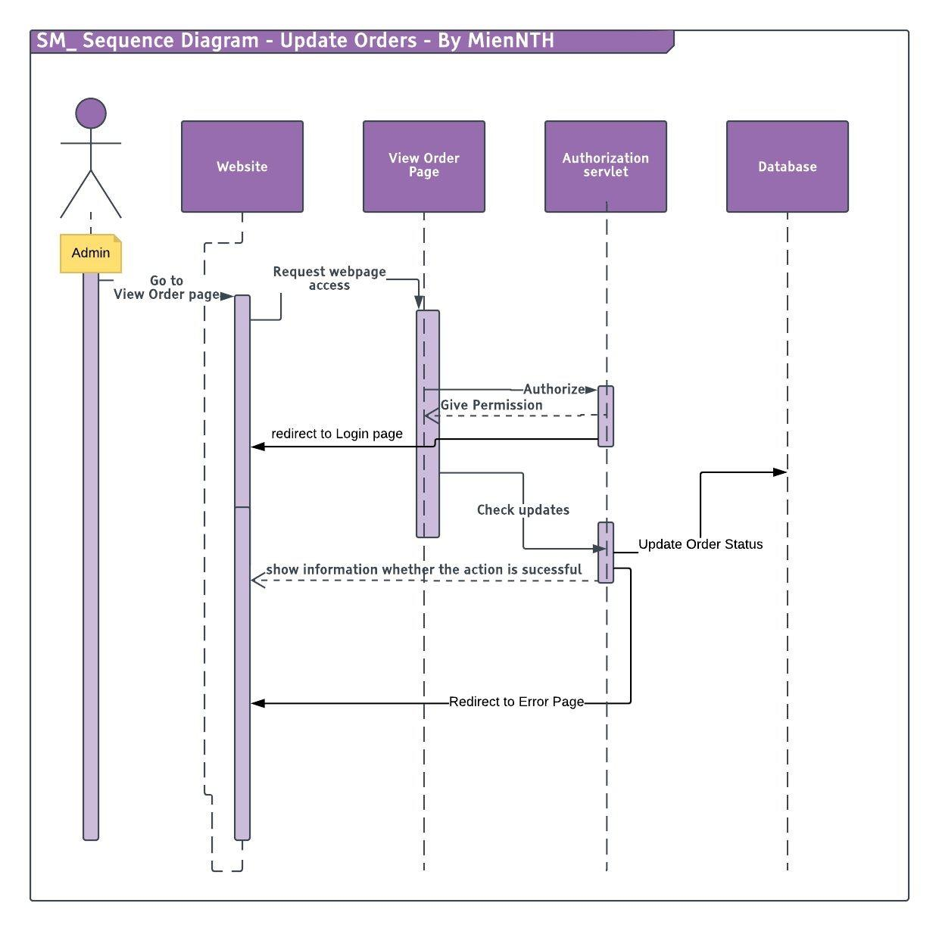

# Product Demonstration