You are required to use database Y17S3B1 for this solution.

1. Design a screen layout look like

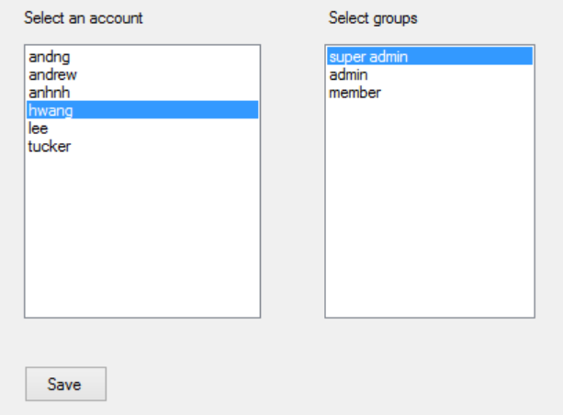

1. The Left List Boxe must be [single selection mode], that you cannot select 2 items on the list, the right list is mutiple selection mode.
2. Accounts will be loaded from [Account Table], display userID
3. Groups will be loaded from [UserGroups Table], display group name
4. When users select an item from left list, output all available groups for selected account (the one in UserGroups table)
5. When users click [Save Button] insert usergroups to user_groups table for selected account

