**Requirements for Assignment 1 for Class SE1201 SE1204 SE1203 ISE_SE1201**

**Deadline 18/6/2018**

**Folow the seteps as below figure**

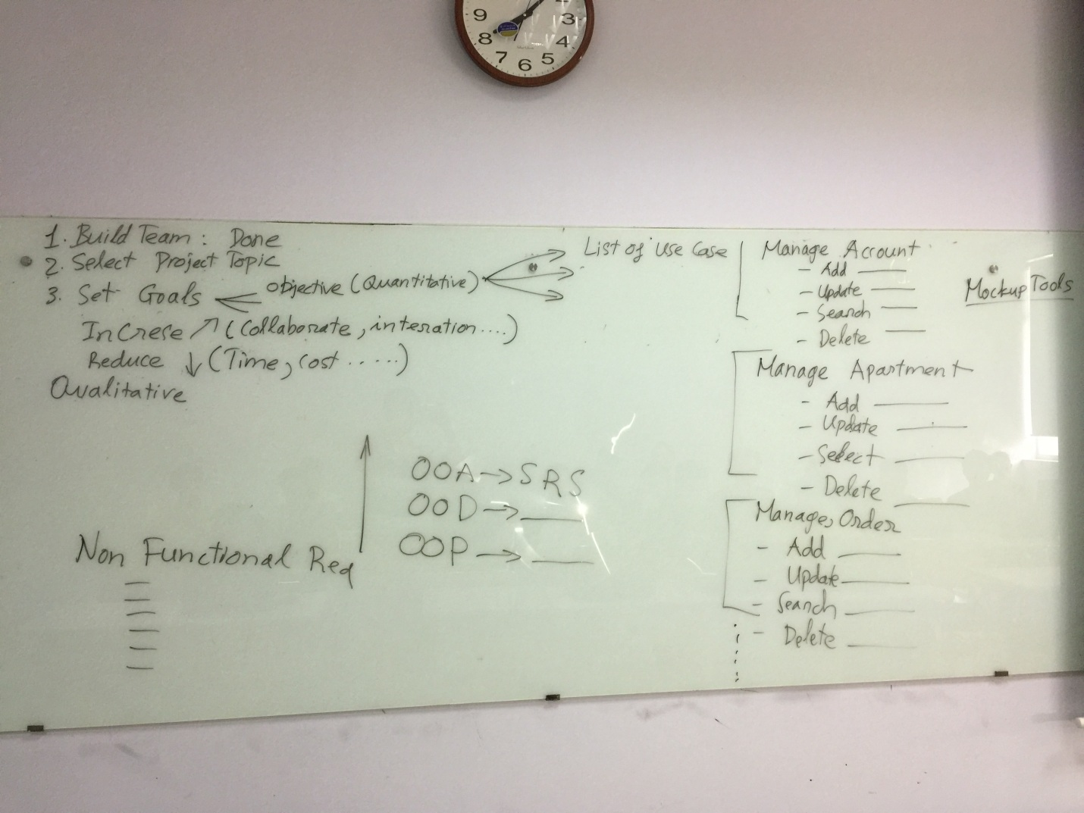

Identify all user class as an example FIGURE 6-1 in chapter 6

Draw Uses case diagram as an example FIGURE 8-2 in chapter 8

Draw screen flow as an example FIGURE 12-5 in chapter 12

Draw mockup screen as an example FIGURE 15-2, FIGURE 15-3, FIGURE 15-4, in chapter 15

Write detail use case description as an example in FIGURE 8-3 in chapter 8

Write business rules in use case description tempate as an example FIGURE 9-1 in chapter 9

Draw context diagram as an exapme below

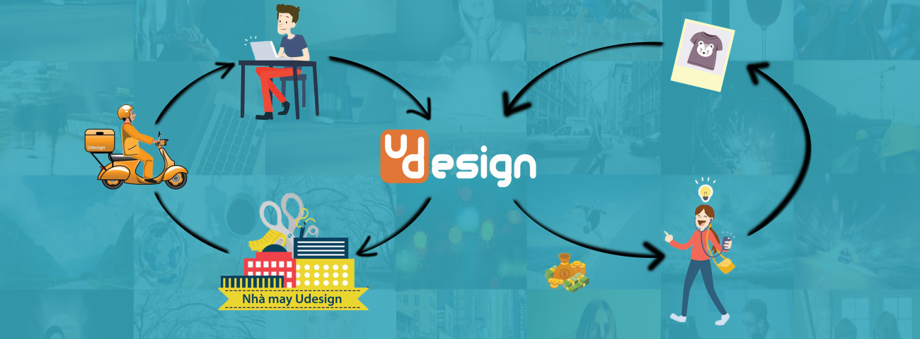

## **The objective**

Before running FDSS, we would like to set objective for team

- Increase the diversity of fashion's style

- Reduce the time, cost and misunderstanding when order "tailor-made" clothes

- Increase opportunities for amateur designers to share their design and earn money

Our proposal system

After reviewing all properties of the current system as well as target customer being consumers who want to share their design or want to buy design from our system, we have come to a decision to choose which features and functions we will provide in our system.

* End user side
  + Allow users to sign in with Google, Facebook account
  + Allow all users to have a shopping system, which displays all available designs. They can filter designs by design’s category, design’s material or design’s target customer.
  + Allow users to search design with keywords. With only one text input, the system should search for multiple attributes of the design: design name, design description, design type or designer
  + Allow user to view detail information of selected design
  + Allow users to order designs from system (add to cart)
  + Allow user to upload their design
  + Allow users to rate design
  + Allow users to give comments on designs.
  + Allow users to take payment via credit card
  + Allow users to change user’s avatar
  + Allow users to change personal information such as full name, phone number, address, etc.
  + Allow users to add bank account information to receiver money when their design has an order
  + Allow users to change design’s status
  + Allow users to manage their designs
  + Allow users to manage their order
  + Allow users to manage their revenue
* Administration side:
  + Allow administrators create and assign roles to others users
  + Allow administrators lock a user
  + Allow administrator add a new manager
  + Allow administrator set manager’s permission
  + Allow administrator check user’s information
* Manager side:
  + Allow managers to manage all designs
  + Allow managers to manage all order (check order status, change order status, etc)
  + Allow managers to export orders information
* Out of scope functions
  + Allow administrator add new role in system
  + Allow manager control shipping or produce product
  + Users pay by ATM card or cash
  + Users request to fix design based on their idea
  + Manage design’s copyright
    1. Comparison with other existing systems

We will make a comparison to explain why FDSS should be run

|  |  |  |  |  |  |
| --- | --- | --- | --- | --- | --- |
| **Features** | Gau Uniform | Online shop | Luxury Fashion brand | Taylor  made | FDSS |
| Create design | Check mark symbol |  |  | Check mark symbol | Check mark symbol |
| Sharing Design |  |  |  |  | Check mark symbol |
| Receive money when upload design |  |  |  |  | Check mark symbol |
| Comment for product | Check mark symbol | Check mark symbol |  |  | Check mark symbol |
| Rate product | Check mark symbol | Check mark symbol |  |  | Check mark symbol |
| Search products | Check mark symbol | Check mark symbol |  |  | Check mark symbol |
| Find designer |  |  |  |  | Check mark symbol |
| Choose size | Check mark symbol | Check mark symbol | Check mark symbol | Check mark symbol | Check mark symbol |
| Customize material | Check mark symbol |  |  | Check mark symbol | Check mark symbol |
| Online payment |  | Check mark symbol |  |  | Check mark symbol |
| Unique product | Check mark symbol |  | Check mark symbol | Check mark symbol | Check mark symbol |

*Compare FDSS system with existing system*





|  |  |  |
| --- | --- | --- |
| **ID** | **Actor** | **Name** |
| UC-1 | Guest | Register new account |
| UC-2 | Guest, Admin, Manager | Sign in |
| UC-3 | Guest | Sign in with Google account |
| UC-4 | Guest | Sign in with Facebook account |
| UC-5 | Guest, User | View all design |
| UC-6 | Guest, User | View design's details |
| UC-7 | Guest, User | Share favorite design to social network |
| UC-8 | Guest, User | Search designs by keywords |
| UC-9 | Guest, User | Filter designs by material |
| UC-10 | Guest, User | Filter designs by type (shirt, pant, skirt, etc) |
| UC-11 | Guest, User | Filter design by target customer |
| UC-12 | Guest, User | Sort designs by rate point |
| UC-13 | Guest, User | Sort designs by created time |
| UC-14 | Guest, User | Filter designs by designer |
| UC-15 | Guest, User | Add to cart |
| UC-16 | Guest, User | View shopping cart |
| UC-17 | Guest, User | Edit detail information of product in shopping cart |
| UC-18 | Guest, User | Delete item in shopping cart |
| UC-19 | Guest, User | Add shipping information |
| UC-20 | Guest, User | Add payment information |
| UC-21 | Guest, User | Payment |
| UC-22 | Guest | Forgot password |
| UC-23 | Guest, User | Tracking order |
| UC-24 | User, Admin, Manager | Sign out |
| UC-25 | User | Upload design |
| UC-26 | User | Update design |
| UC-27 | User | Crop image |
| UC-28 | User | Add design’s information |
| UC-29 | User | Comment for designs |
| UC-30 | User | Rate for designs |
| UC-31 | User | View my profile |
| UC-32 | User | Change password |
| UC-33 | User | Update basic information |
| UC-34 | User | Update bank account information |
| UC-35 | User | Require password before update bank account information |
| UC-36 | User | View my designs |
| UC-37 | User | Change status of design |
| UC-38 | User | Filter my designs by status |
| UC-39 | User | Search my design by keywords |
| UC-40 | User | View my orders |
| UC-41 | User | Filter orders by date |
| UC-42 | User | Filter orders by orders' status |
| UC-43 | User | View order's detail |
| UC-44 | User | View monthly revenue |
| UC-45 | User | View yearly revenue |
| UC-46 | Admin | Add manager roles |
| UC-47 | Admin | Manage all user |
| UC-48 | Admin | Ban user |
| UC-49 | Admin | View user's detail information |
| UC-50 | Admin | Manage all design |
| UC-51 | Admin, Manager | Manage orders |
| UC-52 | Admin, Manager | Manage order's detail |
| UC-53 | Admin, Manager | Filter orders by date |
| UC-54 | Admin, Manager | Filter orders by status |
| UC-55 | Admin, Manager | Change orders' status |
| UC-56 | Admin, Manager | Export orders to file by date |
| UC-57 | Admin, Manager | Export product's list by date (for producer) |
| UC-58 | System | Verify account by email when register |
| UC-59 | System | Send email that has password recover information's link |
| UC-60 | System | Calculate product’s price |
| UC-61 | System | Send detail information of order to customer’s email |
| UC-62 | System | Calculate total viewed time of design |
| UC-63 | System | Suggest related item for customer |
| UC-64 | System | Display recently viewed items |
| UC-65 | System | Generate size base on design's type |
| UC-66 | System | View top 10 designers |

## **Non-functional Requirement**

* + 1. Security
* Apply Authorize Attribute feature to restrict access to the action methods.
* The security matrix is as the following table:

|  |  |  |  |  |
| --- | --- | --- | --- | --- |
| **Function** | **Guest** | **User** | **Manager** | **Admin** |
| Login | Check mark symbol |  | Check mark symbol | Check mark symbol |
| External Login | Check mark symbol |  |  |  |
| Register | Check mark symbol |  |  |  |
| Logout |  | Check mark symbol | Check mark symbol | Check mark symbol |
| Forgot password | Check mark symbol | Check mark symbol |  |  |
| View profile |  | Check mark symbol |  |  |
| Change password |  | Check mark symbol | Check mark symbol | Check mark symbol |
| Change avatar |  | Check mark symbol |  |  |
| Update Users information |  | Check mark symbol |  | Check mark symbol |
| Update bank account information |  | Check mark symbol |  |  |
| Add design to cart | Check mark symbol | Check mark symbol |  |  |
| Edit detail of design in shopping cart | Check mark symbol | Check mark symbol |  |  |
| Delete products in shopping cart | Check mark symbol | Check mark symbol |  |  |
| View user's designs |  | Check mark symbol |  | Check mark symbol |
| Change status of design |  | Check mark symbol |  |  |
| Search user's design by keywords | Check mark symbol | Check mark symbol | Check mark symbol |  |
| View order |  | Check mark symbol | Check mark symbol | Check mark symbol |
| Create Design |  | Check mark symbol |  |  |
| Comment |  | Check mark symbol |  |  |
| Rate |  | Check mark symbol |  |  |
| Add manager account |  |  |  | Check mark symbol |
| Edit manager account |  |  |  | Check mark symbol |
| View all User |  |  |  | Check mark symbol |
| View User’s information |  |  |  | Check mark symbol |
| Ban User |  |  |  | Check mark symbol |

*Table 3.3.1 Security matrix*

* + 1. Maintainability & Extensibility
* Strictly follow the coding convention to help improve readability of source code and make the website more maintainable.
* Develop website based on Object Oriented Programming paradigm in order to increase maintainability and extendibility.
* Follow layered architecture and Model-View-Controller.
  + 1. Availability and Scalability

Apply some third-party services for reducing development time:

* + Stripe for payment
  + Google and Facebook authentication
  + Elastic search
    1. Performance

Add indexes to PostgreSQL, which make query incurring filtering and sorting run much faster.

* + 1. Usability
* The interface should be elegant and simple.
* **Links, buttons and checkboxes are easily clickable**, for example a user can select a checkbox by clicking the text, not just the checkbox.
* **Search box is wide** enough, so that users can see what they've typed.
* **Search is available many pages**, not just the homepage.
* **Links are easily recognizable.** They look clickable. Items that aren't links don't look clickable, for example underlining text is avoided.