**Problem: find x such that:**



**Pseudo code**

A: int a, b, c, d, x1, x2, x3;

delta = ;

int k, tmp;

B: if (delta = 0) then

C: tmp = 

D if (tmp = 0)

E print "PT co 1 nghiem boi"



F else

G print "PT co 1 nghiem duy nhat"



H else

I 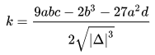

K if (delta > 0)

L tmp = abs(k)

M if (tmp < 1)

N print "PT co 3 nghiem"

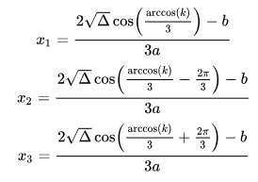

O else

P print "PT co 1 nghiem duy nhat"

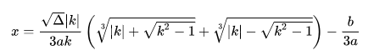

Q else

R print "PT co 1 nghiem duy nhat"



S end