Software Requirements Specification
for
< Smart Electronic License Plate >
Version 1.0 approved
Prepared by <Nguyen Thi Hong Mien>
<SE1201>
<Jun 14 2018>
Tables of Content
1. Introduction 1
1.1 Purpose 1
1.2 Document Conventions 1
1.3 Intended Audience and Reading Suggestions 1
1.4 Product Scope 1
1.5 References 1
2. Overall Description 1
2.1 Product Perspective 1
2.2 Product Functions 2
2.3 User Classes and Characteristics 3
2.4 Operating Environment 3
2.5 Design and Implementation Constraints 3
2.6 User Documentation 3
2.7 Assumptions and Dependencies 4
2.7.1 Assumptions 4
2.7.2 Dependencies 4
3. External Interface Requirements 4
3.1 User Interfaces 4
3.1.1 Home page 4
3.1.2 Login Page 5
3.1.3 Register new account page 6
3.1.4 Register a new license plate 7
3.1.5 Request to renew a current license plate 8
3.1.6 Request to cancel a current license plate 9
3.1.7 View account information (for drivers and officials only) 11
3.1.8 View car’s current position 12
3.1.9 View car’s travelling history 13
3.1.10 View daily reports of car fee (for BOT, similar UI are applied for Fuel Station and Parking Lot) 14
3.1.11 Detect which cars have violated traffic laws (for police) 15
3.1.12 Verify whether a request related to license plate should be granted (Official’s screen) 16
3.2 Hardware Interfaces 17
3.3 Software Interfaces 17
3.4 Communications Interfaces 18
3.4.1 For Web-based version: 18
3.4.2 For Mobile App version: 18
4. System Features 18
4.1 Register a new account 19
4.2 System Feature 2 (and so on) 20
5. Other Nonfunctional Requirements 20
5.1 Performance Requirements 20
5.2 Safety Requirements 21
5.3 Security Requirements 21
5.4 Software Quality Attributes 21
5.5 Business Rules 21
6. Other Requirements 21

Revision History
Name | Date | Reason For Changes | Version
MienNTH | Jun 14th 2018 | Initial Version | First Draft: 1.0
MienNTH | Jul 14th 2018 | Updated Version | 1.1

Introduction

Purpose
The purpose of this document is to provide a consistent and complete description of the requirements for the software: Smart License Plate Specification, which identifies existing project information and the software components that should be tested. Thus, this document provides a basis for evaluating the proposal for a new License Issuing System. This is the version 1.0 of the software requirements specification.

Document Conventions
I use number indexing for all headings throughout this document. Nested headings are marked by appending “.” and ascending number to their outer heading.

Intended Audience and Reading Suggestions
This document is written for software developers, designers, PM and testers involved in developing, testing and managing SELP project. The most important part of this document is functional as well as non-functional requirements parts. Readers may refer to table of content in the beginning of this document to get an idea of what it is about and may opt to read in any order.

Product Scope
Refer to Product Vision and Scope for Smart Electronic License Plate.

References
- Software requirement specification form
- SRS of Cafeteria Ordering System (by Karl Wiegers)
- Software engineering – Ninth Edition (by Ian Sommerville)
- Software requirement – Microsoft Edition

Overall Description

Product Perspective
This system is a proposal in replacement of the existing license plate used every day for cars.
SELP is mostly used for car owners, police and license plate officials, fuel stations, BOT managers, parking lot manager to provide a flexible and automatic way to:
- Pay and track BOT fee
- Pay and track fuel fee
- Pay and track fee for violating traffic law
- Track accidents and incidents on the road
- Pay parking fee in parking lots
- SELP has both Web and Mobile version. Official or Manager can issue, change or cancel a license plate any time. Normal car owner can register a new license and wait for authority officials to check whether they are qualified. Also, they can see the history of their payment as well as their travel history.
- SELP is intended to be a stand-alone product and should not depend on the availability of other software. However, it needs to connect with other system to support paying (banking system) and tracking (GPS).

Product Functions
Functions need to implement | Description of function
Register a license plate | Drivers send a request to have a new license plate for their car and wait for response from authority
Renew a license plate | Drivers send a request to renew their current license plate for their car and wait for response from authority
Cancel a license plate | Drivers send a request to cancel an existing license plate for their car and wait for response from authority
View payment history | BOT and gas station and parking lot managers can view how many cars passed the station and how much money was collected on a daily, weekly or monthly basis.
View account information | Drivers can view their own account information  Authority officials and managers can view all drivers’ and their car’s information
View car’s current position | All users can view a car’s current position
View car’s travelling history | All users can view a car’s travelling history by collecting information from google maps, mostly information about location and time and distances covered
View daily reports of car fee | All managers can view daily report of how much was paid by which car at which time passing their stations
Detect which cars have violated traffic laws | System can capture a car’s information which policeman may have missed and subtract money from their account with a warning or notification sent to their inbox so they know about their violations and policemen don’t need to do so much paper work
Verify whether a request related to license plate should be granted | License plate authority official will check whether a driver is qualified and car’s information is sufficient to approve the request for license plate issuing or renewal or cancellation
Allow drivers to pay money later | This is mostly a matter of business rule but managers of stations can give drivers option to use their service first and pay back later, in that case a debt is issued to their account and the system may subtract money later from their bank account.

User Classes and Characteristics
There would be 5 major classes of users using this system:
- Car owners (Drivers): who wants to save time in BOT and parking lot to pay fee and fill in all of the papers. Also they can manage their car’s license plate easily on the web site or mobile app.
- Police: may view information about car’s travel history as well as current position to track potential traffic jam or accidents for early solutions.
- Authority Officials: they have full control over plate license issuing and give decision whether a car owner should get a plate license or not. There would be less paper work and need fewer staff workers as gatekeeper or BOT fee-collectors.
- Parking lot managers: who use this system to automate their fee-collecting service or for gaining statistics
- Fuel station managers: who use this system to automate their fee-collecting service or for gaining statistics
- BOT station managers: who use this system to automate their fee-collecting service or for gaining statistics

Operating Environment
This system uses a central database, therefore users need to be able to access to the internet.
For the web-based version, they need a modern browser to get access to the web page.
For mobile version, they can download the application and run it on either Android or IOS.
It will require Windows 7 or higher or iOS 8 or higher to run this program.

Design and Implementation Constraints
Drivers may not always turn on GPS, which may affect tracking system. Also, they may object due this due to the breach of privacy involved when their own account and car’s information are distributed online.
Government may not welcome this system due to untested security and cost for sensor systems.
The new license plate may need to follow current rules while making sure there is no duplicate and fake license.
All systems need to be synchronized while some companies are not ready for change and prefer the old profitable current approach, which uses traditional metal license plate.
This documentation is made individually while the whole project ideas are come up with by a team so there may be conflicts and misunderstandings that need to be addressed.

User Documentation
User document will be updated when the project is finished and ready for beta testing.
In the meantime, we’re just making sure the functions work fine and the UI is foolproof and intuitive to users.

Assumptions and Dependencies

Assumptions
All the cars can be tracked with 24/24 available GPS or Wifi.
All the BOT and packing lot as well as fuel stations have hardware to sensor our smart license plate so it can identify the car in terms of milliseconds it enters or moves out of the place.

Dependencies
The calculation of fee and fine is different depending on vendors and business rules.
Our system needs synchronization with banking system where user’s banking account is registered to make timely update whenever they pay a fee or make a request to pay back later.

External Interface Requirements

User Interfaces
Due to time constraints and the fact that actual implementation is not done yet, I will provide expected user interface for web version first. The user interface for mobile version will be updated later.

Home page
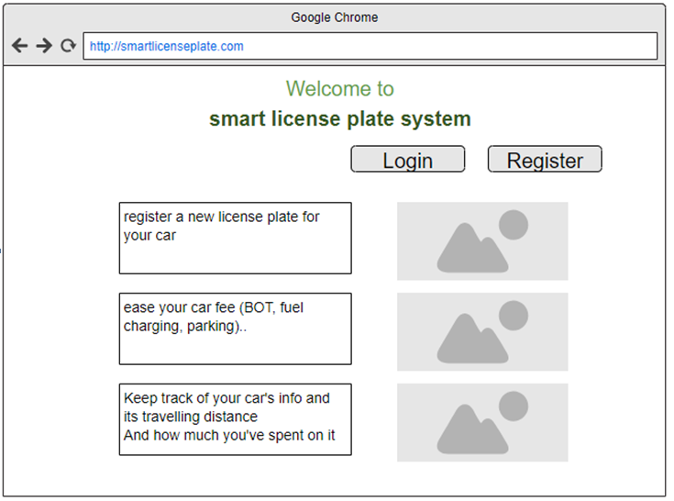

Login Page

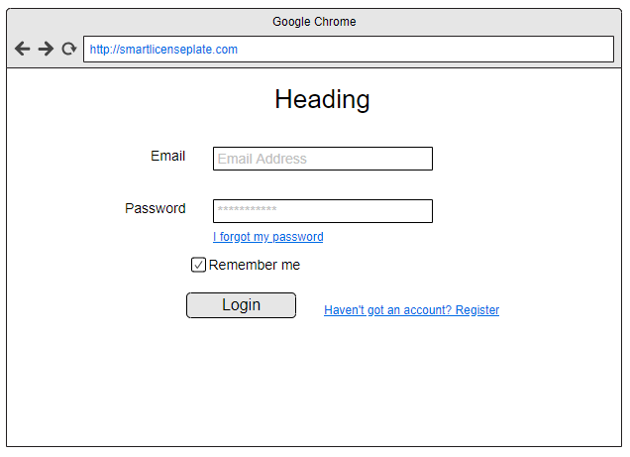

Register new account page

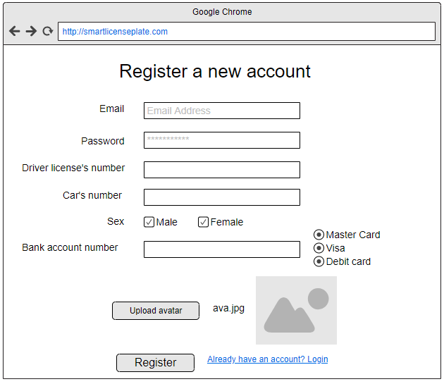

Register a new license plate
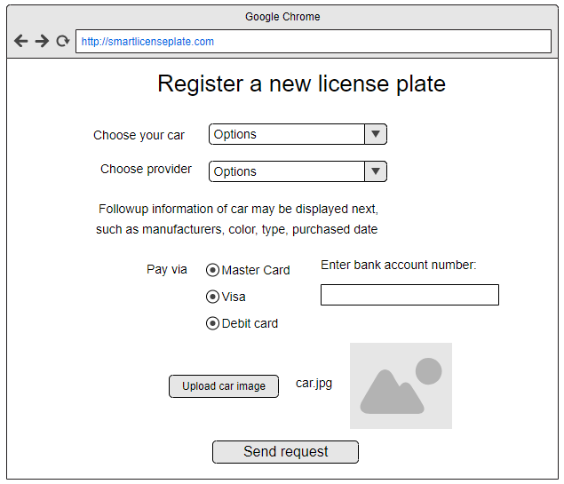

Request to renew a current license plate

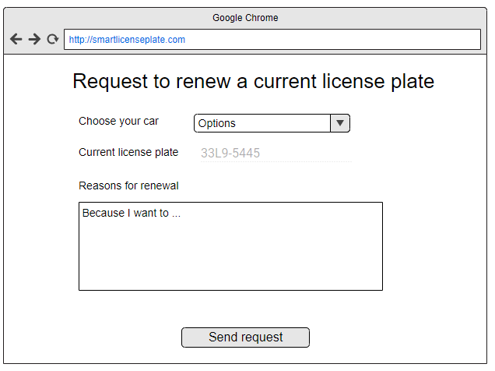

Request to cancel a current license plate
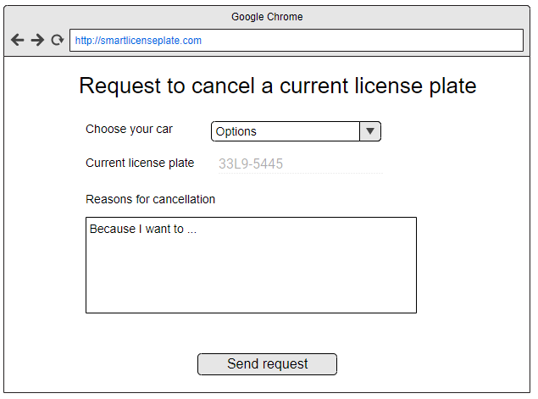
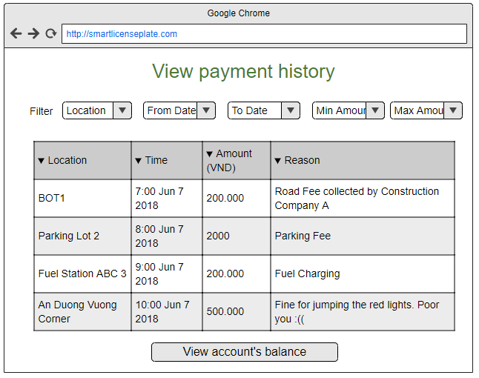

View account information (for drivers and officials only)
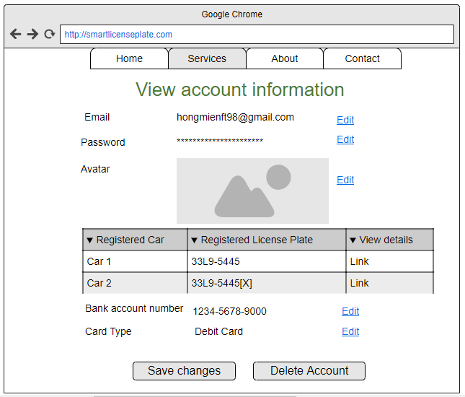

View car’s current position
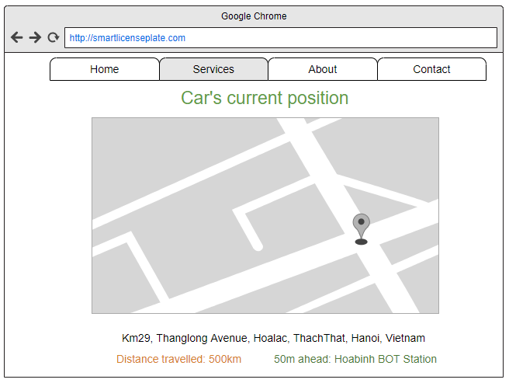

View car’s travel history
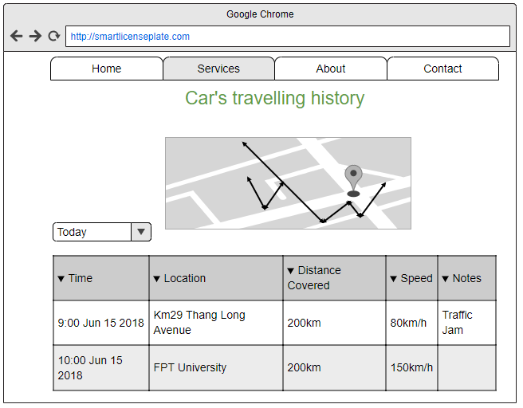

View daily reports of car fee for a specific driver (for driver only)
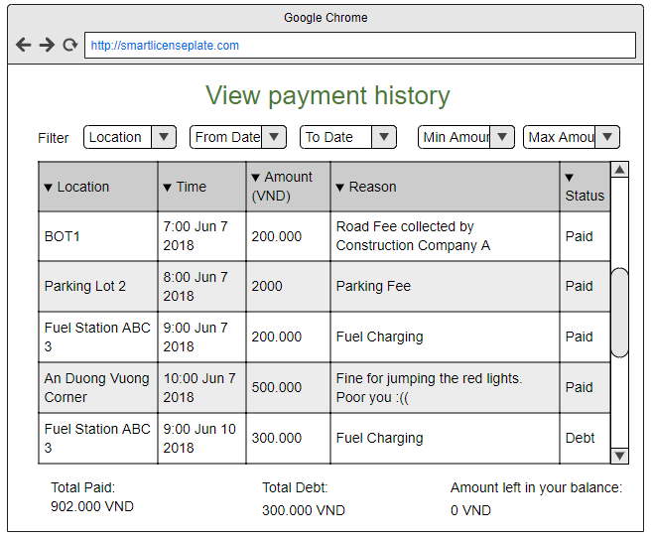

View daily reports of car fee (for BOT, similar UI are applied for Fuel Station and Parking Lot)
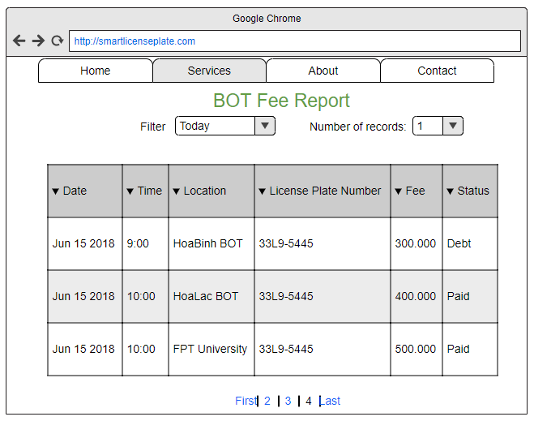

Accident reports for a specific case (for police)
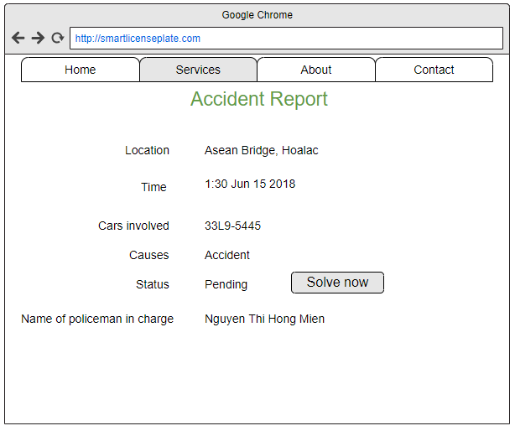

View list of accidents (for police only)
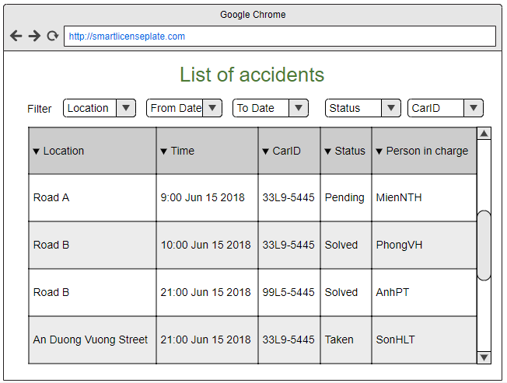

Verify whether a request related to license plate should be granted (Official’s screen)

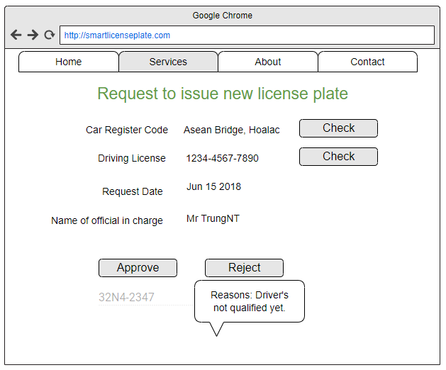

Hardware Interfaces
The prototype software (RR) will be implemented on Localhost web server and used in Windows 7 or higher operating system.
Mobile app will be compiled into .apk file for testing on Android devices and .ipa file for iOS operating system.

Software Interfaces
Android device: Android 8.0 or higher version
iOS device: iOS 8 or higher version

Computer: Any OS version with internet connection and internet browser.

Communications Interfaces
SELP app uses HTTP1.0 (or over) connection to communicate with server over the Internet
Software and DBMS that we will use.

For Web-based version:
- Javascript for coding front end and Java for coding back end (Web version)
- MSSQL Server (for storing and managing data)
- Apache Tomcat Server for hosting website (localhost)

For Mobile App version:
- PHP System (for all web interface and communication with MySQL database)
- MySQL (for storing database)
- Apache service (for HTTP protocol and PHP)

System Features
Main functions:
- Register a new account: all users <drivers, officials, police, managers>
- Login to the system: all users
- Register a license plate: driver only
- Request to renew a license plate: driver only
- Cancel a license plate: drivers and officials only
- View payment history: drivers only
- View account information: drivers and officials only
- View car’s current position: all users
- View car’s travelling history: drivers only
- View daily reports of car fee: all users with different interfaces
- Detect which cars have violated traffic laws: police and drivers only
- Verify whether a request related to license plate should be granted: officials only
- Allow drivers to pay money later: managers
5 different types of users:
+) Drivers:
- Create account, update information (using car owner's bank account), change password
- Receive notifications about updates in their account (fine, personal information, an action has been completed, their license plate request has been approved)
- Detect cars that go into parking lot without tickets (no need for gatekeeper at supermarkets or school)
- Register a license plate
- Renew a license plate
- Cancel a license plate
- View payment history
- View account information
- View car's travelling history (travelled where, how many kilometers, at which time)

+) Officials:
- View car's current position
- Verify whether a license plate request (issue a new one, renew an existing one, cancel an existing one) should be granted

+) Police
- Detect which cars have violated traffic laws
- Detect the exact location of cars that's involved in road accidents.
- View car's current location

+) Parking lot manager
- View information of cars in and out
- View daily report of fees
- View current state of car (whether inside or outside parking lot)

+) BOT station manager
- View information of cars in and out
- View daily report of fees
- View current state of car (whether inside or outside bot)

+) Petrol station manager
- View information of cars in and out
- View daily report of fees
- Check the amount of fuel this car has consumed (assuming all stations are interconnected)
- May allow drivers to pay money later

Register a new account

For driver
UC ID and Name: | UC001 - Register user
Created By: | MienNTH | Date Created: | Jun 15 2018
Primary Actor: | Driver | Secondary Actors:
Trigger: | User clicks on “Register” link on home page
Description: | Create a new account and save it to database  Required field:  - Email  - Password (check strength)  - Avatar Path  - Car registered number  - Driver license number
Preconditions: | User clicks on “Register” link on home page
Postconditions: | A new account is created and saved to database
Normal Flow: | User clicks on “Register” link on home page
Alternative Flows: | User clicks on “Login” and then “Create a new account” link
Exceptions: | User enter not strong enough password, duplicate email, invalid driver license, invalid avatar upload.  In that case, instead of being directed to the expected destination, users are directed back to Register page with error message appended right after each wrong field.  This process is repeated until all input information is validated by the server.
Priority: | High
Frequency of Use: | High
Business Rules: | N/A
Other Information:
Assumptions:

For policeman, officials and managers
UC ID and Name: | UC001 - Register user
Created By: | MienNTH | Date Created: | Jun 15 2018
Primary Actor: | Policeman, official, manager | Secondary Actors:
Trigger: | User clicks on “Register” link on home page
Description: | Create a new account and save it to database  Required field:  - Email  - Password (check strength)  - Role
Preconditions: | User clicks on “Register” link on home page
Postconditions: | A new account is created and saved to database
Normal Flow: | User clicks on “Register” link on home page
Alternative Flows: | User clicks on “Login” and then “Create a new account” link
Exceptions: | If user enters invalid email or password, they are prompted with error messages and must reenter until a valid one is provided.  This process is repeated until all input information is validated by the server.
Priority: | High
Frequency of Use: | High
Business Rules: | N/A
Other Information: | Developer may see a need to add new field to register page such as age, address.
Assumptions:

Login
UC ID and Name: | UC002 - Login
Created By: | MienNTH | Date Created: | Jun 15 2018
Primary Actor: | Driver, Officials | Secondary Actors: | Manager, Policeman
Trigger: | User clicks on “Login” link on home page
Description: | Create a new account and save it to database
Preconditions: | User clicks on “Login” link on home page
Postconditions: | A new account is created and saved to database
Normal Flow: | User clicks on “Login” link on home page
Alternative Flows: | User clicks on “Register” and then “Already have an account? Login” link
Exceptions: | Users enter the combination of password and email wrong for more than 5 times, they are given a warning and system will send an email to users to confirm they are the real users.  Users click on forgot their password, they are directed to a page to enter their email address. They need to go to their mailbox to get a link to reset password.
Priority: | High
Frequency of Use: | High
Business Rules: | N/A
Other Information: | The content of email message as well as warning will be determined by developers
Assumptions:

Request to register a new license plate
UC ID and Name: | UC003 - Register a new license plate
Created By: | MienNTH | Date Created: | Jun 15 2018
Primary Actor: | Driver | Secondary Actors:
Trigger: | User clicks on “Register a new license plate ” link on service tab
Description: | User fills in car information and send request for approval from officials to get a new license plate
Preconditions: | User is logged in to the system and must be a driver  User registered at least a car in the database
Postconditions: | A new request is created and saved to database as well as sent to official’s inbox for further processing.
Normal Flow: | User clicks on “Register a new license plate ” link on service tab
Alternative Flows: | User already has an existing license plate and wants to change to use our service. There will be a checkbox. If he checks it, he will be prompted to enter his current plate number to be sent with the request.
Exceptions: | User has not registered any car in database  User enters wrong banking account  There is no provider available at the moment to consider the request  In that case, instead of sending the request, users are directed back to Register page with error message appended right after each wrong field.  This process is repeated until all input information is validated by the server.
Priority: | High
Frequency of Use: | High
Business Rules: | N/A
Other Information:
Assumptions: | Providers are linked to officials with enough authority to approve or reject a request to grant a new license

Request to renew a current license plate
UC ID and Name: | UC004 - Request to renew a current license plate
Created By: | MienNTH | Date Created: | Jun 15 2018
Primary Actor: | Driver | Secondary Actors: | Official
Trigger: | User clicks on “Renew a current license plate ” link on service tab
Description: | User fills in car information and send request for approval from officials to get a new license plate
Preconditions: | User is logged in to the system and must be a driver  User registered at least a car in the database  User had an existing license plate  Their bank account is sufficient for registering fee.
Postconditions: | A new request is created and saved to database as well as sent to official’s inbox for further processing.
Normal Flow: | Official gets notification about a new renewal request and click on “Approve”.  User gets notifications and their license plate in the database is updated.  Fee for renewal is subtracted from their provided bank account number.  Status of request is changed and automatically updated in the database.
Alternative Flows: | 1.User hasn’t registered any car with license plate approved in the database.  In that case, they are directed to register a new license plate page.  2. Official doesn’t approve the request, he will fill in a reason and send notification to user
Exceptions:
Priority: | High
Frequency of Use: | High
Business Rules: | N/A
Other Information:
Assumptions:

Request to cancel a current license plate

For driver
UC ID and Name: | UC005A - Request to cancel a current license plate
Created By: | MienNTH | Date Created: | Jun 15 2018
Primary Actor: | Driver | Secondary Actors:
Trigger: | User clicks on “Cancel a current license plate ” link on service tab
Description: | User fills in car information and sends request for approval from officials to get a new license plate
Preconditions: | User is logged in to the system and must be a driver  User registered at least a car in the database  User had an existing license plate
Postconditions: | A new request is created with given reasons for cancellation and request is saved to database as well as sent to official’s inbox for further processing.
Normal Flow: | Official gets notification about a new cancel request and click on approve  User gets notifications and their license plate in the database is updated.  Fee for cancellation is subtracted from their provided bank account number.
Alternative Flows: | 1.User hasn’t registered any car with license plate approved in the database. In that case, they are directed to register a new license plate page.  2. Official doesn’t approve the request, he will fill in a reason and send notification to users.  3. User changes his mind and can still cancel cancellation request in waiting time for approval.
Exceptions: | No existing license plate is associated with this driver.  Once the request is not
Priority: | Low
Frequency of Use: | Low
Business Rules: | N/A
Other Information: | Drivers may need to wait 1-2 weeks for response from officials. During that processing time, he can still change his mind and cancel his request.  Fee for cancellation may apply or not depending on business rule.
Assumptions:

For official
UC ID and Name: | UC005B - Request to cancel a current license plate
Created By: | MienNTH | Date Created: | Jun 15 2018
Primary Actor: | Official | Secondary Actors:
Trigger: | Official clicks on “Cancel a current license plate ” link on service tab
Description: | A list of registered license plate is displayed to officials and he may choose one of them and clicks on “Cancel” button. He must submit a reason (maybe a driver has violated so many times) and that decision with reasons will be sent to car owner (driver)’s inbox.
Preconditions: | Official is logged in to the system in the role of Official.  At least on license plate exists in the system.
Postconditions: | License plate is cancelled.
Normal Flow: | Official clicks on “Cancel” button and sumit a reason.  A pop up window will be displayed to ask whether he is sure about the decision.  Official clicks on “Ok”  Notifications are sent to user to inform him about the decision and reason.
Alternative Flows: | 1. Official clicks on “Cancel” button and sumits a reason. A pop up window will be displayed to ask whether he is sure about the decision.  Official clicks on “Cancel” in the pop up window. The request is cancelled. License plate remains intact.  2. User disagrees with the decision and sends a complaint form.  3. Rare case: Official mistakenly Cancels a license plate. In that case, he can reissue that license plate automatically for car owner, even though the owner would obviously see the decision in their inbox right after the decision is made.
Exceptions: | No existing license plate is associated with this driver
Priority: | Low
Frequency of Use: | Low
Business Rules: | N/A
Other Information:
Assumptions: | Some special and convincing reasons force officials to reject a license plate

View account information

For driver
UC ID and Name: | UC006A - View account information
Created By: | MienNTH | Date Created: | Jun 15 2018
Primary Actor: | Driver | Secondary Actors:
Trigger: | Driver clicks on his avatar image, there will be a dropdown list and he clicks on “View profile”
Description: | Display information related to driver account.
Preconditions: | Driver is logged in to the system.
Postconditions: | Information related to driver is displayed with link to edit information and save changes.
Normal Flow: | User clicks on “View profile” and sees their information display
Alternative Flows: | - User clicks on one of those “Edit” hyperlinks and click on “Save changes”. Information about his account is validated and updated in the database and in the display.  - User clicks on “Delete” button. If there is no pending request (related to license mentioned in previous use case), there will be a confirm dialog. If he clicks “Ok”, the account will be deleted.
Exceptions:
Priority: | Low
Frequency of Use: | High
Business Rules: | N/A
Other Information:
Assumptions:

For official
UC ID and Name: | UC006B – View account information
Created By: | MienNTH | Date Created: | Jun 15 2018
Primary Actor: | Official | Secondary Actors:
Trigger: | Official clicks on “View registered license plates”
Description: | Display a list of license plates with associated driver and car. He may view details by clicking on “View details” right besides each records.
Preconditions: | Official is logged in to the system in the role of Official.
Postconditions: | A list of license plates registered is displayed.
Normal Flow: | Official clicks on “View registered license plate”  Official clicks on “View details” and see information related to a particular driver, not including sensitive information such as password, of course. He doesn’t have right to edit any of these either.
Alternative Flows: | Officials click on “Delete” to choose to delete a license plate. In this case, steps are similar to “Cancel a license plate” use case for Official.
Exceptions: | If there is no record to display, there will be a slight warning displayed “There is no registered license plate in the system”
Priority: | Low
Frequency of Use: | High
Business Rules: | N/A
Other Information: | Depending on business rule, cancelled request may also be displayed for reference purpose.
Assumptions:

View car’s current position

For driver
UC ID and Name: | UC007A – View car’s current position
Created By: | MienNTH | Date Created: | Jun 15 2018
Primary Actor: | Driver | Secondary Actors:
Trigger: | Driver clicks on “View car’s current position” in services
Description: | Show real time position of driver’s car.
Preconditions: | Driver is logged in to the system in the role of Driver.  Car’s GPS is turned on.
Postconditions: | A map showing car’s specific location is drawn and displayed on screen.
Normal Flow: | Official clicks on “View current position”  A label showing the exact road name, district and city is displayed together with Google Maps showing the exact location.
Alternative Flows: | If car’s GPS is not turned on, user is prompted with a friendly message saying “Your car must turn on GPS to track position.”  If user turns on GPS for their car, the system needs no refreshing to display the message as in normal flow.
Exceptions: | As this depends highly on GPS system, we may not be 100% sure about the exact location.  Accuracy: 95%
Priority: | Low
Frequency of Use: | High
Business Rules: | Driver does not have permission to track other cars’ current position
Other Information:
Assumptions:

For manager, policeman
UC ID and Name: | UC007B – View car’s current position
Created By: | MienNTH | Date Created: | Jun 15 2018
Primary Actor: | Manager, Policeman | Secondary Actors:
Trigger: | User clicks on “View car’s current position” in services
Description: | View any car’s real time location
Preconditions: | User is logged in to the system in the role of either Manager or Policeman.
Postconditions: | A map and label saying the exact location of a chosen car is displayed on screen.
Normal Flow: | 1. User clicks on “View list of cars” on Service tab.  2. User clicks on “View current location” on a certain row in list of cars table.  3. The chosen car’s exact location is displayed with a map. If GPS is not turned on, a message is displayed “This car’s GPS is not turned on. Please come back later!”
Alternative Flows: | User search for a car with its ID instead of browsing the whole list.  Repeat step 2 in normal flow.
Exceptions:
Priority: | Low
Frequency of Use: | Medium
Business Rules: | N/A
Other Information:
Assumptions:

View car’s travel history
UC ID and Name: | UC008 – View car’s travel history
Created By: | MienNTH | Date Created: | Jun 15 2018
Primary Actor: | Driver | Secondary Actors:
Trigger: | Driver clicks on “View car’s travel history” in services
Description: | View any car’s travel history
Preconditions: | User is logged in to the system in the role of Driver
Postconditions: | Car’s travel history is displayed
Normal Flow: | 1. In the default mode <without filter>, each page will display 10 most recent activities in car’s travel history.  2. User can filter results display such as how many results per page, show only results over the last day, week, month or year only. System displayed the requested results without refreshing.
Alternative Flows: | If there is no record to show, display a message saying “This car hasn’t got any history yet.”
Exceptions:
Priority: | Low
Frequency of Use: | Medium
Business Rules: | N/A
Other Information:
Assumptions: | Car’s GPS is turned on.  Our system retrieves information from GPS system every 30 minutes to make sure trivial results are not pushed into database, which is unnecessary and wastes of space.

View balance’s information of a specific driver
UC ID and Name: | UC009 – View balance information
Created By: | MienNTH | Date Created: | Jun 15 2018
Primary Actor: | Driver | Secondary Actors:
Trigger: | Driver clicks on “View balance information” in services
Description: | View how much the driver has paid with regard to using this license plate.
Preconditions: | User is logged in to the system in the role of Driver
Postconditions: | User’s paying history is displayed
Normal Flow: | 1. User clicks on “View balance information” in services tab  2. A table is displayed with specific information:  - Date  - Time  - Location  - Amount  - Reason  - Status (Paid/ Debt)  Below that, a label showing total amount paid for the displayed records is shown. Another label showing total debt for the display records is shown.  A label showing the amount left in the account is shown.
Alternative Flows: | If there is no record to show, display a message saying “Your account hasn’t made any payments yet.”  3 labels showing total amount paid, total debt as well as amount left are still displayed.
Exceptions:
Priority: | Medium
Frequency of Use: | Medium
Business Rules: | Drivers are only allowed to pay later when there’s no money left in their account.  Next time when they put in the money, the debt will be automatically subtracted from their account.
Other Information:
Assumptions:

View report of car fee for all cars
UC ID and Name: | UC010 – View report of car fee for all cars
Created By: | MienNTH | Date Created: | Jun 15 2018
Primary Actor: | BOT manager, Parking lot manager, Fuel station manager | Secondary Actors:
Trigger: | User clicks on “View report of car fees” in services tab
Description: | View any car’s travel history
Preconditions: | User is logged in to the system in the role of Driver
Postconditions: | Car’s travel history is displayed
Normal Flow: | 1. In the normal mode, each page will display 10 most recent activities as regard which car has made payments to the system.  2. A table is displayed with specific information:  - Date  - Time  - Location  - Amount  - LicensePlateNumber  - Status (Paid/ Debt)  Below that table, a label showing total amount paid for the displayed records is shown. Another label showing total debt for the displayed records is shown.  A label showing the amount left in the account is displayed.  3. User can filter results displayed such as location, from which date to which date, min amount, max amount
Alternative Flows: | If there is no record to show, display a message saying “This car hasn’t got any history yet.”
Exceptions:
Priority: | High
Frequency of Use: | High
Business Rules: | As BOT station, fuel station and parking lot may have different policies, more or less details may be included in the table.
Other Information:
Assumptions:

UC ID and Name: | UC010 – View report of car fee for all cars
Created By: | MienNTH | Date Created: | Jun 15 2018
Primary Actor: | BOT manager, Parking lot manager, Fuel station manager | Secondary Actors:
Trigger: | Driver clicks on “View car’s travel history” in services
Description: | View any car’s travel history
Preconditions: | User is logged in to the system in the role of Driver
Postconditions: | Car’s travel history is displayed
Normal Flow: | 1. In the normal mode, each page will display 10 most recent activities as regard which car has made payments to the system.  2. A table is displayed with specific information:  - Date  - Time  - Location  - Amount  - LicensePlateNumber  - Status (Paid/ Debt)  Below that table, a label showing total amount paid for the displayed records is shown. Another label showing total debt for the displayed records is shown.  A label showing the amount left in the account is displayed.  3. User can filter results displayed such as location, from which date to which date, min amount, max amount
Alternative Flows: | If there is no record to show, display a message saying “This car hasn’t got any history yet.”
Exceptions:
Priority: | High
Frequency of Use: | High
Business Rules: | N/A
Other Information:
Assumptions:

View reports of a specific accident (for policeman only)
UC ID and Name: | UC011 – View report of a specific accident
Created By: | MienNTH | Date Created: | Jun 15 2018
Primary Actor: | Policeman | Secondary Actors:
Trigger: | Policeman clicks on notifications in the dropdown list after he clicks on his profile picture. He clicks on any notifications with title “Accident” that’s unread.
Description: | A recent accident may have occurred with a license plate registered in the system. The sensor in the plate will send message to the nearest police station so that policeman gets notified about the accident and can run to the case as soon as possible.
Preconditions: | User is logged in to the system in the role of Policeman
Postconditions: | Details of accident is displayed, the status may got changed by any policeman: Pending to Take to Taken to Solved.
Normal Flow: | Information to be displayed include:  - Location  - Time  - Cars involved  - Causes  - Status  - Name of policeman in charge
Alternative Flows: | Another user sends accident reports to the station, he will have a form to submit and fill in with details of the cars involved, reason and time, location for policeman.
Exceptions: | Two policemen can change the status at the same time and chooses to undertake the case. In that case, the system only resolves to one (maybe earlier in some milliseconds) and updates the status immediately in terms of milliseconds.
Priority: | High
Frequency of Use: | High
Business Rules: | Business rule of police station may apply, many people can join in solving an accident case but only one user can change the status of the situation at a time, preferably the leader of that station only, for the sake of consistency and efficiency.
Other Information:
Assumptions:

View list of accidents (for police only)
UC ID and Name: | UC012 – View list of all accidents
Created By: | MienNTH | Date Created: | Jun 15 2018
Primary Actor: | Policeman | Secondary Actors:
Trigger: | Policeman clicks “List of accidents” on services page.
Description: | Police may have an overview about how many accidents have happened during given time and location.
Preconditions: | User is logged in to the system in the role of Policeman
Postconditions: | A list of accidents reported is displayed, depending on user’s filter
Normal Flow: | Normally a total of 10 most recent records are displayed, users can select a filter to get their desired view.  Information to be displayed includes:  - Location  - Time  - Car ID  - Status  - Name of policeman in charge
Alternative Flows:
Exceptions: | Two policemen can change the status at the same time and chooses to undertake the case. In that case, the system only resolves to one (maybe earlier in some milliseconds) and updates the status immediately in terms of milliseconds.
Priority: | High
Frequency of Use: | High
Business Rules: | Business rule of police station may apply, many people can join in solving an accident case but only one user can change the status of the situation at a time, preferably the leader of that station only, for the sake of consistency and efficiency.
Other Information:
Assumptions:

Verify a license plate request
UC ID and Name: | UC012 – View list of all accidents
Created By: | MienNTH | Date Created: | Jun 15 2018
Primary Actor: | Official | Secondary Actors:
Trigger: | User clicks on his notifications and clicks on a request for a new license plate, a renewal or a cancellation of an existing license plate.
Description: | This is the place whether officials checks user’s request and makes decision whether to approve a request related to license plate or not.
Preconditions: | User is logged in to the system in the role of Official
Postconditions: | A request’s status is set to Pending, Approved or Rejected.  Notification about status is sent automatically by the system to the requestor (driver).
Normal Flow: | 1. Official will check information about the driver’s license plate as well as car’s registered number to make the decision.  2. He can clicks on the “Approve” or “Reject” button or just leave it there, in that case the request’s status will be set to “Pending”.
Alternative Flows: | If two qualified process a request at the same time, the first person that makes the decision will have the say in this process. Status will be updated in terms of milliseconds to guarantee consistency.
Exceptions: | If request is pending for more than two weeks, request can be sent to official’s email for processing.  In the worst case, that request will be sent to higher official and user can makes a complaint request.
Priority: | High
Frequency of Use: | High
Business Rules: | License plate number may be automatically generated by the system according to normal standards.  Fees are calculated based on the providers.
Other Information:
Assumptions: | The use case writer does not know well about the process of issuing a license plate. The writer would just assume that a person can make a decision (instead of a group of officials or some governmental intervention) regarding whether a new license plate can be given based on driver’s provided information, most importantly is his driving license and car number.

Other Nonfunctional Requirements

Performance Requirements
- SELP server can be available 24/7 and can support a large number of queries (thousands of queries at the same time) for updating status, details (account information, license information)
- Driver who sends a request related to license plate will needs to wait for maximum amount of 2 weeks for response, however, request needs to be sent to someone in charge by the time users clicks “Send”.
- When system failed it would took 10 minutes to completely restart and fully operate again.
- The maximum defect rate is about 20-25 bugs per 1000 lines of code.

Safety Requirements
This system makes no assumptions about car conditions or capability of drivers on the road as we get input from other sources.

Security Requirements
Only specific people can create Official, Manager, Policeman or Driver role to make sure user’s information is not fake or being sniffed into.
Certain information of users and cars are hidden and shown only to the direct user.
Once users establish a role, he cannot change his role, except for creating a new one.

Software Quality Attributes
Testability: Easy to test and maintain
Usability: UI is foolproof and users may take no time to learn how to use it.

Business Rules
- Fee for new license or renewal or cancellation is completely dependent on Officials and Authority that issue that license. Officials can make changes anyway.
- Fee for parking lot, BOT and fuel station is also dependent on the business and price they provide. They can make changes anyway.
- The system is completely free of charge and need sponsorship from government to cover large scale for visible benefits.

Usability
- The interface should be elegant and simple.
- Links, buttons and checkboxes are easily clickable. For example, a user can select a checkbox by clicking the text, not just the checkbox or click on a label and their cursor is focused on the input field.
- Search box is wide enough, so that users can see what they've typed.
- Search is available many pages, not just the homepage.
- Links are easily recognizable. They look clickable. Items that aren't links don't look clickable, for example underlining text is avoided.

Other Requirements
Appendix A: Glossary
List of abbreviations used in this document:

Abbreviation | Meaning
SRS | Software Requirement Specification
UI | User Interface
BOT | Business – Operate – Transfer  A service where building company is allowed to collect fee from those who use their system for a certain amount of time.
UC | Use Case

Use case diagram
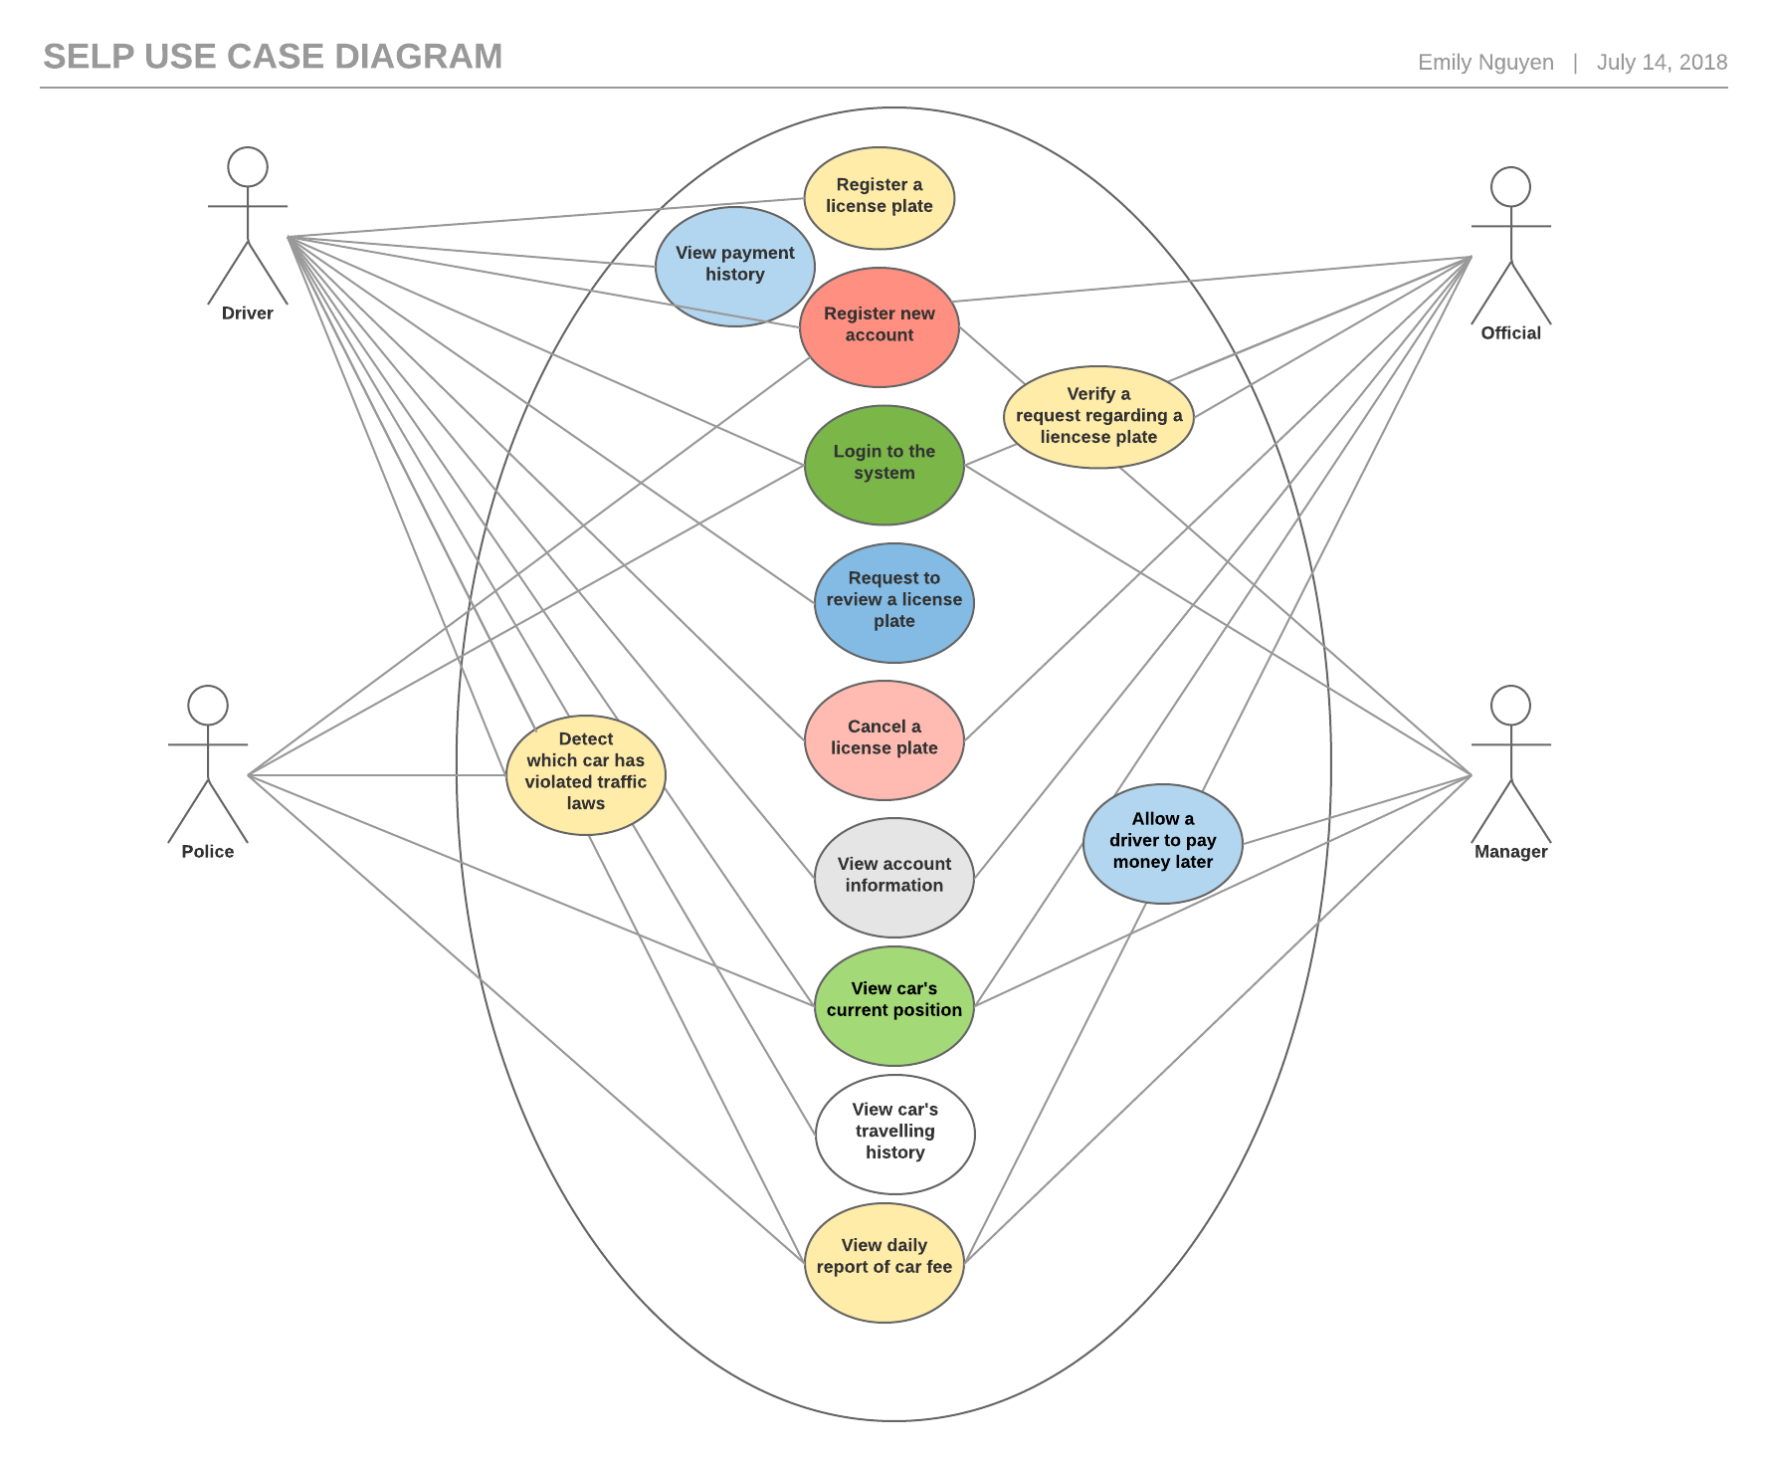

Screen flow (Dialog map)
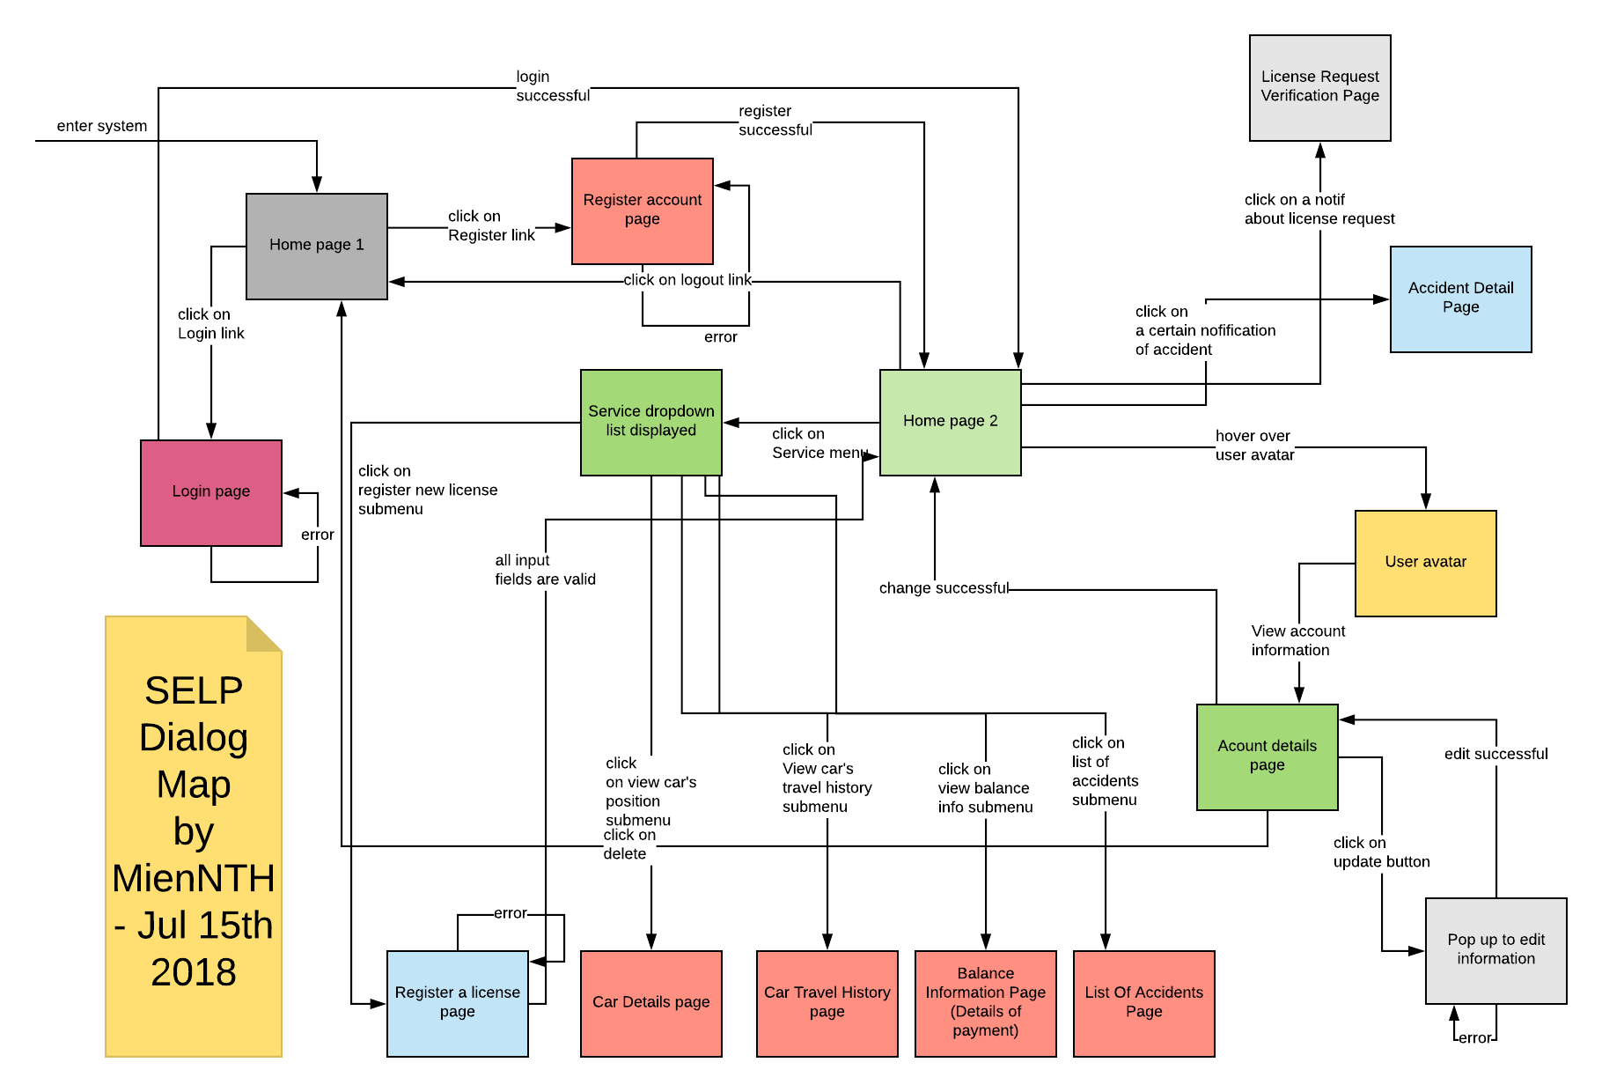

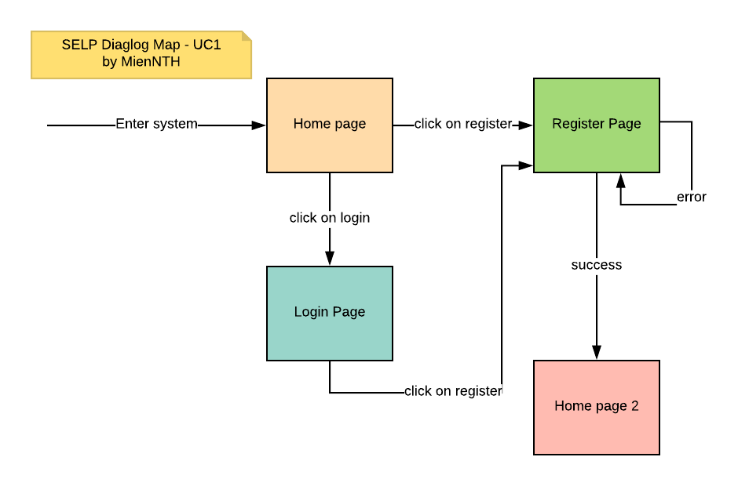

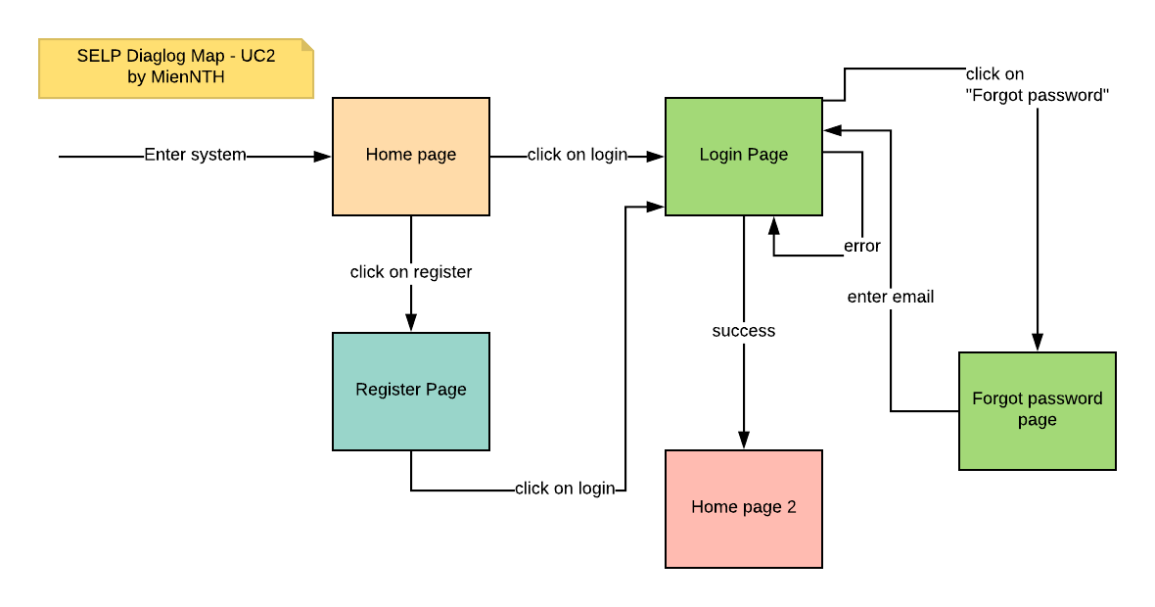

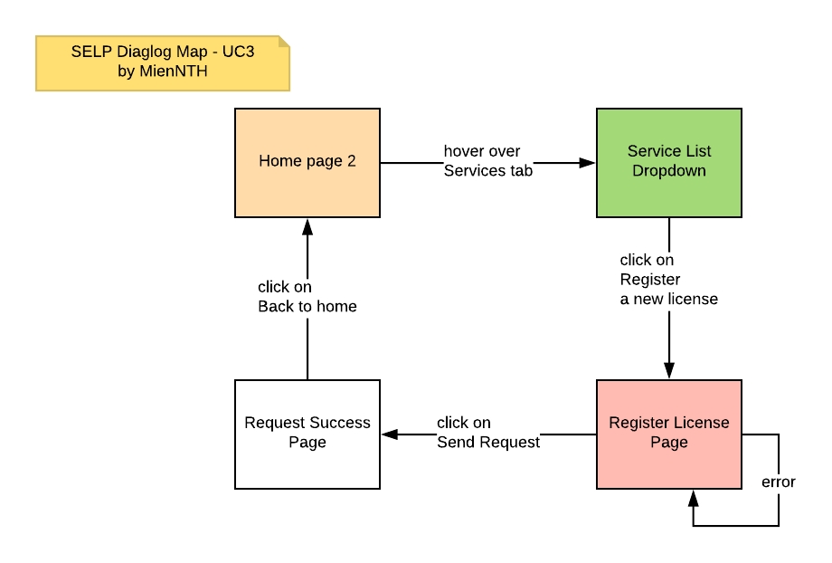

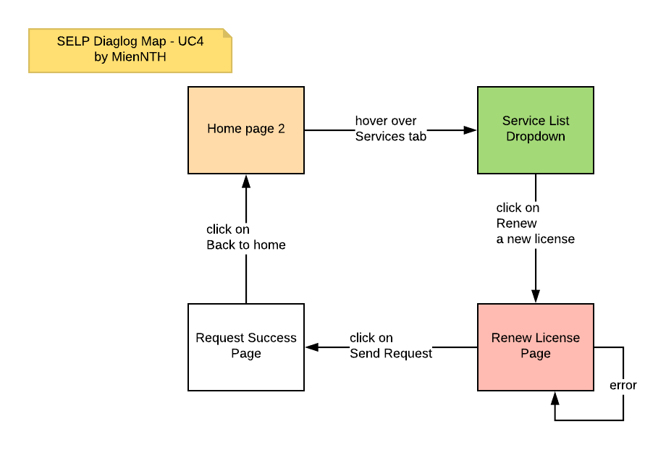

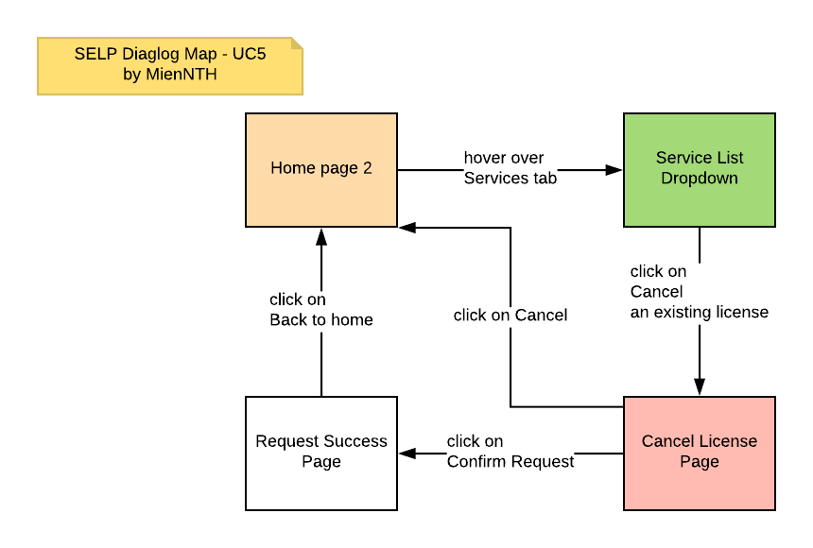

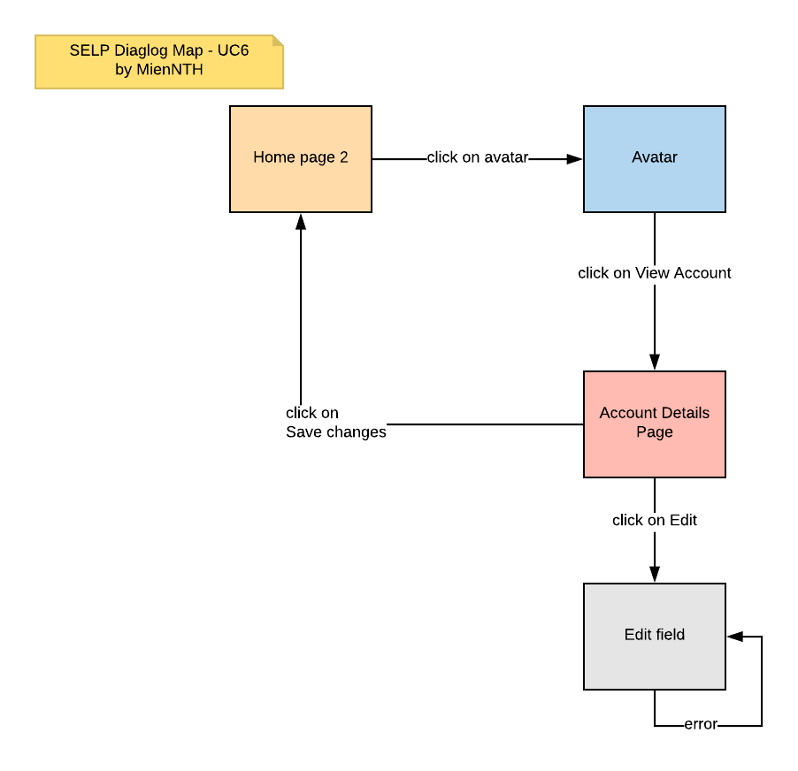

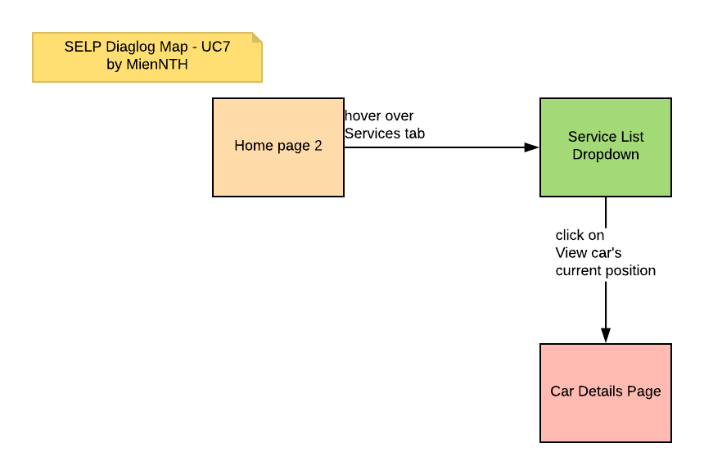

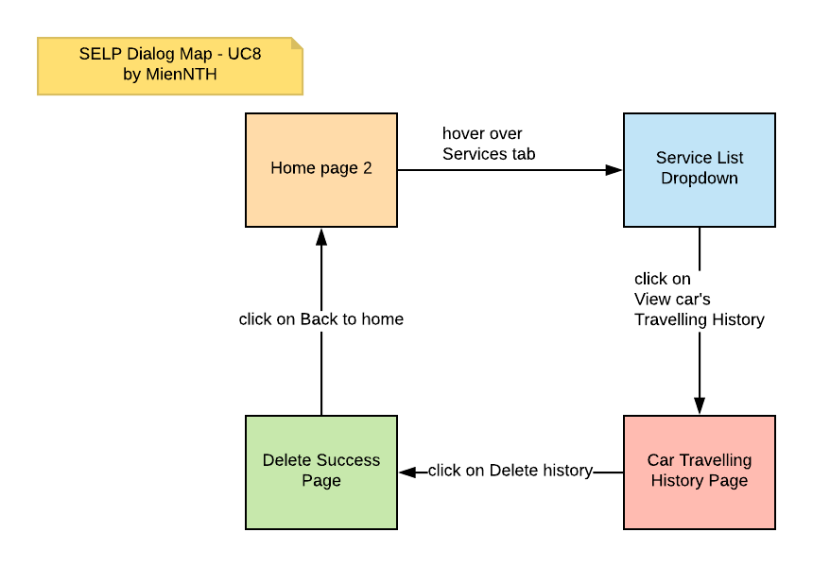

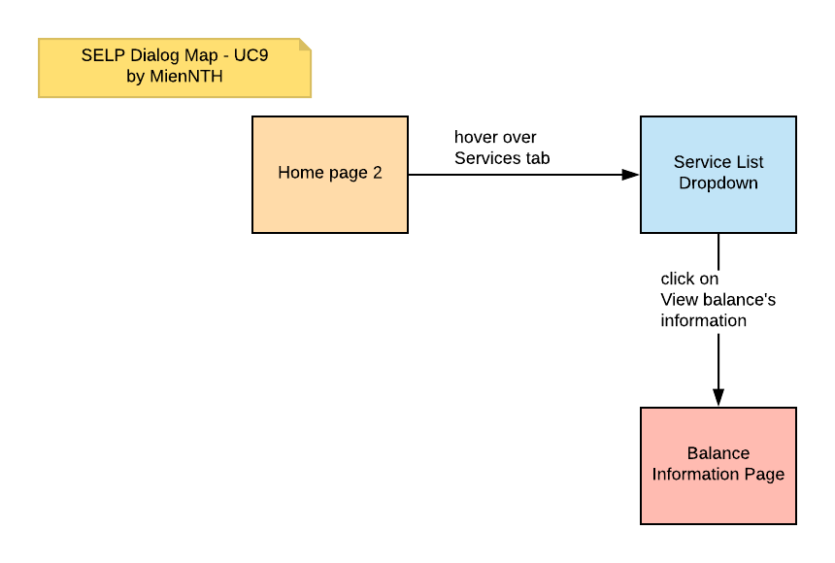

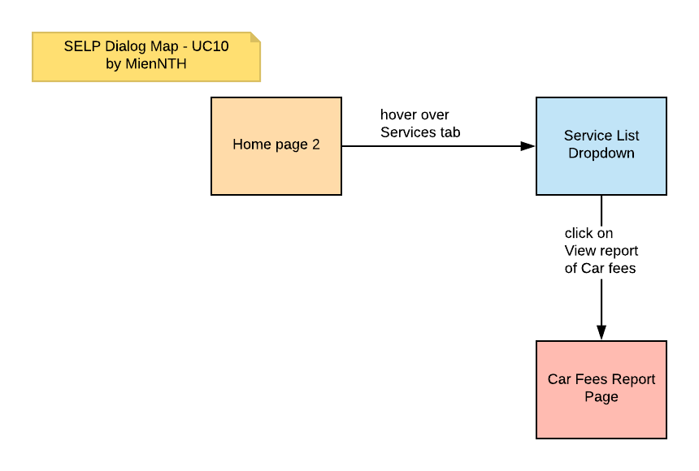

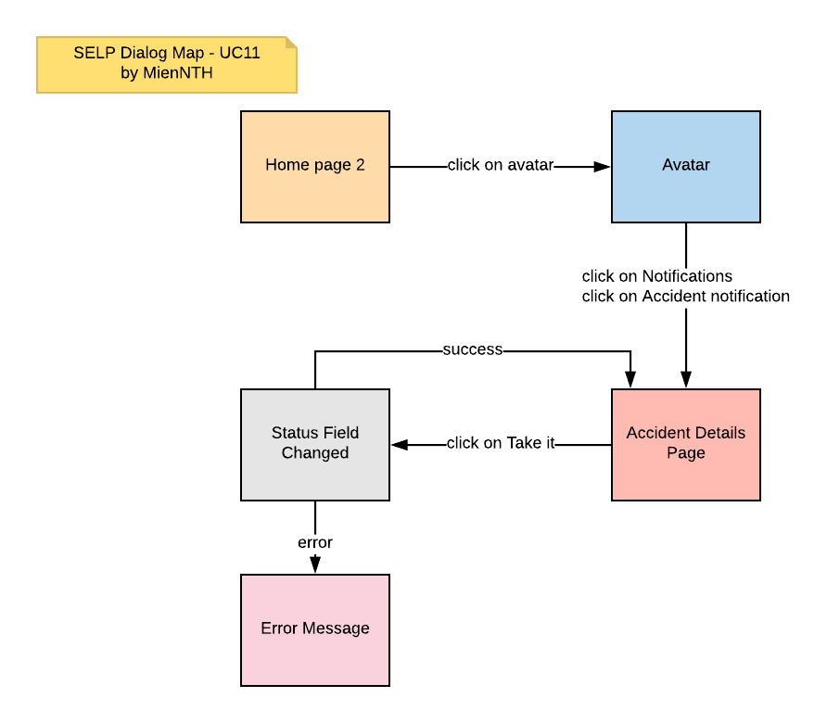

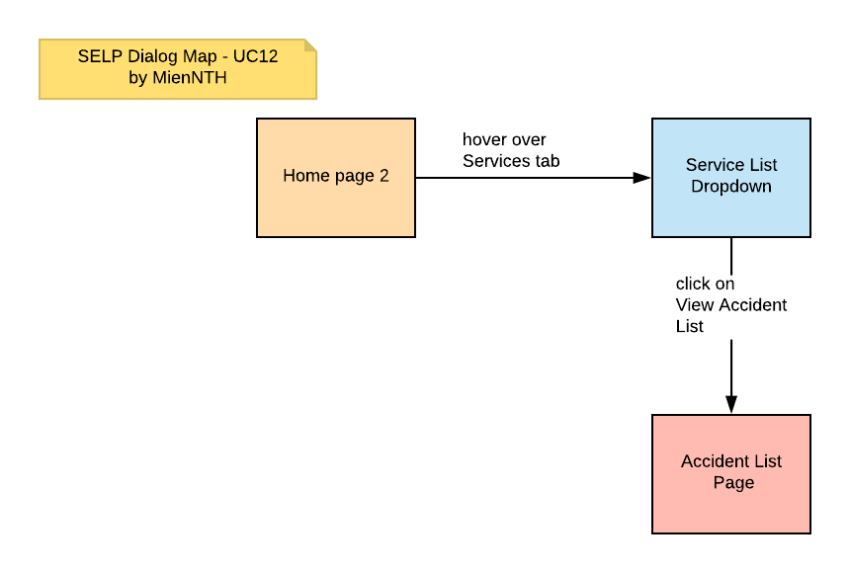

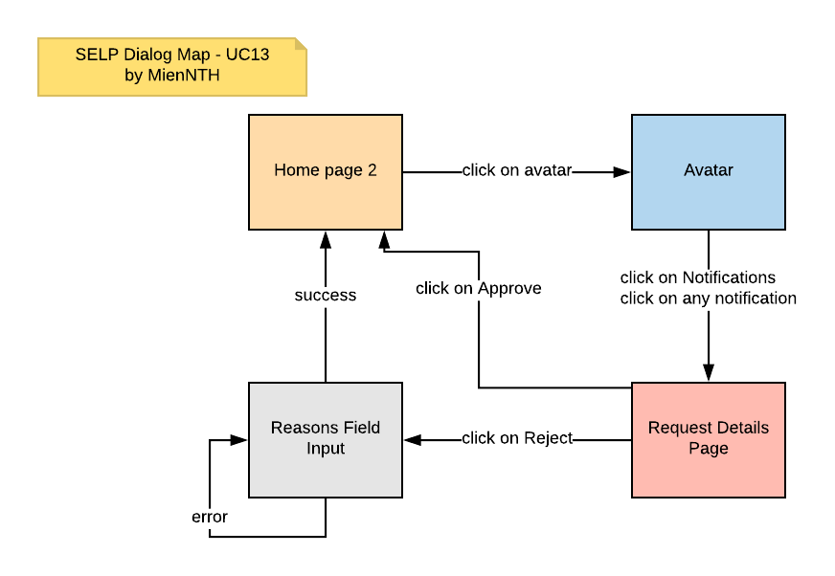

Context diagram
