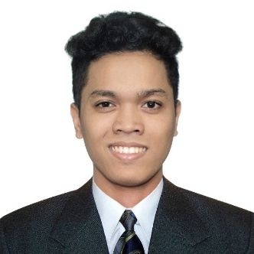16 Binangonan St. Maypajo Caloocan City

Mobile: 0947 270 8320

Email: michael.clemente012@gmail.com

Online Portfolio: <https://emsss.github.io/myPortfolio/>

**Michael Angelo I. Clemente**

v

**OBJECTIVE**

To seek for a challenging role to utilize my technical, database, and management skills for the growth of the company as well as to enhance my knowledge about new and emerging trends in the IT industry.

**PERSONAL DATA**

Date of Birth: October 12, 1997

Place of Birth: Caloocan City

Civil Status: Single

Citizenship: Filipino

Religion: Catholic

Height: 5 ‘5 ‘’

Weight: 62 kg.

Father’s Name: Jesus Ma. C. Clemente Jr.

Mother’s Name: Leila I. Clemente

**EDUCATIONAL BACKGROUND**

**Primary: Lerma Elementary School**

Caloocan City

2005-2011

**Secondary: Maypajo High School**

Caloocan City

2011-2015

**Tertiary: University of Caloocan City**

Caloocan City

Bachelor of Science in Computer Science

Batch 2015-2019

**PERSONAL QUALITIES**

* Determination and eagerness to learn and explore new things.
* Good listener
* Fast learner
* Good communication

**INTERNSHIP**

* Quality Assurance Analyst at Sytian IT Solutions Inc. (Sytian Production)

**WORK EXPERIENCE**

* Pacific Data Resources (Asia) Inc., - July 2019 – March 2021
  + - Worked as a Quality Assurance Specialist
  + The SirQo Group Inc. – July 2021 – Present
    - Worked as Junior Quality Assurance Engineer

**SKILLS**

* Knowledgeable in Microsoft Office Application such as:
  + Microsoft Office Word
  + Microsoft Excel
  + Microsoft Office PowerPoint
* Basic knowledge in Programming C# or VB.Net with Database Management.
* Basic knowledge in Web Development using HTML, CSS, PHP and JavaScript
* Basic knowledge in JMeter and Katalon automation testing software.
* Knowledgeable in 3D Modelling and animation using Blender.

**CHARACTER REFERENCE**

**- Francis Car Sevilla** -*Accenture, Inc.*

*- Contact: 09216302909*

*- Advanced Application Engineering Senior Analyst*

**I hereby certify that all the information stated above are true and correct to the best of my knowledge and beliefs; any falsification can be used as ground for disqualification of my application.**

*Respectfully Yours,*

**Michael Angelo I. Clemente**