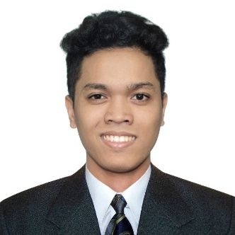16 Binangonan St. Maypajo Caloocan City

Mobile: 0947 270 8320

Email: [michael.clemente012@yahoo.com](mailto:michael.clemente012@yahoo.com)

**Michael Angelo I. Clemente**

v

**OBJECTIVE**

To seek for an employment wherein I am qualified and suits my knowledge. In which where I could improve my knowledge in order to be more skilled and to be trained as IT professional, for the development of myself and the company.

**PERSONAL DATA**

Date of Birth: October 12, 1997

Place of Birth: Caloocan City

Civil Status: Single

Citizenship: Filipino

Religion: Catholic

Height: 5 ‘5 ‘’

Weight: 62 kg.

Father’s Name: Jesus Ma. C. Clemente Jr.

Mother’s Name: Leila I. Clemente

**EDUCATIONAL BACKGROUND**

**Primary: Lerma Elementary School**

Caloocan City

2005-2011

**Secondary: Maypajo High School**

Caloocan City

2011-2015

**Tertiary: University of Caloocan City**

Caloocan City

Bachelor of Science in Computer Science

Batch 2015-2019

**PERSONAL QUALITIES**

* Determination and willingness to learn.
* Good listener
* Fast learner
* Good communication

**INTERNSHIP**

* Quality Assurance Analyst at Sytian IT Solutions Inc. (Sytian Production)

**WORK EXPERIENCE**

* Pacific Data Resources (Asia) Inc., - 2019 – 2021
  + - Work as a Quality Assurance Specialist

**SKILLS**

* Knowledgeable in Microsoft Office Application such as:
  + Microsoft Office Word
  + Microsoft Excel
  + Microsoft Office PowerPoint
* Basic knowledge in Programming C# or VB.Net with Database Management.
* Basic knowledge in Web Development using HTML, CSS, PHP and JavaScript
* Basic knowledge in JMeter and Katalon automation testing software.
* Knowledgeable in 3D Modelling and animation using Blender.

**CHARACTER REFERENCE**

**- Ismael Manalo -** *Pacific Data Resources (Asia) Inc.,*

*- Contact: 0921 426 9874*

*- Software developer II - Full Stack / Acting Team Leader*

**I hereby certify that all the information stated above are true and correct to the best of my knowledge and beliefs; any falsification can be used as ground for disqualification of my application.**

*Respectfully Yours,*

**Michael Angelo I. Clemente**