Apni Factory - Critical Changes Before Launch
This document contains only the critical changes that must be completed before production launch. The attached screenshots illustrate the current system and the areas requiring modification.

1. Seller Notifications
When a new order is placed, the seller must immediately receive:
• Push notification
• Email notification
• Notification badge in seller portal
• Popup after login for unread orders.

2. Seller Response Time (3 Days)
Seller has 3 days to Accept or Reject an order. Show a countdown timer. If no action is taken within 3 days, automatically expire/cancel the order and notify both buyer and admin.

3. Buyer Notifications
Buyer must receive notifications for Accepted, Rejected, Processing, Shipped, Delivered and Cancelled statuses.
If seller rejects the order:
• Show rejection reason.
• Provide Refund option.
• Provide 3 alternative sellers offering similar products.

4. Admin Order Status Visibility
Add a Status column in the order list with colored badges:
🟡 Pending Seller
🟢 Accepted
🔵 Processing
🟠 In Transit
🟢 Delivered
🔴 Rejected
⚫ Cancelled

5. Rejection Reason
If a seller rejects an order, the admin must clearly see the rejection reason and date/time directly from the order details. Track repeated rejections so sellers with poor performance can be suspended or blocked.

6. Rename 'Invoice Details'
Replace the heading 'Invoice Details' with 'Order Details' because no invoice exists when an order is placed.

7. Correct Invoice Workflow
Buyer places order → Seller accepts → Seller uploads Invoice Number, Invoice PDF and Logistics/LR details → System validates uploaded invoice with order → Buyer downloads invoice containing seller invoice number and logistics information.

Reference Screenshots
Admin Order List - Status column should display color-coded order status.
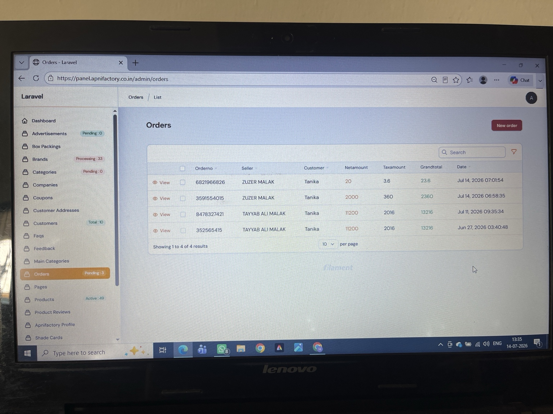
Order Details page - Rename 'Invoice Details' to 'Order Details'.
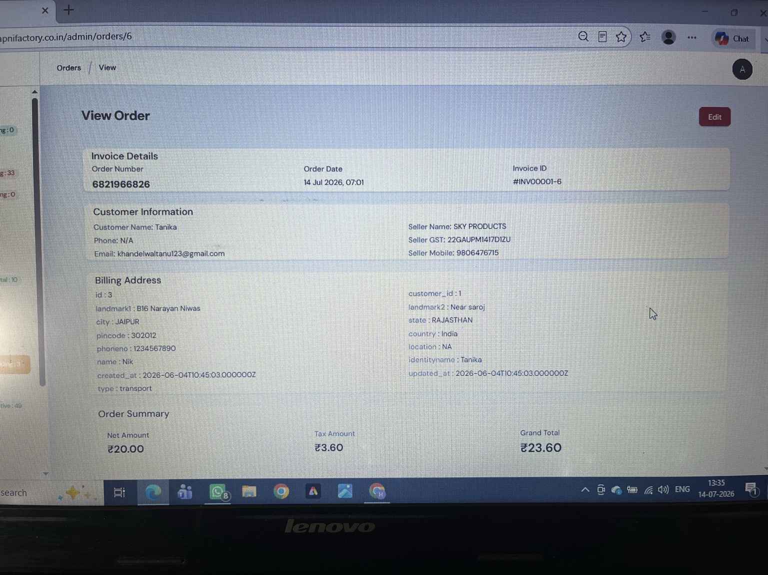
Admin should clearly see rejection reason and payment/order tracking.
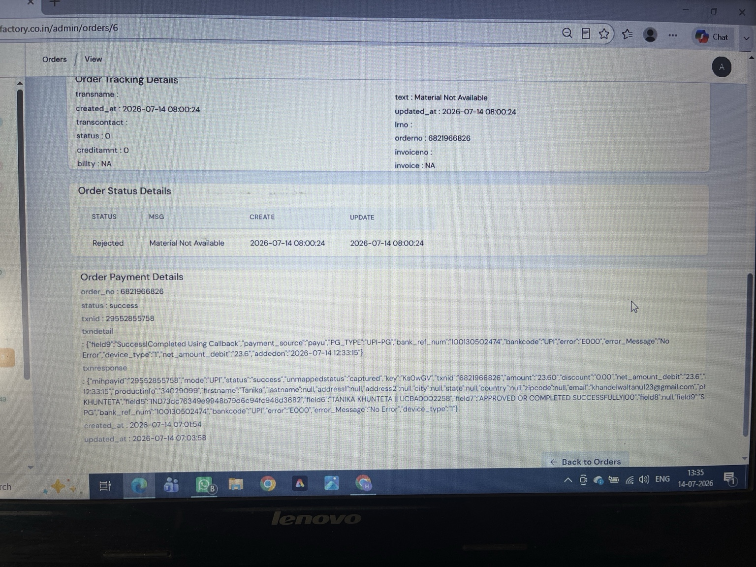
Seller Order List - Seller notifications and 3-day response timer required.
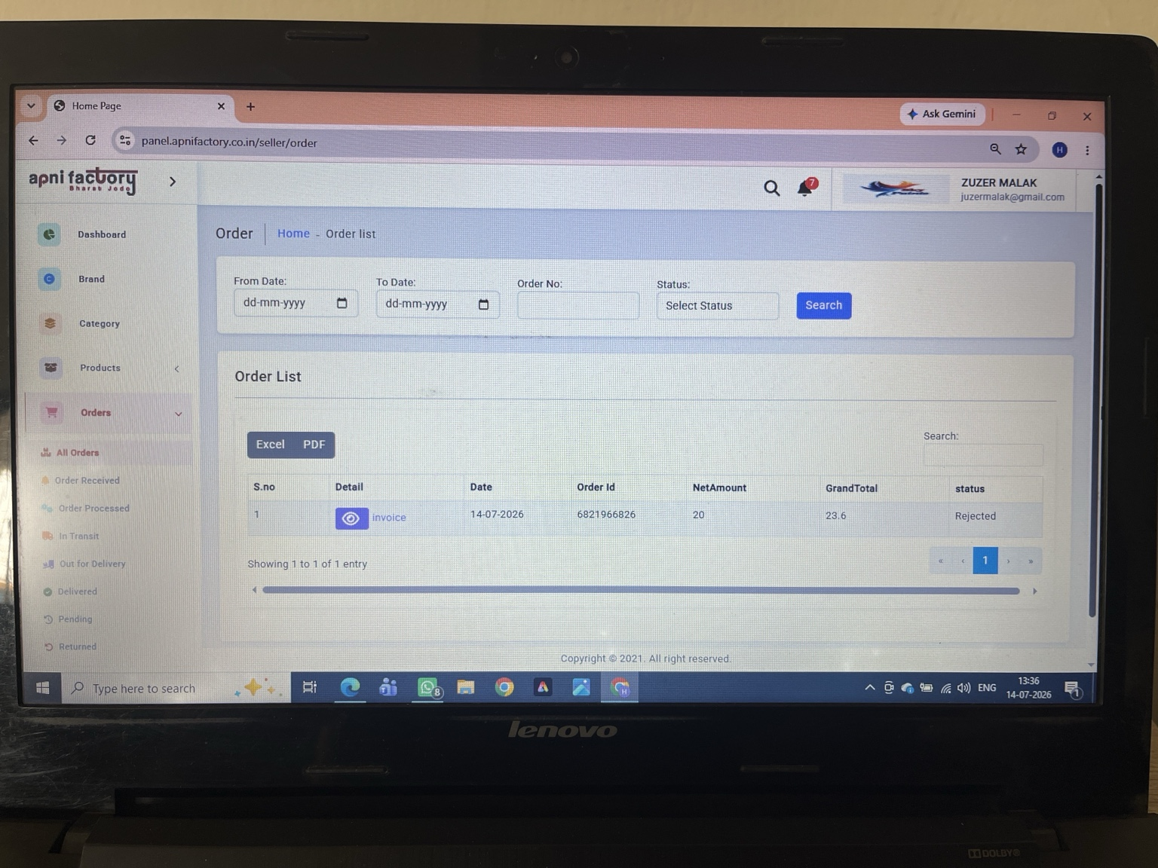
Seller Order Detail - Accept/Reject flow with rejection reason.
