1. Introduction
A Mobile Ad Hoc Network (MANET) is a self-configuring wireless network in which mobile devices communicate without relying on fixed infrastructure such as base stations or access points. Each node functions as both a host and a router, forwarding packets to enable communication across multiple hops.
Due to node mobility, MANETs experience frequent topology changes, limited bandwidth, and shared wireless channels, making efficient routing a significant challenge. Routing protocols must quickly adapt to these dynamic conditions while maintaining reliable communication.

This study evaluates the performance of AODV, AOMDV, DSDV, and DSR under different network sizes using the NS2.35 simulator to analyze their routing efficiency and scalability.

- To simulate the AODV, AOMDV, DSDV, and DSR routing protocols using the NS2.35 simulator.
- To evaluate protocol performance under three different network scenarios consisting of 26, 50, and 75 mobile nodes.
- To measure Packet Delivery Ratio (PDR), Throughput, and Average End-to-End Delay for each routing protocol.
- To compare the scalability and routing efficiency of reactive and proactive routing protocols.
- To analyze the impact of increasing node density on the performance of each routing protocol.
- To identify the routing protocol that provides the most suitable performance under different MANET scenarios.

2. Background Theory
MANET routing protocols are generally classified into three categories:
Proactive (Table-Driven): Continuously maintain routing information for all destinations through periodic updates (e.g., DSDV).
Reactive (On-Demand): Discover routes only when data transmission is required, reducing routing overhead (e.g., AODV, AOMDV, and DSR).
Hybrid: Combine proactive and reactive approaches to improve scalability (e.g., ZRP).

AODV (Ad hoc On-Demand Distance Vector)
AODV is a reactive routing protocol that establishes routes only when data transmission is required. When a source node needs a route, it broadcasts a Route Request (RREQ). The destination or an intermediate node with a valid route responds with a Route Reply (RREP), creating a communication path. AODV uses destination sequence numbers to maintain fresh, loop-free routes. During communication, link failures are detected through Hello messages or link-layer feedback. If a route breaks, a Route Error (RERR) is generated, and a new route discovery process is initiated. This on-demand mechanism reduces routing overhead and improves performance in dynamic MANET environments.

AOMDV (Ad hoc On-Demand Multipath Distance Vector)

AOMDV is an enhanced version of AODV that maintains multiple loop-free routes between the source and destination. During route discovery, several disjoint paths are established instead of only one. If the primary route fails, an alternative path can be used immediately without initiating a new route discovery. This reduces packet loss, improves reliability, and minimizes communication delay. Although AOMDV requires slightly more routing information to be maintained, its multipath capability makes it highly suitable for networks with frequent topology changes.

DSDV (Destination-Sequenced Distance Vector)

DSDV is a proactive routing protocol based on the Bellman-Ford algorithm. Each node maintains a routing table containing the next hop, hop count, and sequence number for every destination. Routing tables are updated periodically and whenever significant topology changes occur. Sequence numbers ensure that the most recent routes are selected while preventing routing loops. Since routes are always available, data packets can be forwarded without delay. However, periodic routing updates increase network overhead, especially in large or highly mobile networks.

DSR (Dynamic Source Routing)

DSR is a reactive routing protocol that uses source routing, where the complete route is included in each packet header. Routes are discovered only when needed and stored in a route cache for future use. This caching mechanism reduces the frequency of route discoveries and improves routing efficiency in smaller networks. However, packet headers become larger as route length increases, and cached routes may become outdated in highly dynamic environments, resulting in increased delay and reduced performance. DSR is particularly effective in networks with low to moderate mobility.

3. Simulation Environment and Tools
Table 1 — Software environment used for the experiment.
Component | Description
Operating system | Ubuntu Linux
Simulator | NS-2 version 2.35 (discrete-event network simulator)
Scenario generator | NSG2.1 — a Java tool that produces NS-2 TCL scripts from a graphical layout
Animator | NAM (Network AniMator) — replays the .nam trace visually
Trace format | New wireless trace format, enabled with $ns use-newtrace
Analysis | Custom Python 3 script (analyzer.py) using matplotlib for charts
Cross-validation | AWK scripts (pdr.awk, delay.awk, Avg_Tput.awk) used to verify the Python results
Each simulation run produces two output files. The .tr file is a plain-text trace in which every send, receive, drop and forward event is recorded with a timestamp, the node involved, the protocol layer, the packet type, its size and a unique identifier. The .nam file contains the same events in a form NAM can animate. All numerical results in this report come from the .tr files; the .nam files were used only for visual inspection.
3.1 Implementation of MANET Protocols in NS-2.35
All four routing protocols are already built into NS-2.35 as C++ agents, so no additional patching or recompilation was required. Each protocol lives in its own subdirectory of the simulator source tree and is selected from the TCL script at run time.
Table 2 — simulator source tree
Protocol | NS-2 agent | Source directory | Interface queue required
AODV | Agent/AODV | ~ns-2.35/aodv/ | Queue/DropTail/PriQueue
AOMDV | Agent/AOMDV | ~ns-2.35/aomdv/ | Queue/DropTail/PriQueue
DSDV | Agent/DSDV | ~ns-2.35/dsdv/ | Queue/DropTail/PriQueue
DSR | Agent/DSRAgent | ~ns-2.35/dsr/ | CMUPriQueue

A wireless simulation script follows a fixed structure. The parameters are declared first, then the simulator, topography and trace files are created, and the routing protocol is attached to every node through a single node-config directive:
set val(rp) AODV

$ns node-config -adhocRouting $val(rp) \
-llType LL \
-macType Mac/802_11 \
-ifqType $val(ifq) \
-propType Propagation/TwoRayGround \
-channel $chan \
-agentTrace ON -routerTrace ON
Because the protocol is chosen by one variable, the same scenario can be run under a different routing agent by editing a single line. This is what makes the comparison in this report a controlled one: node positions, mobility and traffic are byte-for-byte identical across the four protocol scripts in each scenario.
Three implementation details proved important in practice:
- DSR is the exception to the shared configuration. Its agent inspects and reorders packets already waiting in the interface queue when a route changes, which only CMUPriQueue supports. Supplying the ordinary priority queue causes NS-2 to terminate with a segmentation fault.
- DSDV exposes its periodic update interval as a bindable variable (perup_). The NS-2 default was used unchanged in this experiment, which turned out to have a decisive effect on the 50-node result discussed in Section 9.3.
- Trace output must be requested explicitly. The command $ns use-newtrace selects the new wireless trace format, in which each field is labelled with a flag such as -Nl for the trace level and -Ii for the packet identifier. Without it, NS-2 writes the older positional format, and any parser expecting the new format silently reports zero for every metric.
4. Simulation Setup
Table 3 — Radio, MAC and traffic parameters common to every run.
Parameter | Value
Channel type | Channel/WirelessChannel
Radio propagation model | Propagation/TwoRayGround
Network interface | Phy/WirelessPhy
MAC protocol | IEEE 802.11
Antenna | Omnidirectional (Antenna/OmniAntenna)
Interface queue length | 50 packets
Interface queue type | Queue/DropTail/PriQueue (CMUPriQueue for DSR)
Transmission range | Approximately 250 m
Carrier sense range | Approximately 550 m
Transport / application | TCP with TCPSink, carrying FTP bulk transfer
Application packet size | 512 bytes
Mobility model | Random waypoint applied to a subset of nodes
The three scenarios differ in several respects, which are set out explicitly below because they affect how the results may legitimately be compared:
Table 4 — Scenario-specific parameters. Note that field size, duration and offered load all vary alongside node count.
Scenario | Field size (m) | Duration (s) | TCP/FTP flows | Node density (km²)
26 nodes | 2245 × 900 | 50 | 4 | 12.9
50 nodes | 1000 × 1000 | 100 | 5 | 50.0
75 nodes | 1000 × 1000 | 100 | 8 | 75.0
Within each scenario the four protocol scripts are identical apart from the routing agent, so the comparison between protocols at a given node count is a controlled one. Node positions, mobility waypoints, traffic sources and destinations, and start and stop times are all shared. Section 10 discusses the one small exception found during verification.

5. Performance Metrics
Four metrics were computed from the application layer (AGT) events in each trace. Only packets that reach or leave the application agent count as data; routing control traffic is deliberately excluded so that the metrics describe what the user experiences rather than what the protocol does internally.

Packet Delivery Ratio
PDR is the percentage of application packets that arrive successfully out of those that were sent. It is the single clearest indicator of reliability. A low value means packets are being lost to broken routes, queue overflow or collisions.
PDR = (packets received at AGT ÷ packets sent at AGT) × 100

Average End-to-End Delay
For each packet that arrives, the delay is the difference between the time it was received by the destination application and the time it was generated by the source application. This interval includes route discovery, queueing at every intermediate node, retransmissions at the MAC layer and propagation. The metric reported is the mean over all successfully delivered packets, in milliseconds.

Average Throughput
Throughput measures the rate at which useful data actually reaches its destinations. It is calculated as the total number of received application bytes converted to bits and divided by the interval between the first packet being sent and the last packet being received, expressed in kilobits per second. This matches the definition used by the reference Avg_Tput.awk script.
Throughput = (received bytes × 8) ÷ (last receive time − first send time) ÷ 1000

Jitter
Jitter describes how much the delay varies from one packet to the next. Packets are ordered by their arrival time, the absolute difference between consecutive delays is taken, and the mean of those differences is reported. A network can have a perfectly acceptable average delay and still be unusable for interactive or streaming traffic if its jitter is high, which makes this metric a useful complement to the delay figure.

6. Network Animator Observations
Every run was replayed in NAM to confirm visually that the scenario behaved as intended and to observe how each protocol uses the wireless medium. In the images that follow, small numbered circles are the mobile nodes and the large expanding rings are packet transmissions in flight, drawn by NAM as a wave spreading from the transmitting node to everything within its radio range.
These captures are single instants taken from continuous animations, so they should be read as illustrations of behavior rather than as measurements. The quantitative conclusions in this report all come from the trace files. What the animations add is an intuitive picture of where activity is concentrated and how widely each protocol broadcasts.

The 26-Node Scenario
This scenario uses the widest field of the three, 2245 by 900 meters, holding only 26 nodes. The animations make the sparseness obvious: nodes are scattered thinly and much of the field is empty. Radio activity is confined to a small cluster at any given moment, because with so few nodes there are only a handful of usable paths and traffic is funneled along them.
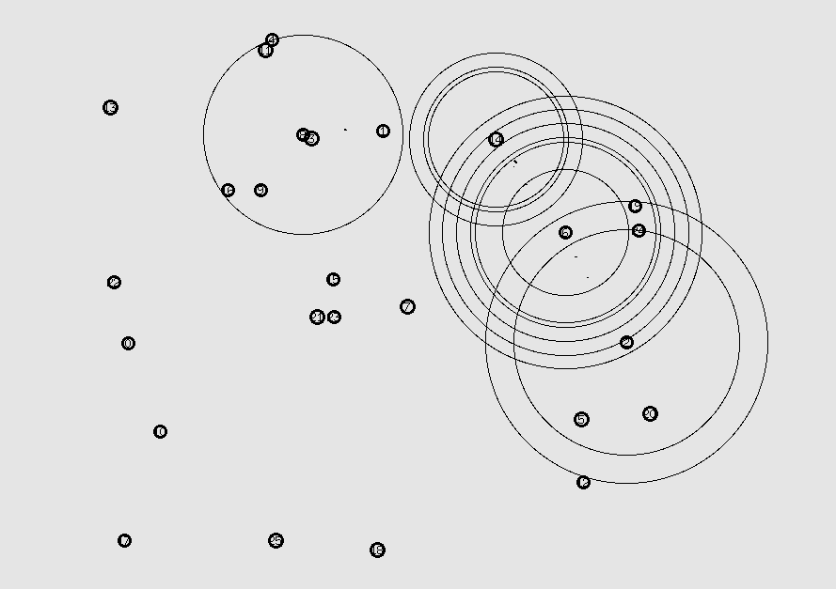
Figure 1 — AODV, 26 nodes. A route request propagating outward, with concentric rings showing the broadcast reaching successive neighbors.
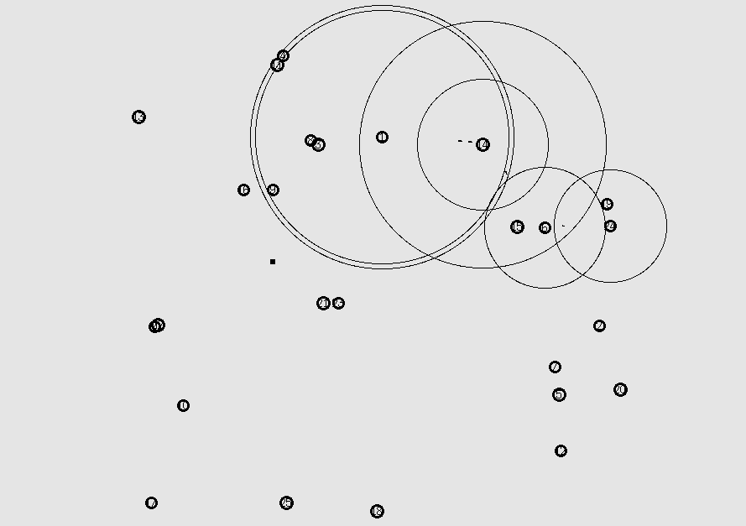
Figure 2 — AOMDV, 26 nodes. The nested rings around a single node indicate several transmissions in quick succession, consistent with AOMDV collecting multiple route replies from one discovery.
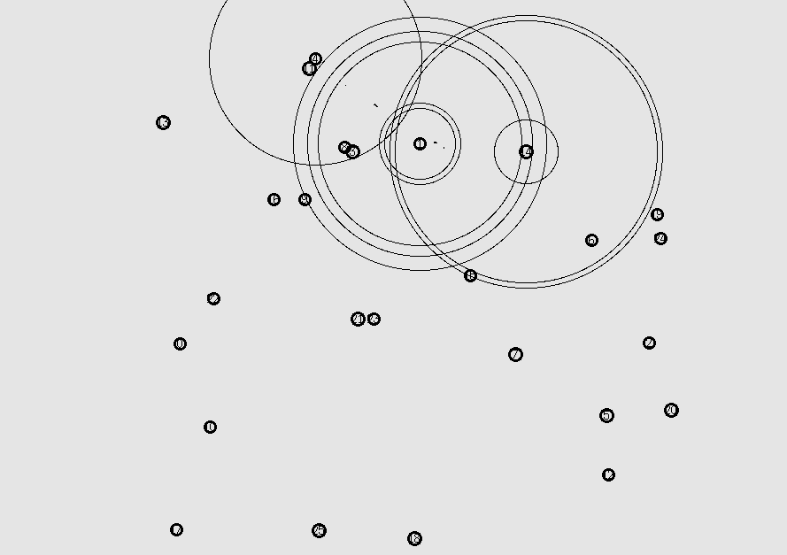
Figure 3 — DSDV, 26 nodes. Activity is compact and localized. Because DSDV already holds routes to every destination, no network-wide search is needed, and packets move straight along established paths.
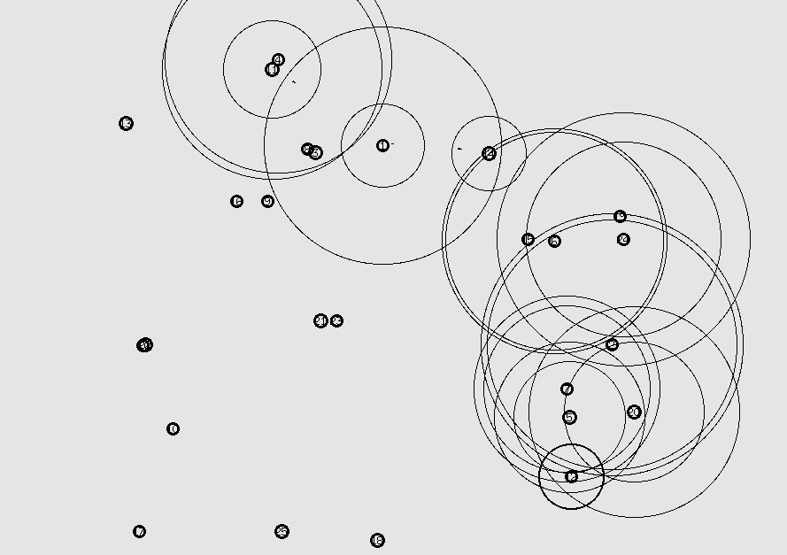
Figure 4 — DSR, 26 nodes. Several overlapping transmission rings appear at once as source-routed packets traverse a multi-hop path.
The DSDV frame is worth comparing directly against the AODV and DSR frames. DSDV shows tight, contained activity, which is what a protocol with pre-computed routes looks like in operation. This matches its measured results in this scenario: the highest delivery ratio at 99.41 per cent, the lowest delay at 164 milliseconds, and jitter of just 29.76 milliseconds, roughly a tenth of DSR's figure. Nothing must be searched for, so nothing waits.

The 50-Node Scenario
Here the field shrinks to 1000 by 1000 metres while the node count roughly doubles, so the network becomes markedly denser. Transmission rings now overlap far more, and the animations begin to show contention: several nodes broadcasting into the same area at the same time, which at the MAC layer means collisions and retransmissions.
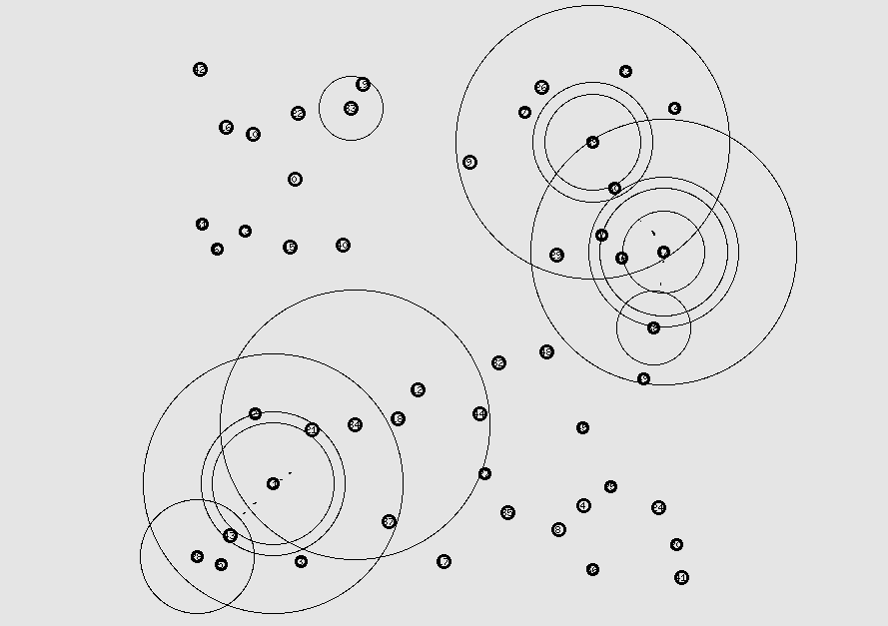
Figure 5 — AODV, 50 nodes. Multiple large rings overlap on the right-hand side of the field where a route discovery is in progress.
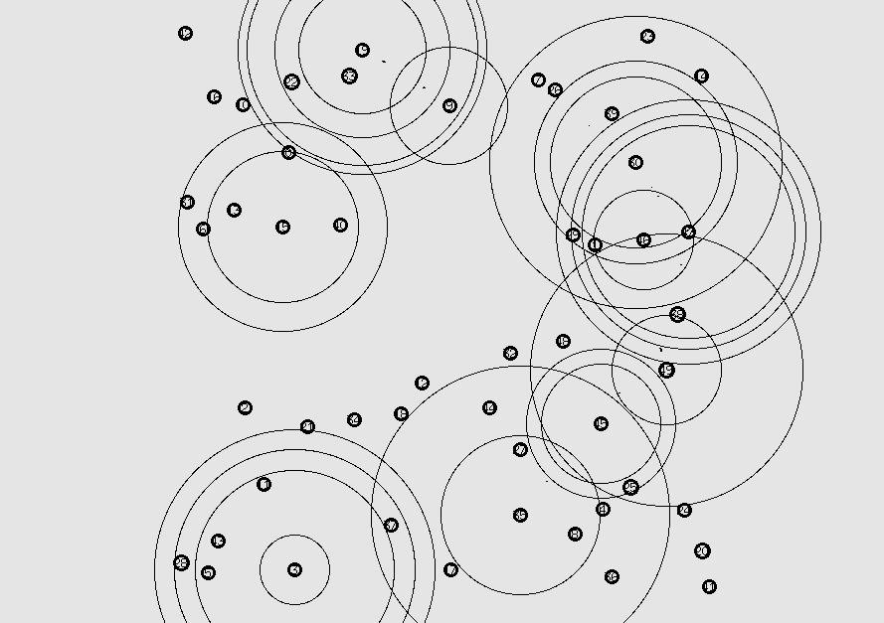
Figure 6 — AOMDV, 50 nodes. Two separate clusters of activity are visible, consistent with AOMDV maintaining and using more than one path at a time.
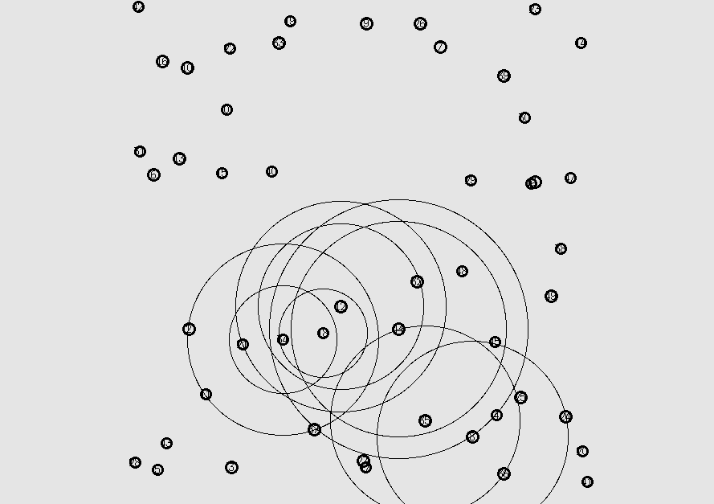
Figure 7 — DSDV, 50 nodes. Activity is confined to one region in the lower half of the field, with much of the network showing no traffic at all.
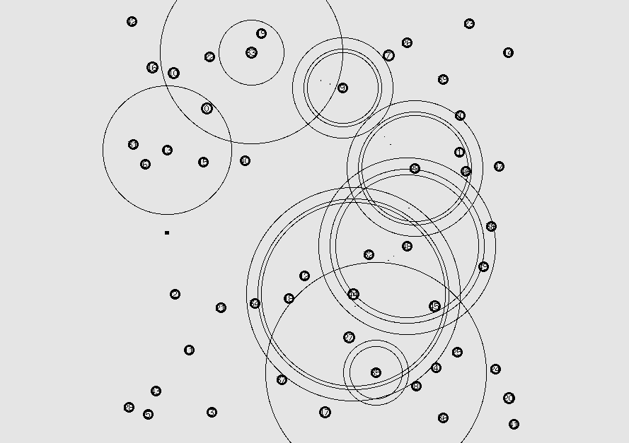
Figure 8 — DSR, 50 nodes. Dense concentric rings around a small group of nodes, showing repeated transmissions in the same area.
Figure 7 deserves attention because it corresponds to the weakest result in the entire study. DSDV managed only 417 sent packets in this scenario against 2340 to 3114 for the other three protocols, and its throughput fell to 10.18 Kbps. The animation is consistent with that: most of the network is idle, and what activity exists is confined to a small area rather than spread along end-to-end paths. As Section 9.3 explains, DSDV had not converged, so the sources had no routes to use and TCP never got its transfers started.

The 75-Node Scenario
The 75-node scenario packs half as many nodes again into the same one-square-kilometre field, giving the highest density tested at 75 nodes per square kilometre. The animations for this scenario are visibly the busiest of the three, with transmission rings covering large portions of the field simultaneously.
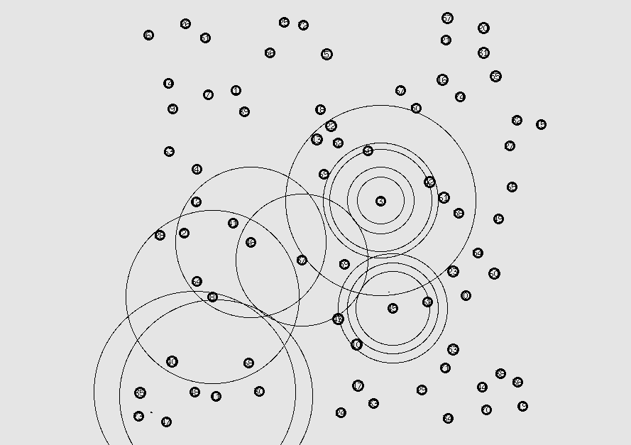
Figure 9 — AODV, 75 nodes. Overlapping rings across the left and center of the field as traffic flows along several concurrent paths.
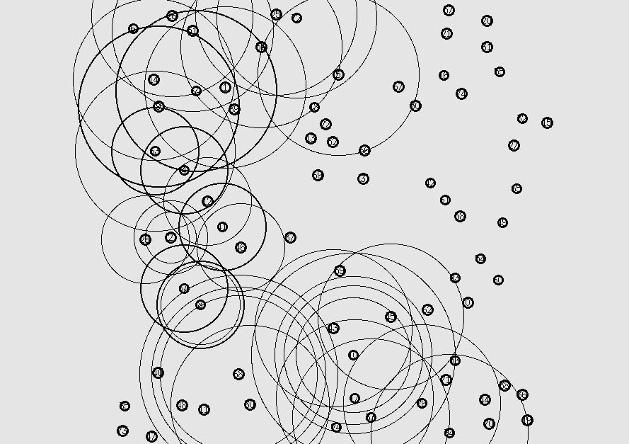
Figure 10 — AOMDV, 75 nodes. Activity spread across three distinct regions, reflecting the eight concurrent TCP flows running in this scenario.
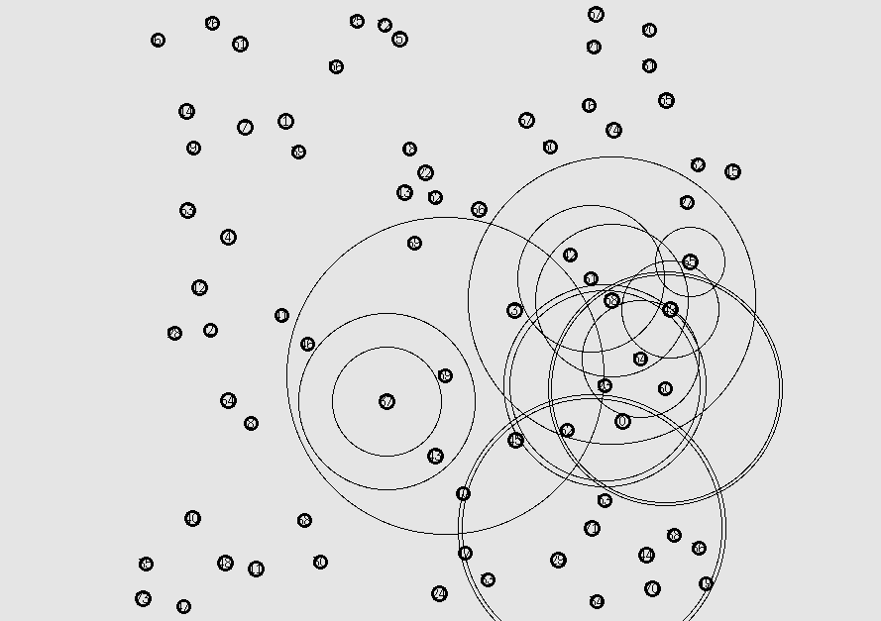
Figure 11 — DSDV, 75 nodes. Unlike the 50-node case, DSDV is now carrying real traffic, with rings extending across a substantial part of the field.
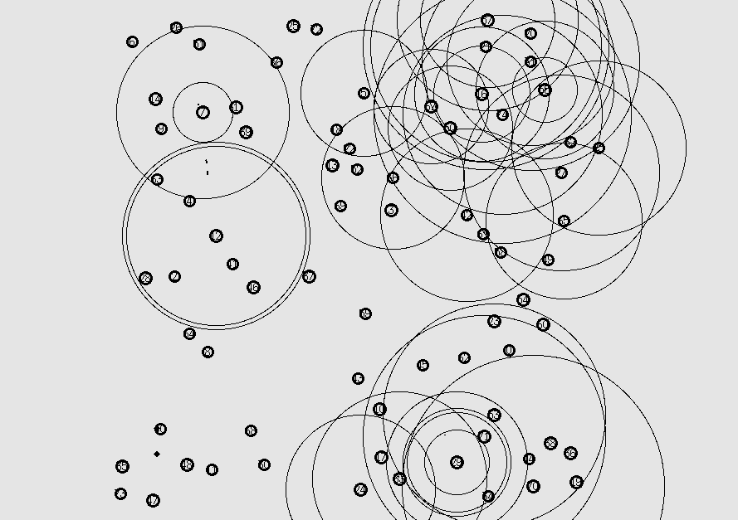
Figure 12 — DSR, 75 nodes. The most congested frame captured, with heavily overlapping transmissions across most of the field.
Comparing Figure 11 against Figure 7 illustrates the DSDV convergence argument visually. The 75-node network occupies the same field as the 50-node one but is considerably denser, so paths between any two nodes are shorter in hops. Since DSDV propagates routing information outward by one hop per update interval, shorter paths converge proportionally faster. DSDV therefore had usable routes in time and recovered to 95.74 per cent delivery, against 86.81 per cent on a far smaller sample at 50 nodes.
Figure 12 is the visual counterpart of DSR's latency problem. DSR achieved the best delivery ratio in this scenario at 98.92 per cent, but also the worst delay at 783 milliseconds and by far the worst jitter at 726 milliseconds. The animation shows why the medium is so heavily loaded: source routing places the full path inside every packet header, so each transmission carries more bytes than the equivalent AODV or AOMDV packet, and stale cached routes cause packets to be sent along paths that no longer work before a fresh discovery is triggered.

Summary of Visual Observations
Table 4 — Visual observations set against the measured results.
Scenario | What the animation shows | Corresponding measurement
26 nodes | Sparse field, activity confined to a small cluster | All protocols above 96% PDR; DSDV best on three of four metrics
50 nodes | Denser field, overlapping transmissions, DSDV largely idle | DSDV collapses to 417 packets and 10.18 Kbps
75 nodes | Highest density, widespread simultaneous transmissions | DSR most reliable at 98.92% but worst delay and jitter

7. Results

AODV:
Table 5 — AODV performance across the three scenarios.
Node scenario | PDR (%) | Throughput (Kbps) | EED (ms) | Jitter (ms)
26 | 96.63 | 152.09 | 262.98 | 75.29
50 | 87.88 | 65.62 | 338.07 | 206.64
75 | 87.11 | 134.29 | 192.89 | 140.88

AOMDV:
Table 6 — AOMDV performance across the three scenarios.
Node scenario | PDR (%) | Throughput (Kbps) | EED (ms) | Jitter (ms)
26 | 97.76 | 170.73 | 301.92 | 121.29
50 | 90.94 | 82.63 | 280.55 | 122.21
75 | 91.34 | 148.49 | 208.79 | 123.23

DSDV:
Table 7 — DSDV performance across the three scenarios.
Node scenario | PDR (%) | Throughput (Kbps) | EED (ms) | Jitter (ms)
26 | 99.41 | 147.48 | 163.68 | 29.76
50 | 86.81 | 10.18 | 672.24 | 917.98
75 | 95.74 | 85.57 | 193.04 | 130.92

DSR:
Table 8 — DSR performance across the three scenarios.
Node scenario | PDR (%) | Throughput (Kbps) | EED (ms) | Jitter (ms)
26 | 99.00 | 196.69 | 325.16 | 295.76
50 | 97.99 | 60.95 | 747.45 | 510.64
75 | 98.92 | 151.39 | 783.47 | 725.90

Complete Results:
Table 9 — Full data set as produced by analyzer.py.
Protocol | Nodes | Sent | Recv | PDR (%) | EED (ms) | Thr (Kbps) | Jitter (ms)
AODV | 26 | 2639 | 2550 | 96.63 | 262.98 | 152.09 | 75.29
 | 50 | 2714 | 2385 | 87.88 | 338.07 | 65.62 | 206.64
 | 75 | 4563 | 3975 | 87.11 | 192.89 | 134.29 | 140.88
AOMDV | 26 | 2907 | 2842 | 97.76 | 301.92 | 170.73 | 121.29
 | 50 | 3114 | 2832 | 90.94 | 280.55 | 82.63 | 122.21
 | 75 | 4448 | 4063 | 91.34 | 208.79 | 148.49 | 123.23
DSDV | 26 | 2358 | 2344 | 99.41 | 163.68 | 147.48 | 29.76
 | 50 | 417 | 362 | 86.81 | 672.24 | 10.18 | 917.98
 | 75 | 2466 | 2361 | 95.74 | 193.04 | 85.57 | 130.92
DSR | 26 | 3385 | 3351 | 99.00 | 325.16 | 196.69 | 295.76
 | 50 | 2340 | 2293 | 97.99 | 747.45 | 60.95 | 510.64
 | 75 | 4613 | 4563 | 98.92 | 783.47 | 151.39 | 725.90

8. Discussion
AODV:
- Achieved 96.63% PDR at 26 nodes, which decreased to 87.11% at 75 nodes due to frequent route rediscovery.
- Throughput dropped at 50 nodes but recovered at 75 nodes as network connectivity improved.
- Recorded the lowest delay (192.89 ms) among all protocols in the 75-node scenario.
- Suitable for dynamic MANETs but performance is affected by frequent link failures.

AOMDV:
- Maintained higher PDR (97.76%–91.34%) than AODV across all scenarios.
- Delivered consistently higher throughput due to its multipath routing capability.
- Delay decreased as node density increased, indicating efficient route recovery.
- Provided the most balanced overall performance in terms of reliability, throughput, and delay.

DSDV:
- Achieved the highest PDR (99.41%) and lowest delay (163.68 ms) in the 26-node scenario.
- Performance dropped significantly at 50 nodes, with throughput decreasing to 10.18 Kbps.
- Recovered in the 75-node scenario as higher node density improved route availability.
- Best suited for small and stable MANET environments.

DSR:
- Recorded the highest PDR (99.00%, 97.99%, and 98.92%) across all scenarios.
- Achieved the highest throughput in the 26-node and 75-node networks.
- Experienced the highest end-to-end delay, reaching 783.47 ms at 75 nodes.
- Suitable for applications requiring reliable packet delivery but not for delay-sensitive communication.
Reactive, Proactive and Hybrid Behavior
The four protocols tested do not represent four independent designs. They represent two design philosophies, one of which is present three times over. Grouping the results by family makes the underlying trade-off much clearer than comparing the protocols individually.
Table 10 — Classification of the protocols examined.
Family | Protocols tested | Core idea
Proactive (table-driven) | DSDV | Maintain a route to every destination at all times through periodic table exchanges. Packets are forwarded immediately, but bandwidth is consumed continuously.
Reactive (on-demand) | AODV, AOMDV, DSR | Discover a route only when data needs to be sent. No background overhead, but the first packet of a conversation waits for discovery.
Hybrid | none tested | Behave proactively inside a local zone and reactively beyond it. ZRP is the standard example.
Averaging the three reactive protocols and setting the result against DSDV gives the following picture. The ratio row shows the reactive average divided by the DSDV value, so a figure above one means the reactive family scored higher on that metric.
Table 11 — Reactive family average against the proactive protocol.
Scenario | Family | PDR (%) | Delay (ms) | Jitter (ms)
26 nodes | Reactive (mean) | 97.80 | 296.69 | 164.11
 | Proactive (DSDV) | 99.41 | 163.68 | 29.76
 | Ratio | 0.98 | 1.81 | 5.51
50 nodes | Reactive (mean) | 92.27 | 455.36 | 279.83
 | Proactive (DSDV) | 86.81 | 672.24 | 917.98
 | Ratio | 1.06 | 0.68 | 0.30
75 nodes | Reactive (mean) | 92.46 | 395.05 | 330.00
 | Proactive (DSDV) | 95.74 | 193.04 | 130.92
 | Ratio | 0.97 | 2.05 | 2.52
Two findings emerge, and they point in opposite directions.
First, where the proactive protocol works, it works decisively on latency. In the 26-node scenario the reactive protocols took 1.81 times longer on average to deliver a packet and produced 5.51 times more jitter. The reason is precisely the mechanism that defines the family: a reactive protocol must flood a Route Request and wait for a reply before the first packet of a conversation can move, and it must repeat that whenever a link breaks. Some packets therefore sail through on an established route while others wait for a discovery, and that variation is what jitter measures. DSDV never waits, so its packets are treated almost identically and its jitter falls to 29.76 milliseconds. The same pattern reappears at 75 nodes, where DSDV again more than halves both the delay and the jitter of the reactive average.
Second, when the proactive protocol fails, it fails completely rather than gracefully. In the 50-node scenario the ratios invert: the reactive family delivered 6.85 times the throughput of DSDV, and DSDV's jitter of 918 milliseconds was more than three times the reactive average. A reactive protocol that cannot find a route simply retries the discovery and eventually succeeds. A proactive protocol that has not converged has nothing to fall back on, because its entire design assumes the table is already populated. This is the practical meaning of the convergence argument in Section 9.3: proactive routing trades robustness for immediacy.
The reactive family is itself far from uniform, which is worth stressing because it is easy to treat "reactive" as a single behavior. The three protocols occupy consistently different positions:
- DSR achieved the highest delivery ratio of the three in every scenario, and the worst delay and jitter in every scenario. Aggressive route caching keeps data flowing but repeatedly sends packets down stale paths before a failure is detected.
- AODV recorded the lowest delivery ratio of the three in every scenario, yet the lowest delay at both 26 and 75 nodes. Holding a single route per destination is cheap when it works and expensive when it breaks.
- AOMDV was the most stable, taking the best jitter of the three in both larger scenarios and the best delay and throughput at 50 nodes. Keeping spare link-disjoint routes converts a network-wide rediscovery into a local table lookup.
The spread within the reactive family is in fact wider than the gap between the families. At 75 nodes, DSR's jitter of 726 milliseconds is nearly six times AOMDV's 123 milliseconds, whereas the reactive average differs from DSDV by a factor of 2.5. How a protocol stores and repairs its routes matters at least as much as when it decides to build them.
No hybrid protocol was included in this experiment, so nothing can be claimed about that family from these measurements. The results do, however, indicate why the hybrid idea exists. A hybrid such as ZRP maintains proactive tables only within a limited radius and uses on-demand discovery beyond it, which would give DSDV's low jitter for nearby destinations while avoiding the convergence failure that destroyed its 50-node result, since the proactive component never has to span the whole network. Testing ZRP alongside these four would be the natural extension of this work.
One qualification applies throughout this subsection. The proactive family is represented by a single protocol, so "proactive" here means "DSDV with its default timers" rather than proactive routing in general. A proactive protocol with a shorter update interval, or one run after a warm-up period, would behave differently in the 50-node scenario. The comparison of families is therefore indicative rather than conclusive.

Overall Comparison:

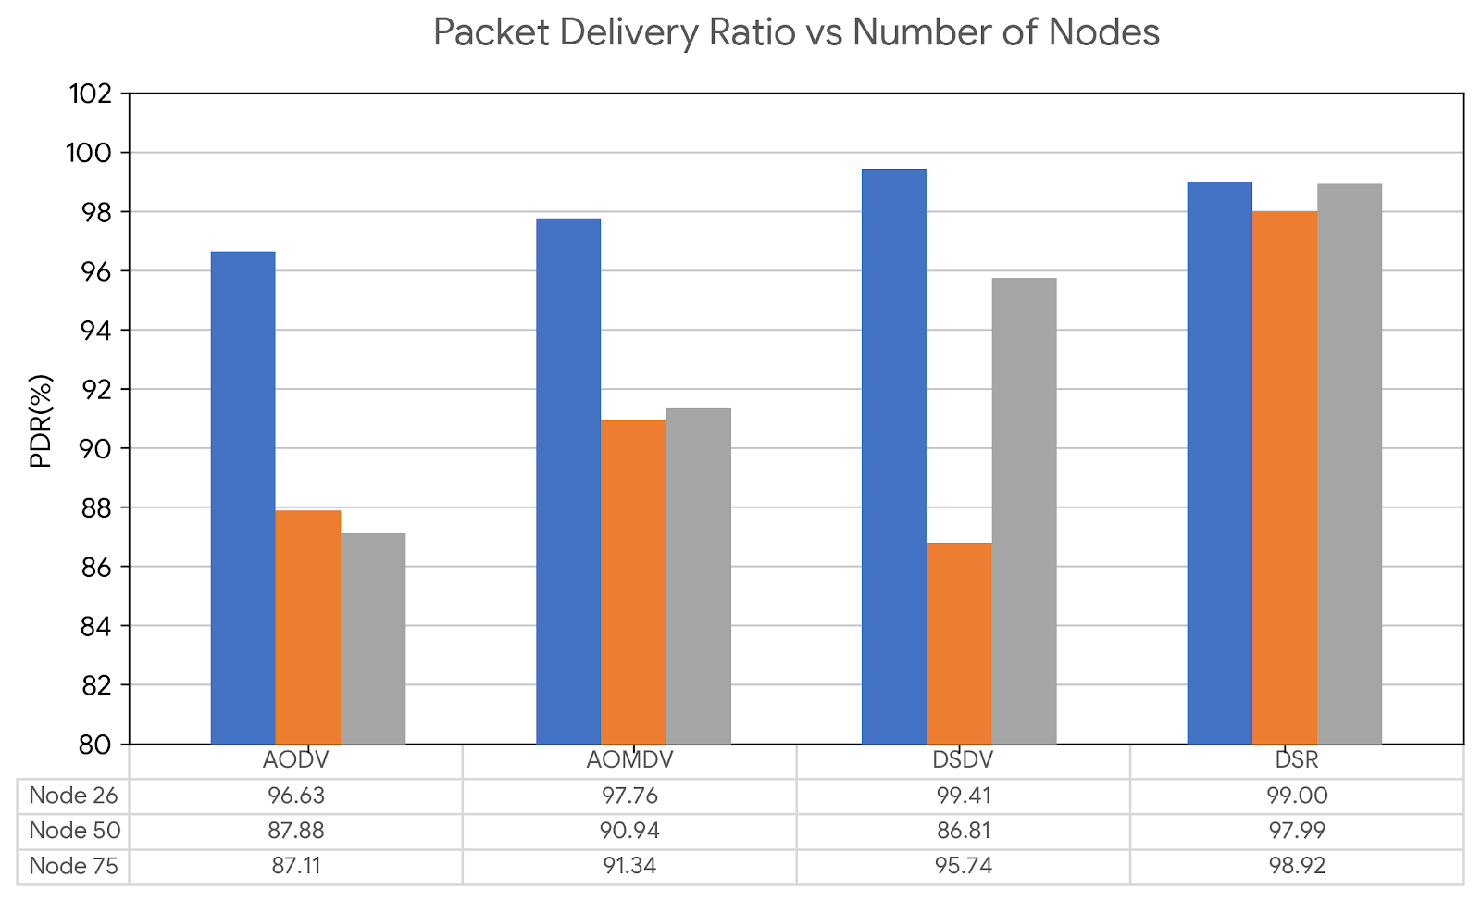

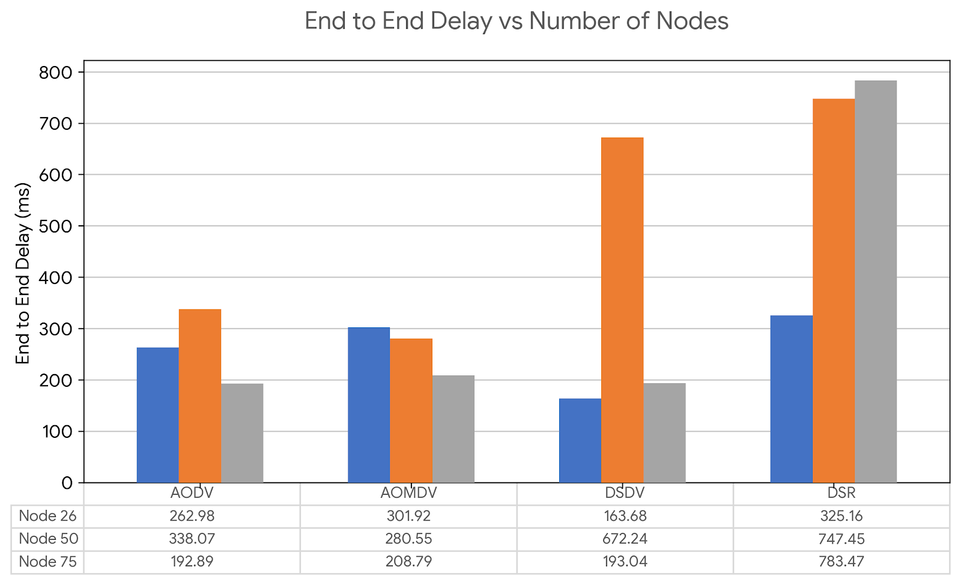

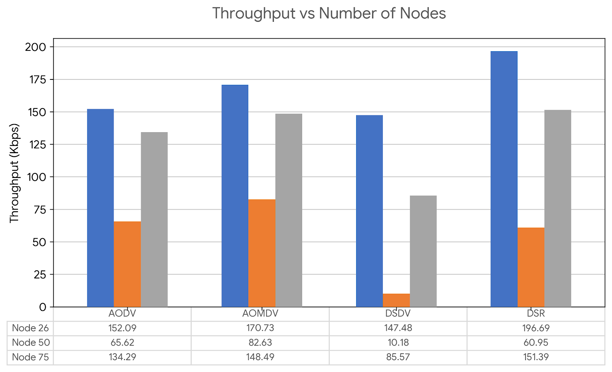

Table 12 — Winner by metric and scenario.
Scenario | Best PDR | Best throughput | Lowest delay | Lowest jitter
26 nodes | DSDV (99.41) | DSR (196.69) | DSDV (163.68) | DSDV (29.76)
50 nodes | DSR (97.99) | AOMDV (82.63) | AOMDV (280.55) | AOMDV (122.21)
75 nodes | DSR (98.92) | DSR (151.39) | AODV (192.89) | AOMDV (123.23)
- DSR achieved the highest packet delivery ratio and throughput in most scenarios.
- AOMDV provided the most balanced performance with high reliability and stable throughput.
- DSDV performed best in small networks but showed poor scalability at medium node density.
- AODV offered moderate throughput and low delay but lower packet delivery in larger networks.
The results indicate that AOMDV is the most suitable overall protocol, while DSR is preferable when reliable packet delivery is the primary requirement.

9. Conclusion
Twelve simulations covering four routing protocols and three network sizes produced a clear and consistent picture, provided the results are read with their context.
DSDV, the only proactive protocol tested, was the best performer by a comfortable margin in the small sparse network, winning on delivery ratio, delay and jitter simultaneously. Its jitter of under 30 milliseconds was not approached by any other protocol in any scenario. That advantage disappeared entirely in the 50-node network, where its slow convergence left it unable to carry meaningful traffic. The conclusion is not that DSDV is a poor protocol but that its performance depends critically on whether the network diameter allows its tables to settle within the time available.
Among the reactive protocols, DSR delivered the highest proportion of packets in the larger networks, but with delays and jitter several times worse than its competitors, which rules it out for time-sensitive traffic. AODV was fast when it worked but lost the most packets, reflecting the cost of maintaining only a single route per destination. AOMDV, by keeping alternative paths ready, consistently improved on AODV in every metric measured and produced the most stable behaviour overall.
If a single recommendation had to be drawn from these results, it would be that AOMDV is the most sensible general-purpose choice for a mobile network of moderate size, DSDV is preferable where the network is small and comparatively stable and low jitter matters, and DSR should be reserved for situations where eventual delivery outweighs timeliness.
The experiment also demonstrated something more general about measurement itself. DSDV's 86.81 per cent delivery ratio in the 50-node scenario looks entirely acceptable until it is placed beside the packet count that produced it. A metric quoted without its context can invert the conclusion a reader draws, and reporting delivery ratio, throughput and raw packet counts together is what makes the result interpretable.

